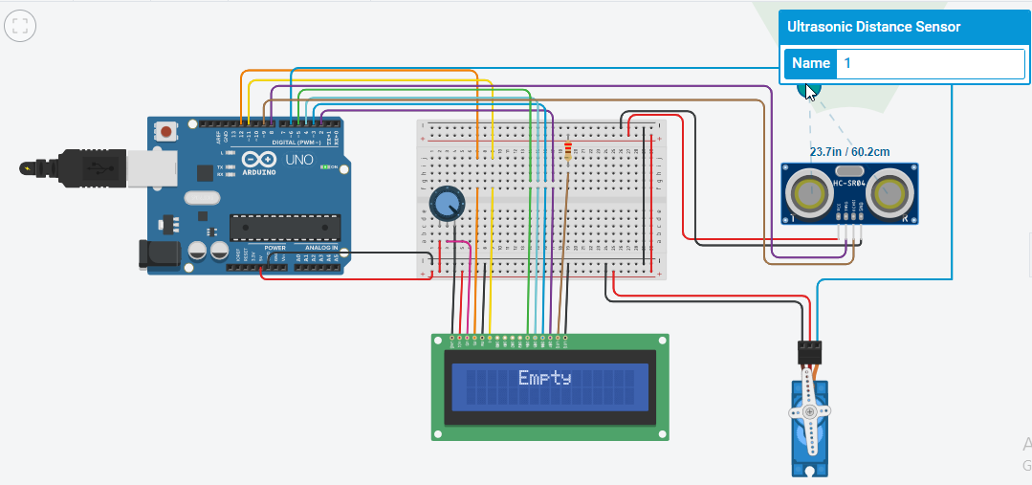

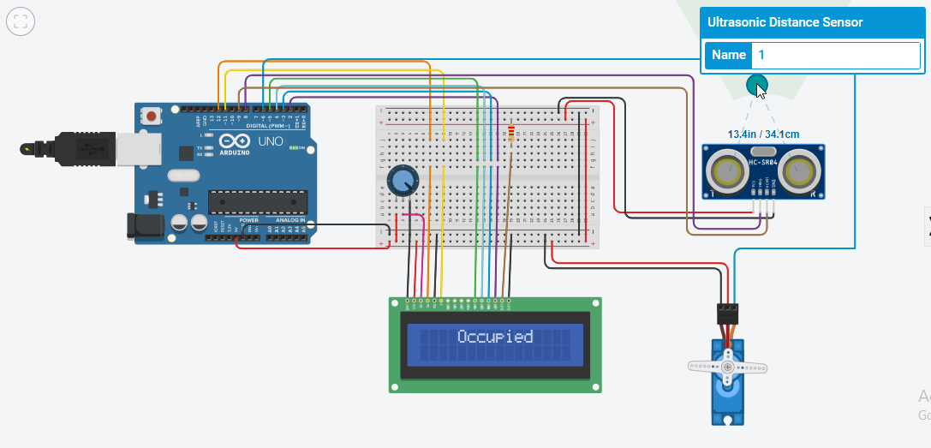

#include<Servo.h>

#include <LiquidCrystal.h>

int rs = 12, en = 11, d4 = 5, d5 = 4, d6 = 3, d7 = 2;

LiquidCrystal lcd(rs, en, d4, d5, d6, d7);

int trigPin = 8, echoPin = 9;

long duration, distance;

int servo = 6;

Servo myServo;

int pos = 0;

void setup()

{

Serial.begin(9600);

myServo.attach(servo);

lcd.begin(16, 2);

pinMode(trigPin, OUTPUT);

pinMode(echoPin, INPUT);

}

void loop() {

digitalWrite(trigPin,HIGH);

delay(1000);

digitalWrite(trigPin, LOW);

duration = pulseIn(echoPin, HIGH);

distance = duration \*0.034 /2;

Serial.print(distance);

Serial.println("CM");

delay(10);

if(distance < 50.000) {

myServo.write(90);

lcd.setCursor(4, 0);

lcd.print("Occupied");

delay(1000);}

else {

lcd.clear();

myServo.write(0);

lcd.setCursor(5, 0);

lcd.print("Empty");

}

}