**2022 MT**

**Disease modelling**

**Multi-strain dynamics**

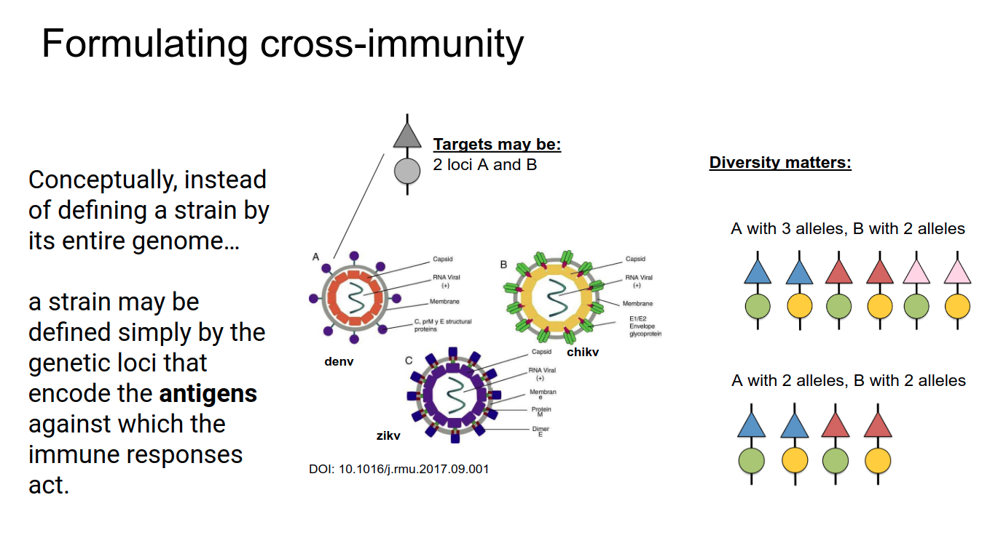

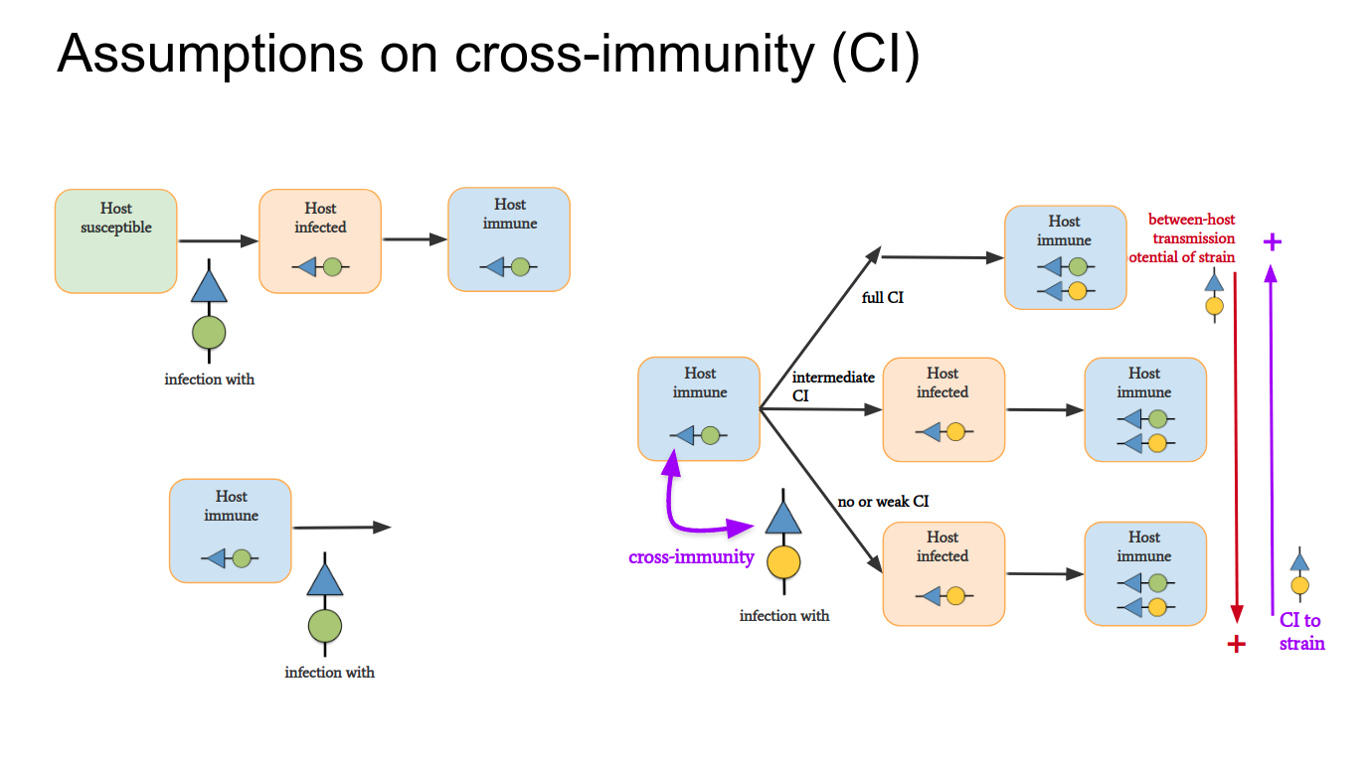

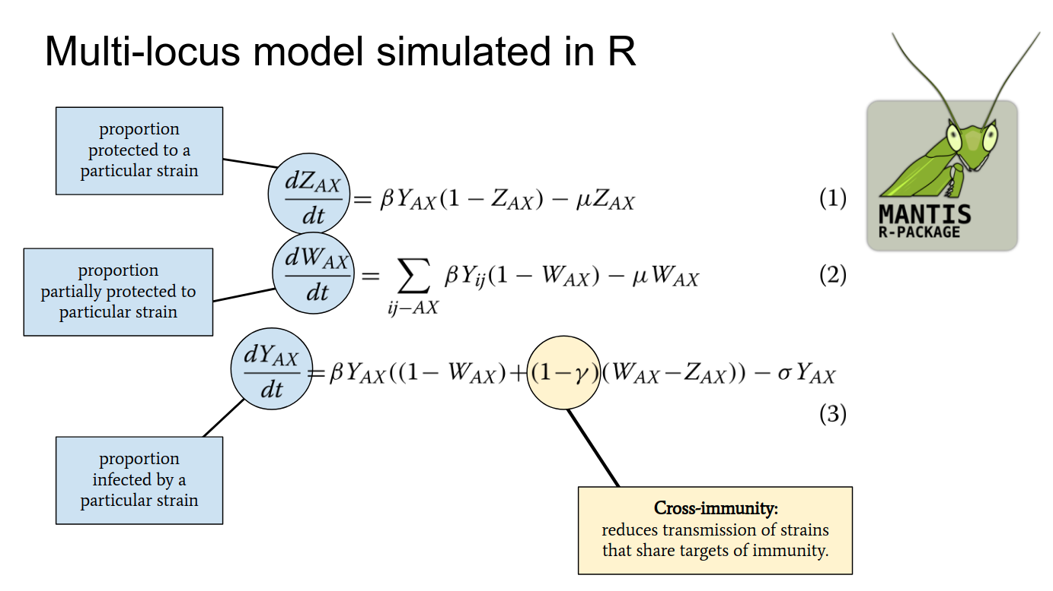

**Part 1 - Scenario i: Multi-strain dynamics with no cross-immunity**

You will introduce a multi-strain pathogen into a susceptible host-population, assuming that no cross-immunity is generated between strains. As the strains spread, self-emergent patterns will be evident in the output of the model. You will address / interpret these patterns within a dynamical and biological perspective.

You are given code for this scenario. When you run the code, you get the following plot. Note that the two panels show the same simulation. The one on the left shows the entire simulation. The one on the right shows a specific period of the simulation – the grey shaded time period presented in the left panel (this is how you will zoom into particular time periods if you want to see better what is going on).

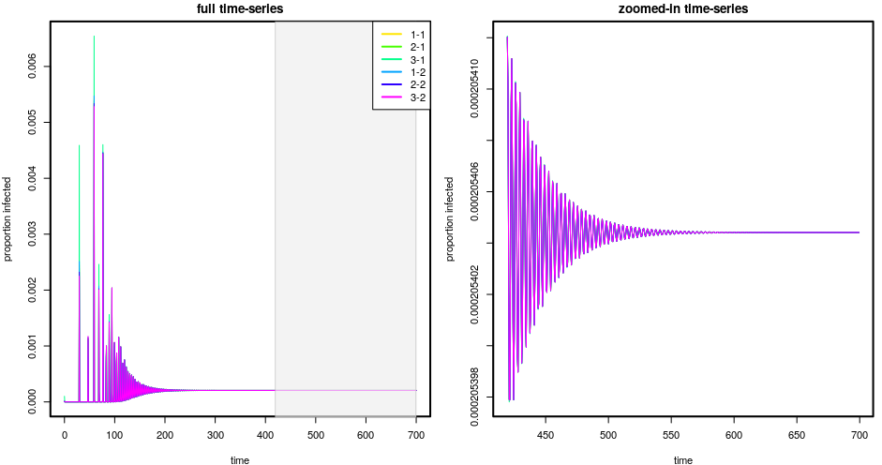

Note the legend on the left panel. It gives you each strain, its colour, and its “allelic sequence” (the allele at each locus). For example, strain 1 = 1-1 means that this strain has allele “1” at locus 1 and allele “1” at locus 2.

**Exercise 1.1** Look at the plot instruction in your code:

plotY(simdata, xiObs=0.6, xfObs=1.0, addLegend=TRUE)

The first parameter (simdata) is the variable that keeps the model’s solution. The second and third parameters (xiObs,xfObs) allow you to choose the proportion of time that you want to see on the right panel of the plot (zoomed-in). Finally, the fourth parameter (addLegend) allows you to add a legend.

Change the second and third parameters to zoom-in between 50 and 250 of the time scale (this is just so you learn how to select a time period, you don’t need to understand or explain any of the dynamics yet).

**Exercise 1.2a** There are two important things to note on these dynamics. First, the dynamics are similar to SIR models. Second, although there are 6 strains, we can’t see all of them in the resulting dynamics because they are plotted on top of each other. Why are the dynamics SIR-like? Why do strains behave so similarly?

**Exercise 1.2b** The following instruction allows you to see (i) the prevalence levels of each strain at the last time step of the simulation, and (ii) the allelic sequence of each of the strains in the simulation: extractYFinalConditions(simdata)*.* Run this instruction and check that indeed all strains have the same prevalence at the end.

**Exercise 1.3** We are now going to make one strain more transmissible than the others. Make sure cross-immunity remains set to zero. Change the transmission potential of the strains to favour strain number 2. Do this by changing beta=c(292, 292, **292**, 292, 292, 292) to beta=c(292, **584**, 292, 292, 292, 292).

What are the dynamic consequences of the change: what happened to the strain for which the change was applied? What happened to the strains for which no change was applied?

**Exercise 1.4** You will measure strain diversity per time step: strain diversity is higher when all strains co-circulate at similar prevalence. Revert the betas back to their original value of 292 and then use plotYDiversity(simdata, xiObs=0.3, xfObs=1.0) to generate a plot of diversity. Explain the dynamics of strain diversity.

**Part 2 – Scenario ii: Multi-strain dynamics with high cross-immunity**

You will introduce a multi-strain pathogen into a susceptible host-population, assuming that cross-immunity generated between strains is **very high**. As the strains spread, self-emergent patterns will be evident in the output of the model. You will address these patterns within a dynamical and biological perspective.

**Exercise 2.1** Make sure the betas are back to their original value of 292. Set cross-immunity to 0.95. Run the model, you should get the following plot.

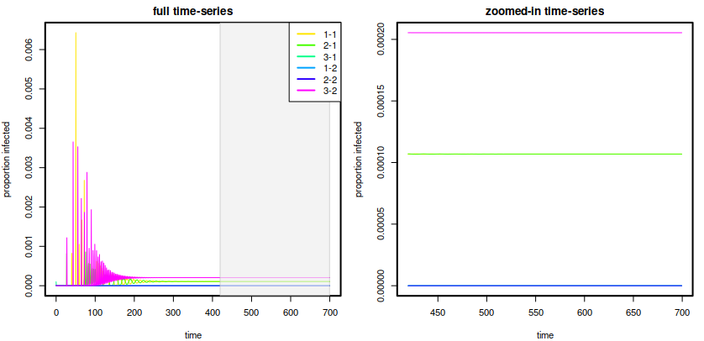

**Exercise 2.2.** The resulting dynamics present a particularly intriguing pattern: although all strains transmit the same, they appear structured into 3 different levels of prevalence: High (called the dominant level), Intermediate (called the subdominant level), and Low (called the exclusion or extinction level). Extract the final state of this simulation using extractYFinalConditions(simdata). For each strain, classify to which of the 3 types of prevalence level they belong to at that last time point.

**Exercise 2.3** Lets name the strain that you found as dominant in the previous exercise as “strain X”. If you check your code, you will see that all strains have the same epidemiological parameters (beta, sigma and mu). As such, none has an explicit fitness advantage over the others. Which strain ends up dominating in this scenario with high cross-immunity is driven by that initial chaotic epidemic period when the strains have epidemics – it is really difficult to predict this. But what we do know, is that once it found itself being the dominant one just after that chaotic period, strain X “forced” the entire system to self-organize because of cross-immunity.

Look at each strain’s allelic sequence (table of previous exercise). Explain why the other strains structured the way they did given their allelic relationships to strain X.

**Exercise 2.4** Change the beta of strain 2 again to 584. What changes in the final state of the simulation compared to exercise 2.3? (classify the final prevalence level of each strain and explain why they belong to each level).

**Exercise 2.5** You will measure strain diversity per time step: strain diversity is higher when all strains co-circulate at similar prevalence. Revert the betas back to their original value of 292 and then use plotYDiversity(simdata, xiObs=0.3, xfObs=1.0) to generate a plot of diversity. Explain the dynamics of strain diversity. Why is strain diversity generally smaller than observed under no cross-immunity?

**Part 3 - Scenario iii: Multi-strain dynamics with intermediate cross-immunity**

You will introduce a multi-strain pathogen into a susceptible host-population, assuming that cross-immunity generated between strains is **intermediate**. As the strains spread, self-emergent patterns will be evident in the output of the model. You will address these patterns within a dynamical and biological perspective.

**Exercise 3.1** Make sure the betas are back to their original value of 292. Set cross-immunity to 0.7. Run the code. The new dynamics are radically different from what was obtained with no cross-immunity (Part 1) and very high cross-immunity (Part 2). Try to explain these dynamics.

**Exercise 3.2** The 3 scenarios explored in the previous exercises are normally termed discrete strain structure (DSS), no strain structure (NSS), chaotic/cyclic strain structure (CSS). Match each of the DSS, NSS, CSS to each scenario Part I, II, III.

**Exercise 3.3** The pathogen behaviour (NSS, CSS, DSS) that most resembles the natural behaviour of influenza A virus strains is CSS. Discuss this, mentioning what you know about vaccination against influenza A.

**Exercise 3.4** The influenza A virus infects a wide range of hosts. One main difference between these hosts is their life-span. Humans, for instance, can live for many decades. Birds, on the other hand, will live much less (domestic ducks, for example, live 10 years or less). Use the code given to you to run two new simulations (remember to keep cross-immunity at 0.7 in both, to get CSS and therefore Influenza-like dynamics).

One simulation will be for a human population, assuming 70 years of life-span. The other simulation will be for a domestic duck population, assuming 10 years of life-span. Plot the two and discuss differences in observed dynamics.

**Exercise 3.5** You will measure strain diversity per time step: strain diversity is higher when all strains co-circulate at similar prevalence. Reset lifespan to its original value of 1/50 and then use plotYDiversity(simdata, xiObs=0.3, xfObs=1.0) to generate a plot of diversity. Explain the dynamics of strain diversity. If you compare the diversity plots you got for NSS, CSS and DSS, you should get that diversity with CSS is generally much lower – why is that ?

**Part 4 – Strain control under high cross-immunity**

You will introduce a multi-strain pathogen into a susceptible host-population, assuming that cross-immunity generated between strains is **very high**. At a particular time point at DSS equilibrium, you will introduce a reduction to a strain’s transmission rate, which will change the DSS equilibrium. You will compare 3 scenarios: (i) no strain control, (ii) control of a subdominant strain, (iii) control of a dominant strain.

You are provided with base code for all 3 scenarios. Note that when no control exists, the model is called using the function runMANTIS (as in previous exercises), but when control exists, the function runInvasionWithOneBetaChange is used instead. This function needs 3 extra parameters: tBetaChange that determines the time step at which control kicks in, changedStrain which determines the strain targetted for control, and changedBeta the new transmission rate for the strain under control.

Run the 3 scenarios and explain what happens in the scenarios ii and iii (with control).