



+256(0)788-872-210

Travelling

Watching

Reading

Exercise

Eating











Coding



**HOBBIES AND INTEREST**

**Front-End Developer**

**2021-2023**

**Andela**

Worked parttime during my school time as a Front-end developer at Andela an American based Software engineering company

Work as an IT specialist at Catholic Medical Mission Board during my internship

**2023**

**CMMB**

**IT Specialist**



**EXPERIENCE**



**EDUCATION**

**AWARDS**



**SKILLS**





**ABOUT ME**







ONZIVU, ARUA CITY

Passed with first class Diploma in IT

Passed with first class certificate in IT

Passed in Division two with 1 Distinctions and 5 Credits

**Kings College HS**

Passed in Division one with 2 Distinctions

**2013**

**2014-2017**

**2020-2021**

**2022-2023**

**Bugema University**

**Bugema University**

**Gracia Primary Sch**

**Diploma In IT**

**Certificate In IT**

**UCE**

**PLE**

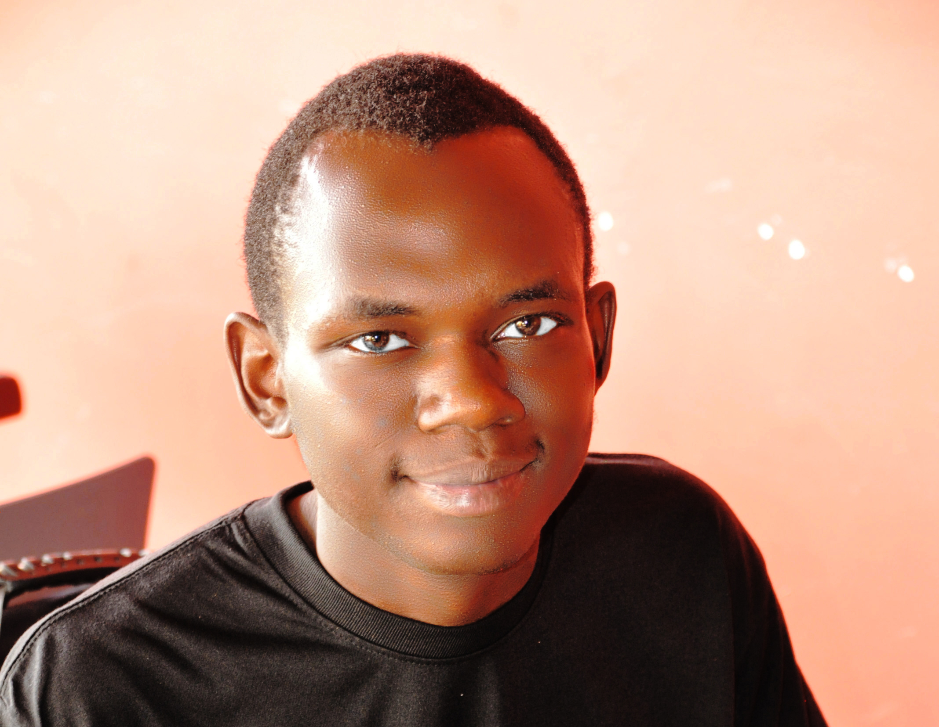

**MTN Hackington coding campion**

Bugema University, 2022

**Andela JavaScript Genius 3rd winner**

Bugema University, 2022

**Andela JavaScript Genius winner**

Bugema University, 2023

I’m a senior software develop developer and computer scientist who believes in caring out researches in computer to help the world

www.davidatoroyosika.com

daviatoo@gmail.com

**DAVID ATOROYO SIKA**