Introduction & Contact Info
This is companion software for our online database site BrainLiner, which specializes in sharing neurophysiological data: http://www.brainliner.jp

This is an open source program made by the Department of Neuroinformatics (http://www.cns.atr.jp/dni/en/) at ATR (www.atr.jp) in Kyoto, Japan. The vision for this software is to enable time-aligning neurophysiological and stimuli data.

You can track the current development status on Pivotal Tracker: https://www.pivotaltracker.com/projects/121385

Please let us know if you find any bugs or want to request any features!
Contact us at: brainliner-admin@atr.jp

This software is licensed with the Creative Commons Attribution license (http://creativecommons.org/licenses/by/3.0/). The statutes in the legalized version apply (http://creativecommons.org/licenses/by/3.0/legalcode). By using our software, you consent to agree to the terms of this license.
BrainLiner
USER GUIDE
BETA
Version: 2011/9/1
If you wish to change or redistribute the source or binary executables, please include the following citation:
Takemiya M, Murata S and Kamitani Y (2011). BrainLiner: A Platform for Neurophysiological Data Sharing and Manipulation. Front. Neurosci. Conference Abstract: Neuroinformatics 2011

Recommended System Requirements
- Mac OS X
- Java 1.6 (Not installed in OS X Lion by default. Please install before running this software!)
- 6 Gb Memory
Quickstart
Upon loading the application, the following screen showing a Timeline to preview data and the Workspace window are shown.
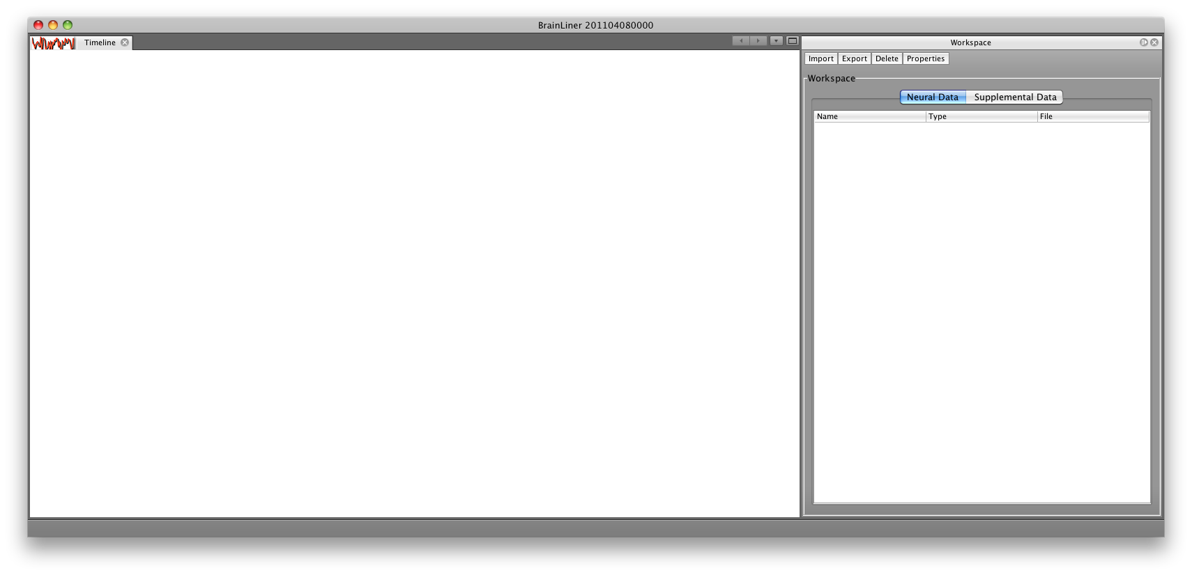From here, there are three things you can do:
- Convert data files to the Neuroshare format (currently Plexon (.plx), BlackRock (.nev, .ns1, ..., .ns9), and ATRCSV (.csv; the format is as specified by ATR) files are supported).
- Navigate the file tree (opened via the Window --> Explorer menu) and use the property editor (Window --> Property Editor) to edit the header information of Neuroshare files.
- Import data files to the workspace, preview data, and export the data to a new Neuroshare file.
Converting Data Files
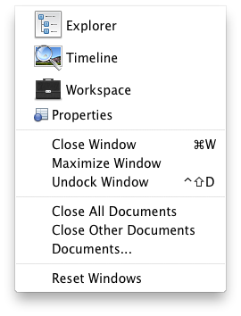
The main utility of the BrainLiner BETA is the ability to easily convert data files to the Neuroshare format. To convert a Plexon (.plx), BlackRock (.nev, .ns1, ..., .ns9), or ATRCSV (.csv) file to the Neuroshare format, simply open the “Explorer” window from Window->Explorer in the top menu bar. Next, in the Explorer window, navigate the file tree until you find the file you want to convert. Right-click on the file and select “Convert to Neuroshare” from the context menu. A dialog will appear telling you that file conversion will take a long time and to patiently wait. It’s that easy!
During file conversion, the application will become gray and you will not be able to interact with it. The application is still working, so please do not close the window or try to kill the process until file conversion has successfully completed. Depending on the size of the file you are trying to convert, quite a large amount of time may be required.
For example, a Plexon (.plx) file that is 300Mb can use over 4Gb of memory for conversion and require approximately 20 minutes. Also, the converted file will increase in file size to around 1Gb, due to differences in the way Plexon and Neuroshare formats represent values. Please keep this in mind while you convert your files.
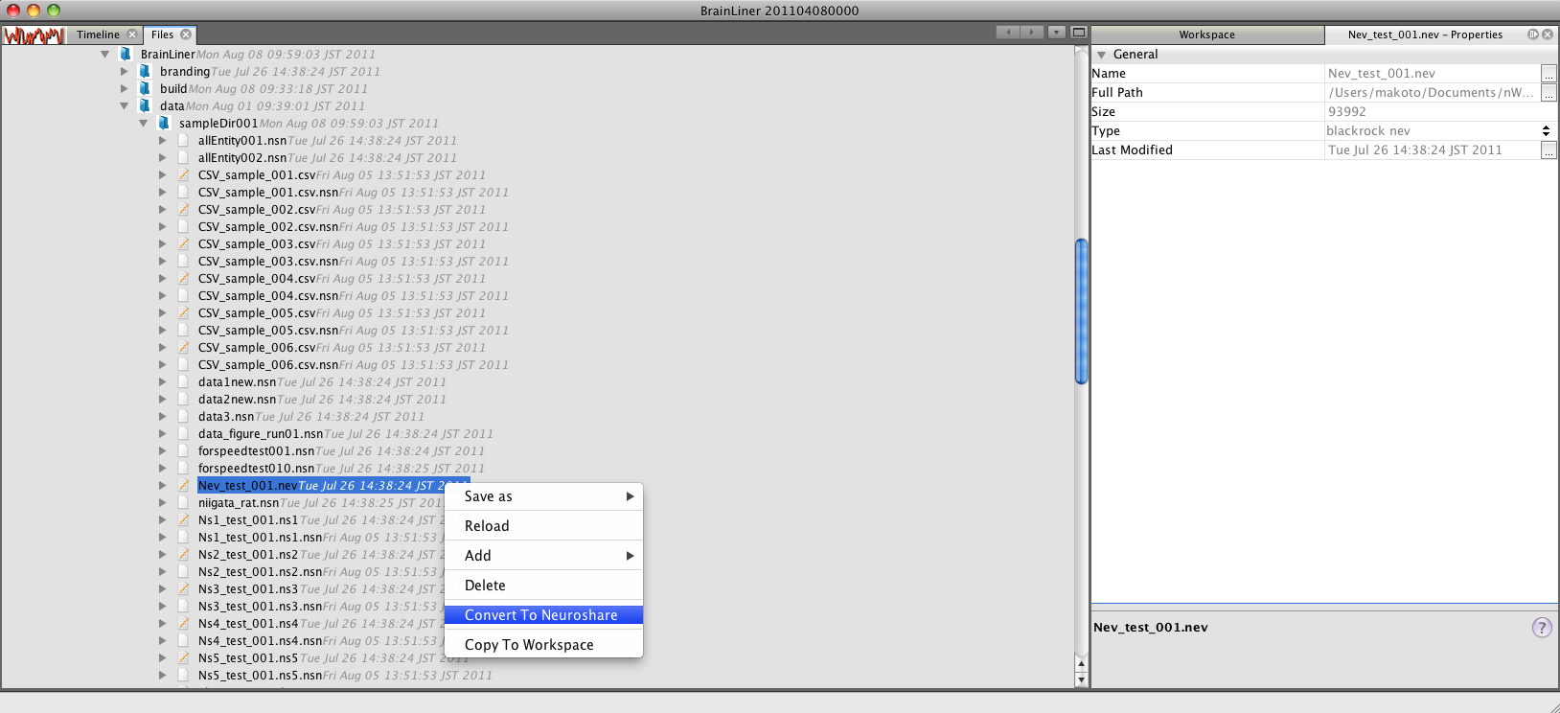
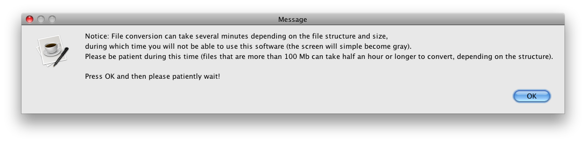
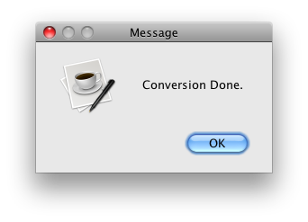
After conversion is done, a message will inform you that conversion is complete. Your new file will be in the same directory as the source file and will have the same name, only a .nsn suffix will be added.
For example, if your source file is “Test.plx,” the converted file will be in the same folder and will be named “Test.plx.nsn.”
After conversion, data from the converted Neuroshare can then be added to the Workspace by right-clicking on the .nsn file and selecting “Copy to Workspace” from the context-menu options.
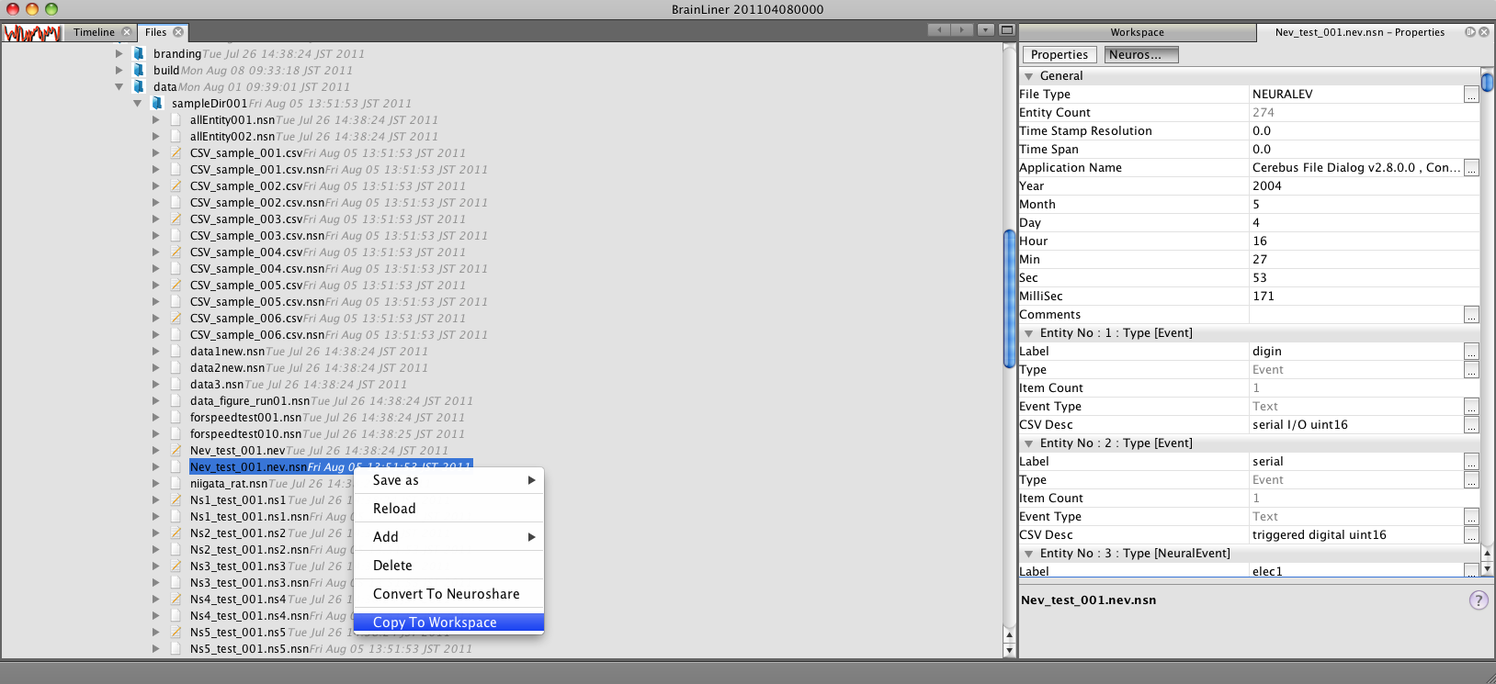
After selecting the “Copy to Workspace” option on the file in the Explorer tree that you want to load data into the workspace from, a “Channel Selector” dialog will appear, asking you to choose data to load to the Workspace. “Unavailable” data channels are channels that do not contain any data, thus they cannot be loaded into the Workspace.
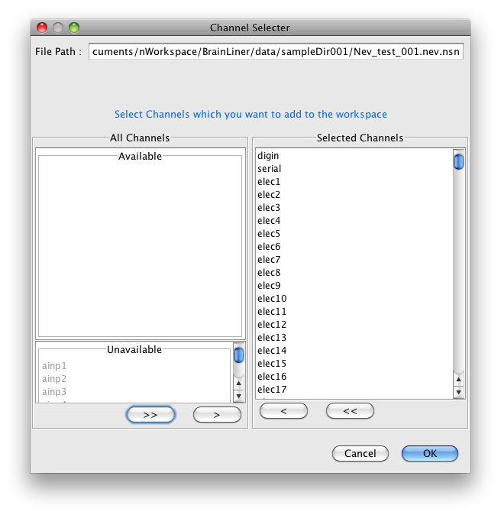
After selecting the desired channels, the “Workspace” window will then be populated with a list of the added channels.

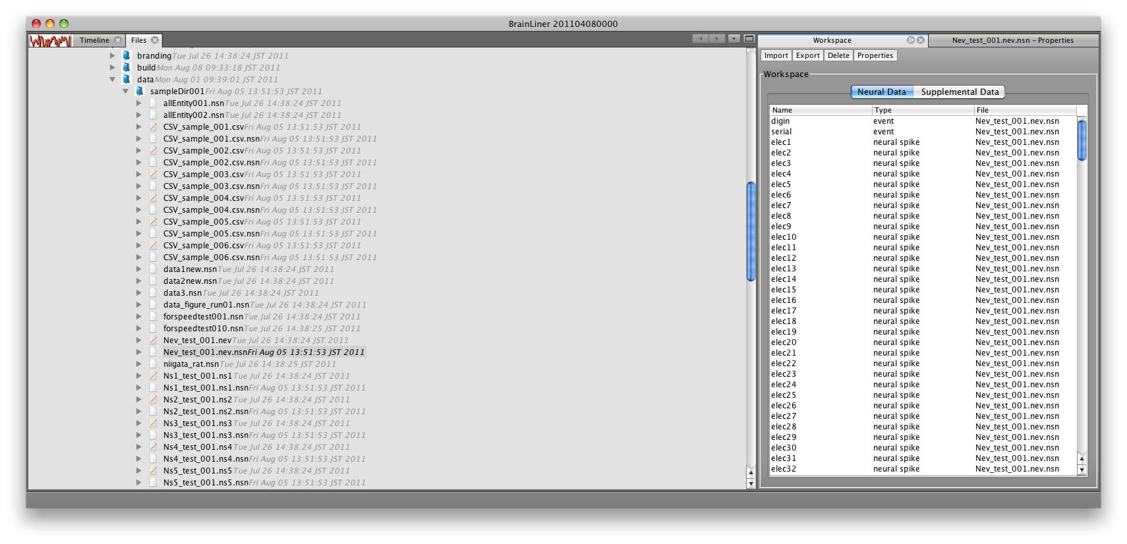
However, it should be noted that this beta version’s timeline only supports previewing of analog data, so “event” and “neural spike” data channel types will not be displayed.
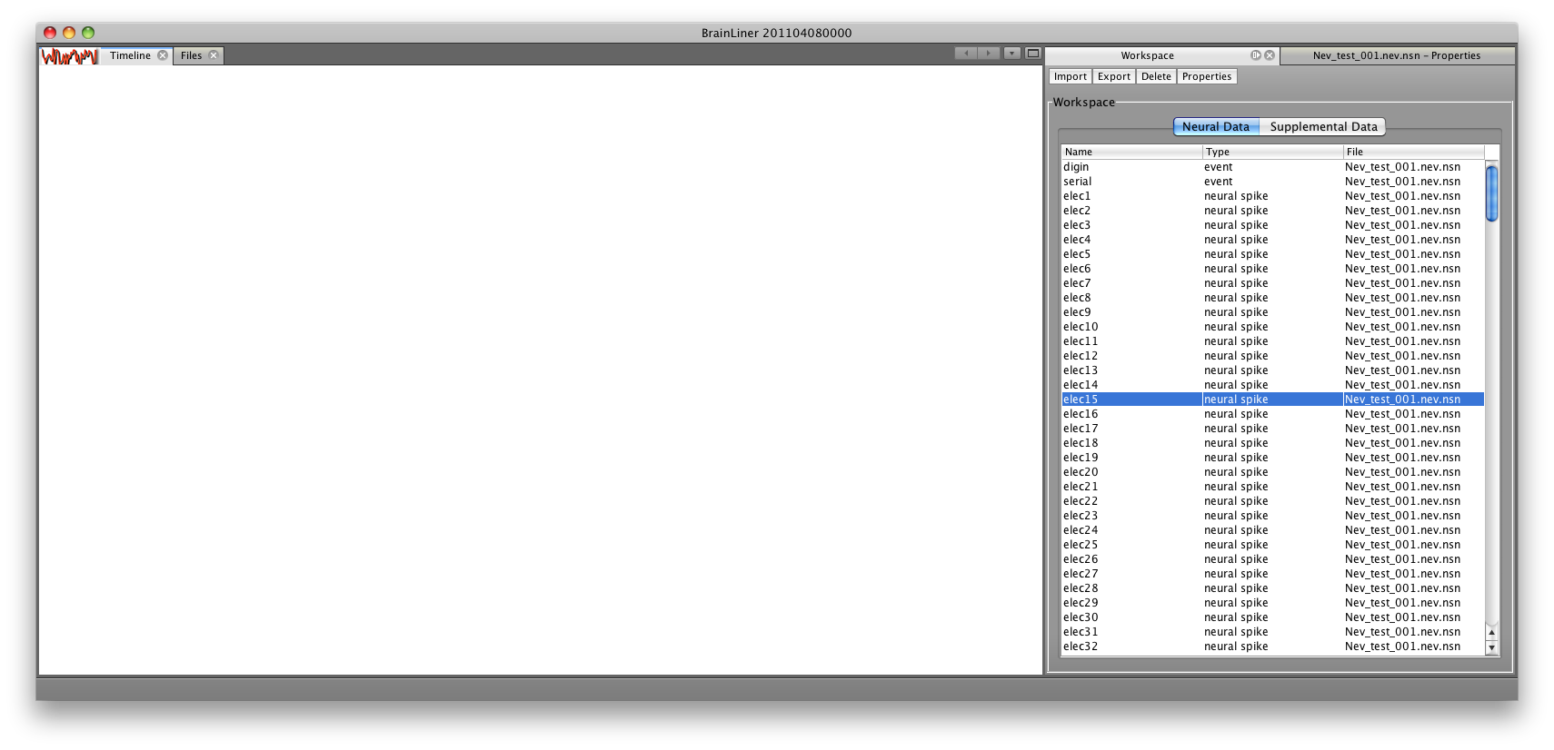
Importing Data to the Workspace
To import data to the workspace, click on the “Import” button in the “Workspace” window. A file chooser will then appear, allowing you to choose a file you would like to open.
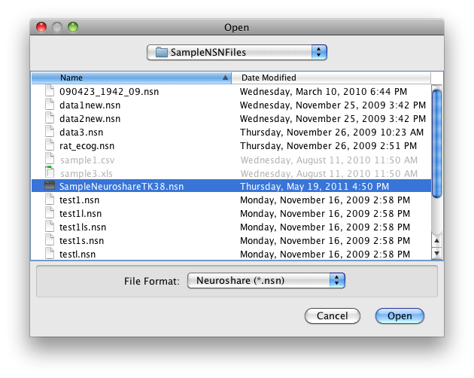
After selecting the file to open, you can then choose which channels of data you would like to add into the workspace.
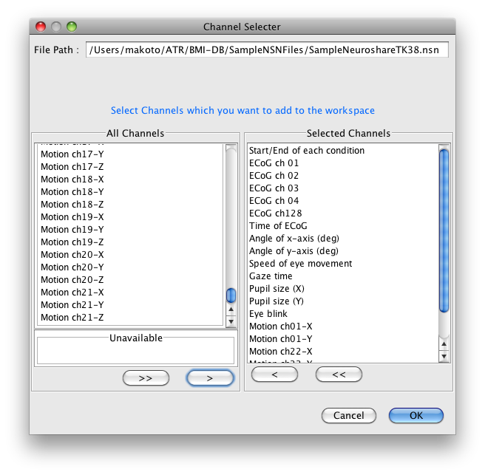
After adding channels to the workspace, you can then preview data in the “Timeline” window. Currently only “analog” data channel types can be displayed in the timeline viewer. This, however, does not inhibit you from adding the channels to the workspace or exporting Neuroshare files. Also, please note that trying to view too much data at one time will require a great amount of memory and processing power. This is especially true when the sampling rate and quantity of data is very high. If viewing data takes too long, please close the program (you may need to kill the process using the Mac OS X Activity Monitor). This beta software is still in development, so performance will improve with future releases.
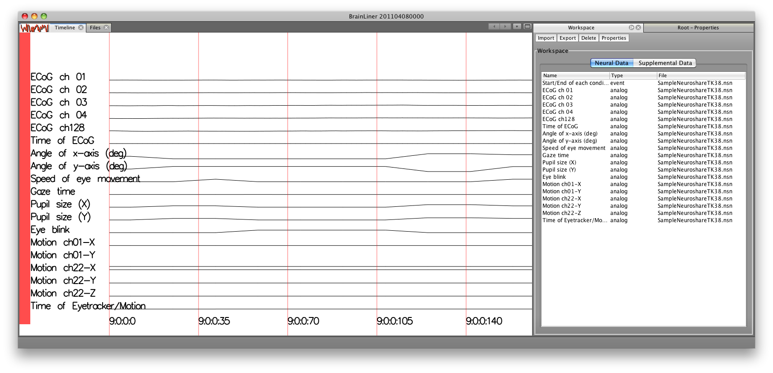
(You can also load in data to the workspace through the file tree on the left, by selecting the “Copy To Workspace” option via the right-click menu, as we demonstrated earlier in this documentation.)
Properties of individual channels in the Workspace can be edited by selecting a channel and clicking on the “Properties” button in the Workspace window. Doing so will cause a “Channel Editor” window to appear. Properties, such as a channel’s label, can then be edited.
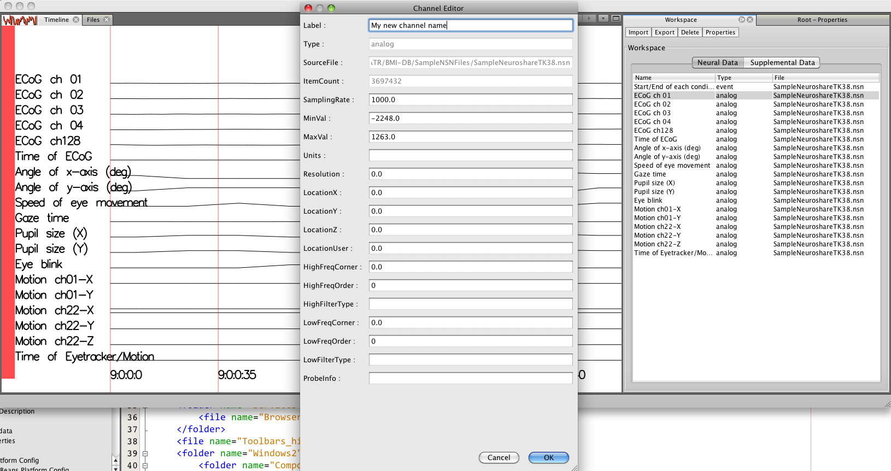

Editing a channel’s label, for example will cause the label displayed in the timeline to be updated as well, to show the new channel name.
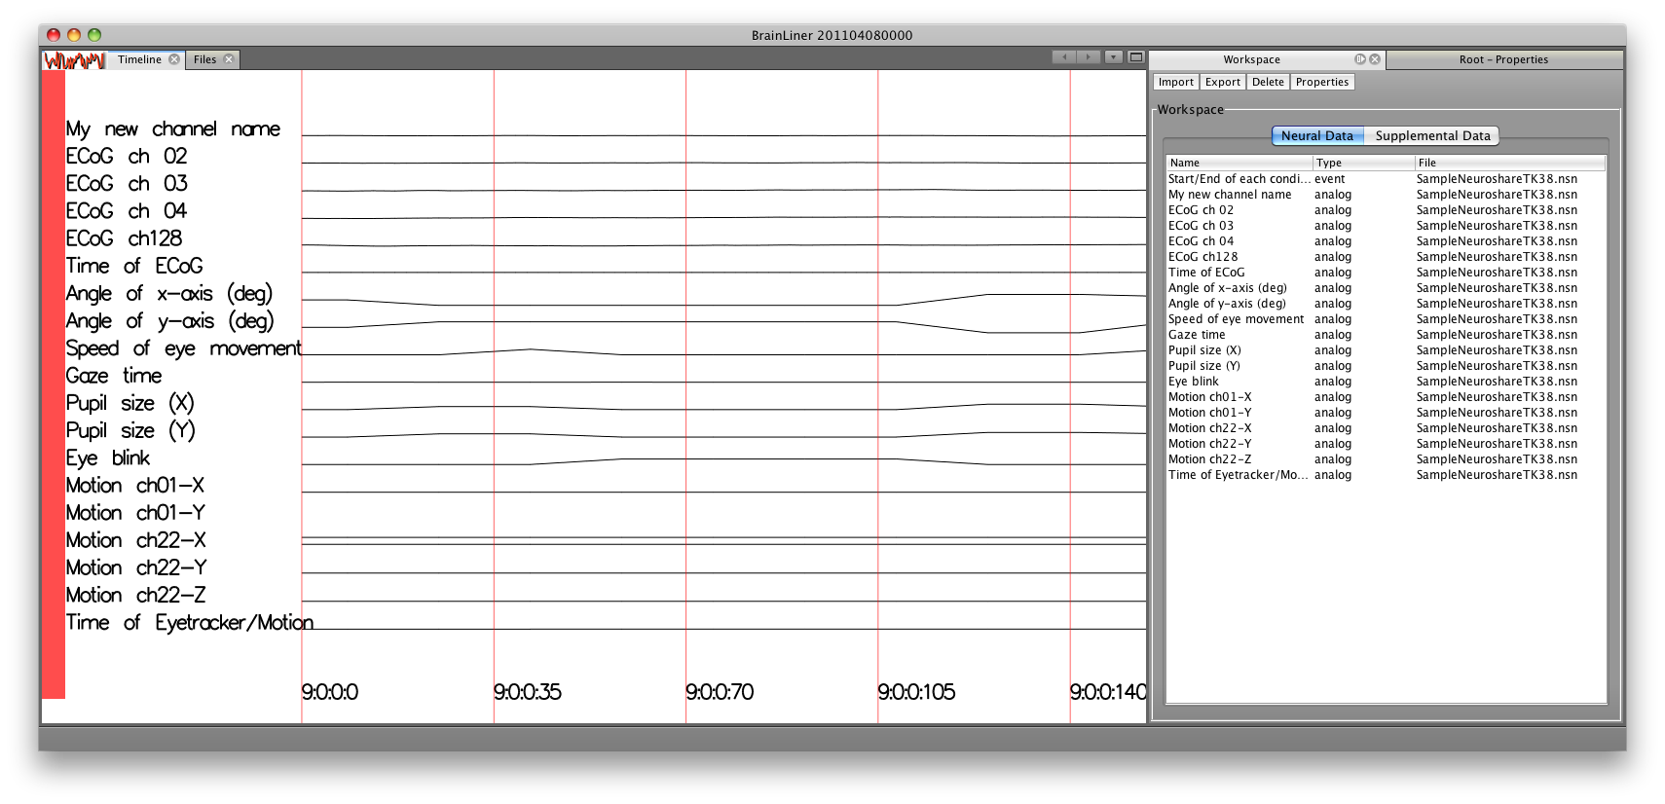

Exporting a New Neuroshare File
Once the Workspace has been populated with the desired data, a new Neuroshare file can be created. This is especially useful for combining data from multiple files into a single file.
To create a new Neuroshare file from the Workspace, click on the “Export” button in the “Workspace” window. A “Create New File Wizard” window will then appear. Click the “Browse” button to choose a name and location for your file and click “Next” to go on to the next screen.
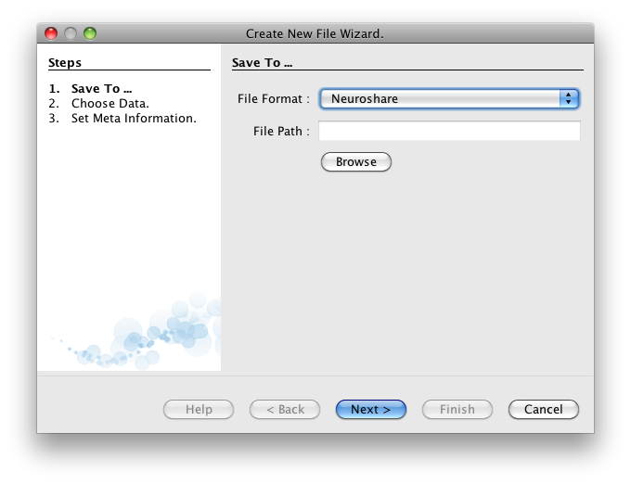

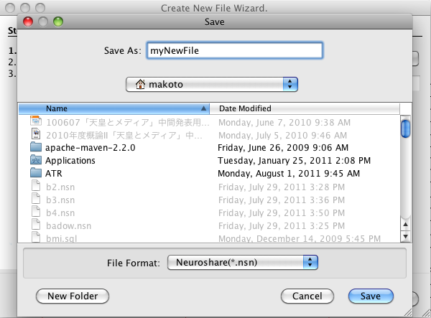

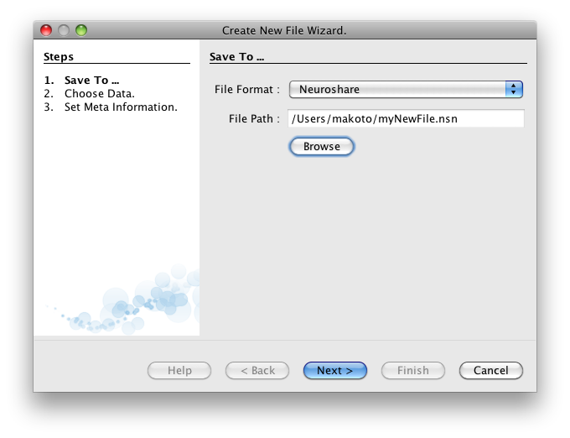
On the next screen, select the data channels that you would like to include in the file.
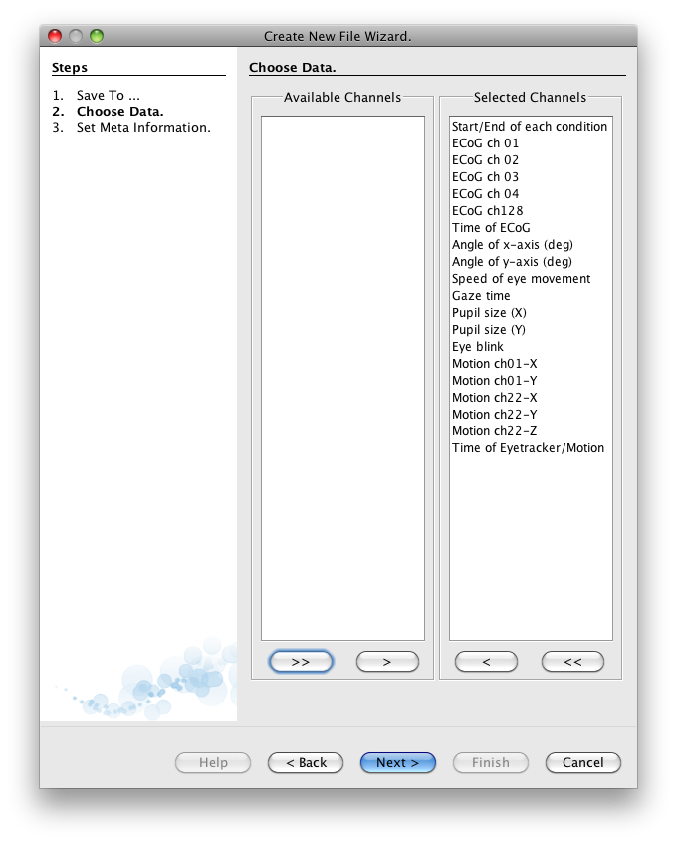
On the second screen you will be prompted to enter meta information about the Neuroshare file. After entering the meta information, click to go to the next screen where you will be prompted to choose the data channels from the Workspace to write to the file. When ready, click the “Finish” button to save your new Neuroshare file.
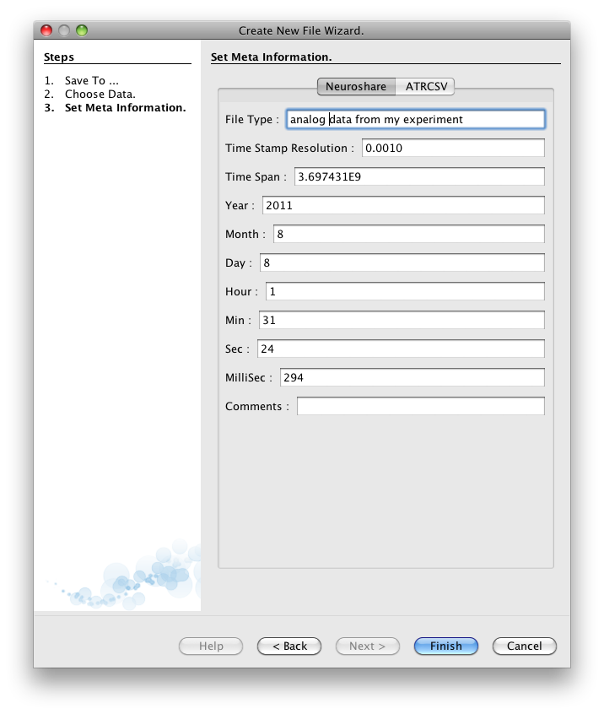
Then the new Neuroshare file will be created. This may take some time, depending on the file size, so please be patient. In the future we will add a progress bar to clarify the status of file creation, but that feature is currently not available in this beta release.

Edit Neuroshare Header Information
In addition to creating new Neuroshare files, our software also allows users to view and edit header information stored in Neuroshare files.
First, make sure the “Properties” window is open. If not, you can open it via the Window menu at the top of the screen. Once open, the Properties menu will show properties for the file that is currently selected in the Explorer’s file tree. For regular files, such as a CSV file, you cannot edit the header information.
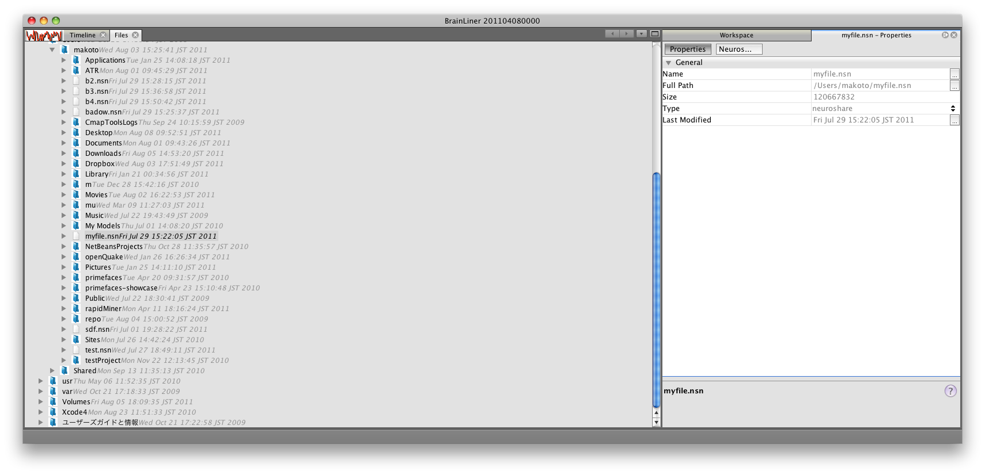
If a Neuroshare file is selected, however, the header information can be viewed and edited by selecting the “Neuroshare” tab in the Properties window:
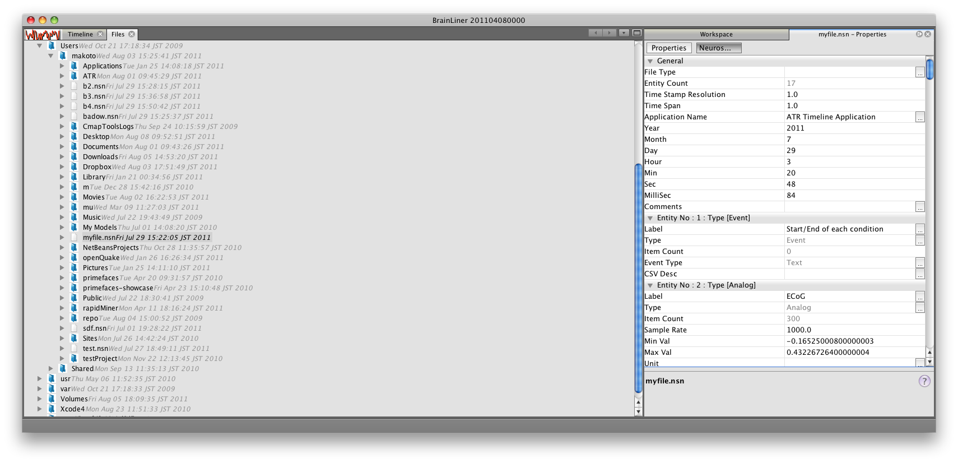
To edit header information in the Neuroshare file, simply click in the Property window and type the new values that you want. For example, to change a Neuroshare entity’s label, just click in the “Label” field on the right, and type the new label that you wish, for example, “Foo.”
Before editing:
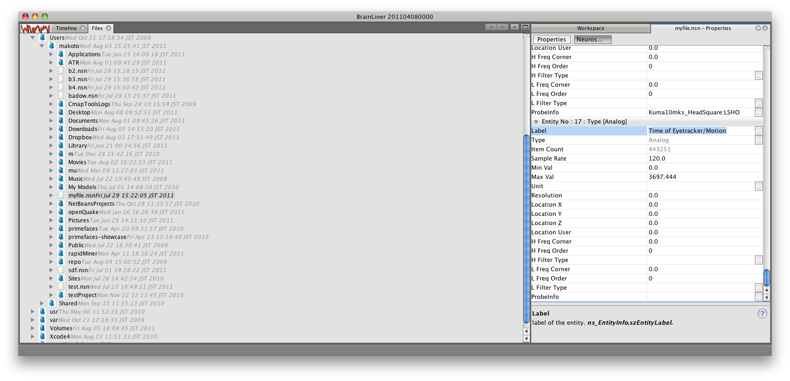

After editing:
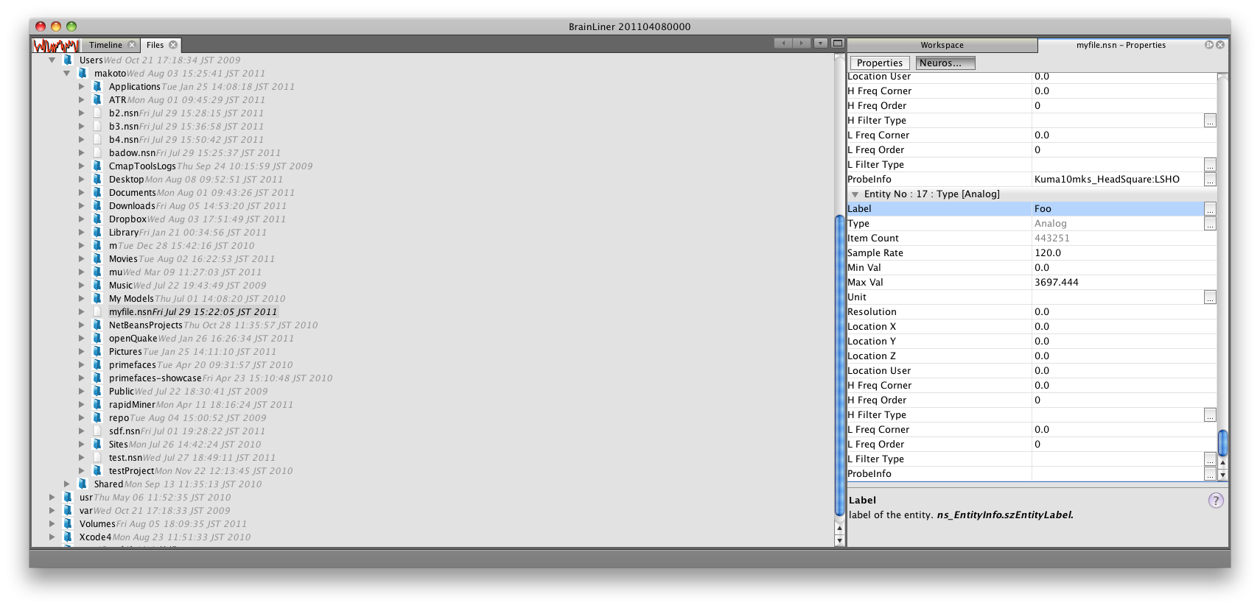
How to Uninstall
As is typical with Mac software, there is no uninstaller provided in this release. Instead please delete the following files and directories to completely remove BrainLiner from your computer:
- /Applications/brainliner.app (.app folder)
- ~/Library/Application Support/brainliner (folder)

In Summary
This beta software is provided to help assist in converting data files to the Neuroshare file format. It is hoped that despite the current limitations, that this software will facilitate sharing neurophysiological data by making it easy to convert to a common file format. After converting your data to the Neuroshare format, please login to BrainLiner.jp and share it with the world!

