**ATRACKCS: AN ALGORITHM FOR TRACKING CONVECTIVE SYSTEMS**

**Background**

Mesoscale convective systems (MCS) are organized cloud clusters that produce regional rainfall over an area of 500 - 1000 km2 and feature vertical development that penetrates the mid-upper troposphere (Houze, 2018). These events are a frequent meteorological feature around the world and are of high relevance because they can represent threats related to floods, thunderstorms, landslides and river overflows, which can lead to damage to infrastructure and loss of human lives. In addition, they represent a risk for private companies and governmental aviation institutions; the reorganization of routes due to meteorological factors, in addition to implying risks for crews, causes aviation delays and economic impacts. Therefore, the spatio-temporal characterization of SCMs plays a fundamental role in the understanding of weather and climate, and allows reducing the vulnerability exposed to the occurrence of severe precipitation events. (Weipert & Hannesen, 2008).

**Summary**

ATRACKCS is a Python package for automated detection and tracking of mesoscale convective systems (MCS) that is a potential tool for characterizing the spatio-temporal meteorology and climatology of MCS. The algorithm uses brightness temperature (Tb) and precipitation (P) from satellite data, whose download via the authoritative portal facilitates data processing as it is possible to select specific regions and periods (2000 - present) around the globe. The principle for detecting the MCS is from the cold top of the clouds, according to a limiting range of brightness temperature, and an approximate horizontal zone that is generated from the convex hull.

The algorithm has the option of operating on Tb scheme only or associating this scheme with precipitation attributes, and can be adapted to the needs of MCS detection, as it allows parameterization of the Tb and P specific criteria. This package includes a collection of Python functions and classes designed for an analysis workflow covering the detection and characterization of each MCS, and the integration in tracks, which allow detailing and monitoring the MCS’s life cycles in space and time. The output of the algorithm is a structured CSV file containing the tracks and their MCS, whose influence’s areas and attributes, reflected in a polygon, can be observed through the use of a map hosted in a .html file provided by the folium library. This package is intended for researchers and students interested in exploring MCS’S dynamics.

**The detection of the MCS (regions) is performed using these steps:**

1. At any time pixel, find all where `Tb <= Tb_threshold [200 k - 240 k]` and trace an approximate region, with the convex hull, according to a binary structure where the pixels that satisfy the described condition are equal to 1 and those that do not are equal to 0.
2. Transform from geographic to plane coordinates the pixels and compute an approximate area of those regions traced.
3. Discard all regions whose area is `>= area_threshold [> 1000 km**2]`
4. Estimate Tb attributes of those regions.
5. Estimate P attributes of those regions. This is optional as the algorithm can operate only with Tb as input variable.

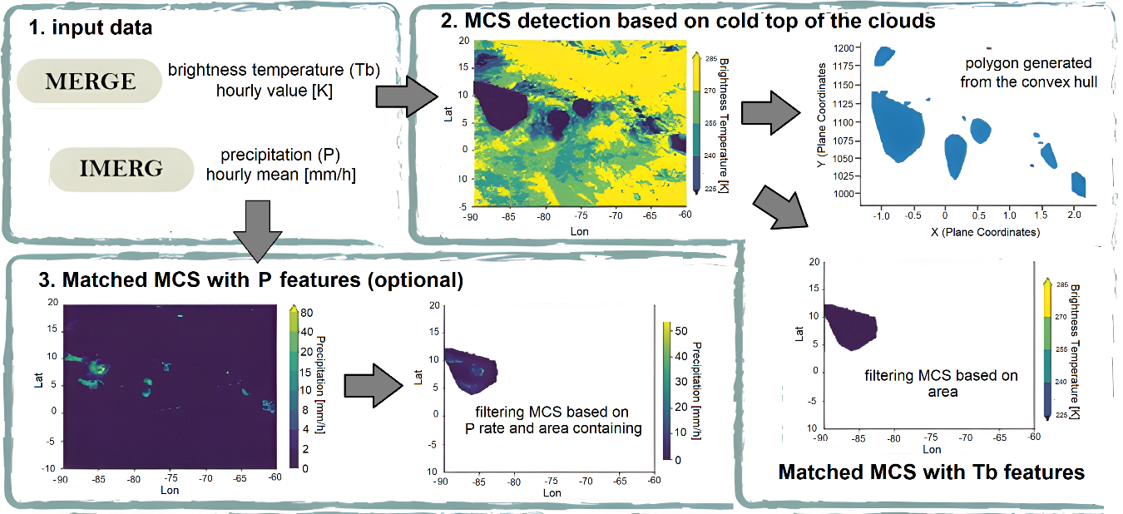

**The tracks are performed using these steps:**

1. overlapping priority principle: for any MCS at time `t`, the MCS with the highest percentage of overlap at time `t+1` "wins" and is associated with it.
2. The MCS with the lowest percentage of overlap at time `t+1` could form a track on their own, and waits to be associated in the next iteration between `t+1` and `t+2`.
3. No merging or splitting is allowed, any MCS at time `t` can only be linked to one MCS at time `t+1`, similarly, any MCS at time `t+1` can only be linked to one MCS at time `t`.
4. All tracks that do not get updated during the `t` - `t+1` process terminate. This assumes that no gap in the track is allowed.

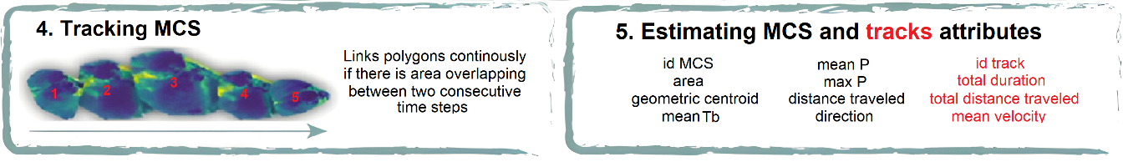

**Statement of need**

In recent decades, satellite infrared channel recordings have made it possible to obtain thermal maps of the Earth's emitting surfaces. At a given surface temperature, electromagnetic radiation is emitted which depends on the emission temperature; this temperature is known as the Tb. With this magnitude is possible to derive the cloud cover, taking into account that the coldest emitting surfaces will be the clouds that are at higher levels of the troposphere and will represent lower brightness temperatures. This magnitude is an indirect representation of cloud cover height and does not represent a direct measurement of precipitation in association with the event, so in some methodologies for the MSC’s detection a proxy for precipitation is usually included by using other satellite spectral bands (Feng et al., 2021; Liu et al., 2019).

Likewise, the literature for the detection of MCS suggests a great variety of maximum limits to the brightness temperature ranging from 211 K to 245 K whose dependence derives from the study region, the area of the event, the methodology used for its detection and the specific use of satellite databases, among other aspects. This situation represents a dilemma at the time of selecting the conditions for the detection of MCS, and it is what motivated the development of an algorithm that allows to perform this task with the flexibility to be parameterized according to the interest of each user.

**Past or ongoing research projects using the software**

The following conference presentations and posters used previous versions of ATRACKCS

1. Spatio-temporal Characterization of Mesoscale Convective Systems over Northern South America. In AGU Fall Meeting 2021.
2. Cloud-resolving Simulations of Mesoscale Convective Systems in Colombia. In AGU Fall Meeting 2021.

**Acknowledgements**

This research was funded by the Colombian Ministry of Science, Technology and Innovation (MINCIENCIAS) through the project : “Implementación de un sistema de investigación y pronóstico meteorológico de corto plazo con el modelo WRF, para apoyo a sistemas de comando y control de la Fuerza Aérea Colombiana” (code 1115-852-70955) with funds from “Patrimonio Autónomo Fondo Nacional de Financiamiento para la Ciencia, la Tecnología y la Innovación, Fondo Francisco José de Caldas” . IMERG and MERGE-IR data was obtained from NASA GES DISC server.

**References**