Contents:
- Introduction To OTEC

- Achievements In OTEC

- Application
Electricity production
Desalinate water
Refrigeration & air-conditioning
Mineral extraction

- Benefits

- Needed research

- Bibliography

Introduction to OTEC
The oceans cover a little more than 70 percent of the Earth's surface. This makes them the world's largest solar energy collector and energy storage system. On an average day, 60 million square kilometers (23 million square miles) of tropical seas absorb an amount of solar radiation equal in heat content to about 250 billion barrels of oil. If less than one-tenth of one percent of this stored solar energy could be converted into electric power, it would supply more than 20 times the total amount of electricity consumed in the United States on any given day.
OTEC, or ocean thermal energy conversion, is an energy technology that converts solar radiation to electric power. OTEC systems use the ocean's natural thermal gradient—the fact that the ocean's layers of water have different temperatures—to drive a power-producing cycle. As long as the temperature between the warm surface water and the cold deep water differs by about 20°C (36°F), an OTEC system can produce a significant amount of power. The oceans are thus a vast renewable resource, with the potential to help us produce billions of watts of electric power. This potential is estimated to be about 10¹³ watts of base load power generation, according to some experts. The cold, deep seawater used in the OTEC process is also rich in nutrients, and it can be used to culture both marine organisms and plant life near the shore or on land.
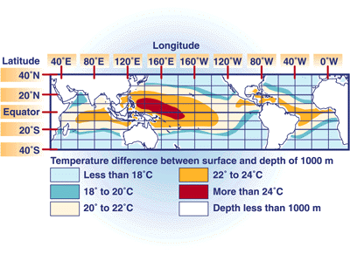
The economics of energy production today have delayed the financing of a permanent, continuously operating OTEC plant. However, OTEC is very promising as an alternative energy resource for tropical island communities that rely heavily on imported fuel. OTEC plants in these markets could provide islanders with much-needed power, as well as desalinated water and a variety of marine culture products.

Achievements In OTEC

In 1881, Jacques Arsene d'Arsonval, a French physicist, was the first to propose tapping the thermal energy of the ocean. Georges Claude, a student of d'Arsonval's, built an experimental open-cycle OTEC system at Matanzas Bay, Cuba, in 1930. The system produced 22 kilowatts (kW) of electricity by using a low-pressure turbine. In 1935, Claude constructed another open-cycle plant, this time aboard a 10,000-ton cargo vessel moored off the coast of Brazil. But both plants were destroyed by weather and waves, and Claude never achieved his goal of producing net power (the remainder after subtracting power needed to run the system) from an open-cycle OTEC system.
Then in 1956, French researchers designed a 3-megawatt (electric) (MWe) open-cycle plant for Abidjan on Africa's west coast. But the plant was never completed because of competition with inexpensive hydroelectric power. In 1974 the Natural Energy Laboratory of Hawaii (NELHA, formerly NELH), at Keahole Point on the Kona coast of the island of Hawaii, was established. It has become the world's foremost laboratory and test facility for OTEC technologies.
In 1979, the first 50-kilowatt (electric) (kWe) closed-cycle OTEC demonstration plant went up at NELHA. Known as "Mini-OTEC," the plant was mounted on a converted U.S. Navy barge moored approximately 2 kilometers off Keahole Point. The plant used a cold-water pipe to produce 52 kWe of gross power and 15 kWe net power.
In 1980, the U.S. Department of Energy (DOE) built OTEC-1, a test site for closed-cycle OTEC heat exchangers installed on board a converted U.S. Navy tanker. Test results identified methods for designing commercial-scale heat exchangers and demonstrated that OTEC systems can operate from slowly moving ships with little effect on the marine environment. A new design for suspended cold-water pipes was validated at that test site. Also in 1980, two laws were enacted to promote the commercial development of OTEC technology: the Ocean Thermal Energy Conversion Act, Public Law (PL) 96-320, later modified by PL 98-623, and the Ocean Thermal Energy Conversion Research, Development, and Demonstration Act, PL 96-310.
At Hawaii's Seacoast Test Facility, which was established as a joint project of the State of Hawaii and DOE, desalinated water was produced by using the open-cycle process. And a 1-meter-diameter cold-seawater/0.7-meter-diameter warm-seawater supply system was deployed at the Seacoast Test Facility to demonstrate how large polyethylene cold-water pipes can be used in an OTEC system.
In 1981, Japan demonstrated a shore-based, 100-kWe closed-cycle plant in the Republic of Nauru in the Pacific Ocean. This plant employed cold-water pipe laid on the sea bed to a depth of 580 meters. Freon was the working fluid, and a titanium shell-and-tube heat exchanger was used. The plant surpassed engineering expectations by producing 31.5 kWe of net power during continuous operating tests.
Later, tests by the U.S. DOE determined that aluminum alloy can be used in place of more expensive titanium to make large heat exchangers for OTEC systems. And at-sea tests by DOE demonstrated that biofouling and corrosion of heat exchangers can be controlled. Biofouling does not appear to be a problem in cold seawater systems. In warm seawater systems, it can be controlled with a small amount of intermittent chlorination (70 parts per billion per hour per day).
In 1984, scientists at a DOE national laboratory, the Solar Energy Research Institute (SERI, now the National Renewable Energy Laboratory), developed a vertical-spout evaporator to convert warm seawater into low-pressure steam for open-cycle plants. Energy conversion efficiencies as high as 97% were achieved. Direct-contact condensers using advanced packings were also shown to be an efficient way to dispose of steam. Using freshwater, SERI staff developed and tested direct-contact condensers for open-cycle OTEC plants.

British researchers, meanwhile, have designed and tested aluminum heat exchangers that could reduce heat exchanger costs to $1500 per installed kilowatt capacity. And the concept for a low-cost soft seawater pipe was developed and patented. Such a pipe could make size limitations unnecessary, as well as improve the economics of OTEC systems.
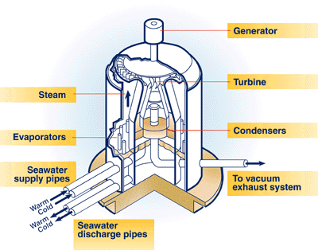

In May 1993, an open-cycle OTEC plant at Keahole Point, Hawaii, produced 50,000 watts of electricity during a net power-producing experiment. This broke the record of 40,000 watts set by a Japanese system in 1982. Today, scientists are developing new, cost-effective, state-of-the-art turbines for open-cycle OTEC systems.
Applications
Ocean thermal energy conversion (OTEC) systems have many applications or uses. OTEC can be used to generate electricity, desalinate water, support deep-water mariculture, and provide refrigeration and air-conditioning as well as aid in crop growth and mineral extraction. These complementary products make OTEC systems attractive to industry and island communities even if the price of oil remains low.

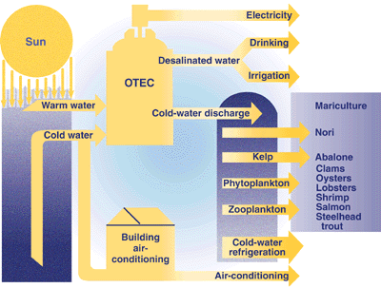
OTEC can also be used to produce methanol, ammonia, hydrogen, aluminum, chlorine, and other chemicals. Floating OTEC processing plants that produce these products would not require a power cable, and station keeping costs would be reduced.

- Electricity Production
Two basic OTEC system designs have been demonstrated to generate electricity: closed cycle and open cycle.

Closed-Cycle OTEC System
In the closed-cycle OTEC system, warm seawater vaporizes a working fluid, such as ammonia, flowing through a heat exchanger (evaporator). The vapor expands at moderate pressures and turns a turbine coupled to a generator that produces electricity. The vapor is then condensed in another heat exchanger (condenser) using cold seawater pumped from the ocean's depths through a cold-water pipe. The condensed working fluid is pumped back to the evaporator to repeat the cycle. The working fluid remains in a closed system and circulates continuously.
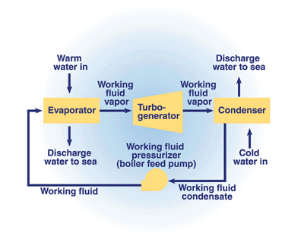
  - Open-Cycle OTEC System
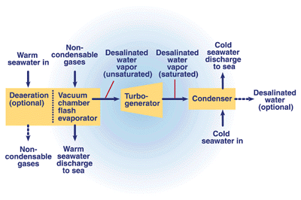
In an open-cycle OTEC system, warm seawater is the working fluid. The warm seawater is "flash"-evaporated in a vacuum chamber to produce steam at an absolute pressure of about 2.4 kilopascals (kPa). The steam expands through a low-pressure turbine that is coupled to a generator to produce electricity. The steam exiting the turbine is condensed by cold seawater pumped from the ocean's depths through a cold-water pipe. If a surface condenser is used in the system, the condensed steam remains separated from the cold seawater and provides a supply of desalinated water.

  - Hybrid OTEC System

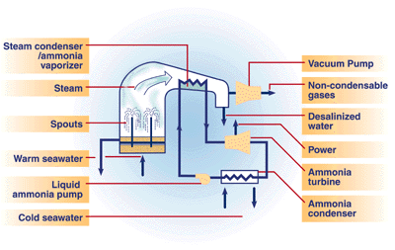
A hybrid cycle combines the features of both the closed-cycle and open-cycle systems. In a hybrid OTEC system, warm seawater enters a vacuum chamber where it is flash-evaporated into steam, which is similar to the open-cycle evaporation process. The steam vaporizes the working fluid of a closed-cycle loop on the other side of an ammonia vaporizer. The vaporized fluid then drives a turbine that produces electricity. The steam condenses within the heat exchanger and provides desalinated water.

- Desalinated Water

Desalinated water can be produced in open- or hybrid-cycle plants using surface condensers. In a surface condenser, the spent steam is condensed by indirect contact with the cold seawater. This condensate is relatively free of impurities and can be collected and sold to local communities where natural freshwater supplies for agriculture or drinking are limited. System analysis indicates that a 2-megawatt (electric) (net) plant could produce about 4300 cubic meters of desalinated water each day (Block and Lalenzuela 1985).The large surface condensers required to condense the entire steam flow increase the size and cost of an open-cycle plant. A surface condenser can be used to recover part of the steam in the cycle and to reduce the overall size of the heat exchangers; the rest of the steam can be passed through the less costly and more efficient direct-contact condenser stages. A second-stage direct-contact condenser concentrates the noncondensable gases and makes it possible to use a smaller vacuum exhaust system, thereby increasing the plant's net power.One way to produce large quantities of desalinated water without incurring the cost of an open-cycle turbine is to use a hybrid system. In a hybrid system, desalinated water is produced by vacuum flash distillation and power is produced by a closed-cycle loop. Other schemes that use discharge waters from OTEC systems to produce desalinated water have also been considered.

- Refrigeration and Air-Conditioning

The cold [5°C (41ºF)] seawater made available by an OTEC system creates an opportunity to provide large amounts of cooling to operations that are related to or close to the plant. Salmon, lobster, abalone, trout, oysters, and clams are not indigenous to tropical waters, but they can be raised in pools created by OTEC-pumped water; this will extend the variety of seafood products for nearby markets. Likewise, the low-cost refrigeration provided by the cold seawater can be used to upgrade or maintain the quality of indigenous fish, which tend to deteriorate quickly in warm tropical regions.
The cold seawater delivered to an OTEC plant can be used in chilled-water coils to provide air-conditioning for buildings. It is estimated that a pipe 0.3-meters in diameter can deliver 0.08 cubic meters of water per second. If 6°C water is received through such a pipe, it could provide more than enough air-conditioning for a large building. If this system operates 8000 hours per year and local electricity sells for 5¢-10¢ per kilowatt-hour, it would save $200,000-$400,000 in energy bills annually (U.S. DOE 1989).

- Mineral Extraction
Not yet exploited to its full potential is the opportunity OTEC could provide to mine ocean water for its 57 elements dissolved in solution. In the past, most economic analyses showed that mining the ocean for trace elements dissolved in solution would be unprofitable because so much energy is required to pump the large volume of water needed and because it is so expensive to separate the minerals from seawater. However, because OTEC plants will already be pumping the water economically, the only problem to solve is the cost of the extraction process. The Japanese recently began investigating the concept of combining the extraction of uranium dissolved in seawater with wave-energy technology. They found that developments in other technologies (especially materials sciences) were improving the viability of mineral extraction processes that employ ocean energy.

Benefits of OTEC
We can measure the value of an ocean thermal energy conversion (OTEC) plant and continued OTEC development by both its economic and non economic benefits. OTEC's economic benefits include these:
- Helps produce fuels such as hydrogen, ammonia, and methanol
- Produces base load electrical energy
- Produces desalinated water for industrial, agricultural, and residential uses
- Is a resource for on-shore and near-shore mariculture operations
- Provides air-conditioning for buildings
- Provides moderate-temperature refrigeration
- Has significant potential to provide clean, cost-effective electricity for the future.
OTEC's non economic benefits, which help us achieve global environmental goals, include these:
- Promotes competitiveness and international trade
- Enhances energy independence and energy security
- Promotes international sociopolitical stability
- Has potential to mitigate greenhouse gas emissions resulting from burning fossil fuels.
In small island nations, the benefits of OTEC include self-sufficiency, minimal environmental impacts, and improved sanitation and nutrition, which result from the greater availability of desalinated water and mariculture products.

Needed Research
To accelerate the development of OTEC systems, researchers need to:
- Obtain data on OTEC plant operation with appropriately sized demonstration plants
- Develop and characterize cold-water pipe technology and create a database of information on materials, design, deployment, and installation
- Conduct further research on the heat exchanger systems to improve heat transfer performance and decrease costs
- Conduct research in the areas of innovative turbine concepts for the large machines required for open-cycle systems
- Identify and evaluate advanced concepts for ocean thermal energy extraction .

BIBLIOGRAPHY

BOOK: Non Conventional Energy Sources - G D Rai

WEBSITES:

http://technologystudent.com

www.wikipedia.com

http://www.rpi.edu/dept/chem-engg.

