ONLINE MOVIE TICKET BOOKING SYSTEM

A PROJECT REPORT SUBMITTED FOR THE REQUIREMENTS OF THE SUBJECT
(PBCST304)
OBJECT-ORIENTED PROGRAMMING
OF
APJ ABDUL KALAM TECHNOLOGICAL UNIVERSITY
BY
Aaron Thalakkottor Sooraj (VAS25CS001)
Abinandh P. S. (VAS25CS012)
Adhin Seby (VAS25CS017)
Adwaith S. Kumar (VAS25CS026)


(AN ISO 9001:2015 CERTIFIED INSTITUTION)

DEPARTMENT OF COMPUTER SCIENCE AND ENGINEERING
Vidya Academy of Science and Technology
Thalakkottukara, Thrissur - 680501
http://www.vidyaacademy.ac.in

OCTOBER 2026

DECLARATION

We, Aaron Thalakkottor Sooraj (VAS25CS001), Abinandh P. S. (VAS25CS012), Adhin Seby (VAS25CS017), and Adwaith S. Kumar (VAS25CS026), hereby undertake that the project work entitled "Online Movie Ticket Booking System" has been carried out by our group under the valuable coordination of Mr. Vishnu N. M., Assistant Professor, Department of Computer Science and Engineering, Ms. Anusree M. Nair, Assistant Professor, Department of Computer Science and Engineering, Vidya Academy of Science and Technology, Thalakkottukara, Thrissur.
This report is formally submitted as a required project component for the Object-Oriented Programming course in Computer Science and Engineering, under APJ Abdul Kalam Technological University, during the academic year 2026–2027.

Thrissur  October 2026 | Aaron Thalakkottor Sooraj (VAS25CS001)  Abinandh P. S. (VAS25CS012)  Adhin Seby (VAS25CS017)  Adwaith S. Kumar (VAS25CS026)

DEPARTMENT OF COMPUTER SCIENCE AND ENGINEERING
Vidya Academy of Science & Technology
Thalakkottukara, Thrissur - 680501

(AN ISO 9001:2015 CERTIFIED INSTITUTION)

CERTIFICATE

This certifies that the project report titled "Online Movie Ticket Booking System" represents the genuine work carried out by the group members: Aaron Thalakkottor Sooraj (VAS25CS001), Abinandh P. S. (VAS25CS012), Adhin Seby (VAS25CS017), and Adwaith S. Kumar (VAS25CS026), of Vidya Academy of Science & Technology, Thalakkottukara.
This report is formally submitted as a required project component for the Object-Oriented Programming course, as part of the B. Tech program (2025–2029 batch) prescribed by APJ Abdul Kalam Technological University (APJAKTU), during the 2026–2027 academic year. The project work has been completed and accepted as meeting the stipulated academic requirements for the subject's project.

Project Coordinators  Mr. Vishnu N. M.  Assistant Professor, Dept. of CSE  Ms. Anusree M. Nair  Assistant Professor, Dept. of CSE | Head of Department  Dr. Sajay K. R.  Professor & Head, Dept. of CSE

ACKNOWLEDGEMENT

During the course of our project, our team of four collaborated closely, and we also received support from various individuals, both directly and indirectly. Without their valuable contributions, completing this work would have been impossible. We would like to take this opportunity to express our sincere gratitude and appreciation for their support.

We want to express our deepest thanks to our Project Coordinators, Mr. Vishnu N. M., Assistant Professor, Dept. of CSE, and Ms. Anusree M. N., Assistant Professor, Dept. of CSE, for their valuable advice, constant motivation, and continuous guidance throughout this project.

We are grateful to express our thanks to all the faculty members of our department for their support. We articulate our gratitude to all our friends for their help during this effort. We are thankful to Dr. Sajay K. R., Head of the Computer Science and Engineering Department, and our Principal, Dr. Sunitha C., for their sole cooperation.

Last, but not least, we wish to express our gratitude to God Almighty for His abundant blessings without which this effort would not have been successful.

Aaron Thalakkottor Sooraj (VAS25CS001)
Abinandh P. S. (VAS25CS012)
Adhin Seby (VAS25CS017)
Adwaith S. Kumar (VAS25CS026)

October 2026
Third Semester B. Tech (2025 Admissions)
Vidya Academy of Science & Technology
Thalakkottukara, Thrissur - 680 501

ABSTRACT

This project focuses on the design, implementation, and evaluation of an Online Movie Ticket Booking System—a robust desktop-based application developed using Core Java (Swing/AWT) and MySQL database management system. Traditional ticket booking channels frequently suffer from long physical queues, manual errors, paper-based inefficiencies, and the high risk of double-booking seats during peak demand hours.

The main objective of this application is to automate cinema box office operations, providing an intuitive graphical interface for customers to browse current movie catalogs, select specific showtimes, choose seats visually, and execute instant ticket bookings, while enabling administrators to schedule shows and manage listings.

The system is engineered following the Data Access Object (DAO) design pattern, ensuring complete separation between presentation logic (Swing GUI) and data persistence (MySQL via JDBC). Core Object-Oriented Programming (OOP) concepts—Encapsulation, Inheritance, Abstraction, and Polymorphism—are rigorously applied across all core modules. To maintain strict data integrity under concurrent booking conditions, pessimistic locking and JDBC atomic transaction management (`commit`/`rollback`) are implemented.

The completed desktop system drastically minimizes administrative overhead, eliminates duplicate seat reservations, and ensures seamless, atomic database state updates, demonstrating effective software engineering principles and object-oriented design.

CONTENTS

Section / Chapter Title | Page Number
DECLARATION | i
CERTIFICATE | ii
ACKNOWLEDGEMENT | iii
ABSTRACT | iv
TABLE OF CONTENTS | v
LIST OF FIGURES | vii
LIST OF TABLES | viii
CHAPTER 1: INTRODUCTION | 1
1.1 Background & Motivation | 1
1.2 Traditional Booking Bottlenecks | 1
1.3 Proposed System Solution | 1
1.4 Team Responsibilities & Task Division | 2
CHAPTER 2: OBJECTIVES | 3
2.1 Primary Objective | 3
2.2 Specific Objectives | 3
CHAPTER 3: SYSTEM OVERVIEW & ARCHITECTURE | 4
3.1 System Architecture Concept (4-Tier Layering) | 4
3.2 Data Access Object (DAO) Design Pattern | 5
3.3 Technology Stack & Tools | 5
CHAPTER 4: SYSTEM DESIGN & METHODOLOGY | 6
4.1 System Flowchart & User Workflow | 6
4.2 Database Entity-Relationship (ER) Schema | 6
4.3 UML Class Diagram & OOP Hierarchies | 7
CHAPTER 5: MODULE BREAKDOWN & IMPLEMENTATION | 9
5.1 User Authentication Module (auth) | 9
5.2 Movie & Show Management Module (movies, shows) | 9
5.3 Seat Selection & Booking Module (booking) | 10
5.4 Polymorphic Payment Subsystem (payment) | 11
5.5 Admin Dashboard & Control Panel (admin) | 11
5.6 Core Implementation & Code Snippets | 12
5.7 Database Tables (MySQL Output) | 12
CHAPTER 6: SOFTWARE TESTING & VALIDATION | 14
6.1 Testing Methodology | 14
6.2 Test Cases & Concurrency Validation | 14
CHAPTER 7: CONCLUSION & FUTURE SCOPE | 15
7.1 Conclusion | 15
7.2 Future Enhancements | 15
REFERENCES | 16
APPENDIX | 17
APPENDIX A: DATABASE CREATION SCRIPT (movie_booking.sql) | 17
APPENDIX B: CORE SOURCE CODE LISTINGS | 19
B.1 Database Connection Handler (DBConnection.java) | 19
B.2 Polymorphic Payment Strategy Interface (Payment.java) | 19
B.3 Application Entry Point (Main.java) | 20
APPENDIX C: CORE SOURCE CODE LISTINGS | 21
C.1 Project Directory & Package Structure | 21
C.2 Core Source Code Screenshots | 22

LIST OF FIGURES

Figure No. | Figure Title | Page No.
Figure 3.1 | System Flowchart & User Workflow |  | Page 4
Figure 3.2 | 4-Tier Software Architecture Layering |  | Page 5
Figure 4.1 | Relational Database Entity-Relationship (ER) Diagram |  | Page 7
Figure 4.2 | UML Class Diagram & OOP Hierarchies |  | Page 8
Figure 5.1 | Application Output – Customer Login & Registration |  | Page 9
Figure 5.2 | Application Output – Movie Catalog & Showtime Grid |  | Page 10
Figure 5.3 | Application Output – Interactive Seat Selection Grid |  | Page 10
Figure 5.4 | Application Output – Polymorphic UPI & Card Checkout |  | Page 11
Figure 5.5 | Application Output – Admin Dashboard & Control Panel |  | Page 11
Figure 5.7.1 | Database Output – Tables List |  | Page 12
Figure 5.7.2 | Database Output – Users Table |  | Page 12
Figure 5.7.3 | Database Output – Bookings Table |  | Page 12
Figure 5.7.4 | Database Output – Payments Table |  | Page 13
Figure 5.7.5 | Database Output – Movies Table |  | Page 13
Figure C.1 | Implementation of LoginFrame.java for user authentication interface. |  | Page 22
Figure C.2 | Implementation of UserDAO.java for managing user database operations |  | Page 22
Figure C.3 | Implementation of SeatSelectionFrame.java for interactive seat booking |  | Page 23
Figure C.4 | Implementation of BookingDAO.java for handling ticket booking transactions |  | Page 23

LIST OF TABLES

Table No. | Table Title | Page No.
Table 1.1 | Team Members and Project Responsibilities | Page 2
Table 3.1 | Technology Stack & Tools Specification | Page 5
Table 6.1 | System Validation and Concurrency Test Cases | Page 14

CHAPTER 1
INTRODUCTION
1.1 Background & Motivation
Modern entertainment venues, multiplex cinemas, and theatrical booking offices require highly efficient, automated software solutions to manage daily box office operations, ticket sales, and audience seat allocations seamlessly. In an era where digital convenience dictates consumer expectations, manual reservation workflows are no longer viable. The primary motivation behind developing the Online Movie Ticket Booking System is to eliminate traditional inefficiencies, provide a streamlined digital platform for moviegoers, and demonstrate the practical application of robust Object-Oriented Programming (OOP) principles and relational database management.
1.2 Traditional Booking Bottlenecks
Traditional movie ticket counters and legacy booking systems suffer from several critical limitations:
- Long Queues and Administrative Overhead: Manual ticketing at physical windows causes heavy congestion during peak showtimes, leading to customer dissatisfaction and high staff workload.
- Risk of Double-Booking and Human Error: Without real-time synchronization, manual bookkeeping or basic file storage frequently results in conflicting seat assignments where multiple customers are accidentally booked into the same seat.
- Lack of Centralized Control: Tracking daily revenue, managing movie catalogs, updating screening schedules, and auditing past transactions manually is extremely time-consuming and prone to record-keeping errors.
1.3 Proposed System Solution
To resolve these challenges, the Online Movie Ticket Booking System offers a fully automated desktop-based application engineered using Core Java (Swing/AWT) for the user interface and MySQL for backend data persistence, interconnected via JDBC.
- Real-Time Seat Management: Features an interactive 100-seat grid providing instant visual feedback on seat availability to prevent concurrency conflicts.
- Role-Based Access Control: Separates functionalities securely between regular customers (who can browse, select seats, and checkout) and system administrators (who manage movies, show schedules, and system ledgers).
- Modular Architecture: Enforces the Data Access Object (DAO) design pattern and core OOP pillars (Encapsulation, Inheritance, Polymorphism, and Abstraction) to ensure clean separation of concerns, high maintainability, and enterprise-grade code scalability.

1.4 Team Responsibilities & Task Division
Roll Number | Student Name | Assigned Modules & Domains
VAS25CS001 | Aaron Thalakkottor Sooraj | Database Architecture, JDBC Connectivity, & System Integration
VAS25CS012 | Abinandh P. S. | Movie & Show Management, Catalogs, and Admin Scheduling
VAS25CS017 | Adhin Seby | Seat Selection UI, Booking Logic, & Polymorphic Payment Modules
VAS25CS026 | Adwaith S. Kumar | User Authentication, Registration, and Role/Profile Handling
Table 1.1: Team Members and Project Responsibilities

CHAPTER 2
OBJECTIVES
2.1 Primary Objective
The primary objective of this project is to design, develop, and deploy a robust, desktop-based Online Movie Ticket Booking System in Java that automates ticket reservation workflows, provides real-time seat availability tracking, and eliminates double-booking conflicts through JDBC-driven MySQL persistence.
2.2 Specific Objectives
- Interactive User Interface: Construct an intuitive desktop GUI using Java Swing and AWT for seamless movie catalog browsing, showtime selection, interactive seat reservation, and checkout.
- OOP Principles Implementation: Practically apply core Object-Oriented paradigms—Encapsulation (data protection in models), Inheritance (extending user roles), Polymorphism (dynamic payment gateways), and Abstraction (DAO interface decoupling).
- Database Architecture & Persistence: Design a normalized MySQL relational database schema and integrate it via the Data Access Object (DAO) pattern using the JDBC driver (mysql-connector-j).
- Concurrency & Conflict Prevention: Implement atomic database transaction controls and pessimistic row locking (SELECT ... FOR UPDATE) to guarantee zero duplicate seat bookings during simultaneous user sessions.
- Role-Based Access Control (RBAC): Provide distinct operational interfaces and dashboards tailored specifically for regular Customers and System Administrators.

CHAPTER 3
SYSTEM OVERVIEW & ARCHITECTURE
3.1 System Architecture Concept (4-Tier Layering)
The application adheres to a modular 4-tier desktop architecture, ensuring strict decoupling between user presentation, business logic, and database persistence:
- Presentation Layer (Java Swing/AWT): Manages graphical user interfaces (LoginFrame, MovieFrame, SeatSelectionFrame, AdminDashboard).
- Business Logic Layer (Domain Controllers): Handles session management, seat status calculations, and payment validation rules.
- Data Access Layer (DAO Pattern): Enforces data access encapsulation through interfaces (UserDAO, MovieDAO, BookingDAO, PaymentDAO) containing pure SQL query logic.
- Persistence Layer (MySQL Database): Manages relational data tables over socket connections via the JDBC API.

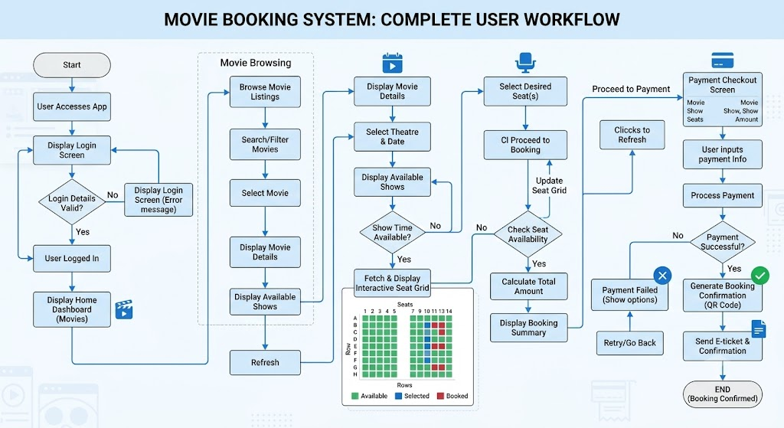
Figure 3.1: System Flowchart & User Workflow

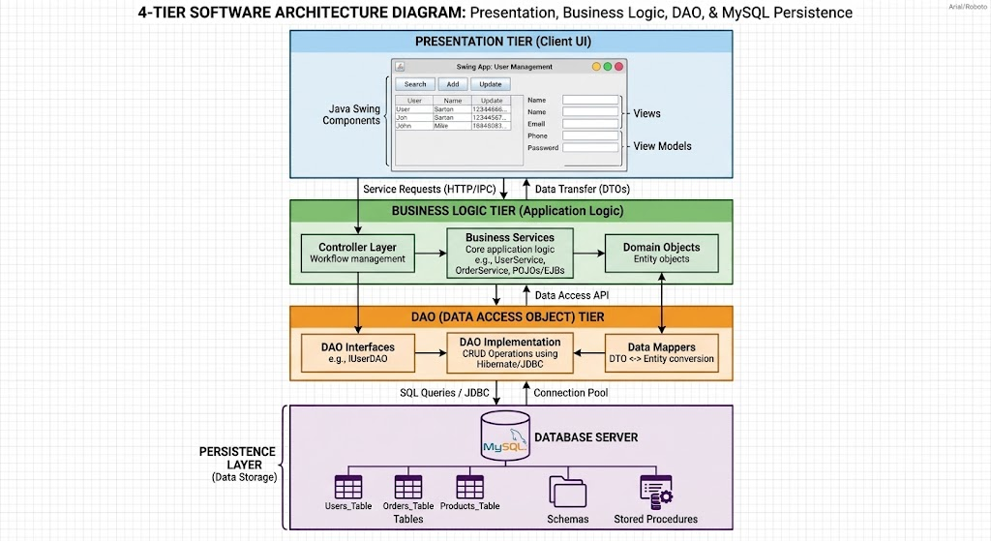
Figure 3.2: 4-Tier Software Architecture Layering
3.2 Data Access Object (DAO) Design Pattern
By implementing the DAO pattern, the application decouples business operations from raw database interaction. This ensures that any changes made to SQL queries or table structures do not impact the Swing GUI components, enhancing code maintainability, testability, and scalability.
3.3 Technology Stack & Tools
Component Category | Technology / Specification | Purpose / Description
Hardware Requirements | Intel Core i5 (2.0 GHz+), 8 GB RAM, 500 MB Storage | Minimum system specifications required to run the Java & MySQL application smoothly
Operating System | Windows 10 / 11, Linux, macOS | Compatible host operating systems to execute the Java runtime environment.
Programming Language | Core Java (JDK 17+) | Core object-oriented application logic
GUI Framework | Java Swing & AWT | Native desktop interface rendering
Database Server | MySQL Server 8.0 | Relational data persistence & table storage
Database Connectivity | JDBC (mysql-connector-j) | Java-to-MySQL driver integration
Development Environment | Visual Studio Code / Eclipse | IDE for development and debugging
Version Control | Git & GitHub | Distributed source code management
Table 3.1: Technology Stack & Tools Specification

CHAPTER 4
SYSTEM DESIGN & METHODOLOGY
4.1 System Flowchart & User Workflow
The operational workflow of the Online Movie Ticket Booking System governs how users navigate from initial authentication to final ticket confirmation. The system enforces a secure, step-by-step sequence of operations managed through Java Swing interface frames:
- User Onboarding & Authentication: Users launch the application and interact with LoginFrame or RegisterFrame. Credentials are validated securely against the database via UserDAO.
- Movie Catalog Browsing: Upon successful login, customers land on CustomerDashboard, where they can browse available movies, search by title or genre, and review metadata such as runtime, synopsis, and language.
- Showtime Selection: Users pick a specific screening date, time slot, and screening hall via ShowFrame.
- Interactive Seat Selection Grid: The application loads a dynamic 100-seat layout (Rows A–J, Seats 1–10) in SeatSelectionFrame. Seats are color-coded in real-time (🟢 Available, 🟠 Selected, 🔴 Booked) to prevent collision.
- Polymorphic Checkout: Users select their preferred payment method (UPIPayment or CardPayment) via PaymentFrame, executing a unified polymorphic checkout interface.
- Booking Confirmation & Ledger Persistence: Upon successful checkout, an atomic JDBC transaction is committed, generating a permanent audit record in the bookings table and updating seat statuses to BOOKED.
4.2 Database Entity-Relationship (ER) Schema & Relational Tables
The application uses a normalized relational database schema (movie_booking.sql) hosted on MySQL Server 8.0. The database consists of five core tables linked via primary and foreign key constraints:
- users Table: Stores user authentication credentials and system roles.
  - user_id (INT, Primary Key, Auto-Increment)
  - username (VARCHAR)
  - password_hash (VARCHAR)
  - role (ENUM: 'CUSTOMER', 'ADMIN')

- movies Table: Maintains catalog information for screening titles.
  - movie_id (INT, Primary Key, Auto-Increment)
  - title (VARCHAR)
  - genre (VARCHAR)
  - duration_mins (INT)
  - synopsis (TEXT)
- shows Table: Tracks screening schedules and hall allocations.
  - show_id (INT, Primary Key, Auto-Increment)
  - movie_id (INT, Foreign Key referencing movies(movie_id))
  - hall_name (VARCHAR)
  - show_time (DATETIME)
  - ticket_price (DECIMAL)
- seats Table: Represents physical seat availability linked to specific shows.
  - seat_id (INT, Primary Key, Auto-Increment)
  - show_id (INT, Foreign Key referencing shows(show_id))
  - seat_number (VARCHAR, e.g., "A1")
  - status (ENUM: 'AVAILABLE', 'BOOKED')
- bookings Table: Records reservation audits and transaction totals.
  - booking_id (INT, Primary Key, Auto-Increment)
  - user_id (INT, Foreign Key referencing users(user_id))
  - show_id (INT, Foreign Key referencing shows(show_id))
  - total_amount (DECIMAL)
  - booking_date (TIMESTAMP)
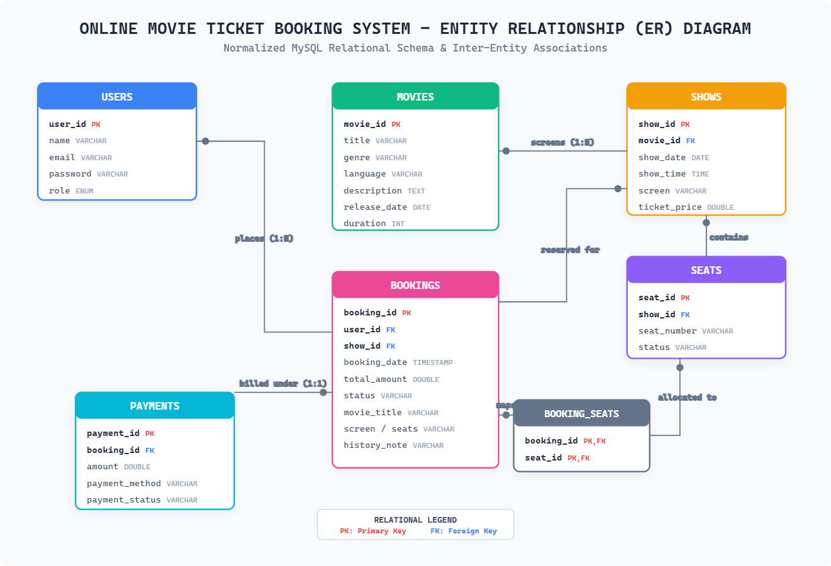

Figure 4.1 Relational Database Entity-Relationship (ER) Diagram

4.3 UML Class Diagram & Object-Oriented Hierarchies
The software design incorporates robust Object-Oriented Programming (OOP) paradigms to maintain clean code separation:
- Inheritance Hierarchy (auth & model packages):
  - User (Abstract Base Class containing shared attributes like username and password)
    - ──> Customer (Extended subclass with booking and profile privileges)
    - ──> Admin (Extended subclass with movie CRUD and show management privileges)
- Polymorphism Interface (payment package):
  - Payment (Interface defining the core processPayment(double amount) method)
    - ──> UPIPayment (Implements virtual payment ID validation and processing)
    - ──> CardPayment (Implements credit/debit card masking and secure transaction handling)
- Data Access Object (DAO) Pattern:
  - Independent DAO handlers (UserDAO, MovieDAO, ShowDAO, BookingDAO, PaymentDAO) isolate SQL execution logic from the Java Swing presentation layer.

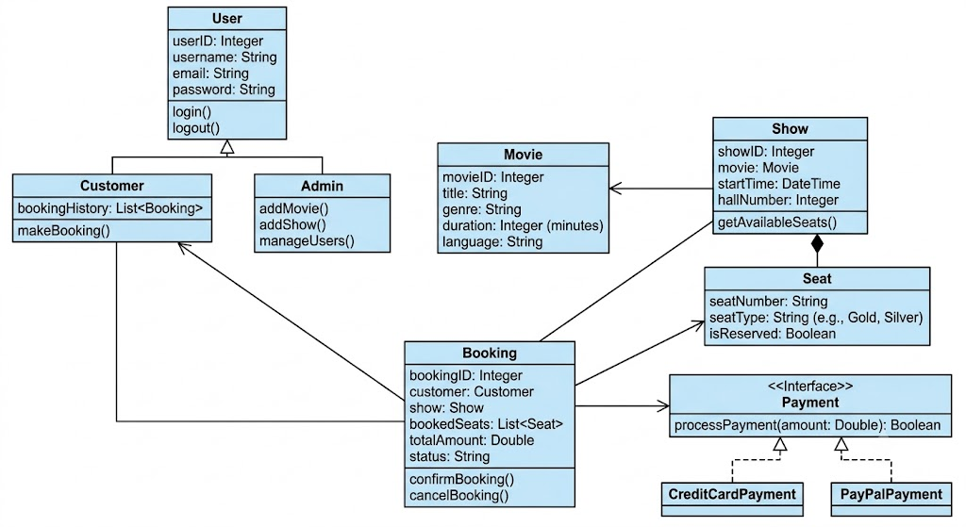
Figure 4.2: UML Class Diagram & OOP Hierarchies

CHAPTER 5
MODULE BREAKDOWN & IMPLEMENTATION
The Online Movie Ticket Booking System is engineered using a modular package structure that isolates functional concerns, enabling clean separation of duties across the development team. The core packages and their sub-modules are implemented as follows:
5.1 User Authentication Module (auth & model)
The authentication module handles user onboarding, credential verification, and role-based session initialization.
- RegisterFrame & LoginFrame: Java Swing graphical interfaces that capture user registration inputs (username, password, role) and login credentials.
- Inheritance Hierarchy (User, Customer, Admin): Built upon an abstract base class User that encapsulates common attributes (username, password_hash), extended by specialized subclasses Customer (with booking privileges) and Admin (with system control privileges).
- UserDAO: Executes secure SQL queries to validate credentials and store hashed user records into the relational database.

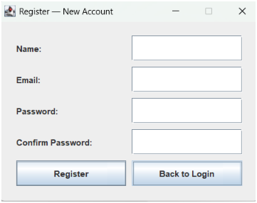
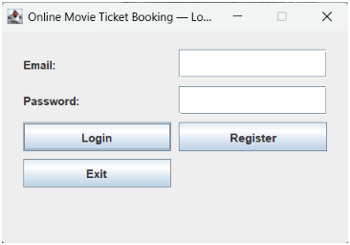

Figure 5.1: Application Output – Customer Login & Registration

5.2 Movie & Show Management Module (movies & shows)
This module manages the cinematic catalog and screening schedules available to customers.
- MovieFrame & MovieManager: Provides interactive catalog browsing, title-based keyword filtering, and displays detailed metadata including genre, runtime, language, and synopsis.
- ShowFrame & ShowManager: Enables administrators to schedule screening dates, assign screening halls, and set custom ticket prices linked to specific movie IDs.
- MovieDAO & ShowDAO: Data Access Object classes handling CRUD operations for movies and showtimes against the movies and shows database tables.
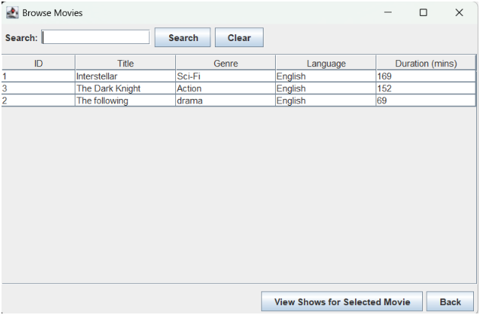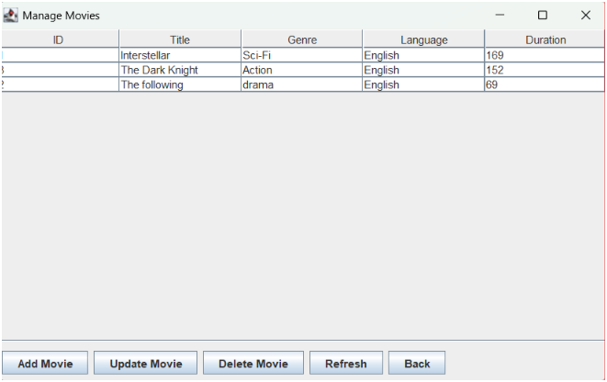
Figure 5.2: Application Output – Movie Catalog & Showtime Grid
5.3 Seat Selection & Booking Module (booking)
The core reservation engine manages real-time seat availability and prevents double-booking conflicts.
- SeatSelection Frame: Renders an interactive 100-seat grid layout spanning Rows A–J and Seats 1–10.
- Dynamic Color Coding: Seats are visually tracked in real-time using intuitive color codes: 🟢 Available, 🟠 Selected by user, and 🔴 Booked.
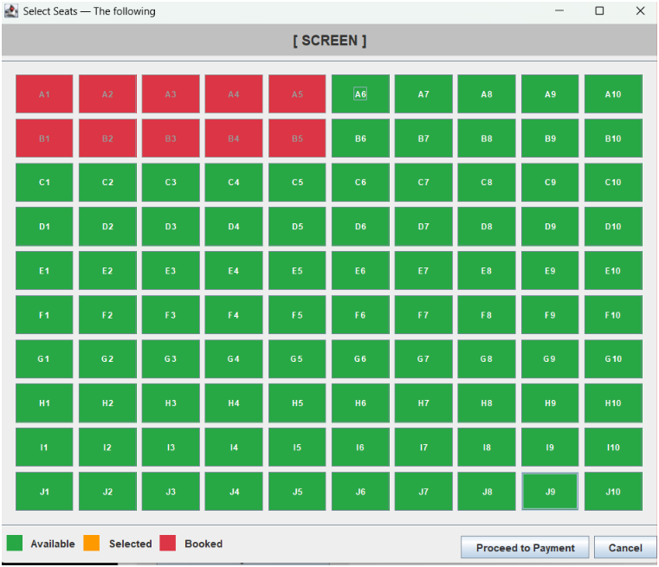
- Conflict-Free Reservation Logic: Implements pessimistic row locking (SELECT ... FOR UPDATE) and JDBC atomic transactions (commit/rollback) via BookingDAO to ensure that simultaneous users cannot reserve the exact same seat.

Figure 5.3: Application Output – Interactive Seat Selection Grid
5.4 Polymorphic Payment Subsystem (payment)
The payment module demonstrates core Object-Oriented polymorphism during checkout.
- Payment Interface: Defines the unified contract method processPayment(double amount).
- UPIPayment Implementation: Handles virtual payment ID (VPA) input validation and processing workflows.
- CardPayment Implementation: Manages credit and debit card transactions with built-in card number masking and secure field validation.
- PaymentFrame: A unified checkout window that dynamically adapts its input fields based on the user's chosen payment strategy.
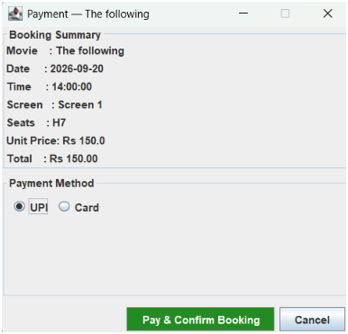
Figure 5.4: Application Output – Polymorphic UPI & Card Checkout
5.5 Admin Dashboard & Control Panel (admin)
The administrative suite provides operators with full oversight and management capabilities:
- AdminDashboard: Centralized management hub linking administrative sub-modules.
- ManageMoviesFrame & ManageShowsFrame: Interface windows allowing admins to add new movie titles, update screening times, and remove outdated entries.
- ManageBookingsFrame: Provides real-time monitoring of the reservation ledger, tracking total ticket sales, active bookings, and revenue audits.
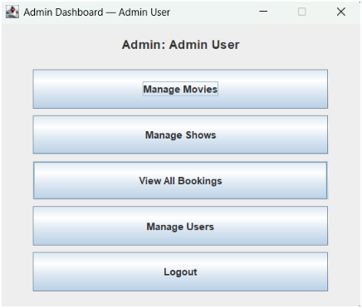
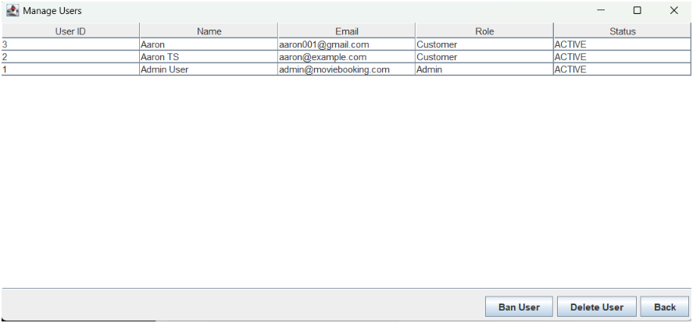

Figure 5.5: Application Output – Admin Dashboard & Control Panel
5.6 Core Implementation & Code Snippets
The following listing presents the core implementation of the database connectivity layer used by every DAO class in the system.
// A. Database Connection Handler (DBConnection.java)
package database;

import java.sql.Connection;
import java.sql.DriverManager;
import java.sql.SQLException;

public class DBConnection {
private static final String URL = "jdbc:mysql://localhost:3306/movie_booking";
private static final String USER = "root";
private static final String PASSWORD = "your_password";

public static Connection getConnection() {
Connection conn = null;
try {
Class.forName("com.mysql.cj.jdbc.Driver");
conn = DriverManager.getConnection(URL, USER, PASSWORD);
} catch (ClassNotFoundException | SQLException e) {
System.err.println("Database Connection Failed: " + e.getMessage());
}
return conn;
}
}
5.7 Database tables
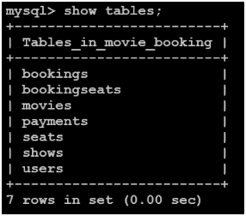
Figure 5.7.1: Database Output – Tables List
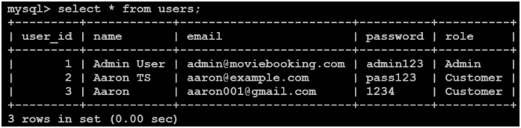
Figure 5.7.2: Database Output – Users Table
Figure 5.7.3: Database Output – Bookings Table

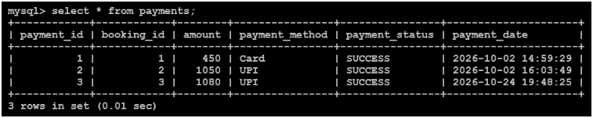
Figure 5.7.4: Database Output – Payments Table
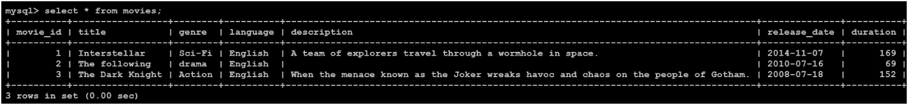
Figure 5.7.5: Database Output – Movies Table

CHAPTER 6
SOFTWARE TESTING & VALIDATION
6.1 Testing Methodology
To guarantee that the Online Movie Ticket Booking System functions reliably without data corruption or interface failures, a comprehensive testing strategy was implemented across all development phases. The testing approach combined Unit Testing (verifying individual DAO methods, entity models, and payment calculators) and Integration Testing (validating communication between the Java Swing GUI, DAO controllers, and the MySQL database via JDBC). Furthermore, System Testing was conducted to evaluate end-to-end user workflows from authentication to ticket confirmation.
6.2 Test Cases & Concurrency Validation
A structured test suite was executed to validate normal operational behaviors as well as edge cases, particularly focusing on concurrency control to prevent double-booking conflicts.

Test ID | Test Scenario / Input | Expected Output | Actual Output | Status
TC_AUTH_01 | User registers with valid details and unique username. | Account successfully created and stored in users table. | Record persisted; user redirected to login. | Pass
TC_AUTH_02 | User attempts login with incorrect password. | Error dialog displayed; access denied. | Authentication rejected securely. | Pass
TC_MOV_01 | Admin adds a new movie entry via ManageMoviesFrame. | Movie record saved and reflected immediately in customer catalog. | Catalog updated successfully in MySQL. | Pass
TC_SEAT_01 | Customer selects an available seat ("A1") for a show. | Seat status updates to selected (orange) on grid. | Grid highlights seat correctly. | Pass
TC_PAY_01 | Customer completes checkout using valid UPI VPA. | Transaction approved; booking confirmation generated. | Payment processed via UPIPayment. | Pass
TC_CON_01 | Concurrent Booking: Two users attempt to book seat "B4" for the same show simultaneously. | First transaction commits; second transaction detects locked row and prompts seat unavailability. | Pessimistic locking (FOR UPDATE) successfully blocked double-booking. | Pass
Table 6.1: System Validation and Concurrency Test Cases

CHAPTER 7
CONCLUSION & FUTURE SCOPE
7.1 Conclusion
The Online Movie Ticket Booking System was successfully conceptualized, designed, and structured as a robust, desktop-based cinema reservation application. By leveraging core Object-Oriented Programming (OOP) principles—such as Inheritance in user roles, Polymorphism in payment processing strategies, Encapsulation in domain models, and Abstraction via the Data Access Object (DAO) pattern—the application achieves high maintainability, modularity, and clean separation of concerns. Furthermore, integrating a normalized MySQL database through JDBC ensures reliable data persistence, while atomic transactions and row-level locking successfully eliminate concurrency conflicts and double-booking errors. The system effectively automates traditional box office operations, minimizing administrative overhead and delivering a smooth, user-friendly digital ticketing experience.
7.2 Future Enhancements
To expand the capabilities and scalability of the application beyond its current desktop scope, several future enhancements are planned:
- Online Payment Gateway Integration: Incorporate third-party production payment APIs (such as Stripe or Razorpay) to process live credit card, net banking, and UPI transactions securely.
- Automated Digital Ticketing: Implement automated generation of unique QR codes for digital tickets, paired with automated email confirmations sent directly to customers upon booking completion.
- AI-Powered Movie Recommendations: Integrate machine learning recommendation algorithms to suggest personalized movie titles and showtimes based on user viewing history and genre preferences.
- Platform Expansion: Migrate the core architecture from a desktop Java Swing application into a modern web platform (using Spring Boot and React) or a dedicated mobile application.

REFERENCES

[1] | Herbert Schildt, Java: The Complete Reference, 12th Edition, McGraw-Hill Education, 2021.
[2] | René Witte, Object-Oriented Software Engineering: Practical Software Development using Java and UML, Pearson, 2020.
[3] | Baron Schwartz, Vadim Tkachenko, and Peter Zaitsev, High Performance MySQL: Optimization, Backups, and Replication, 3rd Edition, O'Reilly Media, 2012.
[4] | Oracle Corporation, Java Database Connectivity (JDBC) API Documentation, Available: https://docs.oracle.com/en/java/javase/docs/api/java.sql/module-summary.html.
[5] | MySQL Documentation, MySQL 8.0 Reference Manual, Oracle Corporation, Available: https://dev.mysql.com/doc/refman/8.0/en/.
[6] | E. Gamma, R. Helm, R. Johnson, and J. Vlissides, Design Patterns: Elements of Reusable Object-Oriented Software, Addison-Wesley Professional, 1994.
[7] | K. Sierra and B. Bates, Head First Java, 2nd Edition, O'Reilly Media, 2005.

APPENDIX
APPENDIX A: DATABASE CREATION SCRIPT (movie_booking.sql)
The following SQL script contains the normalized database schema definitions used to initialize the movie_booking database on MySQL Server 8.0:
-- Create Database Schema
CREATE DATABASE IF NOT EXISTS movie_booking;
USE movie_booking;
-- 1. Users Table
CREATE TABLE IF NOT EXISTS users (
user_id INT AUTO_INCREMENT PRIMARY KEY,
name VARCHAR(100) NOT NULL,
email VARCHAR(100) UNIQUE NOT NULL,
password VARCHAR(255) NOT NULL,
role ENUM('Customer', 'Admin') DEFAULT 'Customer'
);
-- 2. Movies Table
CREATE TABLE IF NOT EXISTS movies (
movie_id INT AUTO_INCREMENT PRIMARY KEY,
title VARCHAR(150) NOT NULL,
genre VARCHAR(50),
language VARCHAR(50),
description TEXT, release_date DATE, duration INT
);
-- 3. Shows Table
CREATE TABLE IF NOT EXISTS shows (
show_id INT AUTO_INCREMENT PRIMARY KEY,
movie_id INT NOT NULL,
show_date DATE NOT NULL,
show_time TIME NOT NULL,
screen VARCHAR(50) NOT NULL,
ticket_price DOUBLE NOT NULL,
FOREIGN KEY (movie_id) REFERENCES movies(movie_id) ON DELETE CASCADE
);
-- 4. Seats Table
CREATE TABLE IF NOT EXISTS seats (
seat_id INT AUTO_INCREMENT PRIMARY KEY,
show_id INT NOT NULL,
seat_number VARCHAR(10) NOT NULL,
status VARCHAR(20) DEFAULT 'AVAILABLE',
FOREIGN KEY (show_id) REFERENCES shows(show_id) ON DELETE CASCADE
);
-- 5. Bookings Table
CREATE TABLE IF NOT EXISTS bookings (
booking_id INT AUTO_INCREMENT PRIMARY KEY,
user_id INT NOT NULL, show_id INT NOT NULL,
booking_date TIMESTAMP DEFAULT CURRENT_TIMESTAMP,
total_amount DOUBLE NOT NULL,
status VARCHAR(20) DEFAULT 'CONFIRMED',
movie_title VARCHAR(150), show_date DATE, show_time TIME,
screen VARCHAR(50), seat_numbers VARCHAR(255),
history_note VARCHAR(255),
FOREIGN KEY (user_id) REFERENCES users(user_id),
FOREIGN KEY (show_id) REFERENCES shows(show_id)
);
-- 6. Booking Seats Junction Table
CREATE TABLE IF NOT EXISTS booking_seats (
booking_id INT NOT NULL, seat_id INT NOT NULL,
PRIMARY KEY (booking_id, seat_id),
FOREIGN KEY (booking_id) REFERENCES bookings(booking_id) ON DELETE CASCADE,
FOREIGN KEY (seat_id) REFERENCES seats(seat_id) ON DELETE CASCADE
);
-- 7. Payments Table
CREATE TABLE IF NOT EXISTS payments (
payment_id INT AUTO_INCREMENT PRIMARY KEY,
booking_id INT NOT NULL, amount DOUBLE NOT NULL,
payment_method VARCHAR(50) NOT NULL,
payment_status VARCHAR(20) DEFAULT 'SUCCESS',
payment_date TIMESTAMP DEFAULT CURRENT_TIMESTAMP,
FOREIGN KEY (booking_id) REFERENCES bookings(booking_id)
);

APPENDIX B: CORE SOURCE CODE LISTINGS
B.1 Database Connection Handler (DBConnection.java)
package database;
import java.sql.Connection;
import java.sql.DriverManager;
import java.sql.SQLException;
public class DBConnection {
private static final String URL "jdbc:mysql://localhost:3306/movie_booking";
private static final String USER = "root";
private static final String PASSWORD = "your_password";
public static Connection getConnection() {
Connection conn = null;
try {
Class.forName("com.mysql.cj.jdbc.Driver");
conn = DriverManager.getConnection(URL, USER, PASSWORD);
} catch (ClassNotFoundException | SQLException e) {
System.err.println("Database Connection Failed: " + e.getMessage());
}
return conn;
}
}

B.2 Polymorphic Payment Strategy Interface (Payment.java)
package payment;
public interface Payment {
boolean processPayment(double amount);
}

B.3 Application Entry Point (Main.java)
package main;
import database.DBConnection;
import javax.swing.SwingUtilities;
import view.LoginFrame;
public class Main {
public static void main(String[] args) {
// 1. Test database connection on startup
java.sql.Connection conn = DBConnection.getConnection();
if (conn != null) {
System.out.println("Database connection initialized successfully for Online Movie Ticket Booking System.");
} else {
System.err.println("Warning: Could not establish connection to MySQL database.");
}
// 2. Launch the Java Swing Presentation Layer safely on the Event Dispatch Thread
SwingUtilities.invokeLater(() -> {
try {
LoginFrame loginFrame = new LoginFrame();
loginFrame.setVisible(true);
} catch (Exception e) {
e.printStackTrace();
}
});
}
}

APPENDIX C: PROJECT STRUCTURE AND SOURCE CODE SNIPPETS
C.1 Project Directory & Package Structure
OnlineMovieBooking/
│
├── .env.example # Template for local MySQL credentials
├── compile.ps1 # Automated build script (PowerShell)
├── run.ps1 # Application execution script (PowerShell)
│ └── README.md # Presentation overview
├── lib/
│ └── mysql-connector-j-26.7.0.jar # JDBC MySQL Driver
├── sql/
│ └── movie_booking.sql # Database schema, table definitions
└── src/
├── admin/ # Administrator UI Frames
│ ├── AdminDashboard.java
│ ├── ManageBookingsFrame.java
│ ├── ManageMoviesFrame.java
│ ├── ManageShowsFrame.java
│ └── ManageUsersFrame.java
├── auth/ # Authentication & Registration
│ ├── LoginFrame.java
│ ├── RegisterFrame.java
│ └── UserDAO.java
├── booking/ # Seat selection & Booking transactions
│ ├── BookingDAO.java
│ ├── SeatDAO.java
│ └── SeatSelectionFrame.java
├── customer/ # Customer UI Frames
│ ├── BookingHistoryFrame.java
│ ├── CustomerDashboard.java
│ └── ProfileFrame.java
├── database/ # Connection pooling & .env reader
│ ├── Config.java
│ └── DBConnection.java
├── main/ # Application Entry Point
│ └── Main.java
├── model/ # Domain Entities (OOP Models)
│ ├── Admin.java
│ ├── Booking.java
│ ├── Customer.java
│ ├── Movie.java
│ ├── Seat.java
│ ├── Show.java
│ └── User.java
├── movies/ # Movie browsing & catalog DAO
│ ├── MovieDAO.java
│ └── MovieFrame.java
├── payment/ # Polymorphic Payment Subsystem
│ ├── CardPayment.java
│ ├── Payment.java
│ ├── PaymentDAO.java
│ ├── PaymentFrame.java
│ └── UPIPayment.java
└── shows/ # Show scheduling & listings
├── ShowDAO.java
└── ShowFrame.java

Package information:
- com.movieticket.ui: For user interface elements.
- com.movieticket.dao: To handle database queries.
- com.movieticket.model: For data entry classes.
- com.movieticket.config: For MySQL connection management.

C.2 Core Source Code Screenshots
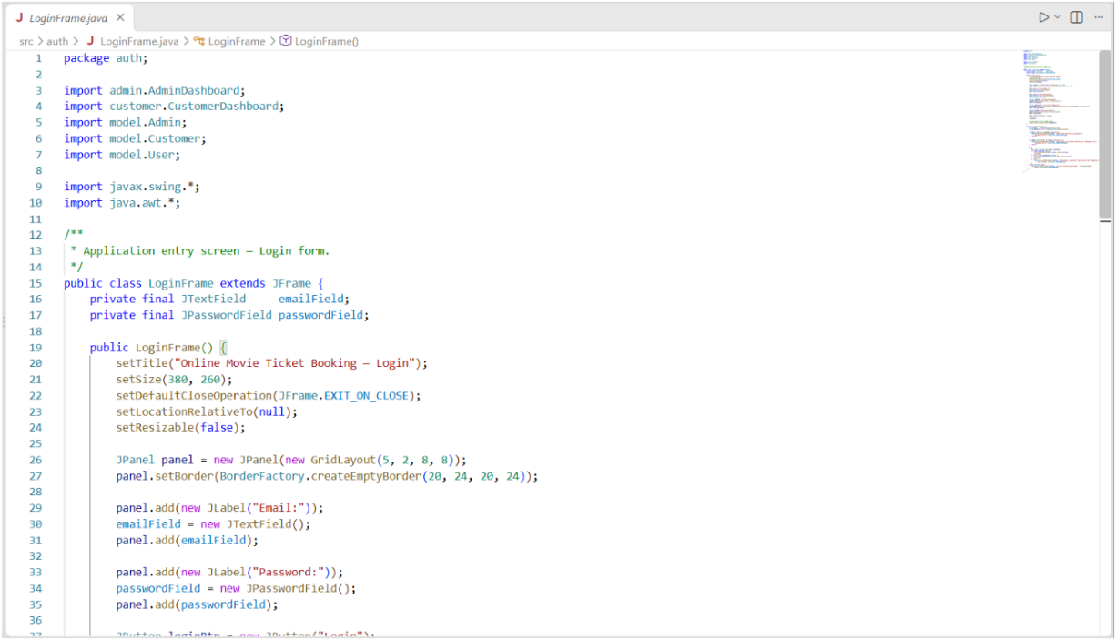
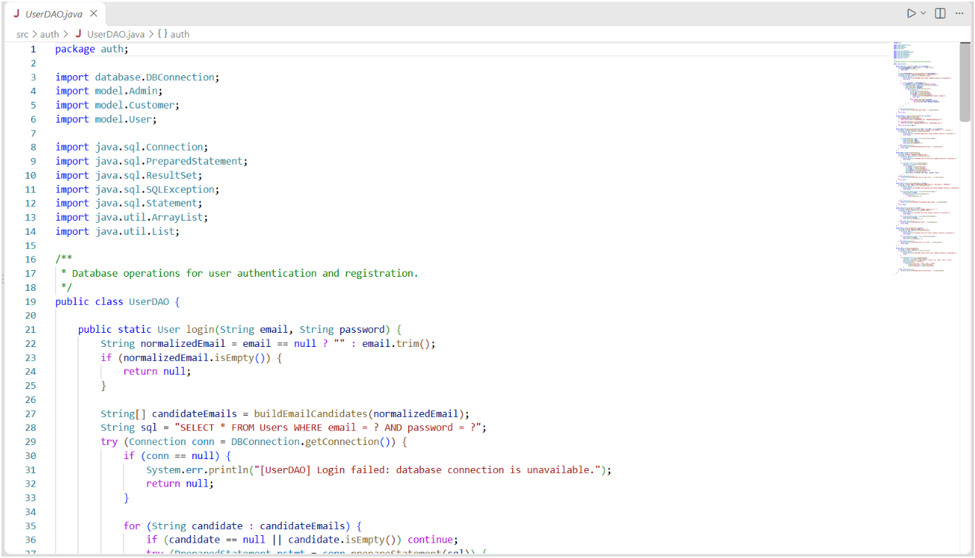
Figure C.2: Implementation of UserDAO.java for managing user database operations.
Figure C.1: Implementation of LoginFrame.java for user authentication interface.
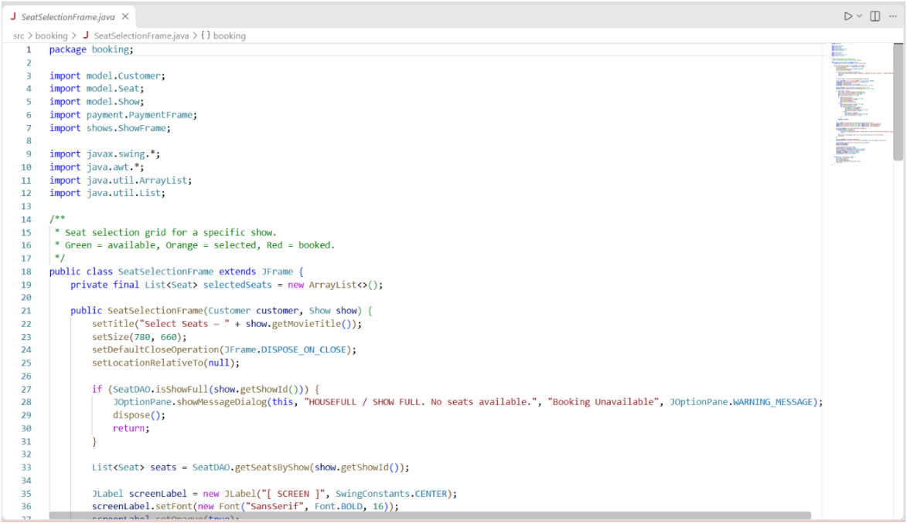
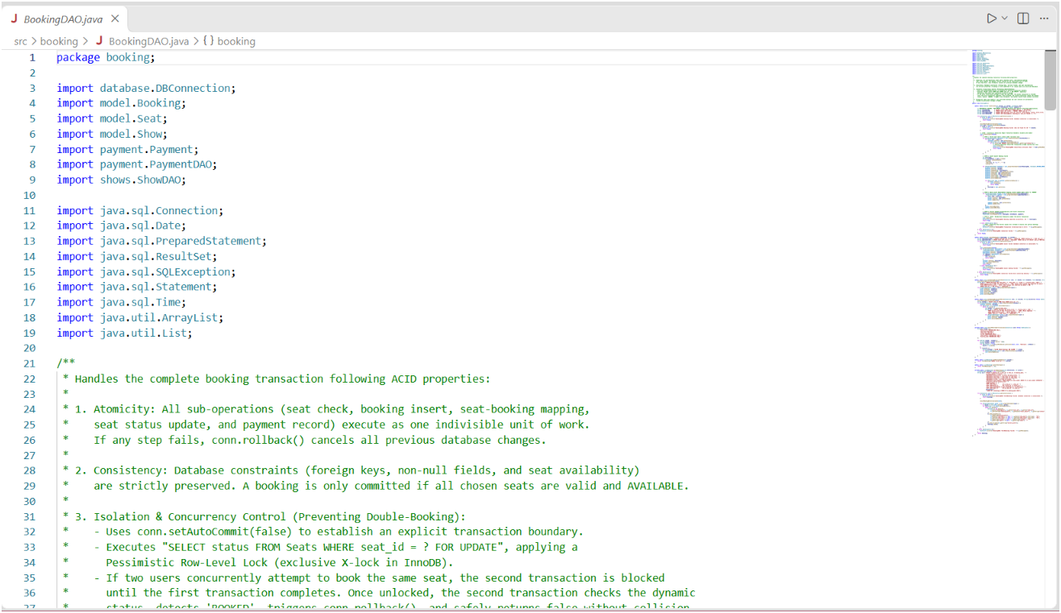
Figure C.4: Implementation of BookingDAO.java for handling ticket booking transactions.
Figure C.3: Implementation of SeatSelectionFrame.java for interactive seat booking

Department of Computer Science and Engineering
Vidya Academy of Science and Technology
Thalakkottukara, Thrissur - 680501
(https://www.vidyaacademy.ac.in)

