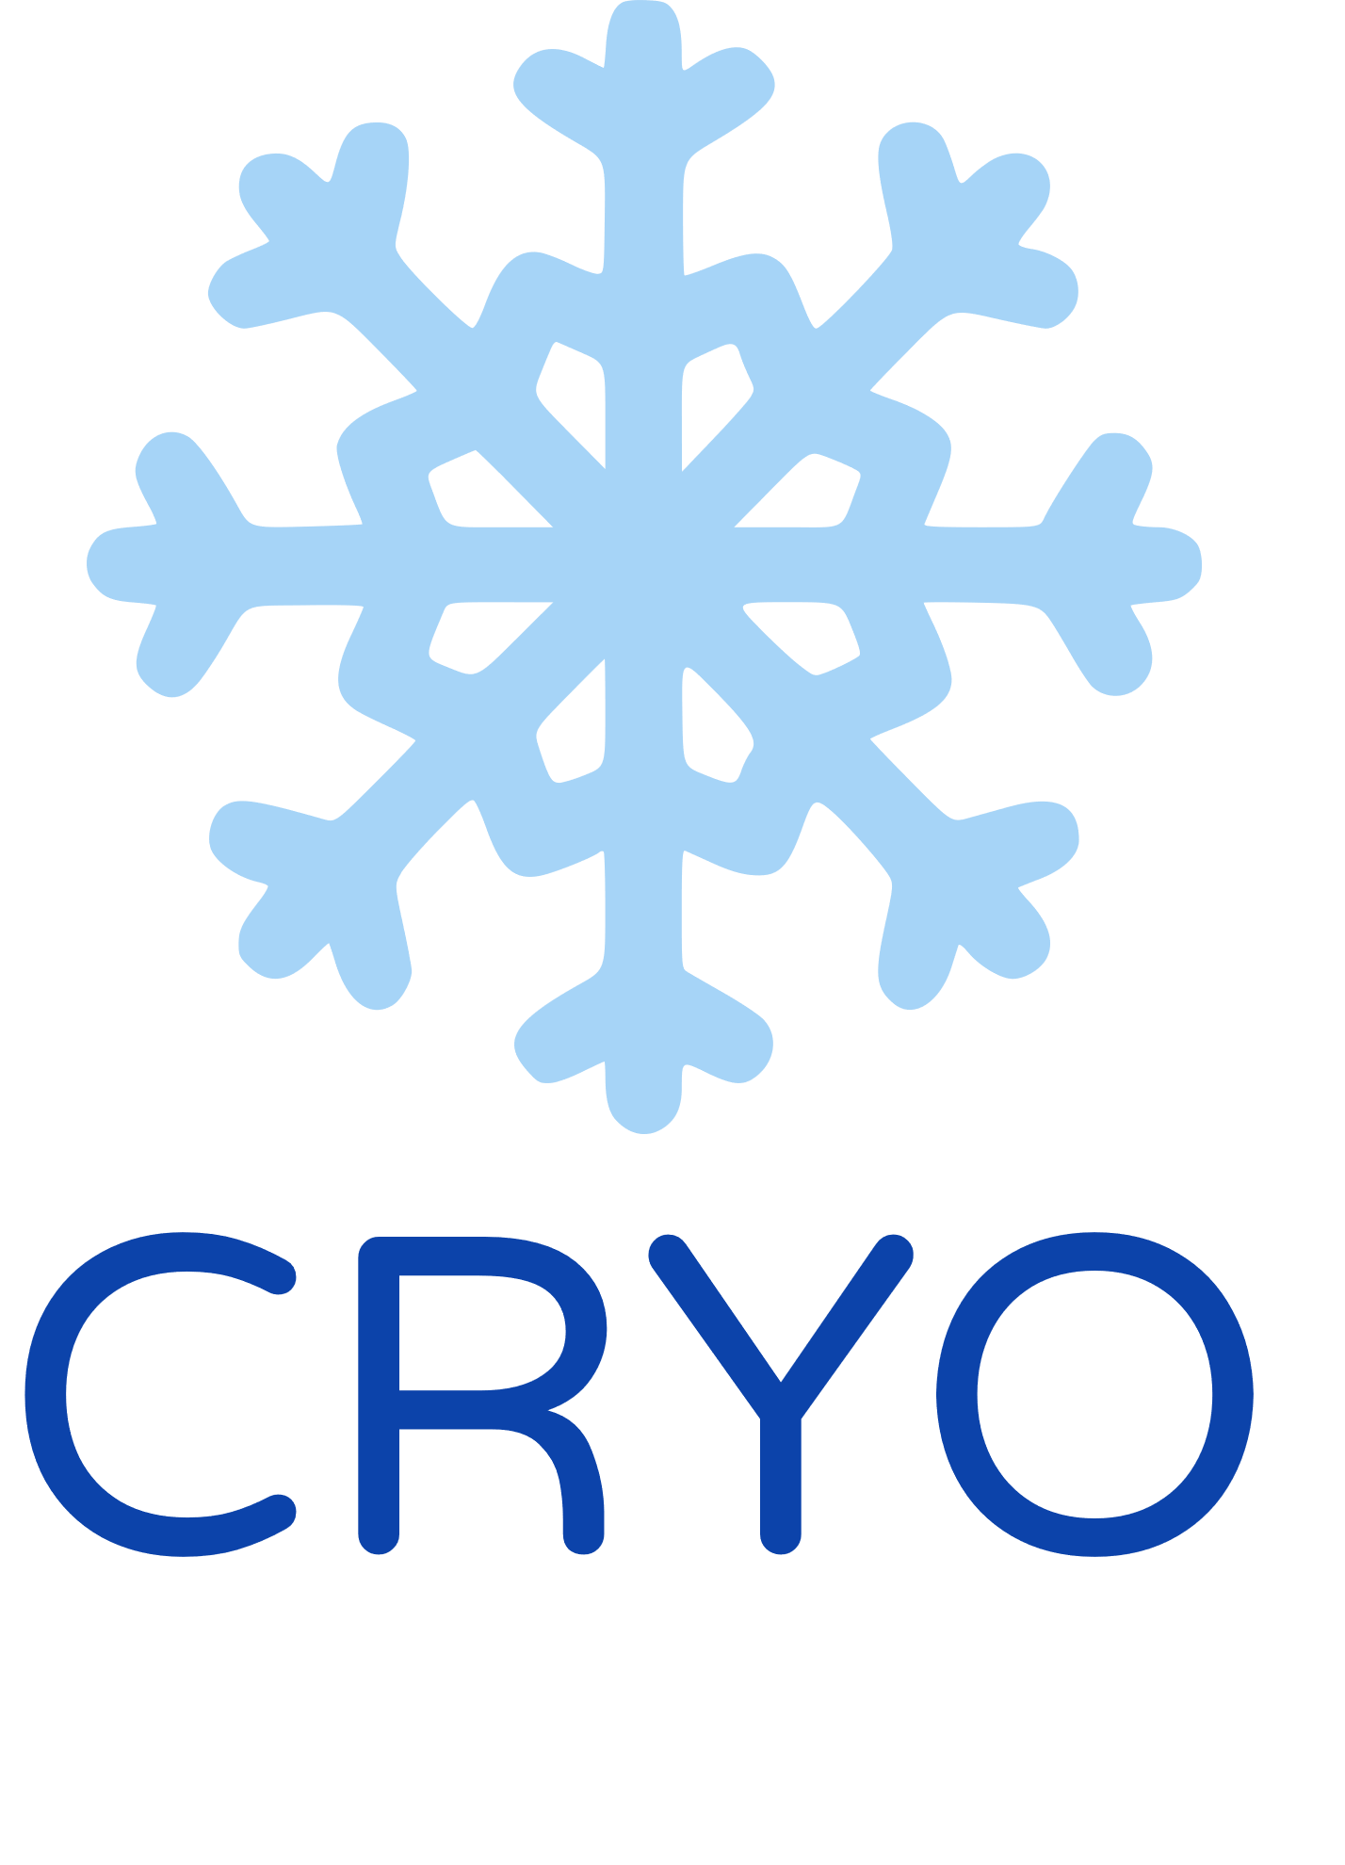

PROJECT DOCUMENTATION

Table of contents

1. Our Team 3

2. What is digital asset? 3

3. Used programs and languages 4

4. Resume 5

5. Idea 5

6. Workflow 5

7. Conclusion 5

1. Our Team

Nadezhda Ivanova – Scrum trainer

[NTIvanova21@codingburgas.bg](mailto:NTIvanova21@codingburgas.bg)

Valeria Chavdarova - Back-end Developer

[VDChavdarova21@codingburgas.bg](mailto:VDChavdarova21@codingburgas.bg)

Antonia Taneva - Back-end Developer

[ATTaneva21@codingburgas.bg](mailto:ATTaneva21@codingburgas.bg)

Viktoria Kupenova - Back-end Developer

[VGKupenova21@codingburgas.bg](mailto:VGKupenova21@codingburgas.bg)

2. What is digital asset?

A digital asset refers to anything in digital form that holds value. It can include various types of digital files such as videos, images, documents, cryptocurrencies, and digital books. Digital assets can have financial, informational, or creative value and are often managed and accessed through digital asset management systems. They are distinct from physical currency and exist in a digital format.

3. Used programs and languages

* React native

React native was our main programming language.

* Python

We used Python to make the customer services for our application.

* Typescript

We used TypeScript to link the database to the application.

* SQL

We used SQL for our database.

* Visual studio code

Visual Studio Code is a code editor that is optimized for building and debugging modern web and cloud applications. It is a lightweight but powerful source code editor that runs on your desktop and is available for Windows, macOS, and Linux.

* Pycharm

PyCharm is an integrated development environment (IDE) designed specifically for Python programming. It is developed by JetBrains.

* Figma

Figma is a collaborative web application and design tool that is widely used for interface design and prototyping. We designed our mobile application there.

* Azure

Azure, also known as Microsoft Azure, is a cloud computing platform and service provided by Microsoft. It offers a wide range of cloud-based services and solutions that enable organizations to build, deploy, and manage applications and services through Microsoft-managed data centers.

* Prisma

Prisma is a next-generation Object-Relational Mapping (ORM) tool that provides a modern and intuitive way to work with databases in Node.js and TypeScript applications. It offers several components that enhance the developer experience and streamline database operations.

* Word

Microsoft Word or MS Word (often called Word) is a graphical word processing program that users can type with. Its purpose is to allow users to type and save documents. We used Word to create this documentation.

* Excel

Excel is a spreadsheet program from Microsoft and a component of its Office product group for business applications. This was the place where we did out QA documentation.

* Power point

PowerPoint is a complete presentation graphics package. It gives you everything you need to produce a professional-looking presentation. This was the place where we did our presentation.

4. Resume

Hello! This is our team Cryo and we decided to make a mobile application dedicated to making bequeling easier. For programing languages we decided to use React Native, Python and TypeScript. More features of our app are: money transfers, adding people to your digital will, keeping track of your money balance, customer services and other.

5. Idea

When the team gathered for the first time, we started thinking about what we had to do. After lots of ideas and proposals we chose to do a mobile application. With our application is easier to bequel your belongings to the people you chose.

6. Workflow

As for the working progress - It went smoothly, without major problems. Even though we had some disagreements during our work regarding the idea for the app, we knew that we had to do it so we made a compromise with each other and then we cleared out what we had to do, to accomplish it.

7. Conclusion

In the end, after lots of late hours work, we finished the mobile app. The work journey was quite enjoyable, yet under pressure, and we learned a lot about teamwork, time, and repository management.