Software Requirements Specification
for
<Plant Tracking System>
Version 1.0 approved
Prepared by <AI Asistant >
< plant technology solutions>
<9/11/2025 >
Table of Contents
Table of Contents ii
Revision History ii
1. Introduction 1
1.1 Purpose 1
1.2 Document Conventions 1
1.3 Intended Audience and Reading Suggestions 1
1.4 Product Scope 1
1.5 References 1
2. Overall Description 2
2.1 Product Perspective 2
2.2 Product Functions 2
2.3 User Classes and Characteristics 2
2.4 Operating Environment 2
2.5 Design and Implementation Constraints 2
2.6 User Documentation 2
2.7 Assumptions and Dependencies 3
3. External Interface Requirements 3
3.1 User Interfaces 3
3.2 Hardware Interfaces 3
3.3 Software Interfaces 3
3.4 Communications Interfaces 3
4. System Features 4
4.1 System Feature 1 4
4.2 System Feature 2 (and so on) 4
5. Other Nonfunctional Requirements 4
5.1 Performance Requirements 4
5.2 Safety Requirements 5
5.3 Security Requirements 5
5.4 Software Quality Attributes 5
5.5 Business Rules 5
6. Other Requirements 5
Appendix A: Glossary 5
Appendix B: Analysis Models 5
Appendix C: To Be Determined List 6

Revision History
Name | Date | Reason For Changes | Version
AI Asistan | 09.11.2025 | First version created | 1.0

Introduction

Purpose
This document defines the software requirements for the Plant Monitoring System 1.0. This SRS covers the entire system, including plant monitoring, irrigation management, maintenance history, and reporting modules.

Document Conventions
- Requirement ID Format: PL_[TYPE]_[NO] (e.g., PL_FUNC_001)
- Priority Levels: High, Medium, Low
- TBD Usage: "TBD" will be used for missing information
- Version Tracking: Semantic Versioning (X.Y.Z)

Intended Audience and Reading Suggestions
- Developers: All sections
- Test Engineers: Sections 3, 4, 5
- Project Managers: Sections 1, 2, 6
- End Users: Section 3.1, Appendix A
- Reading Order: 1 → 2 → 4 → 3 → 5 → 6 → Appendices

Product Scope
The Plant Monitoring System is a web and mobile-based software solution developed to digitize and optimize users' plant care processes. The system aims to improve plant health, reduce maintenance costs, and enhance the user experience.

References
- IEEE 830-1998 Software Requirements Specifications Standard
- Plant Care Expertise Report v1.2
- User Needs Analysis Document v2.0
- GDPR and KVKK Compliance Guide

Overall Description

Product Perspective
The Plant Monitoring System is a next-generation digital solution that operates independently from existing gardening applications. The system distinguishes itself from traditional methods through smart reminders and personalized care plans.

Product Functions
- Create and manage plant profiles
- Generate automatic watering schedules
- Track and plan fertilization
- Maintenance history records
- Smart notification system
- Multi-user management
- Reporting and analytics

User Classes and Characteristics
- Standard User: Tracks household plants, uses basic functions
- Professional User: Manages a large number of plants, requires detailed reporting
- Administrator: Manages system settings, controls user accounts
- Guest User: Has limited viewing permissions

Operating Environment
- Mobile Platforms: Android 8.0+, iOS 12+
- Web Browsers: Chrome 80+, Firefox 75+, Safari 13+
- Server Environment: Linux Ubuntu 18.04+, MySQL 8.0+
- Supported Languages: Turkish, English

Design and Implementation Constraints
- Mandatory compliance with GDPR and KVKK
- Offline functionality requirement
- Responsive design requirement
- Maximum 5GB monthly data storage limit
- Use of open-source licensed libraries

User Documentation
- User Manual (PDF and online)
- Video Training Series
- Frequently Asked Questions (FAQ)
- Online Help Desk
- API Documentation

Assumptions and Dependencies
- Users have periodic access to an internet connection
- Mobile devices support push notifications
- Free usage quota for the OpenWeatherMap API
- Availability of cloud storage services

External Interface Requirements

User Interfaces
- Main Dashboard: Plant summaries, upcoming maintenance tasks, quick access
- Plant Detail Screen: Photo gallery, maintenance history, health status
- Calendar View: Monthly/weekly maintenance plan
- Report Screen: Charts, statistics, filtering options
- Theme: Light/dark mode support, color palette dominated by green tones

Hardware Interfaces
- Camera: Taking plant photos, reading QR codes
- GPS: Location-based weather information
- Notification LED: Maintenance reminders
- Storage: Local data storage (minimum 100MB free space)

Software Interfaces
- OpenWeatherMap API: For weather data
- Google Drive API: For backup and synchronization
- Firebase Cloud Messaging: For push notifications
- SQLite: For local database

Communications Interfaces
- HTTP/HTTPS: RESTful API communication
- WebSocket: Real-time notifications
- SSL/TLS: Data encryption
- JSON: Data exchange format

System Features
Not applicable

System Feature 1
Plant Management System

Description and Priority
A high priority system feature. It allows users to create, edit, and manage plant profiles.

Stimulus/Response Sequences
- User clicks "Add Plant" → System opens the plant form
- User enters information → System performs validation
- User clicks save → System saves the plant and assigns an ID
4.1.3 Functional Requirements
PL_FUNC_001: The user must be able to create a new plant profile.
PL_FUNC_002: The user must be able to edit existing plant information.
PL_FUNC_003: The user must be able to delete a plant (soft delete).
PL_FUNC_004: The system must be able to upload plant photos.

System Feature 2 (and so on)
4.2 Irrigation Tracking System
4.2.1 Description and Priority
A High priority system feature. It creates and tracks an automatic irrigation schedule.

4.2.2 Stimulus/Response Sequences
- Scheduled irrigation time arrives → System sends a notification
- User confirms irrigation is completed → System records it in the maintenance history
- Weather changes → System updates the irrigation schedule

4.2.3 Functional Requirements
PL_FUNC_005: The system must create an automatic irrigation plan based on plant type.
PL_FUNC_006: The user must be able to enter a manual irrigation record.
PL_FUNC_007: The system must be able to adjust the irrigation schedule based on weather conditions.

4.3 Fertilization Tracking System
4.3.1 Description and Priority
A Medium priority system feature. It handles fertilization tracking and planning.

4.3.2 Stimulus/Response Sequences
- Scheduled fertilization time arrives→ System sends a reminder
- User performs fertilization → System records the date and fertilizer information
- Plant enters a growth period → System increases fertilization frequency

4.3.3 Functional Requirements
PL_FUNC_008: The system must create a fertilization schedule.
PL_FUNC_009: The user must be able to record the fertilizer type and amount.
PL_FUNC_010: The system must be able to make seasonal fertilization adjustments.

4.4 Notification System
4.4.1 Description and Priority
A High priority system feature. It is an intelligent reminder and notification system.

4.4.2 Stimulus/Response Sequences
- A maintenance time approaches → System sends a push notification
- User clicks on the notification→ System navigates to the relevant screen
- User changes notification settings → System saves the preferences

4.4.3 Functional Requirements
PL_FUNC_011: The system must be able to send maintenance notifications.
PL_FUNC_012: The user must be able to customize notification preferences.
PL_FUNC_013: The system must be able to send email and SMS notifications.

Other Nonfunctional Requirements

Performance Requirements
- Page Load Time: < 3 seconds
- Search Operation: < 1 second
- Concurrent Users: 10,000+ users
- Database Queries: < 2 seconds
- API Response Time: < 500ms

Safety Requirements
- Daily automatic backups to prevent data loss
- Secure password policy (minimum 8 characters, uppercase/lowercase letters, numbers)
- Session timeout: 30 minutes
- Maximum login attempts: 5

Security Requirements
- Data Encryption: AES-256
- Communication: HTTPS mandatory
- Authentication: JWT token based
- Data Masking: For sensitive data
- Security Audit: Monthly security scans

Software Quality Attributes
- Availability: 99.5% uptime
- Reliability: Error rate < 0.1%
- Maintainability: Modular architecture, detailed logging
- Scalability: Horizontal scaling support
- Accessibility: WCAG 2.1 AA compliance

Business Rules
- User Authorization: Role-based access control
- Data Retention: Deleted data is completely purged after 30 days
- Free Usage: Maximum limit of 50 plants
- Premium Features: Unlimited plants, advanced reporting

Other Requirements
- Database: MySQL 8.0+, compliant with normalization rules
- Internationalization: Multi-language and multi-currency support
- Legal Compliance: GDPR, KVKK, COPRA compliance
- Backup Policy: Daily incremental, weekly full backups
- Disaster Recovery: Maximum 4-hour Recovery Time Objective (RTO)
Appendix A: Glossary
- Plant Profile: All information related to a plant added to the system by a user
- Maintenance History: Chronological record of all operations performed on a plant
- Push Notification: Instant message sent to mobile devices
- Offline Mode: Ability to function without an internet connection
- Smart Reminder: Notifications optimized based on weather conditions and plant needs
Appendix B: Analysis Models
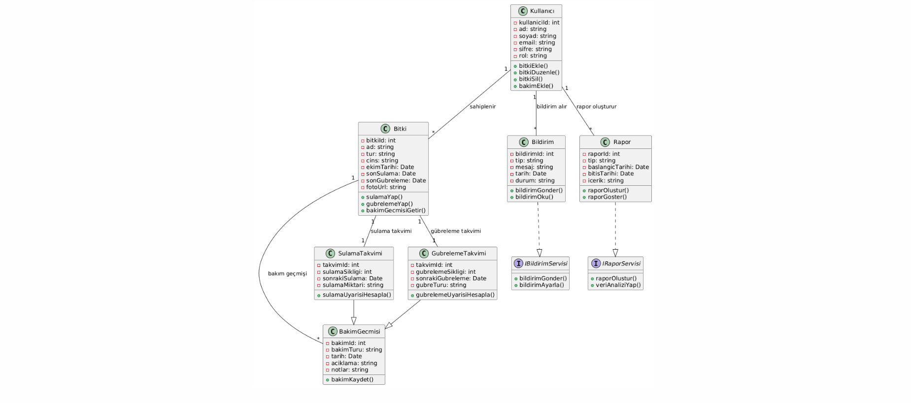
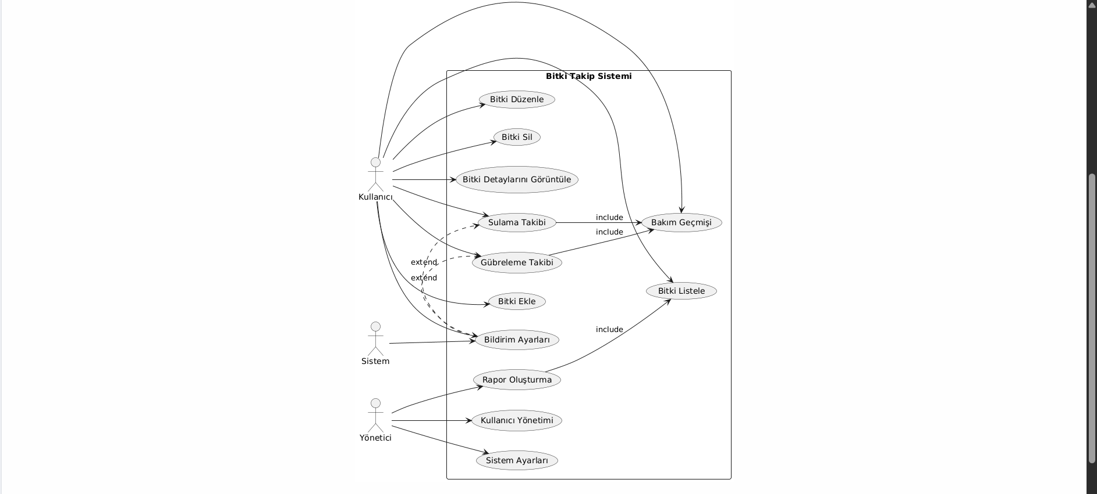
Appendix C: To Be Determined List
1. Monthly budget estimate for the weather API
2. Monthly fee for the premium membership
3. Mobile application store release dates
4. Number of beta test users
5. Maximum plant photo size

