SCHOLARSHIP ELIGIBILITY CHECKER
BEE 208 C++ Programming Mid-Semester Practical Project
Accra Technical University

Table of Contents
- Introduction
- Problem Statement
- Aim
- Objectives
- Scope
- System Requirements
- Program Design
- Program Implementation
- Sample Program Output
- Challenges
- Solutions
- Conclusion
- References
- Appendix

Introduction
The Scholarship Eligibility Checker automates scholarship assessment based on GPA, attendance, and conduct.

Problem Statement
Many schools, colleges, and universities manually assess students for scholarship rewards. This process can be time-consuming, inconsistent, and prone to errors. There is a need for an automated system that evaluates scholarship eligibility quickly and accurately and stores results for documentation.

Aim
Develop a C++ application to determine scholarship eligibility automatically.

Objectives
- Collect student details
- Validate inputs
- Evaluate eligibility
- Save reports
- Produce a summary

Scope
The scope of this project is limited to evaluating students' eligibility for scholarships based on predefined criteria: Grade Point Average (GPA), attendance percentage, and conduct status. The system allows users to enter information for multiple students, validates the input data, determines whether each student qualifies for a scholarship, displays the results, and saves the information in a text file. The project does not handle scholarship applications, financial records, student registration, or database management.

System Requirements
Hardware: Computer
Software: Dev-C++, Microsoft Word, GitHub, Windows

Program Design
This contains the Algorithm, Pseudocode, and Flowchart.
Algorithm
The algorithm describes the step-by-step procedure the system follows to solve the problem. The detailed algorithm is provided in Appendix A.
Pseudocode
The pseudocode represents the logical structure of the program before implementation. It is included in Appendix B.
Flowchart.
The flowchart illustrates the sequence of operations and decision-making process of the system. The complete flowchart is provided in Appendix C.

Program Implementation
The program was implemented using the C++ programming language and developed using the Dev-C++ IDE. The algorithm and pseudocode were translated into C++ code to create the working program.
The implementation involved declaring variables, applying necessary calculations, and using control structures such as selection statements and loops to control the program flow. The program accepts user input, processes the information, and displays the required output.
After development, the program was compiled and tested using different inputs to ensure that it produced accurate results.

Sample Program Output
These are screenshots of the running program and scholarship_report.txt.
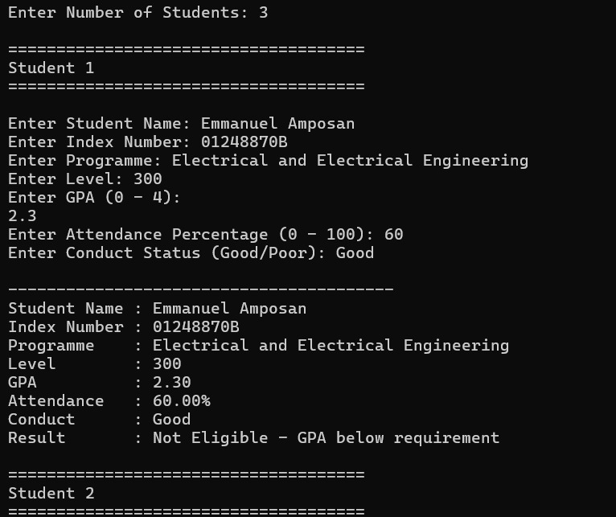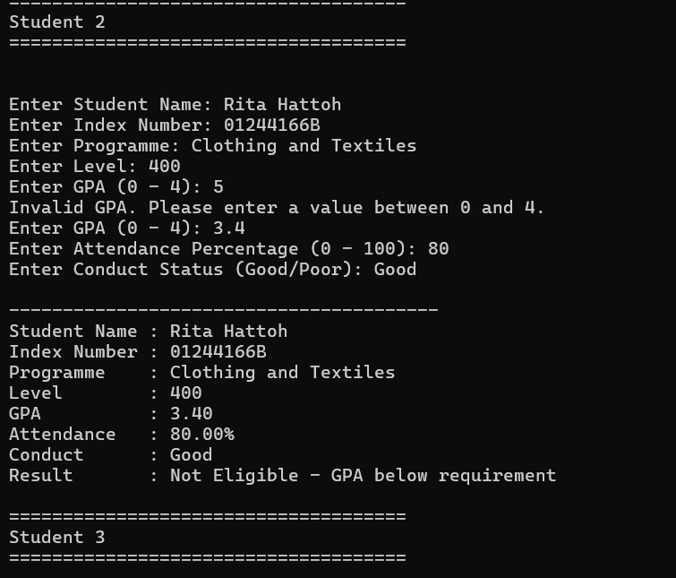

Challenges
- Validating GPA and attendance correctly.
- Processing multiple student records.
- Saving records into a text file.
- Organizing project files for GitHub submission.

Solutions
- Used input validation to prevent invalid entries.
- Used loops to process multiple students.
- Used functions to improve code organization.
- Used file handling to save reports automatically.

Conclusion
The project demonstrates practical C++ programming concepts.

References
Bjarne Stroustrup; cplusplus.com; BEE208 lecture notes.

Appendix
Attach main.cpp, algorithm, pseudocode and flowchart.
