诚信应考,考试作弊将带来严重后果！
_____________ ________
…

姓名 学号
学院 专业 座位号
( 密 封 线 内 不 答 题 )
……………………………………………………密………………………………………………封………………………………………线……………………………………线………………………………………

华南理工大学期末考试
《 软件项目管理 》A试卷
注意事项：1. 考前请将密封线内各项信息填写清楚；
2．考试形式：闭卷；
3. 本试卷共 7 大题，满分100分， 考试时间120分钟。

1、Choice （30 scores）
1）、Project Scope Management Processes include （ ）
A、Scope planning: developing documents to provide the basis for future project decisions
B、Scope definition: subdividing the major project deliverables into smaller, more manageable components
C、Scope verification: formalizing acceptance of the project scope
D、Scope change control: controlling changes to project scope
2）、A scope statement is a document used to develop and confirm a common understanding of the project scope. It should include ( )
A、a project justification
B、a brief description of the project’s products
C、a summary of all project deliverables
D、a statement of what determines project success
3）、There are three basic reasons ( ) for creating dependencies among project activities,
A、Mandatory dependencies
B、Other dependencies
C、Discretionary dependencies
D、External dependencies
4）、Techniques for Shortening a Project Schedule include ( )
A、Shortening durations of critical tasks for adding more resources or changing their scope
B、Add project tasks
C、Fast tracking tasks by doing them in parallel or overlapping them
D、Crashing tasks by obtaining the greatest amount of schedule compression for the least incremental cost
5）、If optimistic time = 8, most likely time = 10, and pessimistic time 24, PERT weighted average = （ ）
A、12
B、14
C、18
D、42
6）、Suggested Skills for a Project Manager include ( )
A、Communication skills: listening, persuading
B、Organizational skills: planning, goal-setting, analyzing
C、Team Building skills: empathy, motivation, esprit de corps
D、Leadership skills: sets example, energetic, vision (big picture), delegates, positive
7）、Ineffective Project Managers include ( )
A、Sets bad example
B、Good communicator
C、Lacks technical expertise
D、 Not self-assured
8）、About Project Plan Development, which is correct （ ）
A、A project plan is a document used to coordinate all project planning documents
B、Its main purpose is to guide project execution
C、Project plans assist the project manager in leading the project team and assessing project status
D、Project performance should be measured against a baseline project plan
9）、Common Elements of a Project Plan are ( )
A、Introduction or overview of the project
B、Description of how the project is organized
C、Management and technical processes used on the project
D、Work to be done, schedule, and budget information
10）、Important Skills for Project Execution include （ ）
A、General management skills like leadership, communication, and political skills
B、Product skills and knowledge
C、Use of specialized tools and techniques
D、Organizational Procedures
11）、Attributes of projects are （ ）
A、unique purpose
B、long-term
C、require resources, often from various areas

D、should have a primary sponsor and/or customer
12）、Stakeholders are the people involved in or affected by project activities，Stakeholders include（ ）
A、the project sponsor and project team
B、support staff
C、customers
D、opponents to the project
13）、Facilitating knowledge areas are（ ）
A、human resources management
B、communication management
C、Scope management
D、procurement management
14）、A project life cycle is a collection of project phases, Project phases vary by project or industry, but some general phases include（ ）
A、concept
B、development
C、Design
D、close-out
15）、Distinguishing between Project Life Cycles and Product Life Cycles ( )
A、The project life cycle applies to all projects, regardless of the products being produced
B、Product life cycle models vary considerably based on the nature of the product
C、Most large IT products are developed as a series of projects
D、Project management is done in all of the product life cycle phases

2 Answer Briefly （15 scores）
Consider the following project network diagram. Assume all times are in days
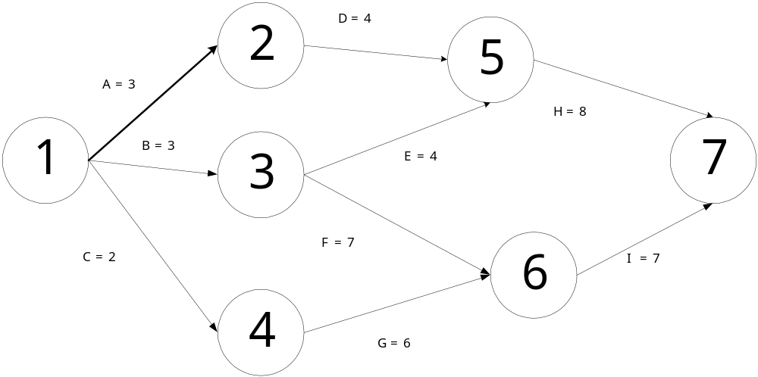
Figure 1

a.How many paths are on this network diagram?
Four

b. How long is each path?
1）15
2）15
3）17
4）15

c. Which is the critical path?
B-F-I

d. What is the shortest amount of time needed to complete this project?
17

3、Narrate the flow of requirement change control briefly.（简述需求变更的流程）（10 scores）
Influencing the factors that create changes to ensure that changes are beneficial
Determining that a change has occurred
Managing actual changes as they occur

4、Narrate the three organizational structures: functional ,projects and matrix briefly.(简述三种组织结构：功能型、项目型、矩阵型) （10 scores）

Functional: functional managers report to the CEO
Project: program managers report to the CEO
Matrix: middle ground between functional and project structures; personnel often report to two or more bosses; structure can be weak, balanced, or strong matrix

5、Analyze the risk of requirement analysis and put forward the related measures to deal with the emergency or avoid it according to your understanding.( 按照你的理解分析需求分析的风险，并提出应急、规避措施) （10 scores）
一 用户不能正确表达自身的需求
二 业务人员配合力度不够
三 用户需求的不断变更
四 需求的完整程度
五 需求的细化程度
六 需求描述的多义性
七 忽略了用户的特点分析
八 需求开发的时间保障

6、Please fill in this form according to the hint of the figure 3（ 请根据图3的说明，填写下图单代号网络图的内容）（10 scores）

A
2

B
4

D
2
E
1

C
3

SS 1
FF 1
FS 1
Figure 2
每个节点填写内容如下：

最早开始
活动编号
持续时间
最迟开始
自由时差
最迟完成
总时差
最早结束

Figure 3

Chapter 6 ppt
Page:17 43

7、阅读下述关于项目沟通管理的叙述，回答问题1至问题3，将解答填入答题纸的对应栏内。
［说明］
老张是某个系统集成公司的项目经理。他身边的员工始终在抱怨公司的工作氛围不好，沟通不足。老张非常希望能够通过自己的努力还改善这一状况，因此他要求项目组成员无论如何每周必须按时参加例会并发言，但对例会具体应如何进行，老张却不知如何规定。很快项目组成员就开始抱怨例会目的不明，时间太长，效率太低，缺乏效果等等，而且由于在例会上意见相左，很多组员开始相互争吵，甚至影响到了人际关系的融洽。为此，老张非常苦恼。
［问题1］（5分）
针对上述情况，请分析问题产生的可能原因。
［问题2］（5分）
针对上述情况，你认为应该怎样提高项目例会的效率。
［问题3］（5分）
针对上述情况，你认为除了项目例会之外，老张还可以采取哪些措施来促进有效沟通？

