华南理工大学2007～2008学年度第一学期试卷
《电路与电子技术》（双语）(计算机双语班、软件工程专业)
考试时间：120 Munites Date： Juanary, 18, 2008
I | II | III | IV | V | VI | VII | VIII | IX | 总分 | 评阅人 | 班级
30 | 10 | 8 | 10 | 8 | 8 | 10 | 6 | 10 | 100 |  | 姓名
 |  |  |  |  |  |  |  |  |  |  | 学号

I. Select the correct answers for the following problems (30 scores)
选择题(每小题3 scores，共30 scores)
1．In Fig. 1, for RL, the part in the dot line can be replaced by ( )。
(a)ideal voltage source (b)ideal current source (c)undetermine

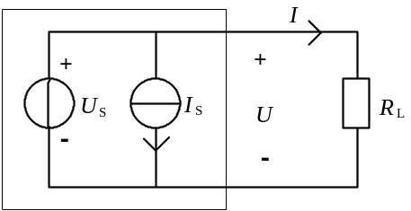

Fig.1 a circuit

2．In Fig. 2， S is on when t=0, if 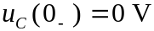，then 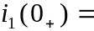( a )。
(a)0mA (b)5mA (c)10mA

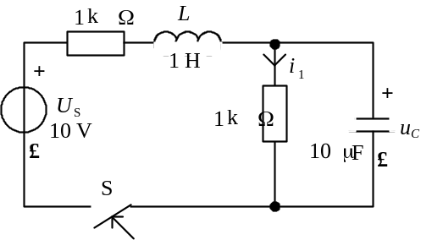
Fig .2 A RLC circuit

3. In the following inductance circuit，the correct relation between voltage and currnet is ( c )。
(a)u=Li (b)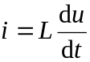 (c)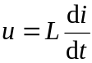
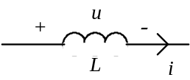
Fig. 3 A inductance circuit

- If bigger input resistance is wanted in a multistage amplifier, the first stage of amplifier will be chosen as ( ).
  - Common-Emitter amplifier (b) differential amplifier (c) emitter follower (d) collector-common amplifier

5. In Fig.4, assume that 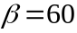，，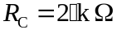，and UBE，is neglected, if IC is set as 1.5mA，then RB is set as ( )。
(a)480kΩ(b)120kΩ (c)240kΩ(d)360kΩ
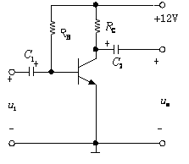
Fig. 4 A Common-Emitter Amplifier

6. In the following circuit, the MOSFET has V_{to}=1V, λ=0, K=0.25mA/V, I_{D} is ( ).
(a) 1mA (b) 0.563mA (c) 0.5mA
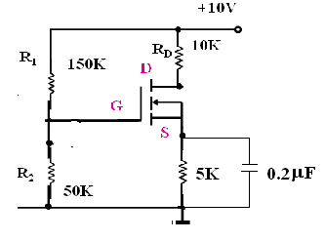
Fig. 5 A Common-Source Amplifier

7. A operational amplifier circuit is shown as follows，the voltage gain of the circuit is ( )。
(a)0 (b)1 (c)2
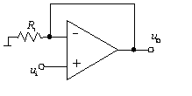

Fig. 6 An Operational Amplifier

8. For the comparator circuit of following figure, the input-ouput charateristic curve is ( )。
(a) (b) (c) 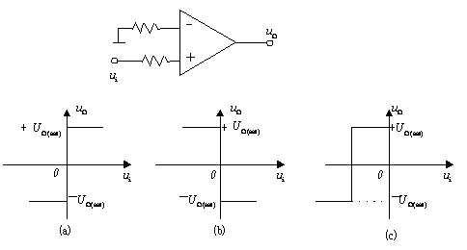

9. Fig. 7 shows a rectify circuit, the average output current 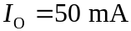，then the average output current flowing through D1 is ( )。
(a)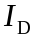=50mA (b)=25mA (c)=12.5mA
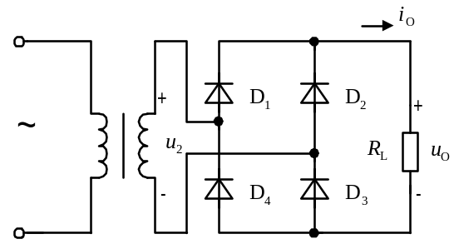

Fig. 7 a DC voltage source

10. Logic circuit and the curve of A and B are shown in the following, when t= t1, F is ( )。
(a)“1” (b)“0” (c)arbitrary

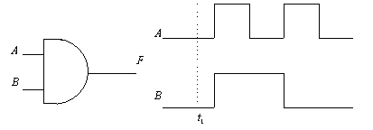

Fig. 7 An And gate

II、（10 scores）
Assume IS1=1A，IS2=5A，US=24V，R1=R3=R4=2Ω，R2=5Ω。Find I and VA with Thevinin’s Law。

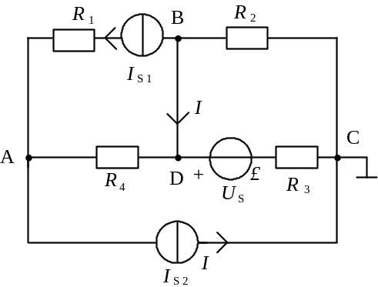

Fig.1 A Circuit Network

III. (8 scores)
In the following figure, The rsm value of i1 is I1=1A，λ1=0.5；the apparent power of R2—X2 branch is
P2=25W， 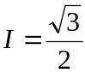A，Total power factor is 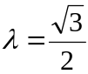(Capacitance)。Find (1) The power factor of R2—XC branch λ2；(2)The rms value U of the source；(3)R1，XL。

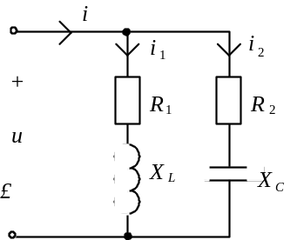

Fig. 2 A sinusoidal steady-state circuit

IV．(10 scores) Assume R1=R2=R3=100Ω，C=100μF，US=100V，If t=0, S is on 。Find 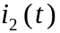and 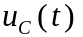.

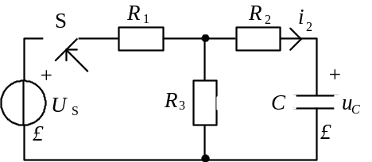

Fig. 3 Transient Process

V. (8 scores)
Assume ，For Dz, 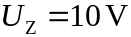， 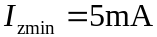， 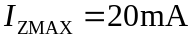，and 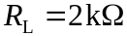。
(1)when change of  is ，determine the range of R;
(2)when the ratio of the transformer is ，find the rms voltage value of the transformer first side。
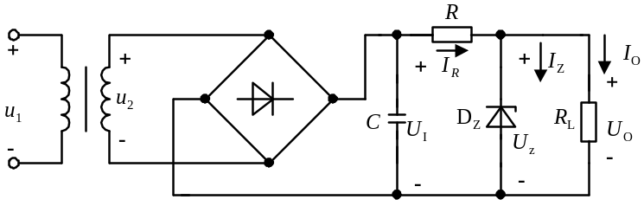

Fig. 11 A DC Voltage Source
VI. (8 scores)
Assume 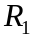, write the formula between 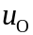 and .
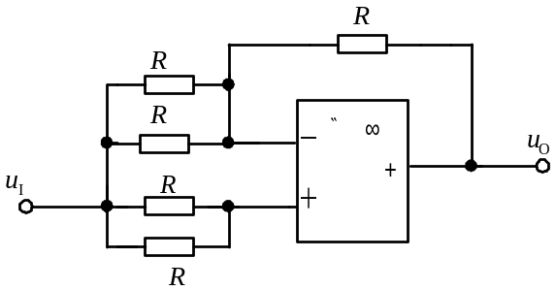
Fig. 12 A Circuit for Operational Amplifier

VIII. （8 scores）
In the circuit shown in Fig.13(a), Assume 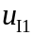,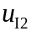 is shown in Fig. 13(b), if the positive-bios of the diodes is neglected, plot and determine D1 and D2 are in what states when t1 <t <t2.
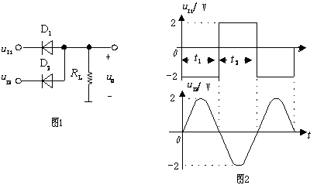
(a) (b)
Fig. 13 A AND gate constructed by diodes

IX. (10 scores)
In Fig.14 assume rbe=2kΩ，β=75, ，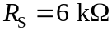，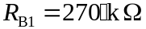，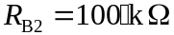，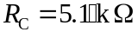，，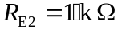。find：(1) small signal equivalent circuit；(2) ;(3)choose proper parameters in order to make 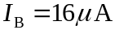.

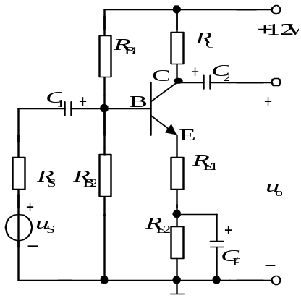
Fig.14 A Common-Emitter Amplifier

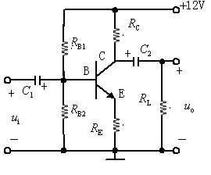
Fig.14 A Common-Emitter Amplifier

VIII． (10 scores)
Write the logic formula of the following the logic circuits, and find the truth table of them

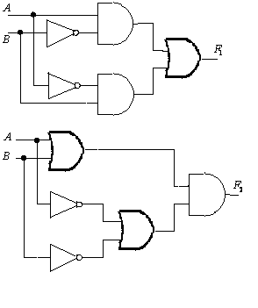
Fig.5 Complex Logic Circuit

