诚信应考,考试作弊将带来严重后果！
_____________ ________
…

姓名 学号
学院 专业 座位号
( 密 封 线 内 不 答 题 )
……………………………………………………密………………………………………………封………………………………………线……………………………………线………………………………………

华南理工大学期末考试
《电路与电子技术》（双语）试卷A
考试时间：120 minutes Date： January, 18, 2008
注意事项：1. 考前请将密封线内填写清楚；
2. 所有答案请直接答在答题纸上；
3．考试形式：闭卷；
4. 本试卷共 八 大题，满分100分， 考试时间120分钟。
题 号 | I | II | III | IV | V | VI | VII | VIII | 总分
得 分
评卷人
I. Select the correct answers for the following problems
选择题（每小题3分，共30分）

1．When Fig. 1 is converted into Fig. 2, I1 and I2 will ( )。
(a)increase (b)not change (c)decrease
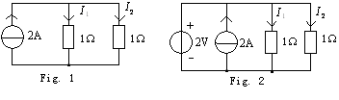

2．In Fig. 2， S is on when t=0, if 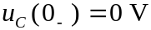，then 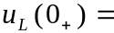( )。
(a)－10V (b)10V (c)0V

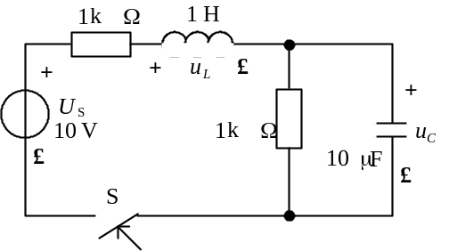

Fig .2 RLC circuit
3．Assume the rms value of a sinusoidal voltage u is 220V，frequency is 50Hz，when t=0, u(0)=220V，the formula of the sinusoidal voltage is ( )。
(a)u=380sin100πtV (b)u=311sin(100πt+45°)V
(c)u=220sin(100πt+90°)V

4．Small signal equivalent circuit can be used for ( ).
（a）dynamic analysis of a transistor amplifier
（b）Q-point calculation of a transistor amplifier
（c）dynamic analysis and Q-point calculation of a transistor amplifier
5．As shown in Fig.3，the two ideal diodes are of the same type，u_{A}=3sintV，u_{B}=3V，R=4k，then voltage uF equal （ ）.
（a）3V （b）3sint V （c）3V+3sint V
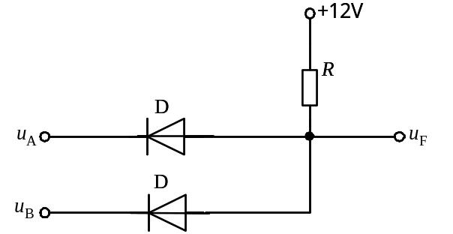
Fig .3
6．In the following circuit, the MOSFET has V_{to}=1V, λ=0, K=0.25mA/V, I_{D} is ( ).
(a) 1mA (b) 0.563mA (c) 0.5mA
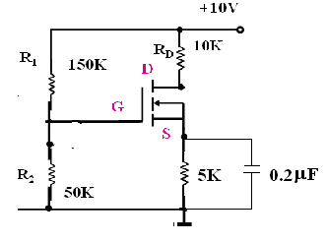
Fig. 5 A Common-Source Amplifier

7．Fig. 5 shows a BJT amplifier，BJT works in ( )。
(a)active region (b)saturation region (c)cutoff region
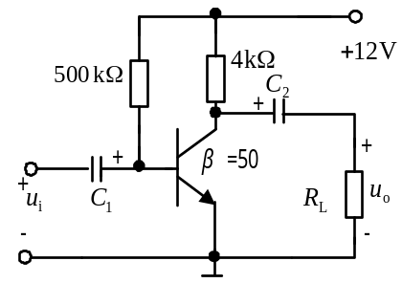

Fig.5 A BJT Amplifier

8．In Fig. 6, Assume R1=10，R2=100，if uO=6V，then ui=( )。
(a)6V(b)3V(c)6/11V(d)3/11V

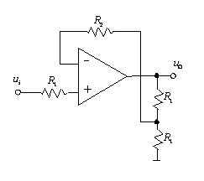
Fig. 6 A operational amplifier circuit

9．Fig. 7 shows a rectify circuit, the average output voltage 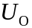is 18V，if one of diodes is damaged and cutoff，then the average output voltage is ( )。
(a)10V (b)20V (c)40V (d)9V
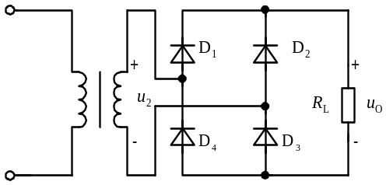

Fig. 7 a DC voltage source

10．Logic circuit and the curve of A and B are shown in Fig.8，F is “0” when t is ( ).
（a）“t₁” （b）“t₂” （c）“t₃”

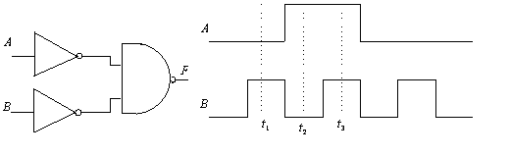

Fig. 8 A combined gate

II． (10 scores) The circuit is shown in Fig.9， assume US2=0.2V，IS=1A，R1=R5=R6=R7=1Ω，R2=R3=2Ω，R4=5Ω，if I=0， determine US1=? With Thevenin’s Law

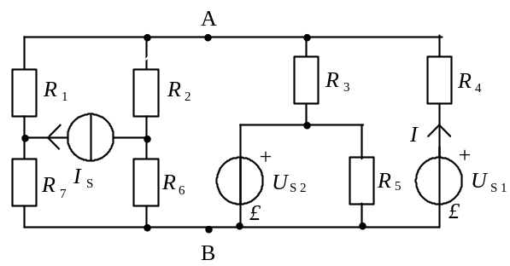

Fig.9

III．（10 scores） When t=0，the S is off t=0，assume R1=60kΩ，R2=40k Ω，R3=6kΩ，C=5μF，US=50V, find and plot 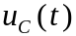.

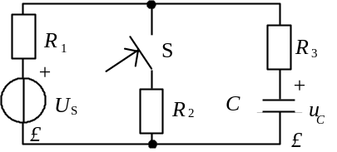

Fig. 10

IV．（12 scores）In Fig. 11, 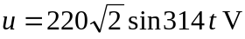，apparent power P=8.8kW，reactive power Q=6.6kvar。Find (1) which flows through R and L， uR，uL and PF (2)plot phasor graphy of ，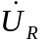，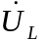and 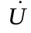.

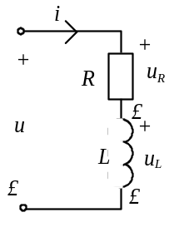

Fig. 11 An AC circuit

V．（10 scores） In Fig. 12, write the formula between 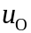 and uI1，uI2 .
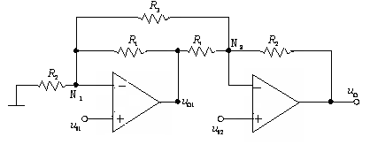

Fig.12 A Complex Op Circuit

VI． （10 scores）
In the following figure， 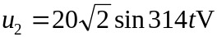， 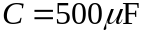， 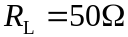，Find：
(1)When S is off，the average voltage 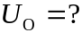 the maximum reverse voltage of D1 and D2 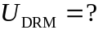
(2) When S is on，the average voltage The average current flows through D1 and D2 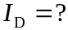
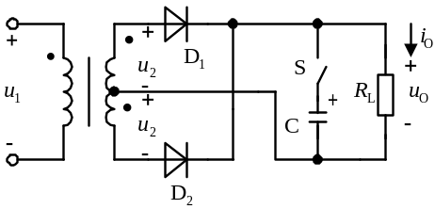

Fig.13 Recitify Circuit

VII．（12 scores）
Assume 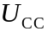=12V,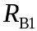=,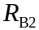=,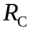=,=, =50,=, determine
（1）Q-point；（2）small signal equivalent circuit；
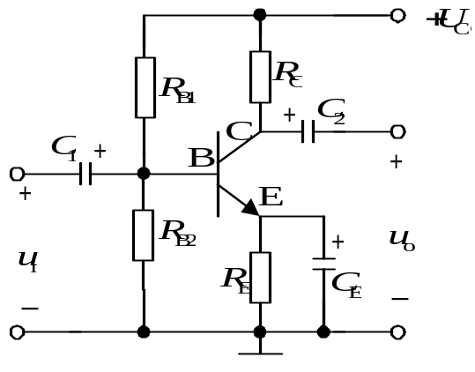

Fig.14 A Common-Emitter Amplifier

VIII．（8 scores） In Fig.15，determine two logic formula.
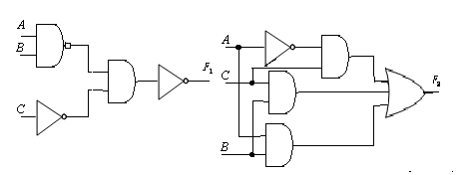

Fig.15 Two Complex Logic Circuit

