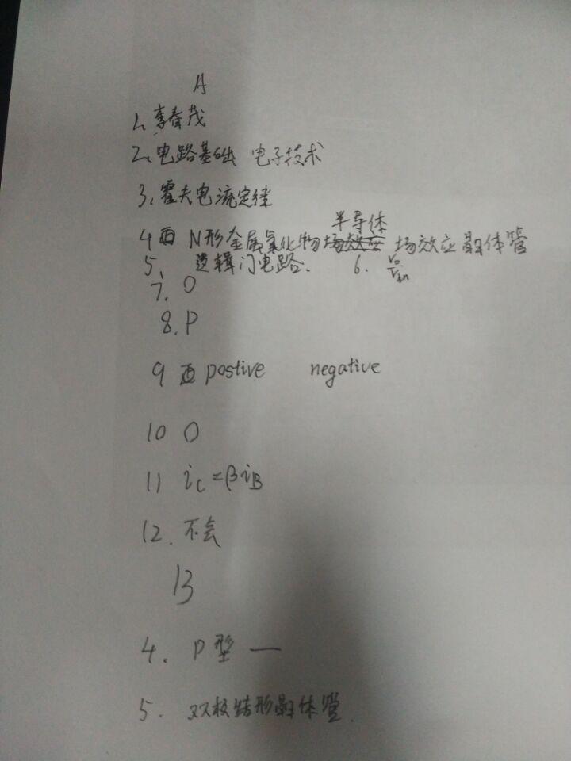
2016年试卷结构：
I、填空（15空，30分）
II、判断（15题30分）
III、分析题（40分）
诚信应考,考试作弊将带来严重后果！
_____________ ________
…

姓名 学号
学院 专业 座位号
( 密 封 线 内 不 答 题 )
……………………………………………………密………………………………………………封………………………………………线……………………………………线………………………………………

华南理工大学期末考试
《电路与电子技术》（双语）试卷A
考试时间：120 minutes
注意事项：1. 考前请将密封线内填写清楚；
2. 所有答案请直接答在答题纸上；
3．考试形式：闭卷；
4. 本试卷共 11 大题，满分100分， 考试时间120分钟。
题 号 | I | II | III | IV | V | VI | VII | VIII | IX | X | XI | 总分
得 分
评卷人
I．Complete each of the following questions (30%)
1. who is this course speaker? Write the name in Chinese 、
2. Write the name of the text book in Chinese，they are 、
3. Write KCL in Chinese
4. Write NMOSFET in Chinese
5. Write TTL in Chinese
6. Voltage gain of emitter follower
7. The ideal op amp open-loop gain is
8. PN turn-on, should be high potential.
9. The work of BJT requires the addition of high voltage to the
emitter junction, and the low voltage is applied to the collector.
10. The gate current of the NMOS transistor is
11. The relationship between the transistor collector current and the base
current is （就那个受控电流）
12.The power amplifier is generally working in state.
II. Determine v1 through v4 in the circuit in Fig. 2. (4%)
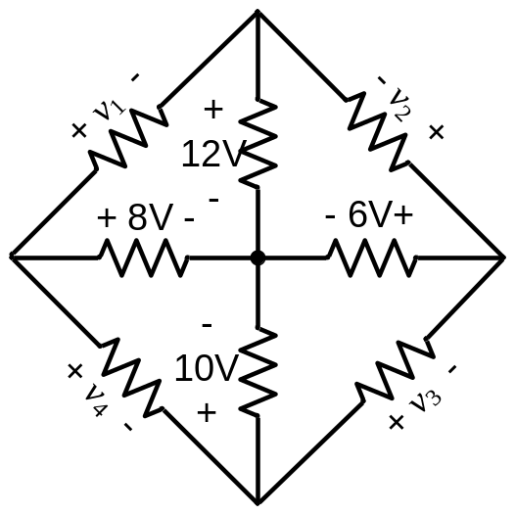
Fig. 2
III．As shown in Fig.3, the two ideal diodes are of the same type. Determine the states of the diodes. (8%)
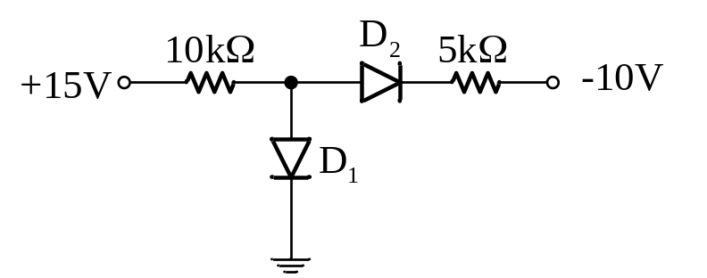
Fig. 3

IV．In Fig.4, assuming that the op-amp is ideal, find the value of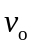. (5%)
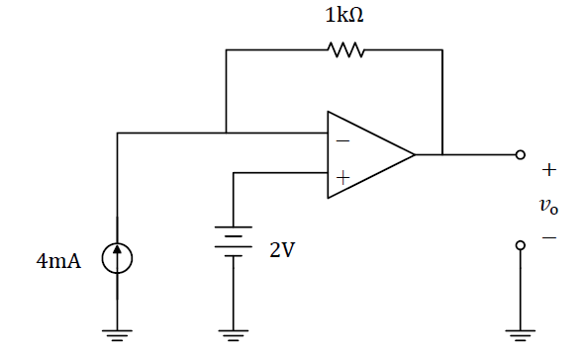
Fig. 4

V. Assume the source follower illustrated in Fig.5. (1) Draw the small signal equivalent circuit; (2) compute the voltage gain, input resistance, and output resistance. (10%)
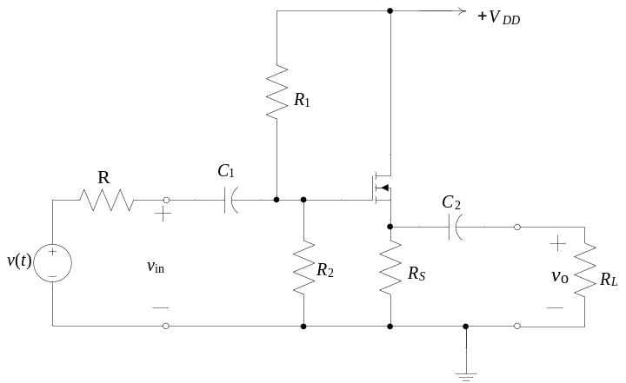
Fig. 5

VI. Calculation of Common-Emitter Amplifier Performance (8%)
(a) Draw the dc circuit and find the values of I_{C} and V_{CE} in the circuit of Figure 6 for β=100. V_{BE} =0.7V.
(b) draw the small signal equivalent circuit; find A_{v}, A_{vo}, Z_{in}, and Z_{O} .
(c) Then, if v_{S} (t) =0.001sin (ωt)V, find an expression for v_{O} (t).
(d) Finally, repeat part (a) if the emitter resistor R_{E} is split into R_{E1}=100Ω and R_{E2}=900Ω, with the bypass capacitor in parallel with R_{E2}.
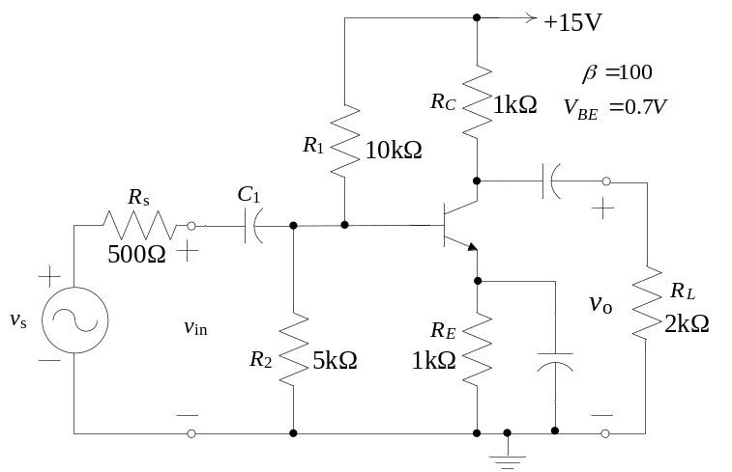
Figure 6 Common-emitter amplifier

VII. Find the voltage gain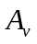=/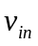and input impedance of the circuit shown in Figure 7 with the switch open. (5%)
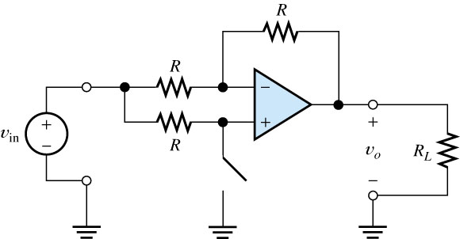
Figure 7.

VIII. A real op amp cannot produce infinite output voltage; instead, the output voltage magnitude cannot exceed a particular value. Let us assume that the op amp shown in Figure 8 has extreme output voltages of ±5V. Thus, the circuit does not function as an amplifier—the output voltage becomes stuck either at +5V or at －5V, depending on the initial polarity of =10sin (ωt)V. draw the plot of the output voltages (5%)
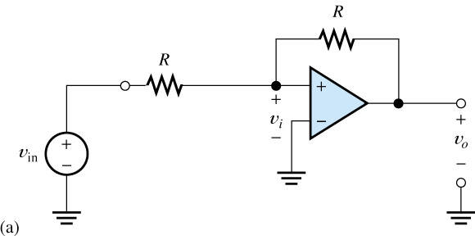
Fig 8.

IX. A power-supply circuit is needed to deliver 0.1A and an average of 15V to a load. The ac source available is 110V rms with a frequency of 60 Hz. Assume that the full-wave circuit of Figure 9 is to be used with a smoothing capacitor in for forward diode drop. Find the turns ratio n that is needed and the approximate value of the smoothing capacitor (Hint: To achieve an average load voltage of 15V with a ripple of 0.4V, design for a peak load voltage of 15.2V.)（8%）
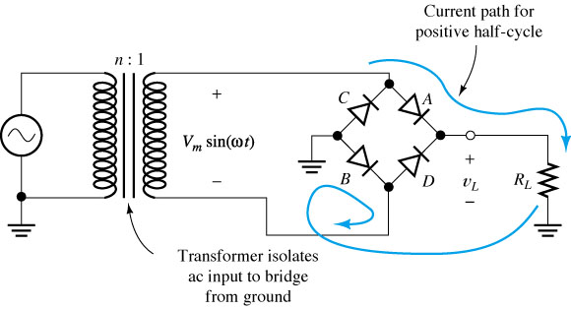
Fig 9 ( C 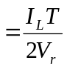 )

X. in the circuit of Figure 10 . (a) Draw the dc circuit and find the values of IC and VCE; (b) draw the small signal equivalent circuit; find Av, Zin, and ZO（8%）。
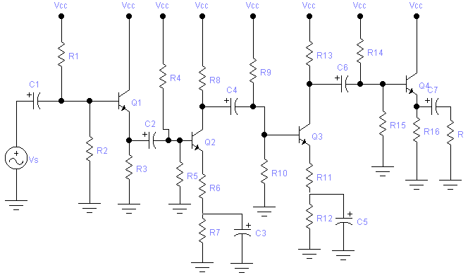
Fig 10

XI. Analyze the circuit of Figure 11. （9%）[16年没教不考嘻嘻]
T₅
Y
R₃
R₅
A
B
C
R₄
R₂
R₁
T₃
T₄
T₂
+5V
T₁
Fig 11

