诚信应考,考试作弊将带来严重后果！
_____________ ________
…

姓名 学号
学院 专业 座位号
( 密 封 线 内 不 答 题 )
……………………………………………………密………………………………………………封………………………………………线……………………………………线………………………………………

华南理工大学期末考试
《面向对象分析与设计》试卷
注意事项：1. 考前请将密封线内填写清楚；
2. 所有答案请直接答在试卷上(或答题纸上)；
3．考试形式：闭卷；
4. 本试卷共 5 大题，满分100分， 考试时间120分钟。
题 号 | 一 | 二 | 三 | 四 | 五 | 总分
得 分
评卷人

1. Single Choice & Short Answer (each choice worths 2 points,each blank worths 1 points , 25 points total )
1) Object-Oriented Technologies have the following benefits ( )
A. Increased encapsulation
B. Decreased coupling between modules
C. High level of abstraction
D. All of the above

2) Which of the following statements are false? ( )
A. A class can have a relationship to itself.
B. An object can have a relationship to other objects of the same class.
C. A class can have only one relationship to another class.
D. A relationship can exist with a cardinality of zero.

3) Which of the following models could be supported by Rational Rose? ( )
A. Business Use Case diagram
B. Use Case diagram
C. Activity diagram
D. Component diagram

4) Which of the following are NOT TRUE about the use case diagram? ( )
A. Use Case diagrams show the interactions between use cases and actors.
B. Use Case diagrams show which actors initiate use cases.
C. Use Case diagrams are used to show the flow of functionality through a use case.
D. Use Case diagrams illustrate that an actor receives information from a use case.

5) A car has four wheels. The class car and the class wheel have what type of relationship? ( B )
A. Association
B. Aggregation
C. Inheritance
D. Realization

6) What is true about messages in scenarios? ( )
A. The operation of the calling object.
B. The operation of the called object.
C. It is sent by the actor to the system.
D. It is sent by the system to the actor.
- dynamic model describe the system change with time.includes:

_________ ， __________ and _____________.

- What are the four view in Rose Model?

use-case view ，logical view ，component view and deployment view .

- Which two UML diagrams can represent concurrent processing?

sequence diagram and ________________ .

- The UML architecture is a four-layer metamodeling architecture. This architecture is a proven infrastructure for defining the precise semantics required by complex models ,Which include

meta-metamodel , metamodel , model and user objects .

- Explain the following Concepts and Give an Example . (each question worths 3 points. 15 points total )
  - Collaboration Diagrams
Collaboration diagrams illustrate object interactions in a graph or network format, in which objects can be placed anywhere on the diagram,
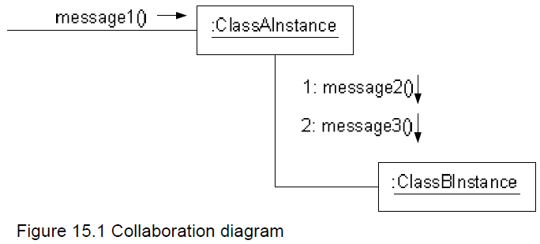

  - Use Cases
A use case is a collection of related success and failure scenarios that describe actors using a system to support a goal. Use cases defined for a system are the basis for the entire development process.
用例是描述系统所执行的一系列顺序事件流，并且某个角色可以看到执行的结果。为系统定义的用例是整个开发过程的基础。

  - Association Relationship
The semantic relationship between two or more classifiers that specifies connections among their instances.

  - Encapsulation
Encapsulation is a mechanism used to hide the data, internal structure, and implementation details of some element, such as an object or subsystem.

  - Generalization
Generalization is a relationship among classes where one class shares the structure and/or behavior of one or more classes. Is an “is a kind of” relationship.

3. Draw class diagram for the following scenario. Be sure to include multiplicities on the ends of the connectors. (10 points)

Mini Office
The following scenario is for a mini office. Each office has up to 10 members and 2 managers. Each manager has their own room, while members are in the main hall. Each member has their own seat. And each seat has a unique id number.

4. Point out the wrong place in the following diagram . (10 points )
Class Diagram: 分析类 / 分析类图
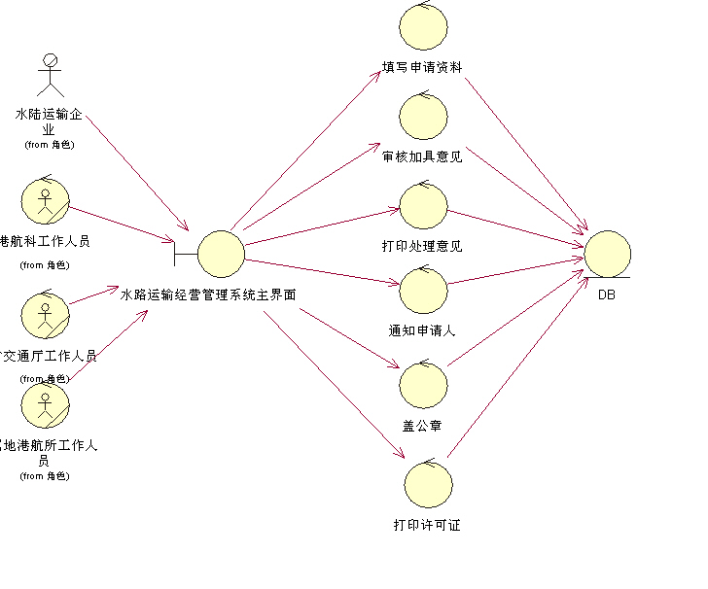

5. OO Modeling (40 Points total ) (40 Points total )
1) Write down all candidate objects and candidate actions in the following usage scenario (10 points)

This is a student registration system. There are full-time and part-time students. Each class has a set of scheduled times and a number of credit hours. When a user tries to register for a class, the system checks their schedule for time-conflicts. If there is a conflict, an error is returned. If there is no error, then the system checks to see if the total number of hours including this class is no more than the maximum number of hours for a full-time student. If so, then the system returns an error. If no problems are found, the system registers the student for the class, and informs the user of success.

2) Produce a class diagram to model the system. (Make sure to include all objects and actions that you will need for the sequence diagram you will produce in part 3 below.) (15 points )

3) Produce a sequence diagram to model the success-case of this scenario (i.e. the sequence of actions performed when there are no errors.) Please label everything with meaningful names, or include a description of each label. (15 points)

