2010研究生华南理工大学《软件需求分析、设计与建模》试卷A

一、单项选择题（本大题共15题，每题2分，共30分）
注：所有的选项中，只有一个答案最符合题目要求，多选、错选均不得分,请将所选的答案依照题号对应填入下表。
1. Which kind of diagram in UML can be applied to describe external system events that are recognized and handled by system operators in the context of a use case ?
A. Statechart Diagram. B
B. Activity Diagram.
C. Sequence Diagram.
D.Collaboration Diagram.

2. Why do we model? D
A. Helps to visualize a system.
B. Gives us a template for constructing a system.
C. Documents our decisions.
D. All of the above.

3. What phrase best represents a composition relationship(组成关系)? A
A. Is a part of. B. Is a kind of.
C. Is an only part of. D. Is an inheritance of.

4. Which of the following is good practice to use while designing for reuse? F
A. Define a persistence framework that provides services for persisting objects
（持久对象）.
B. Use design patterns, wherein（其中） complete solutions are already defined.
C. Use controller objects to control the flow of processes in the system.
D. Assign responsibilities to classes such that coupling between them remains high.
E. A and B.
F. A, B and C.
G. A, B,C and D.

5. Which of the following statement is Not TRUE? D
A. A subsystem is a package that has separate specification and realization parts.
B. A subsystem is a discrete entity that has behavior and interfaces.
C. A subsystem can be identified by the stereotype <<subsystem>>.
D. A subsystem is a package that has specification part only.

6. In an OO system, it is NOT desirable（可取） to assign responsibilities: F
A. relatively evenly across the classes.
B. more heavily in a few controlling classes.
C. according to interaction diagram（顺序图和协作图） messaging.
D. according to the use case diagram.
E．A and B
F．B, C and D

7. For showing how several objects collaborate in single use case, which one of the following OOAD artifacts（构件） is the MOST useful? A
A. Interaction Diagrams（交互图：包括时序图和协作图） B. Activity Diagrams
C. State Diagrams D. Class Diagrams

8. What methods MUST be implemented by the Credit Processor class in the payment sequence diagram? C
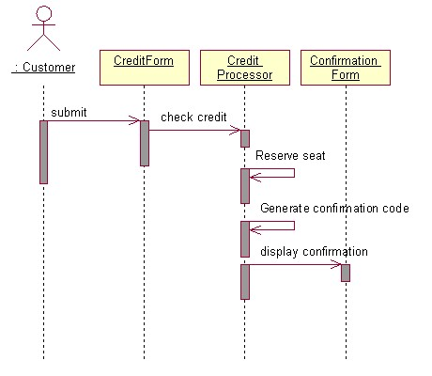
A. checkCredit, generateConfirmationCode, displayCofirmation.
B. checkCredit, generateConfirmationCode.
C. checkCredit, generateConfirmationCode, reserveSeat.
D. checkCredit, reserveSeat, displayCofirmation.

9. Which of the following is TRUE about a deployment diagram? B
A. Since there is always some kind of response to a message, the dependencies are two-way between deployment components.
B. Dependencies between deployment components tend to be the same as the package dependencies.
C. Deployment diagrams are NOT to be used to show physical modules of code.
D. Deployment diagrams do NOT show physical distribution of a system across computers.

10. When using OOAD artifacts to organize and assign team responsibilities on a project, it is BEST to: C
A. evenly distribute use cases among team members and have them work as independently as possible in order to minimize code dependencies.
B. designate（指派） one team for implementing interaction diagrams related to the "common code path" and another team for implementing interaction diagrams related to "code path variations" (for example , conditional or error paths（条件或者错误路径）).
C. divide teams according to the layers in the software architecture and have them work as independently as possible in order to minimize dependencies between the layers.
D. divide teams according to package diagram dependencies and utilize use cases to schedule the work for the individual team members.

11. To MOST effectively manage teams working on different packages within a large project, which one of the following should be TRUE? A
A. One technical leader should control the project details and communicate decisions to the different teams.
B. The team leaders should focus on which type of database ( DB2 UDB, Oracle, Sybase, or Instant DB ) is used.
C. The team leaders should focus on quality designs for the internals of their packages, mentoring their team members.
D. Communications between the teams should be minimized to reduce overhead burdens while they work on separate, independent use cases for their packages.

12. Use cases CANNOT be used for : A
A. modeling the non behavioral aspects such as data requirements, performance and security.
B. capturing behavioral aspect of a system.
C. capturing functional aspect of a system.
D. capturing the business process at high level.

13. What kind of association between the 2 classes described in java below? B
public class A{
private ArrayList _Bs=new ArrayList();
public A(_Bs：B){
this._Bs.add(_Bs);
}
}
public class B{
…;
}
A．Inheritance B. Dependency
C．Composition D. Aggregation

14. Referring to the diagram below, which of the following is TRUE? B
A．Class "Teacher" is a parent class of class "Professor" and class "Lecturer" .
B．Instance of "Professor" has to realized all of the behavior s of "Teacher".
C．There are instances of "Teacher" in the system.
D．"Professor" is a kind of "Teacher" and so does the "Lecturer".
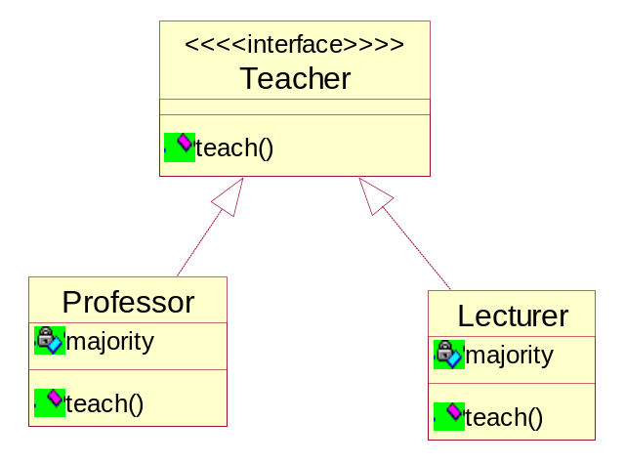

15. During the process of requirement engineering, the software engineer and the user of the system should work together to define E
A. visible context of using the system for the user
B． crucial software properties
C． input and output of the system
D. A and B
E. A, B and C

二、填空题 （共10分）
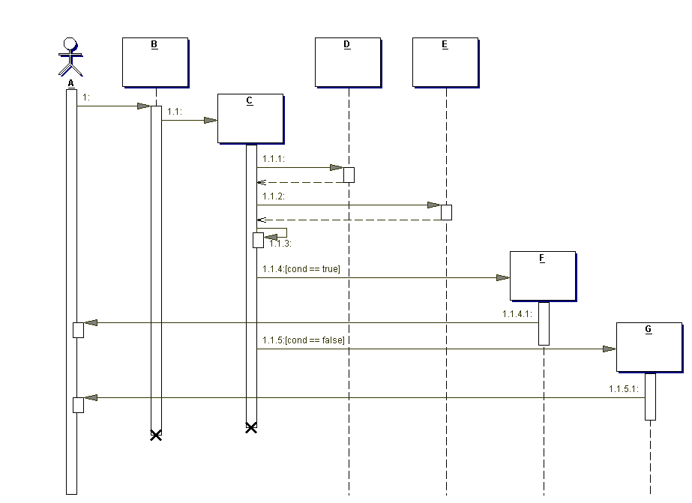
1. A is a(n) 角色 .
2. B is a(n) 边界 object.
3. “1.1.3” is a(n) _______自调用_____ message
4. “1.1” is a(n) ________调用_______ message.
5. The dotted line below the boxes is called the _______对象生命线_____________.
6. The rectangle below the boxes is called the _______控制焦点_________
7. If this system represented part of a web site, what would B most likely represent?
A web page.
8. Why is C lower than A, B, D, and E?
C is created by B.
9. Why are A through G underlined?
They are objects of corresponding class.
10. Which of the following is an invalid sequence of messages, according to the diagram? ( B )
- 1, 1.1, 1.1.1, 1.1.2, 1.1.3, 1.1.4, 1.1.4.1
- 1, 1.1, 1.1.1, 1.1.2, 1.1.3, 1.1.4, 1.1.4.1, 1.1.5, 1.1.5.1
- 1, 1.1, 1.1.1, 1.1.2, 1.1.3, 1.1.5, 1.1.5.1

三、问答题 （本大题共4小题，共25分）

1. Please describe the risks of the software developing and the approaches to avoiding them (Score 8).

User or business needs not met
Requirements not addressed
Modules not integrating
Difficulties with maintenance
Late discovery of flaws
Poor quality of end-user experience
Poor performance under load
No coordinated team effort
Build-and-release issues
Avoiding approaches？
2.Please outline the phases and workflows of RUP (Score 5) .

Inception (初始阶段): Define the scope of project
Elaboration (细化阶段): Plan project, specify features and
baseline architecture
Construction (构造阶段): Build the product
Transition (交付阶段): Transition the product into end-user
community

3. Please name and briefly describe the “4+1 view” of software architecture adopted in RUP (Score 5).
Use-case view+Logical view+Implementation view+Process view+Deployment view】
用例视图，逻辑视图，实现视图，过程视图+部署视图

4. Please describe the use case analysis steps in OOA/D (Score 7).
补充用例说明。
找出用例中的行为，把行为合理分配给各个类。
对每一个分析出来的类，描述其职责，属性，和类间的关联，限定分析机制。
统一分析类。
查检分析过程和结果。

四、判断改错题（本大题共5分）
Suppose the employee of a software company can be classified by some role such as coder、project manager and software engineer. The UML diagram below is suggested as a solution to meet the change of the role of a company employee. Please judge whether the solution is true or not and explain why you make such a judgment. Please give your correction of the diagram when it is wrong (Score 5).
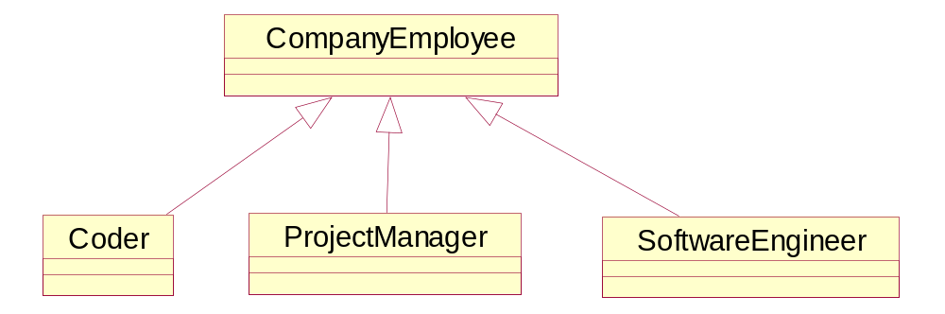

五、建模分析题（本大题共30分）
Suppose you are asked for developing a point of sale (POS) system using OOA/D technologies. A POS system is a computerized application used to record sales and handle payments and it is typically used in a retail store. Processing sale would be one of the key functions that the system has to perform. Please model the key function via the methodology of object-oriented analyze and design.
Suppose the simplified context of processing sale is under-consideration: a customer arrives at a checkout of a retail store with items to purchase. The cashier uses register of the POS system to record each purchased item. Each of the items is described a product specification, which belongs to a product catalogue. The system presents a running total and line-item details. The customer enters payment information, which the system validates and records. The system updates inventory (inventory: The quantity of goods in stock. ). The customer receives a receipt from the system and then leaves with the items and the sale is logged on a ledger with which the manager can checked the information for a period of time.

- Draw a UML use case diagram for the system including their relationships (Score 5).

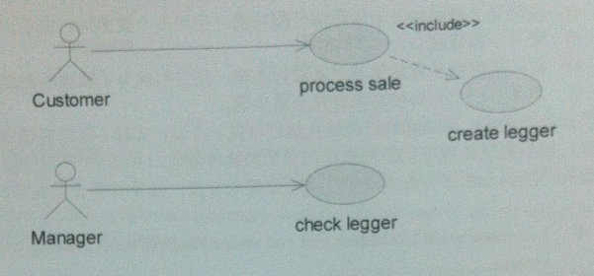
- Give the class diagram with the analysis classes representing business entities
involved in the system (names and brief descriptions only – no attributes orperations), along with their relationships and multiplicities (Score 10).
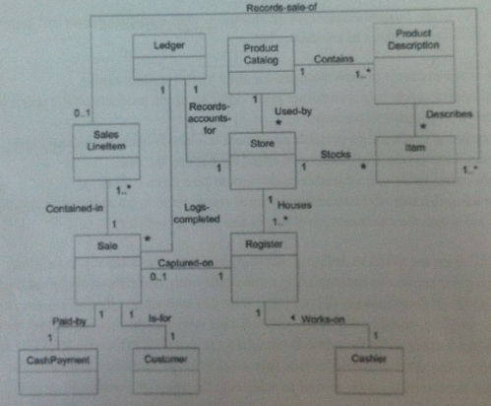

- Give the boundary classes、control classes and entity classes involved in the system to bear responsibility of “process sale” in the case of J2EE (names and brief descriptions with UML class stereotypes only – no attributes or operations) (Score 5).
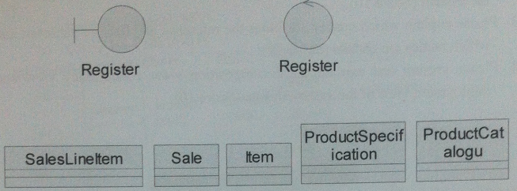

- Draw a UML sequence diagram to model the use case of process sale” in the case of J2EE (Score 10).

