复习题 一

一 判断题

1 A product expression for all sum terms of a logic function must be 0 (×)

2 The output of an exclusive gate with inputs A,B is a 1 (HIGH) when A = 0 and B = 0 (×)

3 The output expression for an AND-OR circuit having one AND gate with input A,B,C and D and one AND gate with input E and F is ABCDEF (×)

4 A full-adder is characterized by two inputs and one outputs (×)

5 If an S-R latch has a 0 on the S input and a 1 on the R input and then the S input goes to 0,the latch will be reset (√)

二 单选题

1 To expand a 4-bit parallel adder to an 8-bit parallel adder, you must (D)

A use three 4-bit adders with no interconnections

B use four 4-bit adders and connect the sum outputs of one to the bit inputs of the other

C use two 4-bit adders with no interconnections

D use two 4-bits adders with the carry output of the one connected to the carry input of the other

2 A J-K flip-flop with J = 1 and K = 1 has a 10KHz clock input The Q output is (F)

A constantly LOW

B constantly HIGH

C a 15 KHz square wave

F a 5 KHz square wave

3 8-input data selector multiplexer show in Figure 1-2 the logic function F = (A)

A、 B、

C、 D、

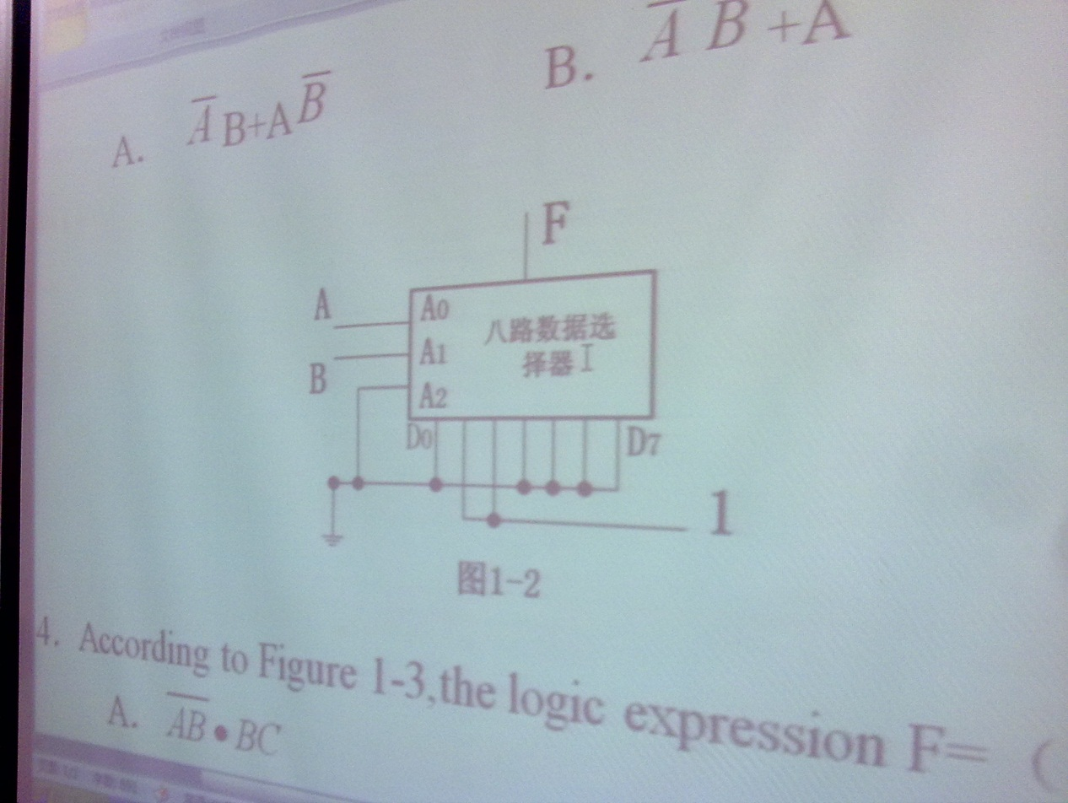

4 According to Figure 1- 3 ,the logic expression F = (B)

A、 B、

C、 D、

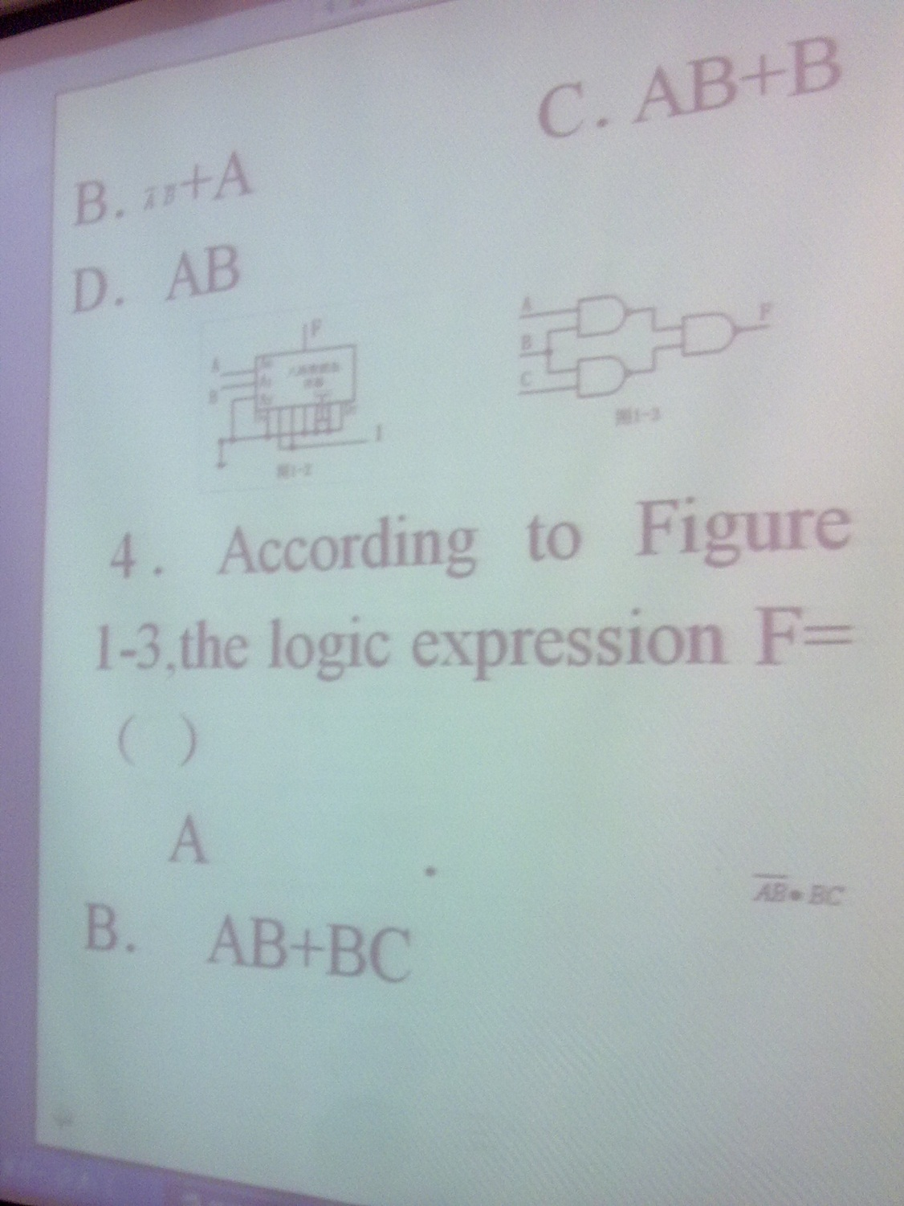

5 The relationship of logic function and  is (A)

A 

B F = G

C F’ = G

D 

6 If a 1-of 16 decoder with active-LOW outputs exhibits a LOW on the decimal 12 output.what are the inputs? (C)

A、A3A2A1A0 = 1011

B、A3A2A1A0 = 1010

C、A3A2A1A0 = 1100

D、A3A2A1A0 = 0101

7 A 4-bit binary up/down counter is in the binary state of zero .The next state in the DOWN mode is (B)

A 0011

B 1111

C 1001

D 1100

8 the group of bits 10110101 is serially shifted (right-most bit first) into an 8-bit parallel output shift register with an initial state of 11100100 After two clock pulses the register contains (C)

A 01011111

B 10110111

C 01111001

D 0110111(少了一位没有拍到)

9 A 4-bit binary up counter counts from 0000, after 1000(dec) clock pulses,the state of counter is (A)

A 1000

B 0101

C 0110

D 1001

10 The AND operation can be produced with (A)

A Two NAND gates

B Three OR gates

C One NAND gate

D three NOR gates

三 简答题

1 Convert the following decimal numbers to 6-bit two’s complement binary numbers and add them and give the decimal result.Indicate whether or not the sum overflows a 6-bit result.

1. 8(dec)+18(dec)

001000+010010=011010 26

1. -6(dec)+9(dec)

111010+001001=000011 3

1. -7(dec)-181(dec)

Overflows

2 Convert the Boolean expression F(A,B,C,D) = AC+BC +ACD into standard SOP form



3Using Boolean algebra to prove the equation



4 Simplify the Boolean expression with Karnaugh map



|  |  |  |  |  |
| --- | --- | --- | --- | --- |
|  |  |  |  |  |
|  |  |  |  |  |
|  |  |  | 1 | 1 |
|  |  | 1 | 1 | 1 |
|  | 1 | 1 | 1 | 1 |

5 Analyze the logic circuit of figure 3-1 write out the logic expression and simplify it

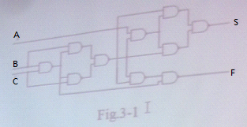

四 综合题

1 分析555定时器

2 一个三位二进制数码由高位至低位分别送至电路的三个输入端,要求三个数码中有两个或两个以上为”1”时, 电路输出为”1”,否则为”0”.试设计并用”与非门”实现这个逻辑电路.



3 Design a counter with the irregular binary count sequence shown in the state diagram of Figure 4-2 Use J-K flip-flop

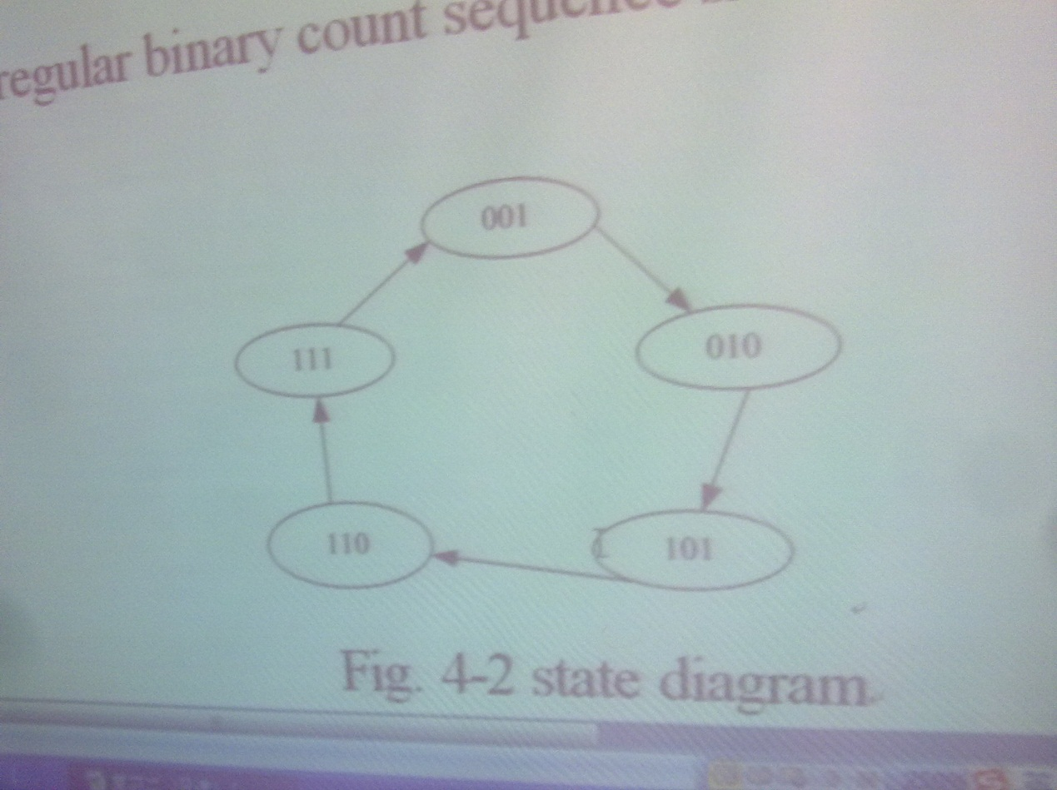

复习题 二

一 判断题

1 For a given set of input values ,a NOR gate produces the opposite output as a NAND gate(×)

2 if AD=BD is true for logic equation, the A=B is Wrong (√)

3The output of an exclusive-OR gate with inputs A.B is a 0(LOW) when A =1 and B=0 (×)

4 On a Karnaugh map , grouping the 0s produce a SOP expression (×)

5 The output expression for an AND-OR circuit having one OR gate with input A,B,C and D and one AND gate with input E and F is ABCD+EF (×)

二 单选题

1 A 4-bit binary up counter counts from 0000, after 100(dec) clock pulses the state of counter is (D)

A 1100

B 0001

C 0011

D 0100

2 A J-K flip-flop with J = 1 and K = 1 has a 10 KHz clock input The Q output is (B)

A constantly HIGH

B a 5 KHz square wave

C constantly LOW

D a 10 KHz square wave

3 A 8-input data selector/multiplexer show in Figure 1-2 the logic function F = (D)

A、 B、

C、 D、



4 According to Figure 1-3 the logic expression F = (D)

A 

B 

C 

D 



5 The relationship of logic function and  is (C)

A 

B 

C 

D 

6 The AND operation can be produced with (A)

A Two NAND gates

B Three NAND gates

C One NOR gate

D Three NOR gates

7 A 4-bit binary up/down counter is in the binary state of zero. The next state in the DOWN mode is (D)

A 0011

B 0111

C 1110

D 1111

8 The group of bits 10110101 is serially shifted (right-most bit first) into an 8-bit parallel output shift register with an initial state of 11100100 After two clock pulses the register contains (A)

A 01111001

B 10110101

C 01011110

D 0101101

9 To expand a 4-bit parallel adder to an 8-bit parallel adder ,you must (A)

A use two 4-bit adders with the carry output of one connected to the carry input of the other

B use two 4-bit adders and connect the sum outputs of one to the bit inputs of the other

C use eight 4-bit adders with no interconnections

D use four 4-bit adders with no interconnections

10 If a 1-of-16 decoder with active-LOW outputs exhibits a LOW on the decimal 12 output what are the inputs? (D)

A A3A2A1A0 = 1110

B A3A2A1A0 = 1111

C A3A2A1A0 = 0101

D A3A2A1A0 = 1100

三 简答题

1 Convert the following decimal numbers to 8-bit two’s complement numbers or indicate that the decimal number would overflow the range

1. -76(dec)

10110100

1. -116(dec)

10001100

1. 127(dec)

01111111

2 Convert the Boolean expression F(A,B,C,D)=AB+CD+AD into standard SOP form



3 Using Boolean algebra to prove the equation



4 Simplify the Boolean expression suing Boolean algebra



|  |  |  |
| --- | --- | --- |
|  |  |  |
|  | 1 | 1 |
|  | 1 | 1 |
|  | 1 | 1 |
|  | 1 | 1 |



5 Simplify the logic circuit of figure 3-1 and analyze its function



四 综合题

1 Please given the combinational logic circuit of segments 6 for Fig 4-1 7-segment display ,the input is 4-bits binary (Note : the 7-segment display is Common-cathode arrangement)

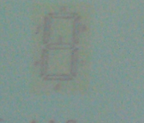



2 For the 8-bit bidirectional register in Figure 4-2. A HIGN on this input enables a shift to the right and a LOW enalbles a shift to the left Assume that the register is initially storing the decimal number seventy-eight in binary ,with the right –most position being the LSB There is a LOW on the data-input line. Determine the state of the register after each clock pulse for the RIGHT/LEFT control waveform given

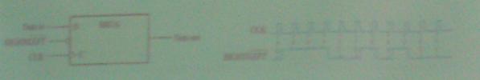

|  |  |  |
| --- | --- | --- |
| initially (78) | 01001100 |  |
| CLK1 | 10011000 | LEFT |
| CLK2 | 01001100 | RIGHT |
| CLK3 | 00100110 | RIGHT |
| CLK4 | 00010011 | RIGHT |
| CLK5 | 00100110 | LEFT |
| CLK6 | 01001100 | LEFT |
| CLK7 | 00100110 | RIGHT |
| CLK8 | 01001100 | LEFT |
| CLK9 | 00100110 | RIGHT |
| CLK10 | 01001100 | LEFT |
| CLK11 | 10011000 | LEFT |

3 用与非门设计四变量的多数表决电路,当输入变量ABCD中有3个或3个以上为1 时.输出为1 用红亮表示 输入为其他状态时输出为0 ,灯灭 要求写出真值表 列写表达式 并画出电路图

|  |  |  |  |  |
| --- | --- | --- | --- | --- |
| A | B | C | D | F |
| 0 | 0 | 0 | 0 | 0 |
| 0 | 0 | 0 | 1 | 0 |
| 0 | 0 | 1 | 0 | 0 |
| 0 | 0 | 1 | 1 | 0 |
| 0 | 1 | 0 | 0 | 0 |
| 0 | 1 | 0 | 1 | 0 |
| 0 | 1 | 1 | 0 | 0 |
| 0 | 1 | 1 | 1 | 1 |
| 1 | 0 | 0 | 0 | 0 |
| 1 | 0 | 0 | 1 | 0 |
| 1 | 0 | 1 | 0 | 0 |
| 1 | 0 | 1 | 1 | 1 |
| 1 | 1 | 0 | 0 | 0 |
| 1 | 1 | 0 | 1 | 1 |
| 1 | 1 | 1 | 0 | 1 |
| 1 | 1 | 1 | 1 | 1 |

