作业及解答

**第一章**

**1. #1.2**

Solution：If we use lines of constant longitude and lines of constant latitude, their intersections define a set of quadrilaterals. If we draw diagonals for each quadrilateral, we get a set of triangles. However, at the poles all the curves of constant longitude meet and we get triangles rather than quadrilaterals.

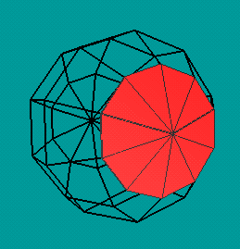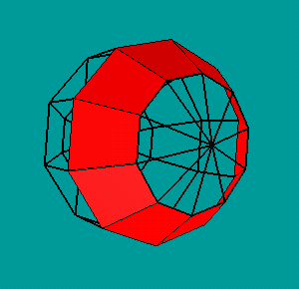

GL_TRIANGLE_FAN GL_TRIANGLE_STRIP

glDrawArrays(GL_TRIANGLE_FAN, 0, NumV);

glDrawArrays(GL_TRIANGLE_STRIP, 0, NumV);

球面坐标点(x, y, z)的计算(用球的半径和角度表示)： 球的半径为R; 半径与y轴的夹角为α;半径在x-z平面上的投影与x轴的夹角为θ。则：

X= R*sinα*cosθ

Y= R*cosα

Z= R*sinα*sinθ

P(x,y,z)

**Z**

**Y**

**X**

θ

α

R

**2. #1.8**

Solution: We have to process 1280 x 1024 x 72 pixels/sec. If we process each successively, there is only about 10 nanoseconds to process each. For a 480 x 640 interlaced display operating at 60 Hz we must process only 480 x 640 x 30 pixels/sec which gives us about 1085 nanoseconds to process each pixel.

1280*1024*72=94,371,840pixels/sec must transmit to the frame buffer.

1/94,371,840=1.0596e-8sec/pixel=10nanosec/pixel must transmit to frame buffer

480*640*30=921,600pixels/sec (interlaced隔行扫描, so refreshed 30 times per second)

1/921,600=1.085e-6sec/pixel must transmit to frame buffer

注：Nanosecond是纳秒，是10亿分之一，即等于10-9秒。

**第二章**

**3．test to write the 2D Sierpinski gasket program with 5000 random points.**

See also the textbook in page 640 by Appendix A A.2

**第三章**

**4．write down the matrices for rotation about y and z axes.**

Solution：

rotation about y : rotation about z:



**5．write down the mtrices for rotation about any line.**

Solution：

M=T(p0)Rx(-θx)Ry(-θy)Rz(θ)Ry(θy)Rx(θx)T(-p0)

**6．#3.10**

Solution: We can start with a rotation about any of the axes. The next rotation can be about either of the other two axes and the third can be either about the third axis or the ﬁrst. Hence there are 3*2*2 = 12 possible orders: xyz, xyx, xzy, xzx, yxz, yxy, yzx, yzy, zyx, zyz, zxy, zxz.

**7． #3.17**

Solution: One test is to use the ﬁrst three vertices to ﬁnd the equation of the plane ax + by + cz + d = 0. Although there are four coeﬃcients in the equation only three are independent so we can select one arbitrarily or normalize so that a2 + b2 + c2 = 1. Then we can successively evaluate ax + bc + cz + d for the other vertices. A vertex will be on the plane if we evaluate to zero. An equivalent test is to form the matrix

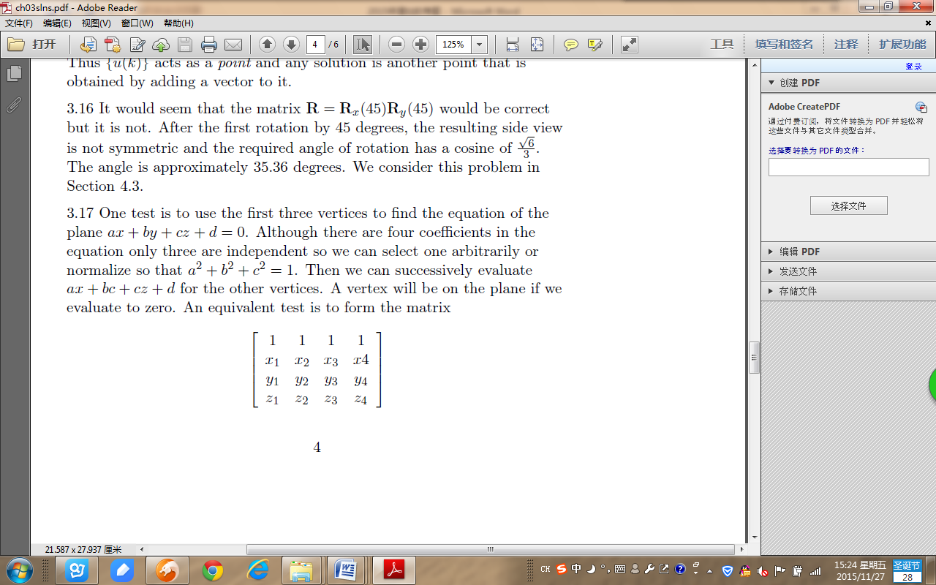

for each i = 4,... If the determinant of this matrix is zero the ith vertex is in the plane determined by the ﬁrst three.

It means:

P0

P

P2

P1

(A,B,C)=(P2-P1)×(P1-P0)=V×W

A=v2w3 – v3w2, B=v3w1 – v1w3, C=v1w2 – v2w1



If (A,B,C)·(x-x0, y-y0, z-z0)=0, then p is in the plane

That is (A,B,C) ·(x-x0, y-y0, z-z0)=A(x-x0)+B(y-y0)+C(z-z0)

**第四章**

**8． #4.2**

Solution：Suppose that the axis of the plane is its z direction and up is the y direction. In the airplane’s coordinate system, the roll, pitch and yaw correspond to rotations about the z, x and y axes respectively. Thus we can control the orientation relative the origin by a rotation of the form R z (roll)R x (pitch)R y (yaw). We must also do a translation to move the airplane to its desired location.

解释：

Roll—滚动角

Pitch—仰视角

Yaw—偏航角

如果是飞机滚动，则是平移T1，再绕z轴滚动Rz，再平移回来T1-1

如果是飞机仰视，则是平移T1，再绕x轴滚动Rx，再平移回来T1-1

如果是飞机偏航，则是平移T1，再绕y轴滚动Ry，再平移回来T1-1

**9．#4.17**

Solution：All the points on the projection of the point (x,y,z) in the direction (dx ,dy ,dz ) are of the form (x + αdx ,y + αdy ,z + αdz ). Thus the shadow of the point (x,y,z) is found by determining the α for which the line intersects the plane, that is axs + bys + czs = d

Substituting and solving, we find

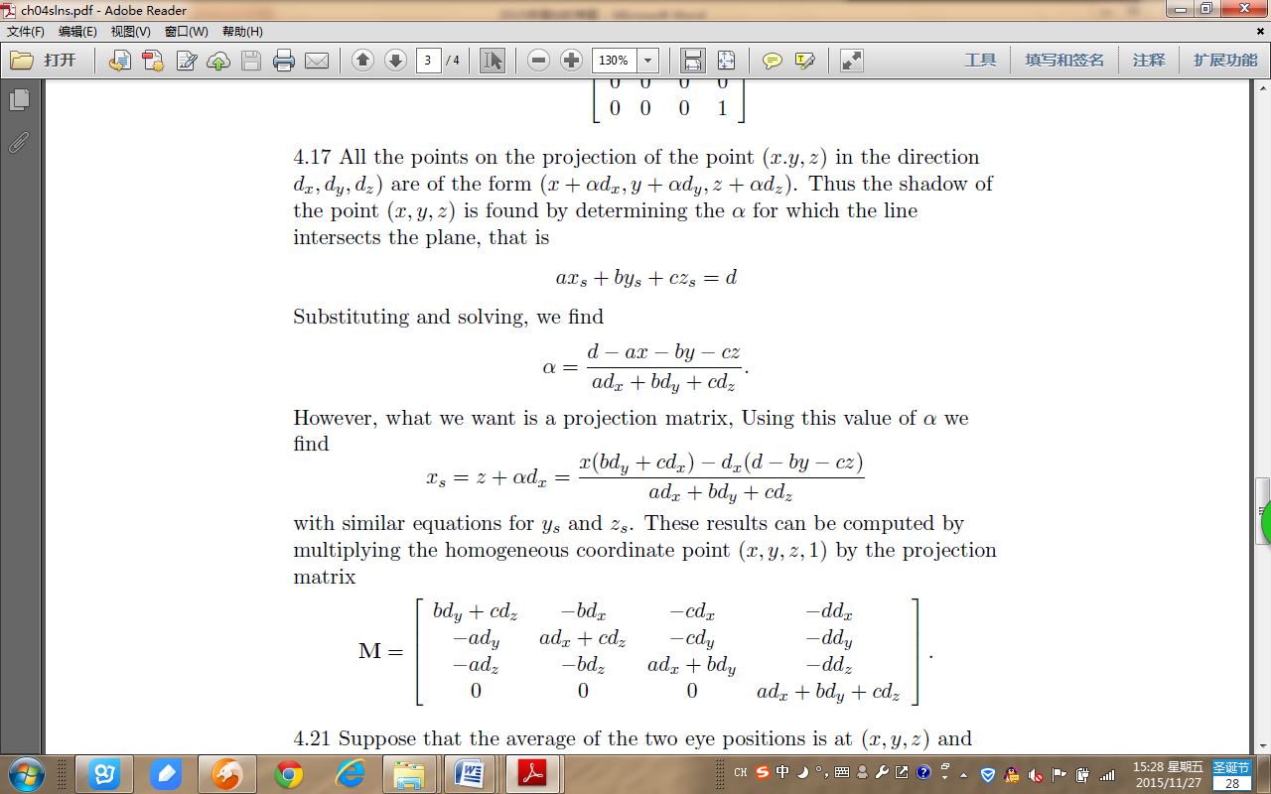

However, what we want is a projection matrix, Using this value of α we find



with similar equations for ys and zs . These results can be computed by multiplying the homogeneous coordinate point (x,y,z,1) by the projection matrix



**10.** 将三角形A(0,0), B(1,1), C(5,2)放大两倍，保持C(5,2)不变，请写出变换矩阵，以及变换后的三角形顶点坐标A’，B’，C’。

Solution：

B(1,2)

C(5,2)

A(0,0)A)

根据向量v=5I+2J得到：



=

=

用列向量表示坐标为（x,y）的P点，得出：

=

=

=

因此=（-5，-2）、=（-3，0）、=（5，2）。

**11.** 写出点Q(x,y)绕定点P(h,k)顺时针旋转θ的旋转变换矩阵。

Solution: 通过三步确定：（1）平移坐标原点到固定点P；（2）绕P点进行旋转；（3）将原点平移回原来的坐标原点。根据向量v=hI+kJ得到所需的变换：



$\left(-\begin{matrix}\cos{θ} & -\sin{θ} & 0 \\ \sin{θ} & \cos{θ} & 0 \\ 0 & 0 & 1\end{matrix}\right)$

M =

错的，是顺时针旋转，- 在第二个sin前。



=

**第五章**

**12．** 画一个材质是白色的cube，再定义三个点光源，分别是红色光、绿色光、蓝色光，光源位置在cube的三个可见面的前方。分别编程实验：

1. 只定义漫反射光
2. 只定义漫反射光和镜面反射光
3. 定义漫反射光、镜面反射光，以及环境光

比较三种情况的结果，并讨论原因。

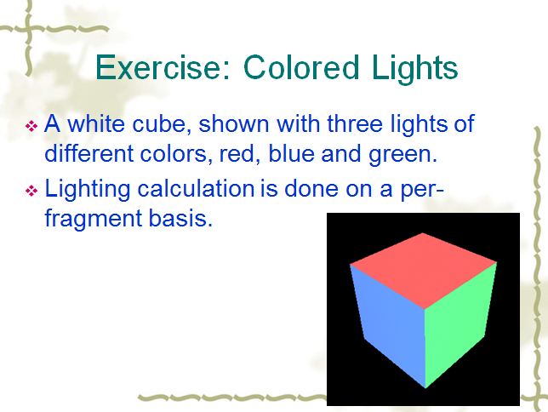

**第六章**

**13.** #6.1 两个参数方程表示的线段，如何判断两个线段是否相交？若相交，如何求交点？

Solution: First, consider the problem in two dimensions. We are looking for an α and β such that both parametric equations yield the same point, that is

x(α) = (1 − α)x 1 + αx 2 = (1 − β)x 3 + βx 4 ,

y(α) = (1 − α)y 1 + αy 2 = (1 − β)y 3 + βy 4 .

These are two equations in the two unknowns α and β and, as long as the line segments are not parallel (a condition that will lead to a division by zero), we can solve for α β. If both these values are between 0 and 1, the segments intersect.

If the equations are in 3D, we can solve two of them for the α and β where x and y meet. If when we use these values of the parameters in the two equations for z, the segments intersect if we get the same z from both equations.

**14.**  #6.2 判断两个多边形是否相交？

Solution:

We can form the equation of the plane of the first polygon using any three of its vertices. We can next put each of the vertices of the second polygon into this equation. If we get the same sign for all, then the second polygon cannot intersect the first. If two successive vertices have different signs, the corresponding edge intersects the plane of the first polygon. We can then determine the point of intersection and see if this point lies inside the first polygon. Note that we also must test of the first polygon intersects the second.

**15．**Stereo images are produced by creating two images with the viewer in two slightly different positions. Consider a viewer who is at the origin but whose eyes are separated by *dx* units. Please write down the LookAt parameters for two eyes.

Solution:

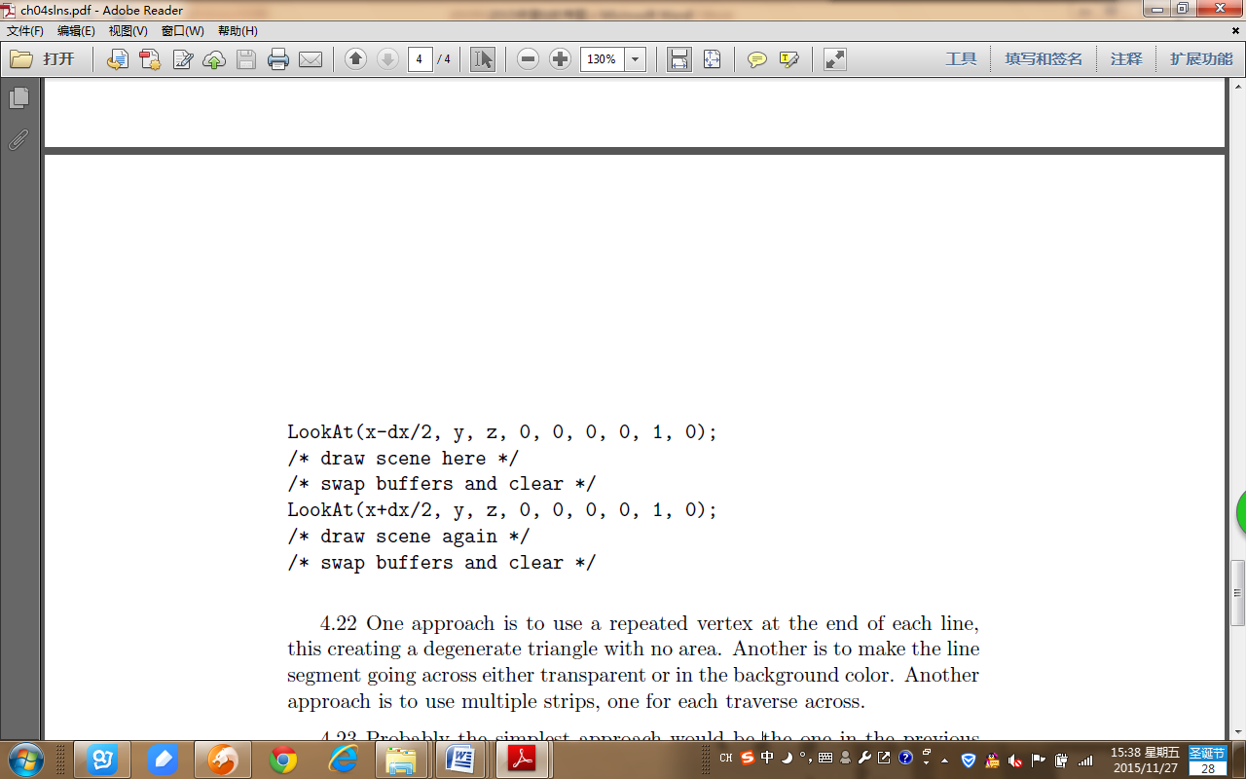

**第七章**

**16．**Textbook in page 668, Appendix A.8: Rotating Cube with Texture.

**17.** How to compute the interpolation illumination Ip2 by previous illumination Ip1 and increment.

A

B

C

Q

P

R

*IQ* = (1-*u* ) × *IA* + *u* ×*IB* 0≤ *u* ≤1, *u* = AQ/AB

*IR* = (1-*w*)×*IB* + *w* ×*IC* 0≤*w* ≤1, *w* = BR/BC

*IP* = (1-*t* ) ×*IQ* + *t* ×*IR* 0≤*t* ≤1, *t* = QP/QR

Increment Computing:

*IP2* = (1-*t2* ) × *IQ* + *t2* ×*IR*

*IP1* = (1-*t1* ) × *IQ* + *t1* × *IR*

Solution:

*IP2* = *IP1* + (*IR* -*IQ* ) (*t2*- *t1* )

= *IP1* + △*IRQ* × △*t*

附加题：

1. **写出相对固定点P(h,k)缩放变换的矩阵。**

解：

通过三步确定：（1）平移坐标原点到固定点P；（2）绕P点进行缩放；（3）将原点平移回原来的坐标原点。根据向量v=hI+kJ得到所需的变换：



=

=

1. **将三角形A(0,0),B(1,1),C(5,2)旋转45°， (a)绕原点 (b)绕P(-1,-1)。**
2. 三个顶点表示为 （A，B，C）



M = =



（A’B’C’）= M * (ABC) = =

因此 A’(0,0)，B’(0, )， C’(, )



1. M =



=



(A’B’C’）= M * (ABC) = =

因此 A’(-1, -1)，B’(-1, 2-1)， C’(-1, -1)