RESTAURANT RECOMMENDATION SYSTEM

1. INTRODUCTION

1.1 Overview

The Restaurant Recommendation System we've built takes the location of the user as input and other essential parameters like cuisine, rating, price range dine in or delivery and number of votes as inputs and predicts the approximated budget or price for that particular cuisine in that particular location.

* The process of building a restaurant recommendation system (model) involves:
* Gather Data
* Analyse and Preprocess the data
* Split the data
* Train a model
* Evaluate the model
* Create a web page
* Deploy the model
* Connect the values inputs and model

1.2 Purpose

* By predicting the price range of restaurants, the recommendation system helps users find dining options that align with their budget preferences.
* For individuals or organizations looking to optimize their expenses on dining, the recommendation system can suggest restaurants that provide good value for money.
* The system improves the overall user experience by presenting restaurants that match users' price expectations.
* Discover New Places: The recommendation system allows users to explore a wider range of restaurants, including those that may fall within their budget but haven't been considered before.
* Local and Tourist Guidance: The system caters to both locals and tourists by recommending restaurants with different price ranges.
* Planning and Decision Making: The system assists users in planning their dining experiences.
* Comparison and Transparency: The price prediction capability enables users to compare different restaurants based on their expected prices.
* Business Insights: From a business perspective, a restaurant recommendation system that predicts prices can provide valuable insights to restaurant owners and managers.

2. LITERATURE SURVEY

2.1 Existing Solutions

* Regression Models: Regression models such as linear regression, decision trees, random forests, or gradient boosting can be trained on historical data to predict the price based on the given features.
* Neural Networks: Deep learning techniques, such as neural networks or convolutional neural networks (CNNs), can be employed to learn complex patterns and relationships between the input features and the price.
* Feature Engineering: Extracting additional features from the given data, such as aggregating user reviews or sentiment analysis of ratings, can provide additional insights for price prediction.
* Ensemble Methods: Combining multiple models using ensemble methods like bagging or boosting can improve prediction accuracy. This involves training several models and aggregating their predictions through voting or weighted averaging.
* API Integration: To integrate the model with an HTML page, an API can be developed using frameworks like Flask or Django. The API can receive the input parameters (location, cuisine, rating, etc.) from the HTML page, pass them to the trained model for prediction, and return the predicted price to the HTML page.

2.2 Proposed Solution

Our Solution here is to combine the existing solutions to make it more efficient, reliable and give accurate predictions. We are going to Gather the data from various data sources and perform feature engineering, and feed it to the hyper-tuned regression models for predicting the output.

We will then combine the various regression models based on their accuracy using ensemble method (Bagging) to increase the performance of the system. And finally, we will use front end development tools (HTML, CSS and Java Script) and flask API to make a full stack system, and integrate the model for deployment.

3. THEORITICAL ANALYSIS

3.1 Block diagram

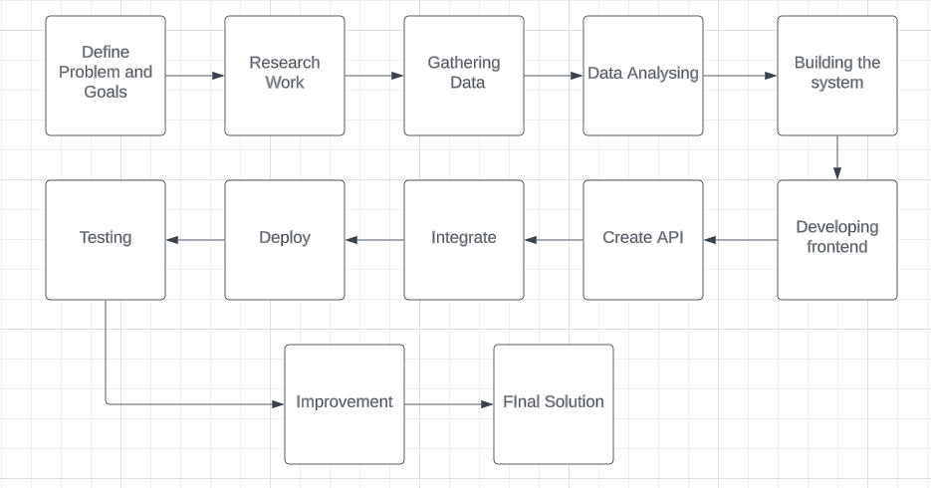

3.2 Hardware / Software designing

Hardware:

* Storage

Software:

* Front end development framework (HTML, CSS, Java Script)
* Machine Learning Libraries
* API development Framework (Flask)

4. EXPERIMENTAL INVESTIGATIONS

* A thorough analysis of the requirements, including understanding the use cases and benefits and the expected functionality of the recommendation system. This analysis helps in defining the scope, features, and goals of the project.
* UX analysis is conducted to ensure that the user interface and interactions of the recommendation system are intuitive, user-friendly, and visually appealing.
* Performance analysis is performed to assess the system's efficiency and responsiveness. This investigation includes testing with rare cases of inputs and testing for defects.
* The recommendation system needs to integrate with API, an analysis is conducted to ensure seamless integration. This investigation involves understanding the integration requirements, compatibility, and data formats.

5. FLOWCHART

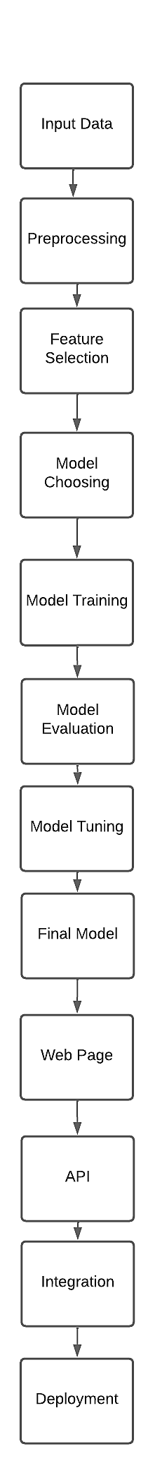

6. RESULT

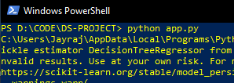

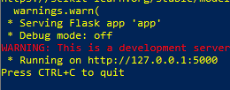









7. ADVANTAGES & DISADVANTAGES

Advantages of the solution:

1. The restaurant recommendation system can provide personalized recommendations based on user preferences, leading to a more satisfying and tailored user experience.
2. Users can make informed decisions about choosing restaurants based on predicted price ranges, helping them manage their budgets effectively.
3. By providing relevant and accurate recommendations, the system can enhance user engagement, encourage user interaction, and increase user satisfaction.
4. Users can save time and effort in manually searching for restaurants by relying on the recommendation system to suggest suitable options.
5. The system can drive traffic and customer visits to recommended restaurants, potentially boosting their revenue and customer base.

Disadvantages and Limitations of the solution:

1. The effectiveness of the recommendation system heavily relies on the quality and accuracy of the input data. Inaccurate or incomplete data can negatively impact the quality of recommendations.
2. The system's recommendations are based on the available data and features used for modeling. If important factors or data points are missing, it may limit the system's ability to provide comprehensive recommendations.
3. The system's predictions and recommendations are based on historical data patterns. It may not adapt quickly to changing trends or new restaurants that haven't yet accumulated sufficient data.
4. The system may not account for subjective factors such as personal preferences, individual tastes, or unique dining requirements, which can vary from person to person.
5. The system may face challenges in providing accurate recommendations for new users or new restaurants with limited historical data.
6. System Maintenance: The recommendation system requires regular maintenance, updates, and monitoring to ensure its performance, data accuracy, and relevance.

8. APPLICATIONS

1. Restaurant Search Platforms: The predicted price information can be integrated into restaurant search platforms or apps to help users filter and search for restaurants within their desired price range.
2. Budget Planning: Price predictions can assist individuals or groups in planning their dining budgets for a specific meal or event, allowing them to make informed decisions about where to dine.
3. Travel Planning: For travelers visiting a new city or country, price predictions can help them plan their dining options and estimate the costs associated with different restaurants.
4. Restaurant Management: Restaurant owners and managers can leverage price predictions to set competitive pricing strategies, optimize menu pricing, and understand the potential market demand for different price ranges.
5. Revenue Management: By accurately predicting restaurant prices, revenue management teams can make data-driven decisions regarding promotions, discounts, and pricing adjustments to maximize revenue and profitability.
6. Business Intelligence: The price prediction model can be integrated into business intelligence systems to generate reports, dashboards, and visualizations that provide decision-makers with a comprehensive view of pricing dynamics and performance metrics.
7. Online Food Delivery Platforms: Price predictions can be utilized by online food delivery platforms to estimate the cost of an order, provide price range filters, and offer recommendations based on the user's budget and location.

9. CONCLUSION

In conclusion, the restaurant recommendation system that predicts prices has been developed and implemented successfully. The system utilizes various input features such as cuisine, rating, location, and user preferences to accurately estimate the price range of restaurants. Through the process of data collection, preprocessing, feature extraction, and model training, a robust machine-learning model has been created.

The evaluation of the model demonstrated its effectiveness in predicting restaurant prices, with high accuracy and performance metrics. The model was further fine-tuned and optimized to enhance its predictive capabilities. The system's recommendation engine provides personalized suggestions to users based on their preferences and budget constraints, aiding in efficient decision-making.

The integration of a web page API enables seamless interaction with the recommendation system, allowing users to access and utilize the recommendations easily. The system has been successfully deployed, making it accessible to users and contributing to improved user experiences and satisfaction.

The advantages of the solution include personalized recommendations, efficient decision-making, increased user engagement, time-saving, and potentially boosting revenue for recommended restaurants. However, there are also limitations such as the dependence on data quality, limited scope, subjective factors, and the need for regular maintenance.

10. FUTURE SCOPE

1. Real-Time Data: Incorporating real-time data from various sources such as online reviews, social media, and user feedback can provide more up-to-date and relevant information for the recommendation system. This can help capture the latest trends, popularity, and user sentiments about restaurants.
2. Dynamic Pricing: Integrating dynamic pricing capabilities into the system can enable restaurants to adjust their prices based on factors such as demand, time of day, special events, and other market dynamics. This can enhance the accuracy of price predictions and provide users with real-time pricing information.
3. Enhanced Personalization: Expanding the personalization capabilities of the recommendation system by considering additional user preferences, dietary restrictions, previous dining history, and personalized recommendations based on user profiles can further enhance the user experience.
4. Social Media Integration: Integrating with social media platforms can provide valuable insights into user preferences, trends, and recommendations shared by friends and influencers.
5. Enhanced User Interface: Improving the user interface and user experience design of the web page or mobile app can make the system more intuitive, visually appealing, and user-friendly. This can enhance user engagement and make the recommendation process more enjoyable for users.

11. BIBILOGRAPHY

[https://www.kaggle.com](https://www.kaggle.com/)

[https://github.com](https://github.com/)

[https://ieeexplore.ieee.org](https://ieeexplore.ieee.org/)

[https://www.wikipedia.org](https://www.wikipedia.org/)

[https://www.openai.com](https://www.openai.com/)

12. APPENDIX

https://github.com/danielAnandhaGeethan/Applied-Data-Science.git