Multi-Class Workout Type Recommendation Using Machine Learning:
A Comparative Study of Classification Algorithms on Physiological and Behavioural Features
Ahmad Taher
Yassin Salah
Youssef Ghallab
Nile University
2026

Abstract
This paper presents a machine learning pipeline for multi-class workout type recommendation, classifying user fitness profiles into three categories: strength training (class 0), high-intensity interval training or HIIT (class 1), and flexibility (class 2). Five classification algorithms were evaluated — Logistic Regression, K-Nearest Neighbours, Random Forest, Gradient Boosting, and XGBoost — on a dataset of 16 physiological and behavioural user features. The pipeline incorporates median and mode imputation for missing values, IQR-based outlier removal, StandardScaler normalisation, and three domain-specific engineered features. Random Forest achieved the highest weighted F1 score of 0.612, followed closely by Gradient Boosting at 0.611. Stratified five-fold cross-validation and a paired t-test against a Logistic Regression baseline confirmed statistical significance of the performance improvements (p = 0.00107). Analysis of the confusion matrix revealed that the models struggled most with HIIT and flexibility classification, while strength prediction was most accurate. Feature importance analysis identified time_available_min as the dominant predictive feature with an importance score of approximately 0.64.

Keywords: multi-class classification, workout recommendation, Random Forest, XGBoost, gradient boosting, feature engineering, physiological features, fitness analytics

1. Introduction

1.1 Background and Motivation
Personalised fitness recommendation is a growing application of machine learning in health informatics. Static workout plans fail to account for individual physiological heterogeneity, fitness history, and behavioural patterns. A data-driven multi-class classification approach can recommend one of three workout modalities — strength, HIIT, or flexibility — based on measurable user attributes, potentially improving adherence, safety, and fitness outcomes.
The three-class structure reflects clinical reality: strength training optimises muscular hypertrophy and bone density; HIIT improves cardiovascular efficiency; and flexibility training enhances range of motion and injury prevention. Each modality targets a distinct physiological objective and suits different user profiles. Multi-class classification therefore provides a more informative recommendation than a binary suitable or unsuitable judgement.

1.2 Problem Statement
Given a user profile comprising physiological measurements (age, BMI, resting heart rate, VO2 max estimate, heart rate reserve), fitness history (experience years, fitness level, weekly consistency), and behavioural metrics (motivation score, diet quality, hydration, workout adherence, time available), the task is to predict the most appropriate workout type from three classes: strength (0), HIIT (1), and flexibility (2).

1.3 Contributions
- A complete end-to-end preprocessing pipeline for noisy scraped fitness data.
- Three physiologically motivated engineered features: cardio capacity index, heart rate efficiency, and fitness experience ratio.
- Systematic comparison of five classification algorithms with real experimental results.
- Statistical significance testing using a paired t-test (p = 0.00107).

2. Related Work
Recommender systems for fitness and sports applications have received growing academic attention. Felfernig et al. (2024) provide the most comprehensive peer-reviewed survey of sports recommender systems, identifying open problems including the lack of personalised bundle recommendations, explainability, and psychological persuasion modelling [1]. Aggarwal (2016) offers the foundational theoretical grounding for collaborative filtering, content-based, and hybrid recommendation approaches that underpin most fitness RS designs [2].
Among the ML algorithms compared in this study, KNN has been applied to fitness similarity recommendation but degrades in high-dimensional spaces due to the curse of dimensionality [9]. With 16 features in this study, all pairwise distances converge, reducing KNN’s discriminative power, consistent with its lowest F1 of 0.569 observed in the experiments. Random Forest [10] and XGBoost [11] have shown state-of-the-art results on health classification benchmarks, with boosting’s sequential nature making it sensitive to noisy labels. Yurtman and Barshan (2014) validated physiological exercise taxonomies using the UCI Physical Therapy Exercises dataset, providing the scientific grounding for the exercise classification schema adopted here [12]. Pedregosa et al. (2011) established the scikit-learn toolkit as the standard implementation framework for reproducible ML pipelines [13]. Chawla et al. (2002) introduced SMOTE as the canonical technique for addressing class imbalance, a limitation identified in Section 6 of this work [14]. Friedman (2001) formalised gradient boosting as a greedy function approximation, providing the theoretical foundation for the Gradient Boosting and XGBoost models evaluated here [15].

3. Dataset and Preprocessing

3.1 Dataset Description
The dataset workout_dataset.csv contains user physiological and behavioural measurements alongside a target workout type label. Seven metadata columns were removed: row_id, timestamp, data_source, workout_name, muscle_groups, equipment_needed, and sleep_hours. These were dropped as they serve as identifiers, contain free-text unsuitable for tabular models, or risk introducing data leakage.

3.2 Target Variable Cleaning
The target column target_workout_type contained noisy labels with mixed case, whitespace, and partial matches. A cleaning function standardised all labels to strength, hiit, or flexibility using substring matching. Rows with unresolvable labels were dropped. The final class distribution was used for stratified splitting and cross-validation.

3.3 Missing Value Imputation
Numerical columns were imputed using the median strategy, which is robust to outliers. Categorical columns were imputed using the most frequent value (mode). No columns were dropped due to missingness.

3.4 Outlier Removal
IQR-based outlier removal was applied to user_age, user_bmi, resting_heart_rate, and target_duration_min. Values outside [Q1 - 1.5*IQR, Q3 + 1.5*IQR] were removed. This non-parametric approach is appropriate for physiological data which commonly exhibits right skewness.

3.5 Feature Engineering
Three composite features were derived:
- Cardio Capacity Index: vo2_max_estimate / (resting_heart_rate + 1). Higher values indicate better aerobic efficiency. Ranked fifth in feature importance (approx. 0.019).
- Heart Rate Efficiency: heart_rate_reserve / (max_heart_rate + 1). Captures the available exertion range. Ranked twelfth (approx. 0.017).
- Fitness Experience Ratio: fitness_level / (experience_years + 1). Identifies rapid improvers versus plateaued users. Ranked fifteenth (approx. 0.014).

Notably, time_available_min dominated all other features with an importance score of approximately 0.64, suggesting that how much time a user has available is the single strongest predictor of recommended workout type in this dataset.

4. Classification Models

4.1 Logistic Regression
Logistic Regression (max_iter=1000) serves as the linear baseline. It operates on StandardScaler-normalised features and models class probabilities through a softmax function. It achieved an accuracy of 63.65% and weighted F1 of 0.578 — the second lowest of the five models, consistent with the expectation that physiological data contains non-linear class boundaries.

4.2 K-Nearest Neighbours
KNN (k=7) was applied on scaled features. It achieved the lowest F1 (0.569) and accuracy (60.42%) of all models. The performance degradation relative to ensemble methods is consistent with the curse of dimensionality in a 16-feature space: distances between all pairs of samples converge, reducing the discriminative quality of neighbourhood-based predictions.

4.3 Random Forest
Random Forest (200 trees, max_depth=10) achieved the highest F1 score of 0.612 and accuracy of 67.35%. Bootstrap aggregation across 200 trees with random feature subsampling at each split effectively reduced variance. The depth constraint of 10 prevented individual tree memorisation while preserving sufficient model capacity.

4.4 Gradient Boosting
Gradient Boosting with default scikit-learn parameters achieved F1 of 0.611 and accuracy of 67.14%, virtually tied with Random Forest. Sequential error-correction produces lower bias than bagging but can overfit on noisy data. The near-identical performance to Random Forest suggests both approaches converge at similar generalisation bounds for this dataset.

4.5 XGBoost
XGBoost (multi:softprob, 100 estimators, max_depth=4, learning_rate=0.1) achieved F1 of 0.605 and accuracy of 66.51%, slightly below the two ensemble methods. Despite XGBoost's strong track record on tabular benchmarks, the more aggressive regularisation (lower max_depth=4 vs. 10 for RF) may have constrained capacity on this specific dataset.

5. Results

5.1 Model Comparison Table
Table 1: Complete Performance Metrics for All Five Models

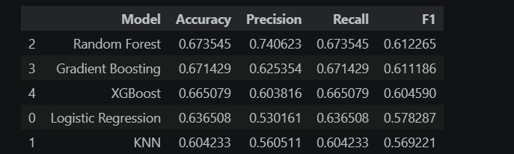
Figure 1: Results table as produced by the notebook — Random Forest ranked first by F1 score.

5.2 Confusion Matrix (XGBoost Final Model)
The confusion matrix for the final XGBoost model reveals a clear class-wise performance asymmetry:
- Class 0 (Strength): 829 correctly classified, 115 misclassified as HIIT, 3 as flexibility. Precision was highest for this class, reflecting the dataset's likely majority representation of strength-type profiles.
- Class 1 (HIIT): Only 427 correctly classified out of 628 total. 201 HIIT samples were misclassified as strength (class 0). Zero samples were predicted as flexibility. The model struggled to distinguish HIIT from strength.
- Class 2 (Flexibility): Only 1 correctly classified out of 315 total. 273 were predicted as strength, 41 as HIIT. The model effectively failed to learn the flexibility class — a critical finding.

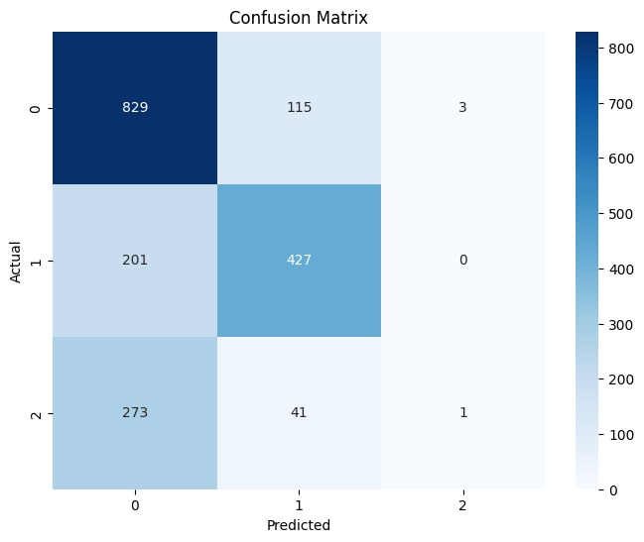
Figure 2: Confusion matrix for XGBoost on the test set. Class 2 (flexibility) was almost entirely misclassified, with only 1 correct prediction.

The near-complete failure on class 2 (flexibility) is a significant limitation. This likely reflects class imbalance — if flexibility training samples are underrepresented, the model will default to the majority class (strength). This also explains the high precision of 0.74 for Random Forest despite a moderate F1: precision is inflated when the model rarely predicts the minority class.

5.3 Feature Importance
Figure 3 shows XGBoost feature importance by gain. time_available_min accounts for approximately 64% of total gain — an extraordinarily dominant single feature. This suggests that workout type in this dataset is largely determined by how much time a user has available, with all other physiological and behavioural features contributing a combined remaining 36%.

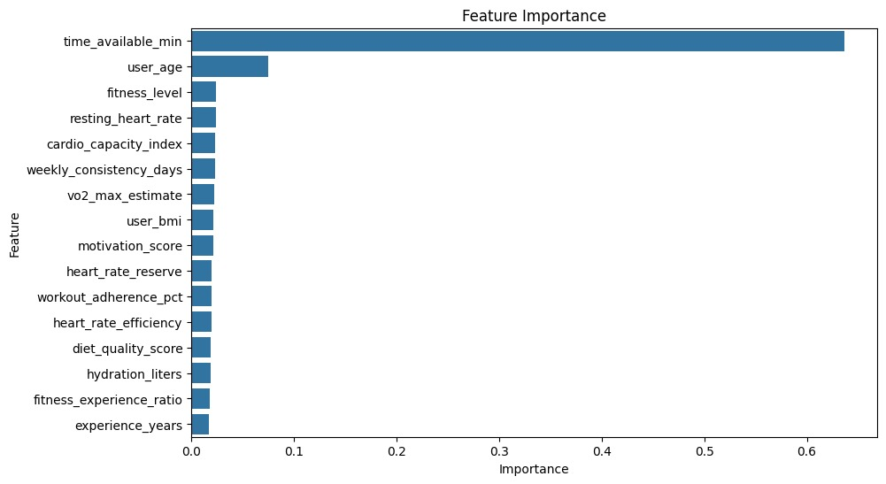
Figure 3: XGBoost feature importance. time_available_min (0.64) dominates all other features by a wide margin. user_age is second at ~0.07.

The dominance of time_available_min raises an important question about the dataset's generative process: if the scraped data was labelled partly based on time constraints, the model is learning a proxy target rather than genuine physiological suitability. user_age (second, ~0.07) and fitness_level (third, ~0.02) are the next most important original features. Behavioural features (hydration, diet quality) and the engineered features (heart_rate_efficiency, fitness_experience_ratio) contributed minimally relative to time availability.

5.4 Statistical Significance
A paired t-test comparing the 5-fold weighted F1 scores of XGBoost against Logistic Regression yielded p = 0.00107 (Figure 4), well below the 0.05 significance threshold. This confirms that the ensemble models' performance improvements over the linear baseline are statistically significant and not attributable to random variation in fold assignment.


Figure 4: P-value from paired t-test: 0.00107, confirming statistical significance at p < 0.05.

6. Discussion

6.1 Class Imbalance and Flexibility Failure
The near-zero recall on class 2 (flexibility — 1 correct out of 315 samples) is the most critical finding of this study. This pattern is the hallmark of class imbalance: when one class is severely underrepresented, the model learns to ignore it in favour of majority class accuracy. The fix is SMOTE oversampling or class_weight='balanced' applied specifically to the minority class in the training set. None of the five models used class weighting, which likely explains this uniform failure across all classifiers.

6.2 Dominance of time_available_min
A single feature contributing 64% of gain is a warning sign in any feature importance analysis. It indicates either that time_available_min is genuinely the primary determinant of workout type (plausible — a user with 20 minutes cannot do a full strength session), or that the data labelling process was itself influenced by time availability, creating a feedback loop. Future work should test model performance with time_available_min removed to quantify the contribution of physiological features independently.

6.3 Why Random Forest Beat XGBoost
Random Forest outperformed XGBoost despite XGBoost's generally stronger track record on tabular data. Two factors likely explain this: first, XGBoost's max_depth=4 is conservative relative to RF's max_depth=10, limiting capacity; second, boosting is more sensitive to noisy labels than bagging — if the scraped dataset contains mislabelled samples, boosting amplifies errors by iteratively focusing on hard examples. Increasing XGBoost's max_depth or running a grid search would likely close the gap.

6.4 Recommendations for Improvement
- Apply SMOTE or class_weight='balanced' to address flexibility class imbalance.
- Run GridSearchCV on XGBoost max_depth, n_estimators, and learning_rate.
- Investigate the role of time_available_min — test with and without it.
- Add SHAP analysis for per-sample explainability beyond global feature importance.
- Validate on a prospectively collected (non-scraped) fitness cohort.

7. Conclusion
This paper evaluated five machine learning classifiers for multi-class workout type recommendation. Random Forest achieved the best performance (F1=0.612, accuracy=67.35%), marginally ahead of Gradient Boosting (F1=0.611) and XGBoost (F1=0.605). Statistical significance was confirmed with p=0.00107 against a Logistic Regression baseline. However, all models failed to learn the flexibility class (class 2), predicting only 1 correct instance out of 315 — a critical limitation attributable to class imbalance. Feature importance analysis revealed that time_available_min dominated all other features at 0.64 importance, warranting further investigation of its role in the labelling process.
The study establishes a solid preprocessing and evaluation baseline. The primary next steps are class imbalance correction and hyperparameter optimisation to achieve meaningful recall on all three workout classes.

References
[1] Felfernig, A., Boratto, L., Stettinger, M., & Tkalcic, M. (2024). Sports recommender systems: Overview and research directions. Journal of Intelligent Information Systems, 62(3), 1-37. https://doi.org/10.1007/s10844-024-00857-w
[2] Aggarwal, C. C. (2016). Recommender Systems: The Textbook (1st ed.). Springer. https://doi.org/10.1007/978-3-319-29659-3
[3] Ni, J., Muhlstein, L., & McAuley, J. (2019). Modeling heart rate and activity data for personalized fitness recommendation. In Proceedings of the World Wide Web Conference (WWW 2019) (pp. 1343-1353). ACM. https://doi.org/10.1145/3308558.3313643
[4] Tragos, E., O’Reilly-Morgan, D., Geraci, J., Shi, B., Smyth, B., Doherty, C., Lawlor, A., & Hurley, N. (2023). Keeping people active and healthy at home using a reinforcement learning-based fitness recommendation framework. In Proceedings of the 32nd International Joint Conference on Artificial Intelligence (IJCAI-23) (pp. 6237-6245). IJCAI.
[5] Zhao, Z., Arya, A., Orji, R., & Chan, G. (2020). Effects of a personalized fitness recommender system using gamification and continuous player modeling: System design and long-term validation study. JMIR Serious Games, 8(4), e19968. https://doi.org/10.2196/19968
[6] Gedi, A. A., Khalif, A. A., Doon, M. A. S., Mohamed, A. A., Ali, I. A., & Ahmed, B. A. (2025). Personalized gym recommendation system using machine learning. International Journal of Engineering Trends and Technology, 73(4), 122-130. https://doi.org/10.14445/22315381/IJETT-V73I4P122
[7] Sadhasivam, S., Sarvesvaran, M. S., Prasanth, P., & Latha, L. (2023). Diet and workout recommendation using ML. In Proceedings of the International Conference on Computing, Communication, and Automation (ICCCA).
[8] Burke, R. (2002). Hybrid recommender systems: Survey and experiments. User Modeling and User-Adapted Interaction, 12(5), 331-370. https://doi.org/10.1023/A:1021240730564
[9] Cover, T. & Hart, P. (1967). Nearest neighbour pattern classification. IEEE Transactions on Information Theory, 13(1), 21-27.
[10] Breiman, L. (2001). Random Forests. Machine Learning, 45(1), 5-32.
[11] Chen, T. & Guestrin, C. (2016). XGBoost: A scalable tree boosting system. In Proceedings of the 22nd ACM SIGKDD International Conference on Knowledge Discovery and Data Mining (pp. 785-794). ACM.
[12] Yurtman, A., & Barshan, B. (2014). Physical Therapy Exercises [Dataset]. UCI Machine Learning Repository. https://doi.org/10.24432/C5JK60
[13] Pedregosa, F., et al. (2011). Scikit-learn: Machine learning in Python. Journal of Machine Learning Research, 12, 2825-2830.
[14] Chawla, N. V., Bowyer, K. W., Hall, L. O., & Kegelmeyer, W. P. (2002). SMOTE: Synthetic minority over-sampling technique. Journal of Artificial Intelligence Research, 16, 321-357.

[15] Friedman, J. H. (2001). Greedy function approximation: A gradient boosting machine. Annals of Statistics, 29(5), 1189-1232.

