%--------------------Section 3 - Nitrous Oxide Bay Loads----------------%
%---3a----%
fname = 'prob3nums.txt';
[year, area, Q, NLoad ] = ...
textread(fname, '%u %u %u %u',...
-1, 'headerlines', 1);
figure
hold on
plot(year,area,'DisplayName','Area')
plot(year,Q,'DisplayName','Discharge')
plot(year,NLoad,'DisplayName','NOx Load')
xlabel('Year')
ylabel('Area (km^2), Discharge (m^3/s), and NOx Load (MT/month)')
legend('show')
hold off
%NOx Load seems to be correlated with Discharge
%----3b----%
figure
hold on
title('NOx Load and Area')
scatter(NLoad,area)
ylim([-10000 40000])
xlabel('NOx Load (MT/Month)')
ylabel('Area (km^2)')
%There appears to be no real correlation between area and NOx Load%
%----3c-----%
xmean2 = mean(NLoad);
ymean2 = mean(area);
ssx2 = sum(((NLoad-xmean2).^2));
ssy2 = sum(((area-ymean2).^2));
ssxy2 = sum((NLoad-xmean2).*(area-ymean2));
b12 = ssxy2/ssx2
b02 = ymean2 - (b12*xmean2)
rss2 = sum((area - (b02 + (b12 * NLoad))).^2)
SSReg2 = ssy2-rss2
rsquared2 = (SSReg2)/(SSReg2+rss2);
fratio2 = (SSReg2/1)/(rss2/23)
ppp2 = 1 - fcdf(fratio2, 1, 23)
n2=25;
t2 = tinv(0.95,8);
var2 = (rss2/(n2-2));
varb02 = var2*((1/n2)+((xmean2^2)/ssx2));
stdb02 = sqrt(varb02);
lowerbound2 = b02- (t2*stdb02);
upperbound2 = b02 + (t2*stdb02);
covi2 = cov(NLoad,area);
cov2 = covi2(1,2)
y_lo2 = b02 + b12*NLoad - t2*sqrt(cov2);
y_hi2 = b02 + b12*NLoad + t2*sqrt(cov2);
line(NLoad, b02 + b12*NLoad);
line(NLoad,y_lo2);
line(NLoad,y_hi2);
hold off
%----------3c Table Values-----------------%
dfrs = 23
blankvar = 0
rms = SSReg2/1
resms = rss2/dfrs
fratio2
SSReg2
rss2
ppp2
%------------3d-----------------%
rsquared2 = (SSReg2)/(SSReg2+rss2)
%The coefficient of determination for N-Load versus Area is .237, implying
%that using N-Load is not a very good way to predict hypoxic area.
%-------------3e-----------------%
figure
hold on
title('Discharge and Area')
scatter(Q,area)
ylim([-10000 40000])
xlabel('Discharge (m^3/s)')
ylabel('Area (km^2)')
xmean3 = mean(Q);
ymean3 = mean(area);
ssx3 = sum(((Q-xmean3).^2));
ssy3 = sum(((area-ymean3).^2));
ssxy3 = sum((Q-xmean3).*(area-ymean3));
b13 = ssxy3/ssx3
b03 = ymean3 - (b13*xmean3)
rss3 = sum((area - (b03 + (b13 * Q))).^2);
SSReg3 = ssy3-rss3
rsquared3 = (SSReg3)/(SSReg3+rss3);
fratio3 = (SSReg3/1)/(rss3/23)
ppp3 = 1 - fcdf(fratio3, 1, 23)
n3=25;
t3 = tinv(0.95,8);
var3 = (rss3/(n3-2));
varb03 = var3*((1/n3)+((xmean3^2)/ssx3));
stdb03 = sqrt(varb03);
lowerbound3 = b03- (t3*stdb03);
upperbound3 = b03 + (t3*stdb03);
covi3 = cov(Q,area);
cov3 = covi3(1,2)
y_lo3 = b03 + b13*Q - t3*sqrt(cov3);
y_hi3 = b03 + b13*Q + t3*sqrt(cov3);
line(Q, b03 + b13*Q);
line(Q,y_lo3);
line(Q,y_hi3);
hold off
%----------3e Table Values-----------------%
dfrs = 23
blankvar = 0
rms2 = SSReg3/1
resms2 = rss3/dfrs
fratio3
SSReg3
rss3
ppp3
%------------3e-----------------%
rsquared3
%The coefficient of determination for Discharge versus Area is .0969, implying
%that discharge is not a very good way to predict hypoxic area.
%-----------3f-----------------%
%The coefficient of determination for discharge was almost 2.5 times smaller
%than it was for NOx Load. This would imply that despite the fact that
%both are not particularly good predictors of hypoxic area,NOx load has
%more of an effect (if any according to the model) than just discharge.
%-----------3g-----------------%
fname = 'prob3numsedit.txt';
[year1, area1, Q1, NLoad1 ] = ...
textread(fname, '%u %u %u %u',...
-1, 'headerlines', 1);
figure
hold on
title('NOx Load and Area')
scatter(NLoad1,area1)
ylim([-30000 60000])
xlim([0 215000])
xlabel('NOx Load (MT/Month)')
ylabel('Area (km^2)')
%There appears to be no real correlation between area and NOx Load for the
%'85-'96 data
%----3g-----%
xmean3 = mean(NLoad1);
ymean3 = mean(area1);
ssx3 = sum(((NLoad1-xmean3).^2));
ssy3 = sum(((area1-ymean3).^2));
ssxy3 = sum((NLoad1-xmean3).*(area1-ymean3));
b13 = ssxy3/ssx3
b03 = ymean3 - (b13*xmean3)
rss3 = sum((area1 - (b03 + (b13 * NLoad1))).^2)
SSReg3 = ssy3-rss3
rsquared3 = (SSReg3)/(SSReg3+rss3);
fratio3 = (SSReg3/1)/(rss3/9)
ppp3 = 1 - fcdf(fratio3, 1, 9)
n3=11;
t3 = tinv(0.95,8);
var3 = (rss3/(n3-2));
varb03 = var3*((1/n3)+((xmean3^2)/ssx3));
stdb03 = sqrt(varb03);
lowerbound3 = b13 - (t3*stdb03)
upperbound3 = b03 + (t3*stdb03)
covi3 = cov(NLoad1,area1);
cov3 = covi3(1,2)
y_lo3 = b03 + b13*NLoad1 - t3*sqrt(cov3);
y_hi3 = b03 + b13*NLoad1 + t3*sqrt(cov3);
line(NLoad1, b03 + b13*NLoad1);
line(NLoad1,y_lo3);
line(NLoad1,y_hi3);
hold off
%----------3g Table Values-----------------%
dfrs2 = 23
blankvar = 0
rms2 = SSReg3/1
resms2 = rss3/dfrs2
fratio3
SSReg3
rss3
ppp3
%------------3g-----------------%
rsquared3 = (SSReg3)/(SSReg3+rss3)
%The coefficient of determination for N-Load versus Area is .0969, implying
%that using N-Load is not a very good way to predict hypoxic area.
%===============Section 4 =======================%
fname = 'problem4.txt';
[x1 y1 x2 y2 x3 y3 x4 y4] = ...
textread(fname, '%f %f %f %f %f %f %f %f', ...
-1,'headerlines',1);
figure
subplot(2,2,1);
meanx1 = mean(x1);
meany1 = mean(y1);
plot(x1,y1,'.');
hold on
plot(meanx1,meany1,'x')
xlabel('x1')
ylabel('y1')
title('X1 and Y1')
nssx1 = sum(((x1-meanx1).^2));
nssy1 = sum(((y1-meany1).^2));
nssxy1 = sum((x1-meanx1).*(y1-meany1));
nb1 = nssxy1/nssx1;
nb0 = meany1 - (nb1*meanx1);
nrss1 = sum((y1 - (nb0 + (nb1 * x1))).^2);
nSSReg1 = nssy1-nrss1;
nrsquared1 = (nSSReg1)/(nSSReg1+nrss1);
line(x1, nb0 + nb1*x1);
hold off
%Table Values + Coef of Determin.%
nssx1
nrss1
nSSReg1
nrsquared1
%----X2/Y2 Values-----%
subplot(2,2,2);
meanx2 = mean(x2);
meany2 = mean(y2);
plot(x2,y2,'.')
hold on
plot(meanx2,meany2,'x')
xlabel('x2')
ylabel('y2')
title('X2 and Y2')
nssx2 = sum(((x2-meanx2).^2));
nssy2 = sum(((y2-meany2).^2));
nssxy2 = sum((x2-meanx2).*(y2-meany2));
nb12= nssxy2/nssx2;
nb02 = meany2 - (nb12*meanx2);
nrss2 = sum((y2 - (nb02 + (nb12 * x2))).^2);
nSSReg2 = nssy2-nrss2;
nrsquared2 = (nSSReg2)/(nSSReg2+nrss2);
line(x2, nb02 + nb12*x2)
hold off
%Table Values + Coef of Determin.%
nssx2
nrss2
nSSReg2
nrsquared2
%----X3/Y3 Values-----%
subplot(2,2,3);
meanx3 = mean(x3);
meany3 = mean(y3);
plot(x3,y3,'.')
hold on
plot(meanx3,meany3,'x')
xlabel('x3')
ylabel('y3')
title('X3 and Y3')
nssx3 = sum(((x3-meanx3).^2));
nssy3 = sum(((y3-meany3).^2));
nssxy3 = sum((x3-meanx3).*(y3-meany3));
nb13= nssxy3/nssx3;
nb03 = meany3 - (nb13*meanx3);
nrss3 = sum((y3 - (nb03 + (nb13 * x3))).^2);
nSSReg3 = nssy3-nrss3;
nrsquared3 = (nSSReg3)/(nSSReg3+nrss3);
line(x3, nb03 + nb13*x3);
hold off
%Table Values + Coef of Determin.%
nssx3
nrss3
nSSReg3
nrsquared3
%----X4/Y4 Values-----%
subplot(2,2,4);
meanx4 = mean(x4);
meany4 = mean(y4);
plot(x4,y4,'.')
hold on
plot(meanx4,meany4,'x')
xlabel('x4')
ylabel('y4')
title('X4 and Y4')
nssx4 = sum(((x4-meanx4).^2));
nssy4 = sum(((y4-meany4).^2));
nssxy4 = sum((x4-meanx4).*(y4-meany4));
nb14= nssxy4/nssx4;
nb04 = meany4 - (nb14*meanx4);
nrss4 = sum((y4 - (nb04 + (nb14 * x4))).^2)
nSSReg4 = nssy4-nrss4;
nrsquared4 = (nSSReg4)/(nSSReg4+nrss4);
line(x4, nb04 + nb14*x4)
hold off
%Table Values + Coef of Determin.%
nssx4
nrss4
nSSReg4
nrsquared4
%--4e----%
%This data set coupled with it's graph and regression line is a good
%example of how a visualization of data can look very different from
%the statistics used to generate it. If one were to look at only the
%r-squared data for the X4/Y4 data, for example, you might be under the
%impression that the data is far more horizontal than it actually is. This
%shows the usefulness of data visualization as opposed to pure numerical
%analysis.
b12 =
0.0676
b02 =
5.3310e+03
rss2 =
4.7814e+08
SSReg2 =
1.4849e+08
fratio2 =
7.1428
ppp2 =
0.0136
cov2 =
9.5523e+07
dfrs =
23
blankvar =
0
rms =
1.4849e+08
resms =
2.0789e+07
fratio2 =
7.1428
SSReg2 =
1.4849e+08
rss2 =
4.7814e+08
ppp2 =
0.0136
Source | Df | SS | MS | f-ratio | p-value
Regression | 1 | 1.4849e+08 | 1.4849e+08 | 7.1428 | 0.0136
Residual | 23 | 4.7814e+08 | 2.0789e+07

rsquared2 =
0.2370
b13 =
0.1691
b03 =
9.2638e+03
SSReg3 =
6.0739e+07
fratio3 =
2.4687
ppp3 =
0.1298
cov3 =
1.5620e+07
dfrs =
23
blankvar =
0
rms2 =
6.0739e+07
resms2 =
2.4604e+07
fratio3 =
2.4687
SSReg3 =
6.0739e+07
rss3 =
5.6589e+08
ppp3 =
0.1298
Source | Df | SS | MS | f-ratio | p-value
Regression | 1 | 6.0739e+07 | 6.0739e+07 | 2.4687 | 0.1298
Residual | 23 | 4.7814e+08 | 2.4604e+07
rsquared3 =
0.0969
b13 =
0.0795
b03 =
1.6008e+03
rss3 =
1.2143e+08
SSReg3 =
1.9505e+08
fratio3 =
14.4566
ppp3 =
0.0042
lowerbound3 =
-5.3324e+03
upperbound3 =
6.9332e+03
cov3 =
245312600
dfrs2 =
23
blankvar =
0
rms2 =
1.9505e+08
resms2 =
5.2794e+06
fratio3 =
14.4566
SSReg3 =
1.9505e+08
rss3 =
1.2143e+08
ppp3 =
0.0042
Source | Df | SS | MS | f-ratio | p-value
Regression | 1 | 1.9505e+08 | 1.9505e+08 | 14.4566 | 0.0042
Residual | 23 | 1.2143e+08 | 5.2794e+06

Sum of Squares X | Residual Sum of Squares | Regression Sum of Squares
110 | 13.7627 | 27.5100
rsquared3 =
0.6163
nssx1 =
110
nrss1 =
13.7627
nSSReg1 =
27.5100

nrsquared1 =
0.6665

X1/y1 Table
Sum of Squares X | Residual Sum of Squares | Regression Sum of Squares
110 | 13.7763 | 27.5000
nssx2 =
110
nrss2 =
13.7763
nSSReg2 =
27.5000
nrsquared2 =
0.6662
x2/y2 Table
nssx3 =
110
nrss3 =
13.7562
nSSReg3 =
27.4700
nrsquared3 =
0.6663
Sum of Squares X | Residual Sum of Squares | Regression Sum of Squares
110 | 13.7562 | 27.4700
X3/y3 Table

nrss4 =
13.7425
nssx4 =
110
nrss4 =
13.7425
nSSReg4 =
27.4900
nrsquared4 =
0.6667

Sum of Squares X | Residual Sum of Squares | Regression Sum of Squares
110 | 13.7425 | 27.4900
X4/y4 table
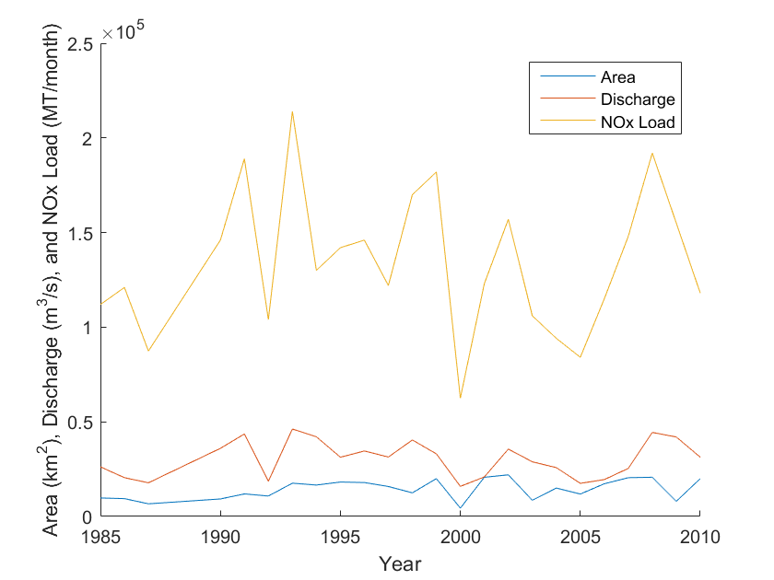
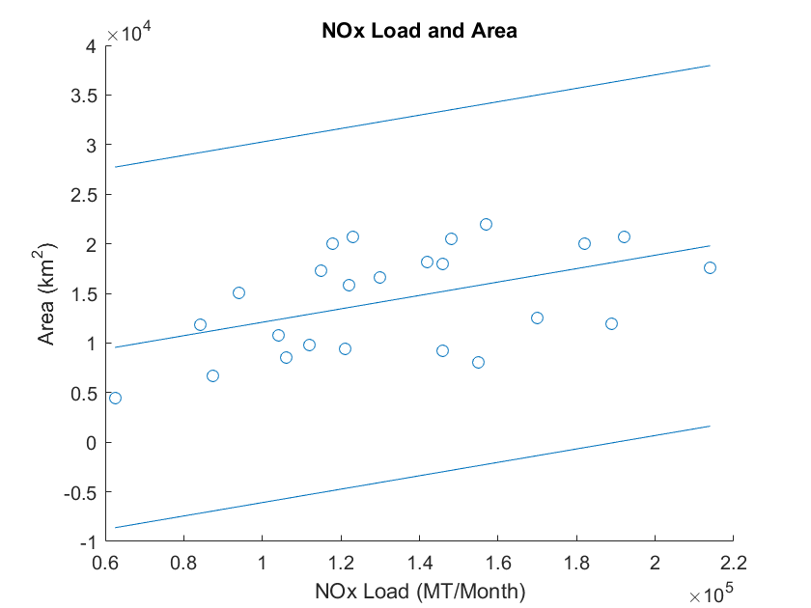
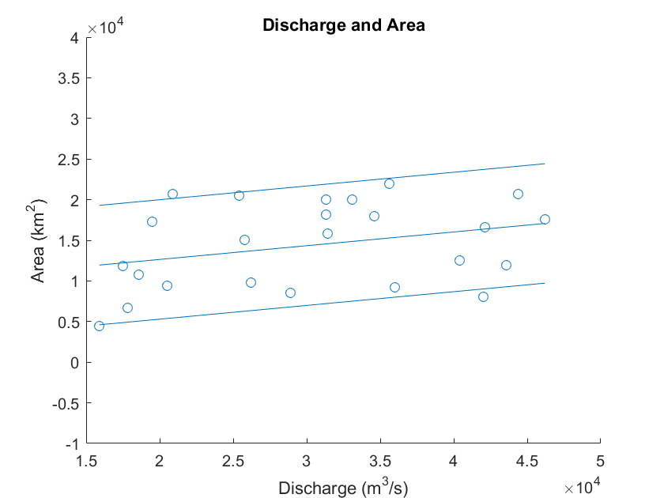
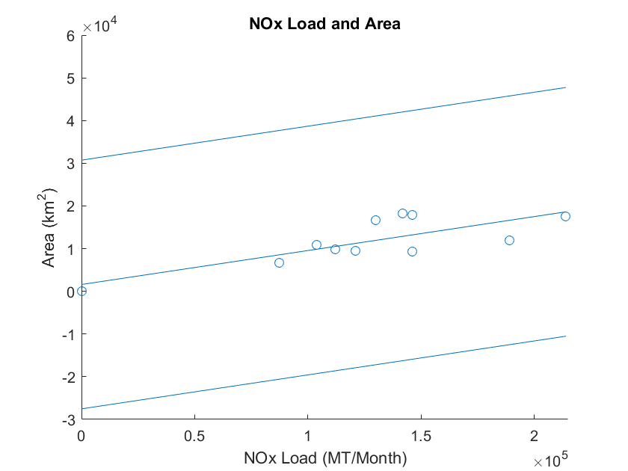
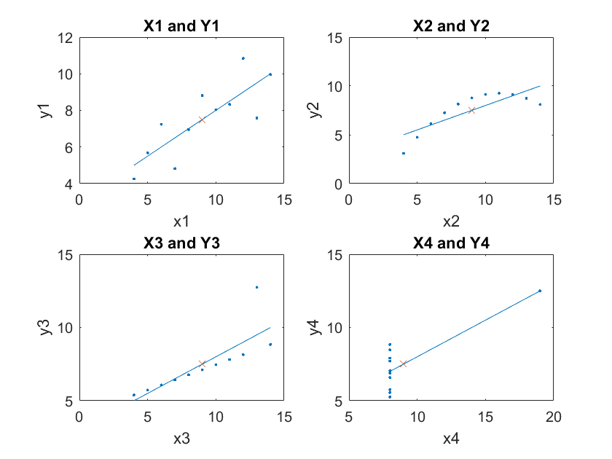
Published with MATLAB® R2015b

