Experiment – 8

Aim :
Write MATLAB program to design digital FIR filter employing windowing technique..

Theory:
The FIR filter design consists of two steps;
1) The filter order is determined, then the coefficients.
2) An approximate formula for the filter order N, developed by Kaiser:
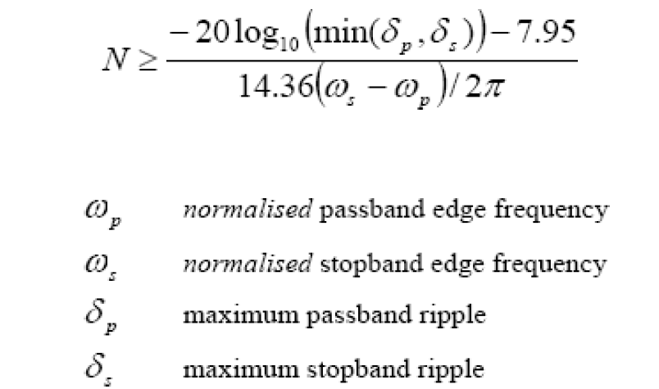
Steps to design MATLAB Code:
1) Create sampled sinusoids at different frequencies.
2) Calculate samples for a 4-tone input signal
3) Design FIR Filter using any window.
4) Plot frequency response - both amp and phase response.
5) Apply this filter to the 4-tone test sequence

IN LAB EXERCISE
Design following filters using rectangular window and black man window with given specifications
(a) Low pass (Wp=0.5, ws=0.6, delp=0.1,dels=0.1,Fs=8KHz) ,
(b) High pass ( Wp=0.5, ws=0.6, delp=0.1,dels=0.1, Fs=8KHz)
(c) Band pass (wp1=0.3, wp2=0.6,ws1=0.2, ws2=0.7, Fs=8KHz)
(d) Band stop filter(wp1=0.2, wp2=0.7,ws1=0.3, ws2=0.6, Fs=8KHz)

%1 22102071`
Fs = 8000;
wp = 0.5;
ws = 0.6;
delp = 0.1;
dels = 0.1;

% Calculate filter order
N1=-1*20*log10(dels)-7.95;
N2=14.36*(ws-wp)/2*pi;
N=N1/N2;
M=int8(N);
wc = (ws + wp)/2;

% Low Pass Filter design (Rectangular Window)
b_rect = fir1(M, wc, 'low',rectwin(M+1));
% Low Pass Filter design (Blackman Window)
b_blackman = fir1(M, wc, 'low', blackman(M+1));

freqz(b_rect, 1, 512);
freqz(b_blackman, 1, 512,Fs);

%2 22102071
Fs = 8000;
wp = 0.5;
ws = 0.6;
delp = 0.1;
dels = 0.1;

% Calculate filter order
N1=-1*20*log10(dels)-7.95;
N2=14.36*(ws-wp)/2*pi;
N=N1/N2;
M=ceil(N);
wc = (ws + wp)/2;

% high Pass Filter design (Rectangular Window)
b_rect = fir1(M, wc, 'high',rectwin(M+1));
% high Pass Filter design (Blackman Window)
b_blackman = fir1(M, wc, 'high', blackman(M+1));

freqz(b_rect, 1, 512);
freqz(b_blackman, 1, 512,Fs);

%3 22102071
Fs = 8000;
wp1 = 0.3;
wp2 = 0.6;
ws1 = 0.2;
ws2 = 0.7;
dels = 0.1;

% Calculate filter order
N1=-1*20*log10(dels)-7.95;
N2=14.36*(ws2-ws1)*Fs/(2*pi);
N=N1/N2;
R=ceil(6.2*pi/(ws2-ws1));
M=ceil(N);
wc1 = (ws1 + wp1)/2;
wc2 = (ws2 + wp2)/2;

% BPF design (Rectangular Window)
b_rect = fir1(M, [wc1,wc2], 'bandpass');
% BPF design (Blackman Window)
b_blackman = fir1(R, [wc1,wc2], 'bandpass', blackman(R+1));

freqz(b_rect, 1, 512);
freqz(b_blackman, 1, 512,Fs);

%4 22102071
Fs = 8000;
wp1 = 0.2;
wp2 = 0.7;
ws1 = 0.3;
ws2 = 0.6;
dels = 0.1;

% Calculate filter order
N1=-1*20*log10(dels)-7.95;
N2=14.36*(ws2-ws1)*Fs/(2*pi);
N=N1/N2;
M=max(1,ceil(N));
wc1 = (ws1 + wp1)/2;
wc2 = (ws2 + wp2)/2;

% BSF design (Rectangular Window)
b_rect = fir1(M, [wc1,wc2], 'stop');
% BSF design (Blackman Window)
b_blackman = fir1(M, [wc1,wc2], 'stop').*blackman(M);

freqz(b_rect, 1, 512);
freqz(b_blackman, 1, 512,Fs);

output:

1.
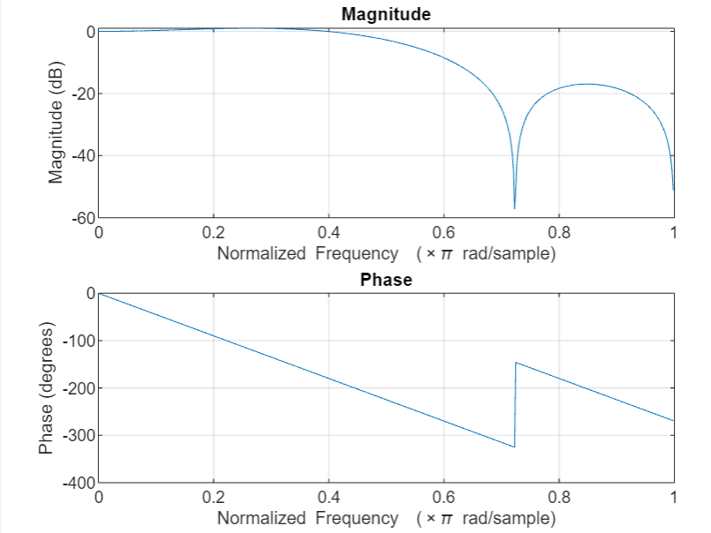

2.

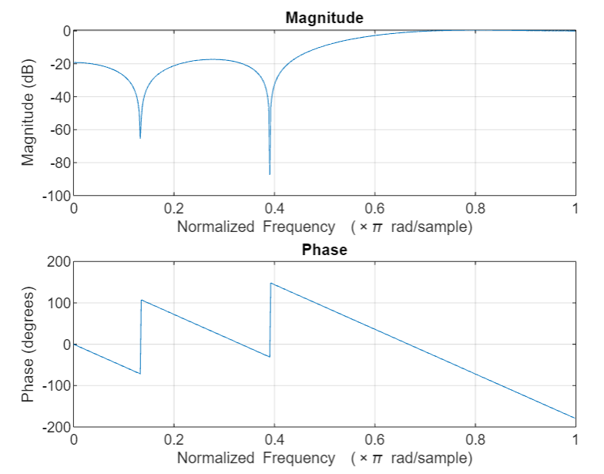

3.
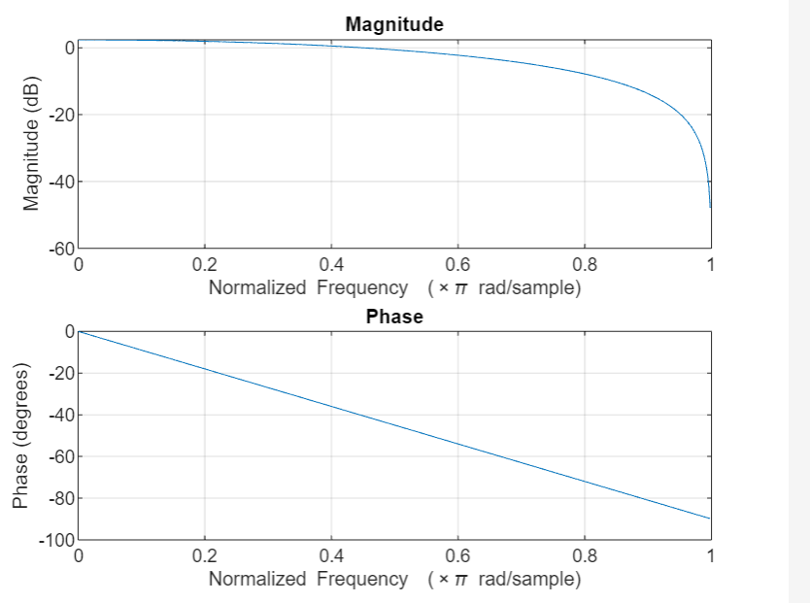
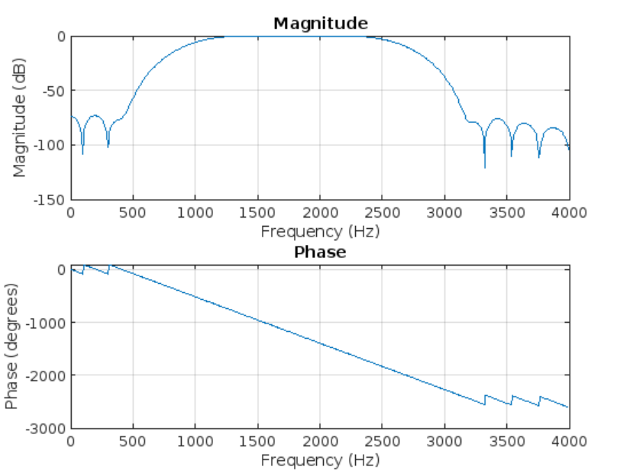

4.

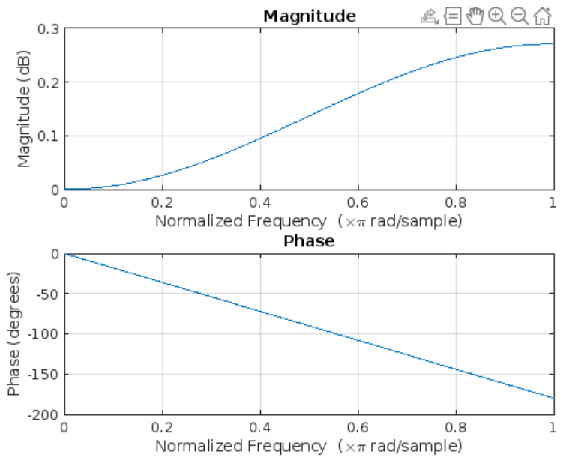

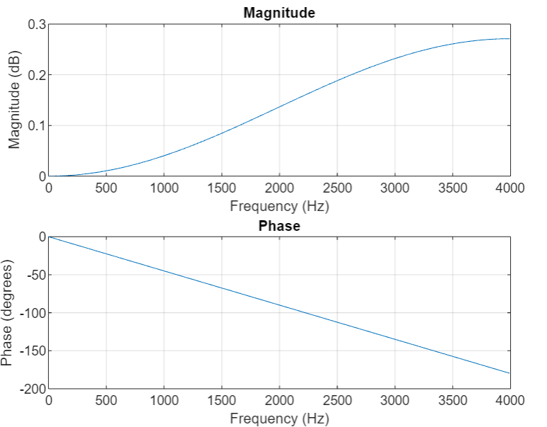

POSTLAB EXERCISE :
Design following filters using Kaiser window and Hamming window with given specifications
(a) Low pass (Wp=0.5, ws=0.6, delp=0.1,dels=0.1, Fs=8KHz) ,
(b) High pass( Wp=0.5, ws=0.6, delp=0.1,dels=0.1, , Fs=8KHz)
(c) Band pass (wp1=0.3, wp2=0.6,ws1=0.2, ws2=0.7, Fs=8KHz)
(d) Band stop filter(wp1=0.2, wp2=0.7,ws1=0.3, ws2=0.6, Fs=8KHz)
%1 22102071`
Fs = 8000;
wp = 0.5;
ws = 0.6;
delp = 0.1;
dels = 0.1;

% Calculate filter order
N1=-1*20*log10(dels)-7.95;
N2=14.36*(ws-wp)/2*pi;
N=N1/N2;
M=ceil(N);
wc = (ws + wp)/2;

% Low Pass Filter design (Kaiser Window)
b = fir1(M, wc, 'low',kaiser(M+1));
% Low Pass Filter design (Hamming Window)
b_ham = fir1(M, wc, 'low', hamming(M+1));

freqz(b, 1, 512);
freqz(b_ham, 1, 512);

%2 22102071
Fs = 8000;
wp = 0.5;
ws = 0.6;
delp = 0.1;
dels = 0.1;

% Calculate filter order
N1=-1*20*log10(dels)-7.95;
N2=14.36*(ws-wp)/2*pi;
N=N1/N2;
M=ceil(N);
wc = (ws + wp)/2;

% high Pass Filter design (Kaiser Window)
b = fir1(M, wc, 'high',kaiser(M+1));
% high Pass Filter design (hamming Window)
b_ham = fir1(M, wc, 'high', hamming(M+1));

freqz(b, 1, 512);
freqz(b_ham, 1, 512);

%3 22102071
Fs = 8000;
wp1 = 0.3;
wp2 = 0.6;
ws1 = 0.2;
ws2 = 0.7;
dels = 0.1;

% Calculate filter order
N1=-1*20*log10(dels)-7.95;
N2=14.36*(ws2-ws1)*Fs/(2*pi);
N=N1/N2;
R=ceil(6.2*pi/(ws2-ws1));
M=ceil(N);
wc1 = (ws1 + wp1)/2;
wc2 = (ws2 + wp2)/2;

% BPF design (Kaiser Window)
b = fir1(R, [wc1,wc2], 'bandpass', kaiser(R+1);
% BPF design (Hamming Window)
b_ham = fir1(R, [wc1,wc2], 'bandpass', hamming(R+1));

freqz(b, 1, 512);
freqz(b_ham, 1, 512,Fs);

%4 22102071
Fs = 8000;
wp1 = 0.2;
wp2 = 0.7;
ws1 = 0.3;
ws2 = 0.6;
dels = 0.1;

% Calculate filter order
N1=-1*20*log10(dels)-7.95;
N2=14.36*(ws2-ws1)*Fs/(2*pi);
N=N1/N2;
M=max(1,ceil(N));
wc1 = (ws1 + wp1)/2;
wc2 = (ws2 + wp2)/2;

% BSF design (Kaiser Window)
b = fir1(M, [wc1,wc2], 'stop', kaiser(M);
% BSF design (Hamming Window)
b_ham = fir1(M, [wc1,wc2], 'stop').*hamming(M);

freqz(b, 1, 512);
freqz(b_ham, 1, 512);

Output:

1.

2.

3.

4.

Learning Outcomes-
1. Learning the various commands required for filter designing in MATLAB.
2. Understanding filter designing using window techniques.

