🎯 Project Proposal (15-min cadence): YouTube Trending & Comments Analytics Platform
Goal: Track how trending YouTube videos evolve in US and Israel, collect engagement + top/latest comments, and visualize real-time trends in Grafana.
Cadence: Every 15 minutes (core pulls), with a few daily jobs.

⚙️ 1) What we collect (15-min plan)
Data | Endpoint | Frequency | Purpose
Top 200 videos per region (US & IL) | /videos?chart=mostPopular&part=snippet,statistics,contentDetails&maxResults=50 (4 calls: US/IL × paginate) | Every 15 min | Base snapshots (views/likes/comments, duration, tags, publish time).
Metrics refresh for already-seen videos | /videos?id=…&part=statistics (batched ≤50 IDs) | Every 15 min | Time-series history even if a video drops from the list.
Top 5 comments | /commentThreads?videoId=…&part=snippet&maxResults=5&order=relevance | Every 15 min for latest trending set (or every 30–45 min to save quota) | Audience “top voice”.
Last 5 comments | /commentThreads?videoId=…&part=snippet&maxResults=5&order=time | Every 15–30 min | Freshest feedback.
Channels | /channels?id=…&part=snippet,statistics | Daily | Creator reach: subscribers, total views.
Categories | /videoCategories?regionCode=US/IL | Daily | categoryId → categoryName lookup.
(Optional) Topics | /videos?part=topicDetails&id=… | Daily | Semantic topics (“AI”, “Gaming”).
Quota note: 15-min cadence stays well below the free 10k units/day if we limit comments to the currently trending 200 videos.

🧩 2) End-to-end workflow (with exact steps)
(Every 15 minutes)

1) Discover trending:
/videos?chart=mostPopular (US, IL) → 200 videos/region snapshot
↓ emit one event per video

2) Hydrate/refresh metrics:
/videos?id=batched_ids&part=statistics
↓ append time-series point for each video

3) Pull comments (for current trending set):
/commentThreads?videoId=...&order=relevance&maxResults=5
/commentThreads?videoId=...&order=time&maxResults=5
↓ store top 5 + last 5 (dedupe by comment_id)

4) Ship:
→ Kafka topic `youtube_trending_snapshot` (append, key=video_id)
→ Elasticsearch index `youtube_video_metrics` (for Grafana)

5) Land raw → Bronze (S3/MinIO) as JSON (append-only)
6) Transform → Silver (Parquet/Iceberg): clean, typed, deduped
7) Aggregate → Gold views: velocity, engagement, rank history

(Daily)
8) /channels and /videoCategories refresh → dims
9) (Optional) topics → enrichers
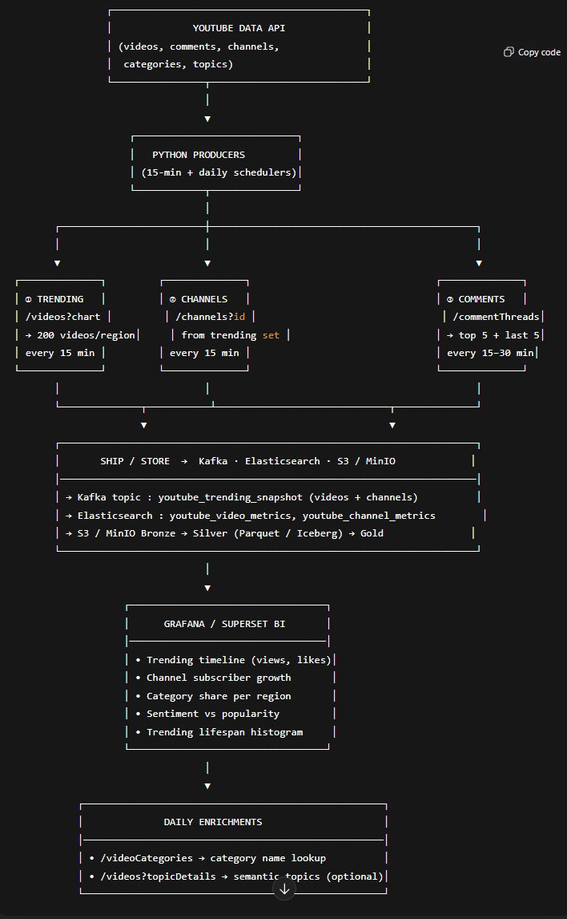

Idempotency & Watermarks
- Keep last_seen_at per video and last_comment_seen_at per video to avoid re-pulls. ?
- Use composite keys: (video_id, collected_at) for metrics; (comment_id) for comments.

🗃️ 3) Storage layers (with partitions)
- Bronze (raw JSON, append-only)
bronze/videos/region=US/yyyymmdd/HH/mm/*.json
bronze/comments/video_id=XYZ/yyyymmdd/HH/mm/*.json
bronze/channel_id/yyyymmdd/HH/mm/*.json (optional)
- Silver (clean Parquet/Iceberg)
  - dim_video(video_id PK, channel_id, title, tags[], category_id, published_at, duration_sec, first_seen_at, last_seen_at)
  - fact_video_metrics(video_id, collected_at, views, likes, comments, region, category_id, rank)
Partition: date(collected_at); Key: (video_id, collected_at)
  - fact_comment(comment_id PK, video_id, author, text, like_count, published_at, pulled_at, type: {top|latest})
Partition: date(pulled_at)
  - dim_channel(channel_id PK, title, country, created_at) + fact_channel_daily(channel_id, date, subscribers, total_views)
  - dim_category(category_id PK, category_name)
- Gold (views for BI/Grafana via ES/Athena)
  - vw_video_latest (window function for latest metrics)
  - video_velocity_1h_24h (deltas per window)
  - trending_lifespan (first_seen ↔ last_seen)
  - category_share / regional_comparison
  - sentiment_daily(video_id, date, avg_sentiment, toxicity_rate) (if NLP)

🔌 4) Event shapes (precise JSON examples)

a) Video snapshot event (15-min)
{
"video_id": "abc123",
"channel_id": "UCxyz",
"title": "AI dances salsa",
"tags": ["AI", "dance", "fun"],
"category_id": 28,
"region": "US",
"duration_sec": 630,
"published_at": "2025-11-12T08:00:00Z",
"collected_at": "2025-11-12T10:00:00Z",
"views": 2100000,
"likes": 53000,
"comments": 1200,
"rank": 8,
"source": "mostPopular"
}

b) Metrics refresh event (same shape, stats-only update)
{
"video_id": "abc123",
"collected_at": "2025-11-12T10:15:00Z",
"region": "US",
"views": 2145000,
"likes": 54200,
"comments": 1220,
"rank": 7,
"source": "refresh"
}

c) Comment (top 5 or last 5)
{
"comment_id": "UgxTlm1",
"video_id": "abc123",
"type": "top", // "top" or "latest"
"text": "This video is insane!",
"author": "Alex",
"like_count": 1500,
"published_at": "2025-11-12T08:30:00Z",
"pulled_at": "2025-11-12T10:00:00Z",
"region": "US"
}

d) Channel daily
{
"channel_id": "UCxyz",
"title": "Tech Insider",
"subscribers": 2300000,
"total_views": 120000000,
"video_count": 315,
"country": "US",
"collected_on": "2025-11-12"
}

e) Category mapping (daily)
{
"region": "US",
"category_id": 28,
"category_name": "Science & Technology",
"pulled_on": "2025-11-12"
}

🧠 5) Derived metrics we compute (per 15-min windows)
- Velocity_15m = views_t - views_t-15m
- Velocity_1h = sum of last four 15-min deltas
- Velocity_24h = sum of last 96 15-min deltas
- Engagement rate = (likes + comments) / views (guard against division by 0)
- Trending lifetime = last_seen_at - first_seen_at
- Sentiment_avg (if NLP): mean over comments pulled this window
These are computed in Silver→Gold jobs, then pushed to Elasticsearch for instant Grafana.

📊 6) Grafana panels (wired for 15-min granularity)
- Trending timeline (per video)
  - Data source: ES: youtube_video_metrics
  - Time field: collected_at; Split by: video_id (alias by title)
  - Refresh: auto every 15 min
- Velocity now (Top N by Velocity_1h)
  - Sort by computed velocity_1h descending; last 1h window
- Region & category share (stacked area)
  - Group by region, category_name; metric: sum(views)
- Trending lifespan (violin/histogram)
  - From Gold trending_lifespan table
- Comment pulse
  - Count comments per 15-min window; overlay average sentiment if computed

🧰 7) Airflow DAGs (concise & production-friendly)
**DAG: trending_discovery_15m (/15 * * * )
- pull_trending_US (videos, 200)
- pull_trending_IL (videos, 200)
- emit_video_events (Kafka + ES)
- land_bronze_videos
**DAG: metrics_refresh_15m (/15 * * * )
- gather_known_video_ids (from dim_video last 7 days)
- fetch_stats_batched (/videos?id=…, 50 ids/request)
- append_fact_video_metrics (Silver)
- bulk_index_es_metrics
**DAG: comments_pull_15m (/15 * * * )
- select_current_trending_ids
- pull_top5_comments (order=relevance)
- pull_last5_comments (order=time)
- append_fact_comment (Silver)
- (optional) nlp_sentiment_batch
- push_comment_signals_to_es
*DAG: daily_dims (0 3 * * )
- pull_channels_daily
- pull_categories_daily
- upsert_dim_channel, upsert_dim_category
Notes:
- Retry on 429 with exponential backoff.
- Track rate limit headroom; stop early if quota approaches threshold.
- Idempotent writes using upserts or Iceberg MERGE on keys.

🔐 8) Keys, partitioning, and Kafka
- Kafka: topic youtube_trending_snapshot, key = video_id (ensures ordering per video).
- ES index: youtube_video_metrics, mappings:
  - video_id, channel_id, region, category → keyword
  - collected_at → date
  - views/likes/comments/rank/velocity_* → numeric
- Silver partitions: by date(collected_at), and optionally bucket by video_id for comments.
- Late arrivals: ok; we append and recompute velocities in Gold.

✅ Why 15-minutes works great
- Captures fast viral spikes that hourly granularity can miss.
- Keeps data volume tiny (96 snapshots/day/video) but analytically rich.
- Grafana charts feel alive; alerts can trigger within the hour.

🧪 9) Minimal “first deliverable” (MVP in a week)
- One Python producer that every 15 min pulls US & IL trending, emits one event per video to Kafka + ES.
- Bronze landing to S3, plus a simple Silver table fact_video_metrics.
- Grafana panels: Trending timeline, Velocity (1h), Top channels.
- Comments pull for top 200 (top5 + last5) every 30–45 min.
- Daily channels & categories dims.
You’ll have a live dashboard with per-video lines that rise, peak, and stop when they drop from trending — exactly the story you want to show.

