**Assignment 1: Product Optimization**

Contents

**Question#1** 3

**Question#2** 4

**Question#3** 4

**Question#4.1** 5

**Question#4.2** 6

**Question#4.3** 6

**Question#4.4** 7

**Appendix** 7

## **Question#1**

As per the assignment ask, expectation is to perform the compensatory rule with the logit adjustment. In this part, we have compute and reported the Brand C (our candidate) share, cost, margin and expected profit per person under the "proposed market scenario" as mentioned in the screenshot below:

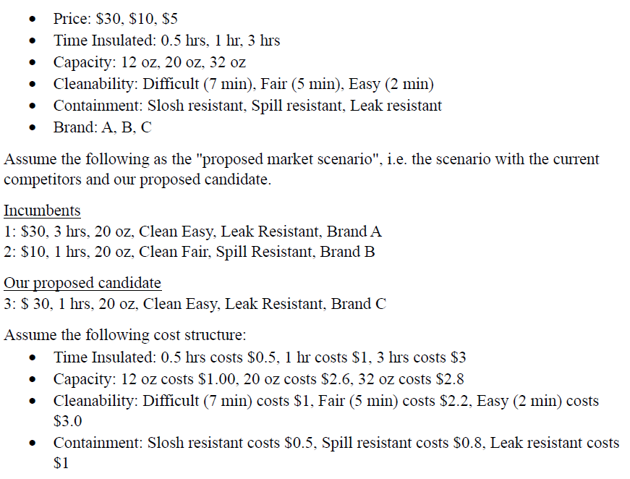

Based on the question’s ask, below screenshot shows the Candidate #45 which corresponds to our proposed candidate in the above “proposed market scenario”. In the attached excel sheet, candidate#45 is in row 46.

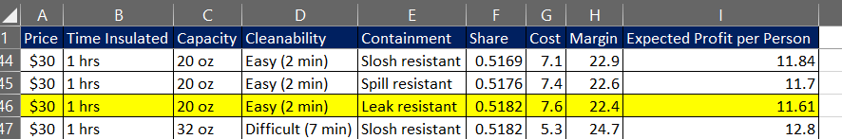

From the analysis of the data and using the compensatory rule with logit adjustment, I have also calculated the Average Candidate Share, Average Cost, Average Margin, Average Expected Profit per Person

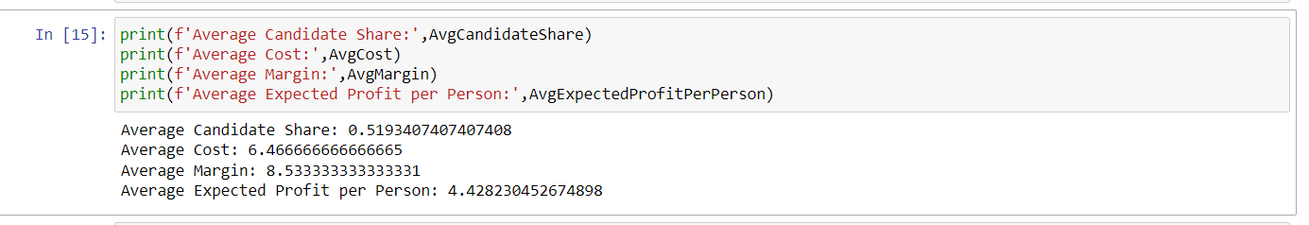

Therefore, I can conclude that the **Average Expected Profit per Person** is **4.43.**

## **Question#2**

Using the discreate optimization technique, after considering each of the three levels for all five attributes and enumerated all the possible combinations in the lexical order that is given in above “proposed market scenario” keeping price is the left most attribute with slowest chaining attribute. Attached excel has details for each customer calculation.

As request, for the two-product candidate#106 & 230, which is row# 107 & 231 respectively in the attached excel. Below screenshot shows their expected share, cost, margin and expected profit per person.



## **Question#3**

As per the question ask, below screenshot shows the optimal product and list the values of each of the product attribute.

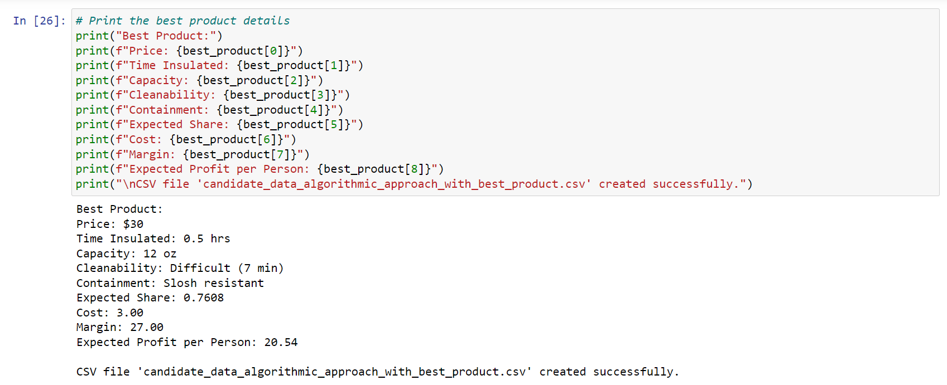

## **Question#4.1**

Considering the pure algorithmic analytical approach, the best product is the one that we identified as part of Question#3. But as asked in the question, the **Business Rational** to launch product with the highest expected share instead of EPPP is, opting to introduce a product projected to attain the utmost market share holds considerable strategic value for achieving market dominance and heightened visibility. A superior market share not only signifies widespread customer approval but also has the potential to draw in a larger consumer base. This approach proves advantageous, particularly when the company’s objective is **swift market penetration and the establishment of a robust and influential brand presence**. Below screenshot shows the product attribute of the product having highest market share.

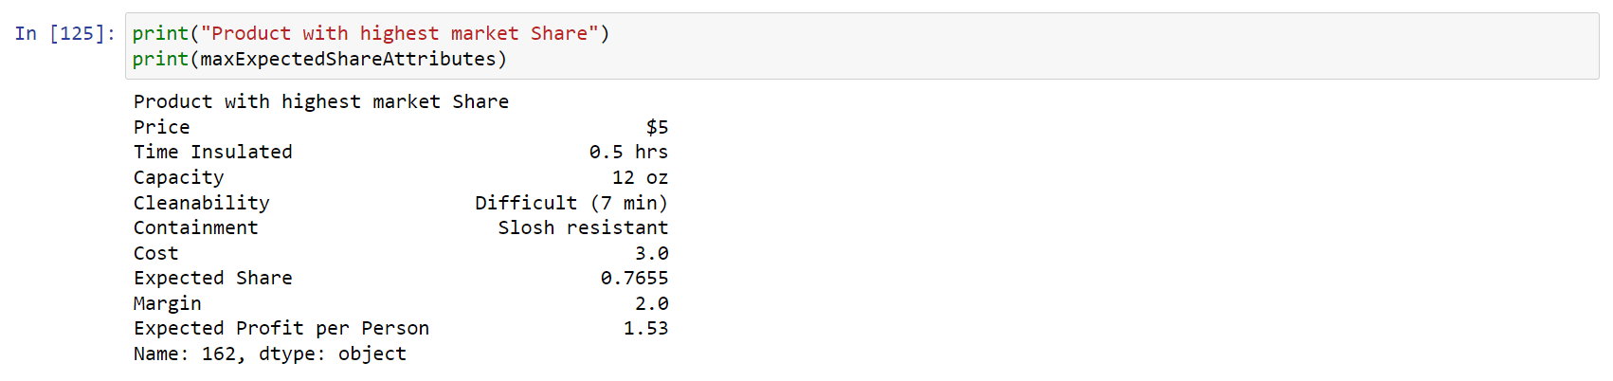

As per the asked and hint suggested in the question, the scatter plot between the EPPP vs Expected Share is as shown in below screenshot.

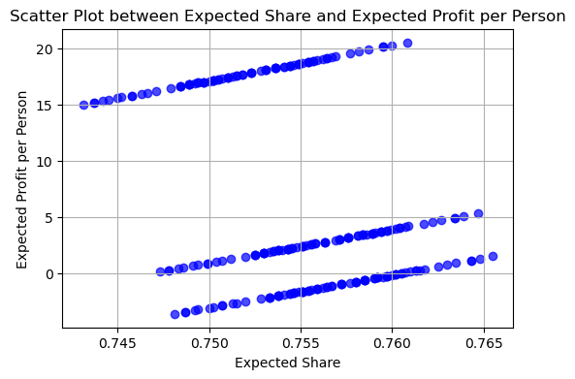

## **Question#4.2**

As asked in the question, the **Business Rational** to launch product with the maximum margin instead of EPPP is, opting to introduce a product with the utmost margin proves advantageous when the company’s central emphasis lies on maximizing profitability per unit sold. A substantial margin not only fosters enhanced financial sustainability of the company but also affords increased flexibility. This strategic choice becomes particularly apt when the company's primary goal is to **prioritize profitability**, valuing it over the pursuit of sheer market share. Below screenshot shows the product attribute of the product having maximum margin.

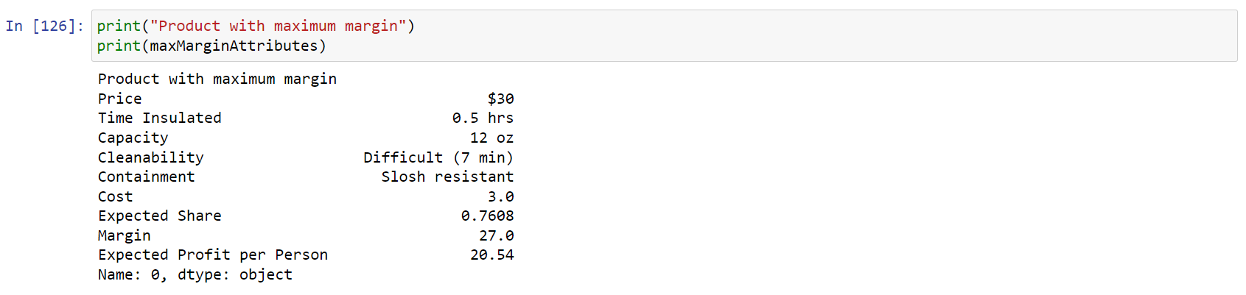

## **Question#4.3**

As asked in the question, the **Business Rational** to launch product with the lowest cost instead of EPPP is, by introducing the product with minimal cost/expense presents a company’s financially prudent strategy, particularly appealing in markets with a heightened sensitivity to pricing. It facilitates company’s competitive pricing approach, potentially leading to increased sales volume. Such an approach is well-suited for scenarios where the objective is **to attract a segment of the market with a strong emphasis on cost consciousness**. Below screenshot shows the product attribute of the product having lowest cost.

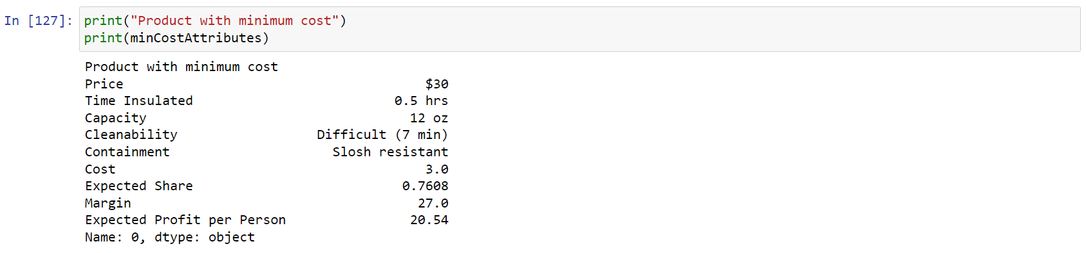

## **Question#4.4**

As asked in the question, the **Business Rational** to launch product with the maximum revenue instead of EPPP is the company adopts a strategy that involves achieving a balanced alignment among variables like price, market share, and cost. The objective is to meticulously adjust these elements, ultimately reaching **ambitious revenue generation targets**. Below screenshot shows the product attribute of the product having maximum revenue.

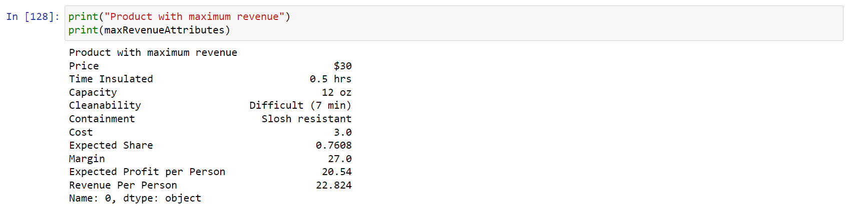

## **Appendix**

|  |  |
| --- | --- |
| Candidate data algorithmic approach with best product |  |
| Candidate data 243 combinations |  |
| Candidate data algorithmic approach |  |