RentalCar

Installation and Deployment Guide

August 10, 2024

Contents iii

1 Introduction 1-1

1.1 Purpose 1-1

1.2 Revision history 1-1

1.3 Intended audience and reading suggestions 1-1

1.4 Technical project stakeholders 1-1

1.5 References 1-2

2 Server Configurations 2-1

2.1 Microsoft SQL Server 2019 (Database) 2-1

2.1.1 Roles, Features, and Packages 2-1

2.1.2 Configuration 2-1

2.2 Visual Studio 2022(IDE) 2-2

2.2.1 Packages 2-2

3 Azure Setup 3-1

3.1 Create Azure SQL (Database) 3-1

3.1.1 Prerequisites 3-1

3.1.2 Installation Steps 3-1

3.1.3 Configured Values 3-1

3.2 Rental Car (Web Application) 3-2

3.2.1 Prerequisites 3-2

3.2.2 Installation Steps 3-2

3.2.3 Configured Values 3-3

4 Publishing using Visual Studio 4-1

4.1.1 Prerequisites 4-1

4.1.2 Publishing Steps 4-1

5 Troubleshooting 5-1

# Introduction

## Purpose

The purpose of this Installation and Deployment Guide is to describe in technical terms the steps necessary to install the software and make it operational.

## Revision history

The Revision history table shows the date, changes, and authors who have worked on this document.

| Version/Change request number | Version date | Description of changes | Author |
| --- | --- | --- | --- |
| 1 | August,10,2024 | First version | KietNVT2 |

## Intended audience and reading suggestions

This Installation and Deployment Guide is intended to be used by technical stakeholders of the project who will be responsible for planning, performing, or maintaining the installation or deployment.

It is intended that stakeholders and software support personnel can read this document and coordinate their efforts in the installation/deployment of the application.

## Technical project stakeholders

This section provides a list of all known stakeholders with an interest in the project.

| Name | E-mail address | Phone | Role |
| --- | --- | --- | --- |
| 1. Len Van Hau | haulv1@fpt.com |  | Project Manager |
| 1. Vu Truong An | anvt15@fpt.com |  | Developer |
| 1. Cao Duy Quan | quancd2@fpt.com |  | Developer |
| 1. Nguyen Minh Quan | quannm66@fpt.com |  | Developer |
| 1. Nguyen Hoang Bach | bachnh4@fpt.com |  | Developer |
| 1. Le Anh Tien | tienla3@fpt.com |  | Developer |
| 1. Nguyen Vu Tuan Kiet | kietnvt2@fpt.com |  | Developer |

## References

| Reference No. | Document | Author(s) |
| --- | --- | --- |
| REF-1 | [Visual Studio 2022(Community)](http://www.microsoft.com/download/en/details.aspx?displaylang=en&id=17718) | Microsoft |
| REF-2 | [SQL Server installation guide](http://msdn.microsoft.com/en-us/library/ms143219.aspx) | Microsoft |
| REF-3 | [Azure for Students](http://www.microsoft.com/download/en/details.aspx?displaylang=en&id=17718) | Microsoft |
| REF-4 | [Microsoft Azure Portal](http://www.microsoft.com/download/en/details.aspx?displaylang=en&id=19663) | Microsoft |

# Server Configurations

## Microsoft SQL Server 2019 (Database)

SQL Server 2019 is not supported on Windows 8.1 or Windows Server 2012 R2.

### Roles, Features, and Packages

**Packages**

The following software packages must be installed on the operating system prior to installation of the software:

* Microsoft SQL Server 2019 (see REF-2)
  + Database Engine
  + Management Tools

### Configuration

SQL Server Configuration:

Authentication

SQL Server Authentication should be enabled

SQL Server Network Configuration

TCP/IP should be enabled

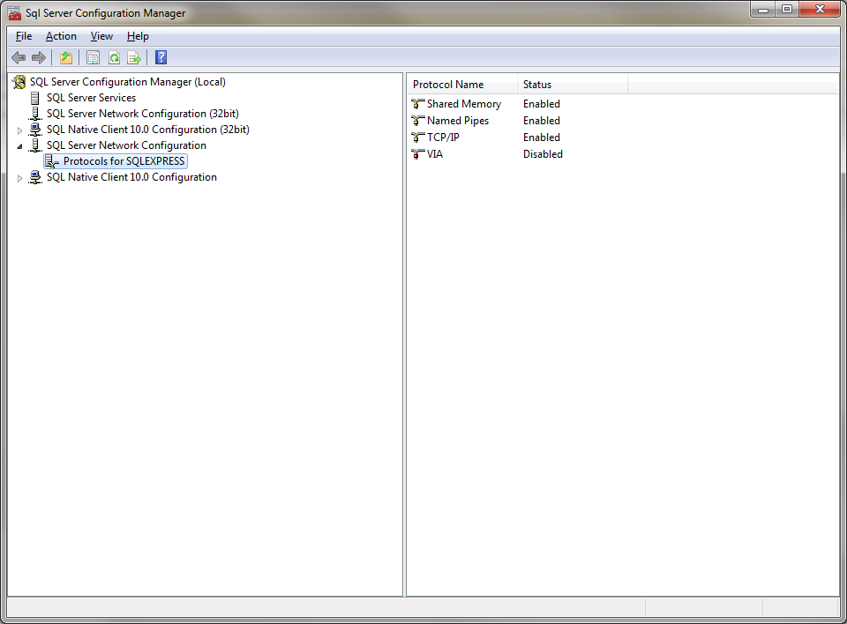

## Visual Studio 2022 (IDE)

### Packages

The following software packages must be installed on the operating system prior to installation of the software:

* Visual Studio 2022 (see REF-1).
* ASP.NET and web development in VS2022.
* SDK 8.0.303.

# Azure Setup

## Create Azure SQL (Database)

### Prerequisites

1. All steps in section 2.1 “Microsoft SQL Server 2019” have been performed.

### Installation Steps

1. Open Azure portal, login to portal using account with Student Subscription (see REF-3).
2. Create a new Resource group named “WebApp”.
3. Create a new Azure SQL database in “WebApp” named “RentCarDB”.
4. Set Firewall rule “Add current client IP address”.
5. “Use existing data” choose none
6. “Allow Azure services and resources to access this sever” choose yes.
7. “Authentication” choose SQL Authentication.
8. “Subscription” choose Azure for Students.
9. Create new database server named “rental-car-db-server” with account name and password

in 3.1.3.

1. Choose “rental-car-db-server” as database server for “RentCarDB”.
2. You will have 2 resources in your resource group like this:

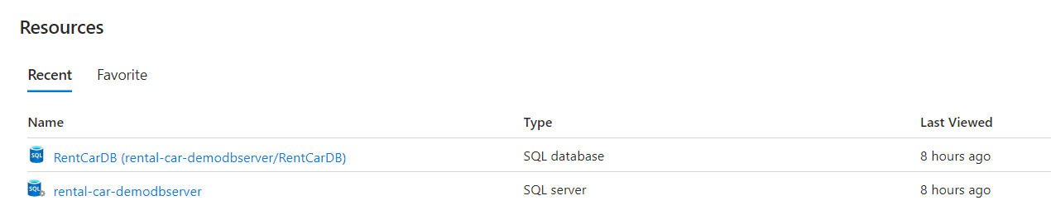

1. Open SQL Server Management Studio and log into the server and instance using the account name and password in 3.1.3.
2. In “RentCarDB” run the script to create data.

### Configured Values

Use the table below to make note of the values for your installation environment for future reference.

| Information | Value |
| --- | --- |
| SQL admin | tuankietnvu |
| SQL password | Hehehe123@@ |
| Connection string name | DefaultConnection |

## Rental Car (Web Application)

### Prerequisites

1. All steps in section 2 “Server Configurations” have been performed.
2. All steps in section 3.1 “Azure Setup, Create Azure SQL (Database)” have been performed.

### Installation Steps

1. Create a new App Services in resources “WebApp” named “rentalcar”.

1.1 Basic

* 1. “Subscription” choose Azure for Students.
  2. “Publish” choose Code.
  3. “Runtime stack” choose .NET 8.
  4. “Operating System” choose Windows.
  5. “Region” choose Southeast Asia.

1.2 Deployment

a. “Continuous deployment” choose Disable.

1.3 Networking

a. “Enable public access” choose On.

2. Review and create.

3. After that you will have App Service like this

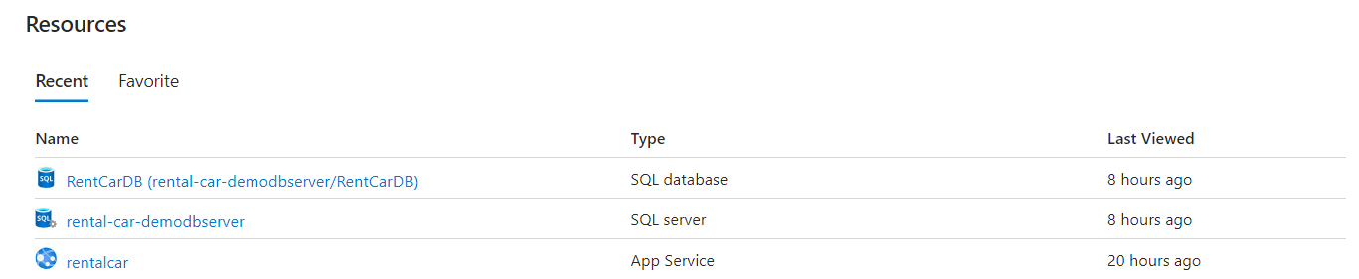

### Configured Values

Use the table below to make note of the values for your installation environment for future reference.

| Information | Value |
| --- | --- |
| Default domain | rentalcar.azurewebsites.net |
| FTP basic auth publishing credentials | On |
| HTTPS only | On |
| .NET version | .NET 8(LTS) |

# Publishing using Visual Studio.

### 4.1.1. Prerequisites.

All steps in section 2.“Server Configurations” and 3.”Azure Setup” have been performed.

### 4.1.2. Publishing Step.

1. Open project with Visual Studio 2022.

2. Right click on your project, select “Publish”

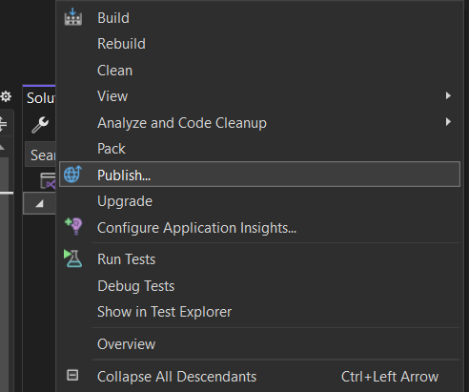

3 . “Target” Select “Azure”

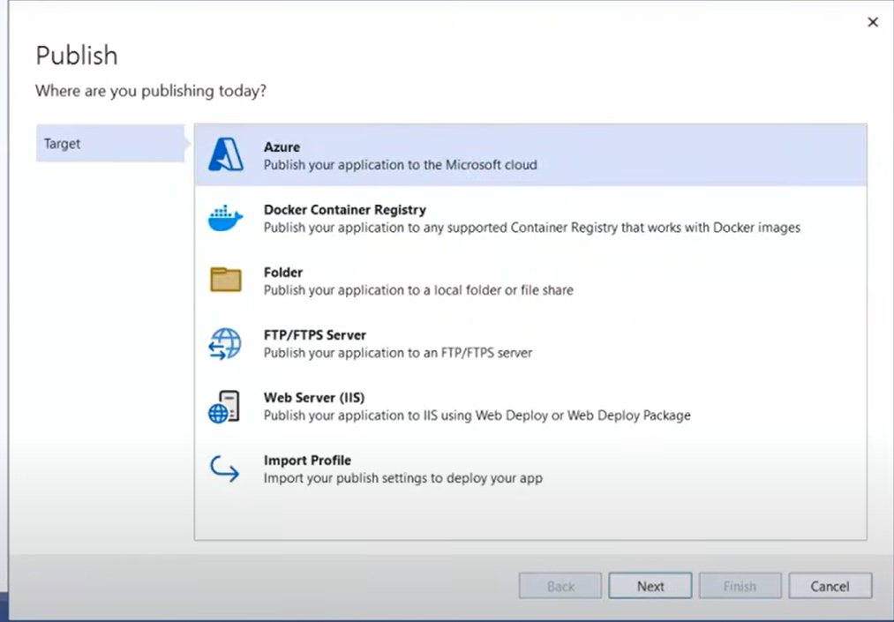

4.”Specific target” choose “Azure App Service(Windows)”

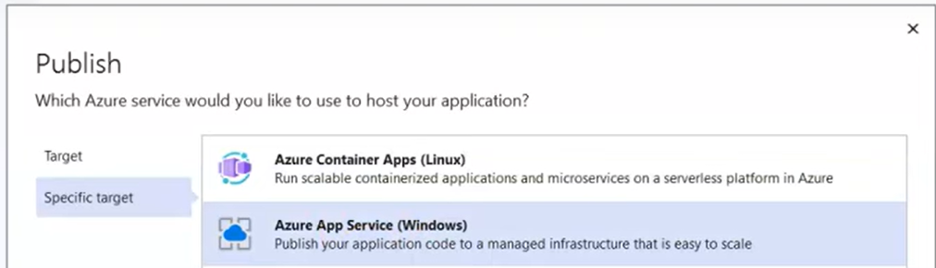

5.”App Service” choose your app service create in section 3.2.

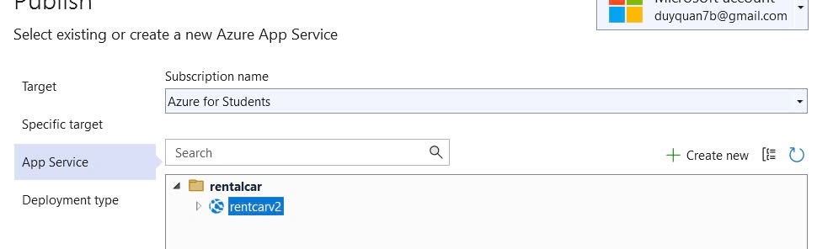

1. "Deployment type” choose “Publish(generates pubxml file)”

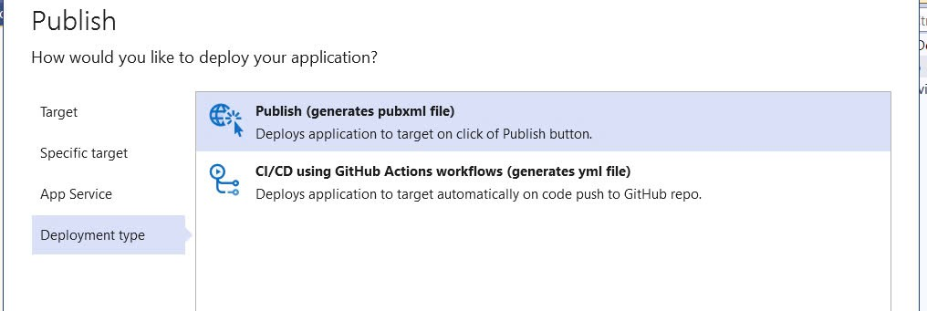

1. Finish.
2. Add database dependency following these steps:
3. select “Azure SQL Database”

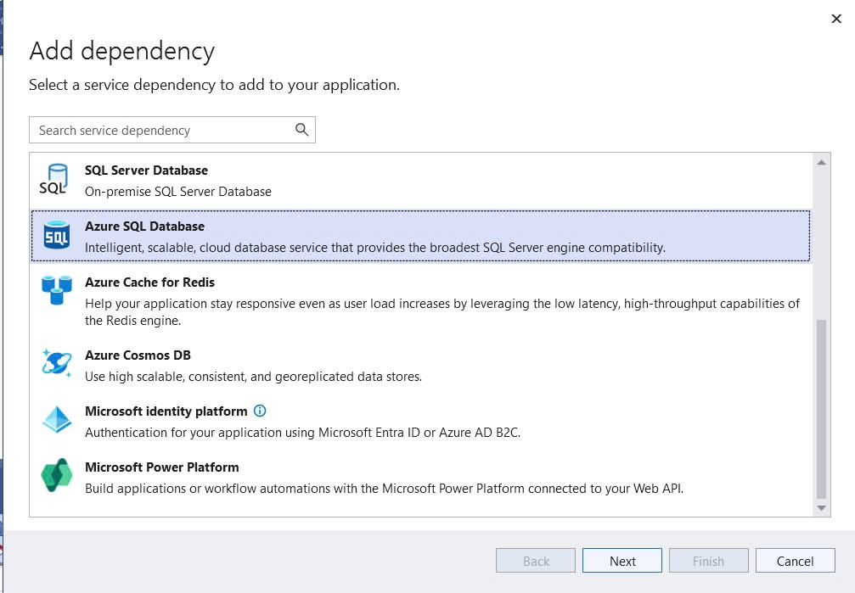

1. Select database created in section 3.1.

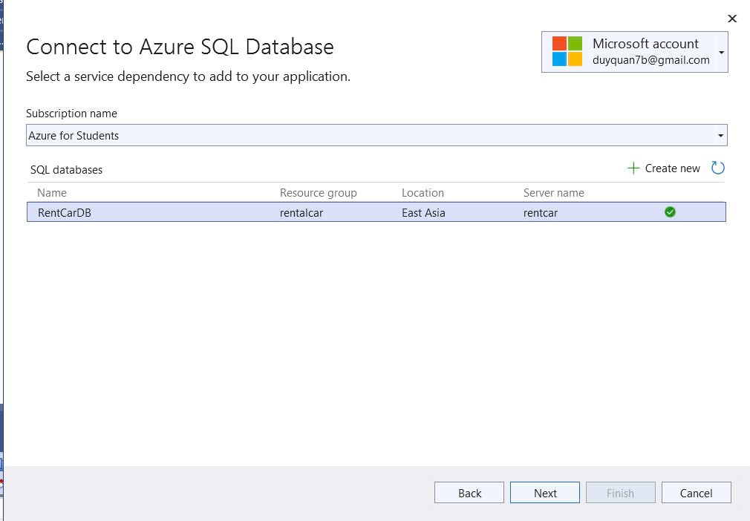

1. Using section 3.1.3 to fill this.

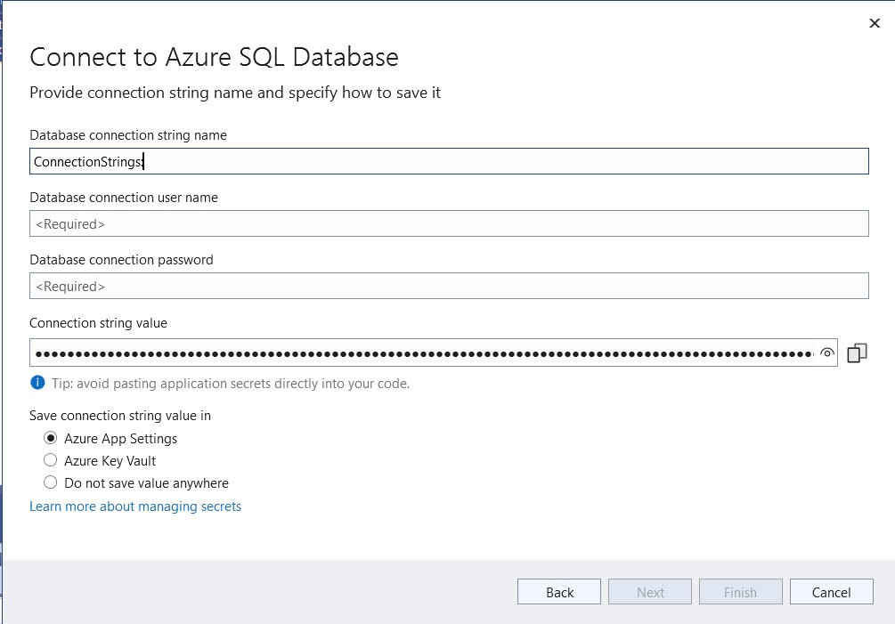

1. Finish.

# Testing the Installation

1. Navigate your web browser to the Host Name you noted in section 3.2.3.
2. Ensure that the web appears.
3. Ensure that functions of web work correctly.