Practical No. 5
Aim: To create a web-based calculator using HTML, CSS, and JavaScript that performs various arithmetic operations with a user-friendly interface.

Theory:

Program :

Index.html (Document save as Index.html)

<!DOCTYPE html>
<html lang="en">
<head>
<meta charset="UTF-8">
<meta name="viewport" content="width=device-width, initial-scale=1.0">
<title>Calculator</title>
<link rel="stylesheet" href="style.css">
</head>
<body>
<div class="calculator">
<input type="text" id="display" class="display" disabled/>
<div class="buttons">
<button class="btn" onclick="appendToDisplay('1')">1</button>
<button class="btn" onclick="appendToDisplay('2')">2</button>
<button class="btn" onclick="appendToDisplay('3')">3</button>
<button class="btn" onclick="appendToDisplay('+')">+</button>

<button class="btn" onclick="appendToDisplay('4')">4</button>
<button class="btn" onclick="appendToDisplay('5')">5</button>
<button class="btn" onclick="appendToDisplay('6')">6</button>
<button class="btn" onclick="appendToDisplay('-')">-</button>

<button class="btn" onclick="appendToDisplay('7')">7</button>
<button class="btn" onclick="appendToDisplay('8')">8</button>
<button class="btn" onclick="appendToDisplay('9')">9</button>
<button class="btn" onclick="appendToDisplay('*')">*</button>

<button class="btn" onclick="appendToDisplay('0')">0</button>
<button class="btn" onclick="clearDisplay()">C</button>
<button class="btn" onclick="calculateResult()">=</button>
<button class="btn" onclick="appendToDisplay('/')">/</button>
</div>
</div>

<script src="script.js"></script>
</body>
</html>

Style.css
* {
margin: 0;
padding: 0;
box-sizing: border-box;
}

body {
font-family: Arial, sans-serif;
display: flex;
justify-content: center;
align-items: center;
height: 100vh;
background-color: #f4f4f4;
}

.calculator {
background-color: #fff;
border-radius: 10px;
box-shadow: 0 10px 20px rgba(0, 0, 0, 0.1);
padding: 20px;
width: 280px;
display: flex;
flex-direction: column;
align-items: center;
}

.display {
width: 100%;
height: 50px;
margin-bottom: 10px;
font-size: 2em;
text-align: right;
padding: 10px;
border-radius: 10px;
border: 1px solid #ccc;
background-color: #f9f9f9;
}

.buttons {
display: grid;
grid-template-columns: repeat(4, 1fr);
gap: 10px;
width: 100%;
}

.btn {
padding: 20px;
font-size: 1.5em;
border: 1px solid #ddd;
background-color: #f1f1f1;
border-radius: 10px;
cursor: pointer;
transition: background-color 0.3s;
}

.btn:hover {
background-color: #ddd;
}

.btn:active {
background-color: #bbb;
}

Script.js

let display = document.getElementById('display');

function appendToDisplay(value) {
display.value += value;
}

function clearDisplay() {
display.value = '';
}

function calculateResult() {
try {
display.value = eval(display.value);
} catch (error) {
display.value = 'Error';
}
}

Output:
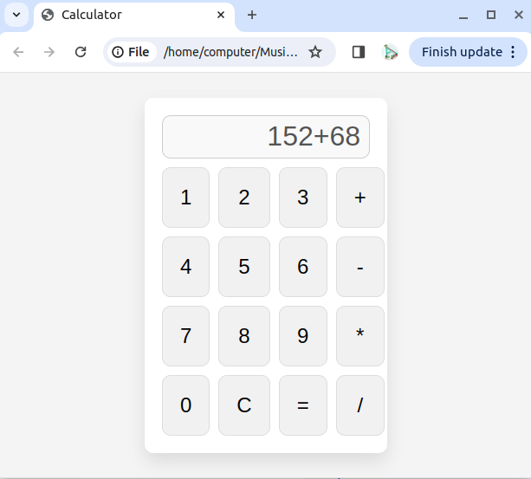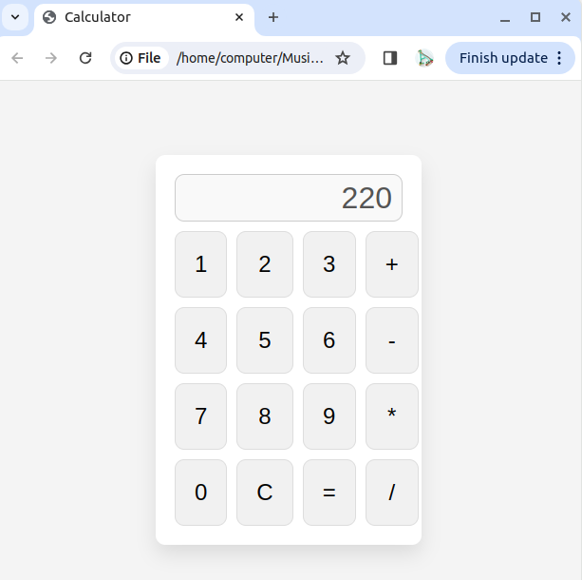

Conclusion: We have designed calculator successfully by using HTML, CSS and Javascript function.

