GDD

Type: Shooter  
Style: Stylized  
Setting: fantasy  
first-person

Levels: Floating islands based on biome

Island arena, plains(forest)/desert/arena for boss colosseum  
boss elk 3e island

Weapons:  
pistol: medium-medium  
sniper: low firerate-highdamage  
watergun: high firerate-lowdamage

Characters:  
elemental(fire, nature, water): ranged / slow but versatile  
goblin: melee / tiny and fast  
golem with elemental crystal: melee /heavy slow tank

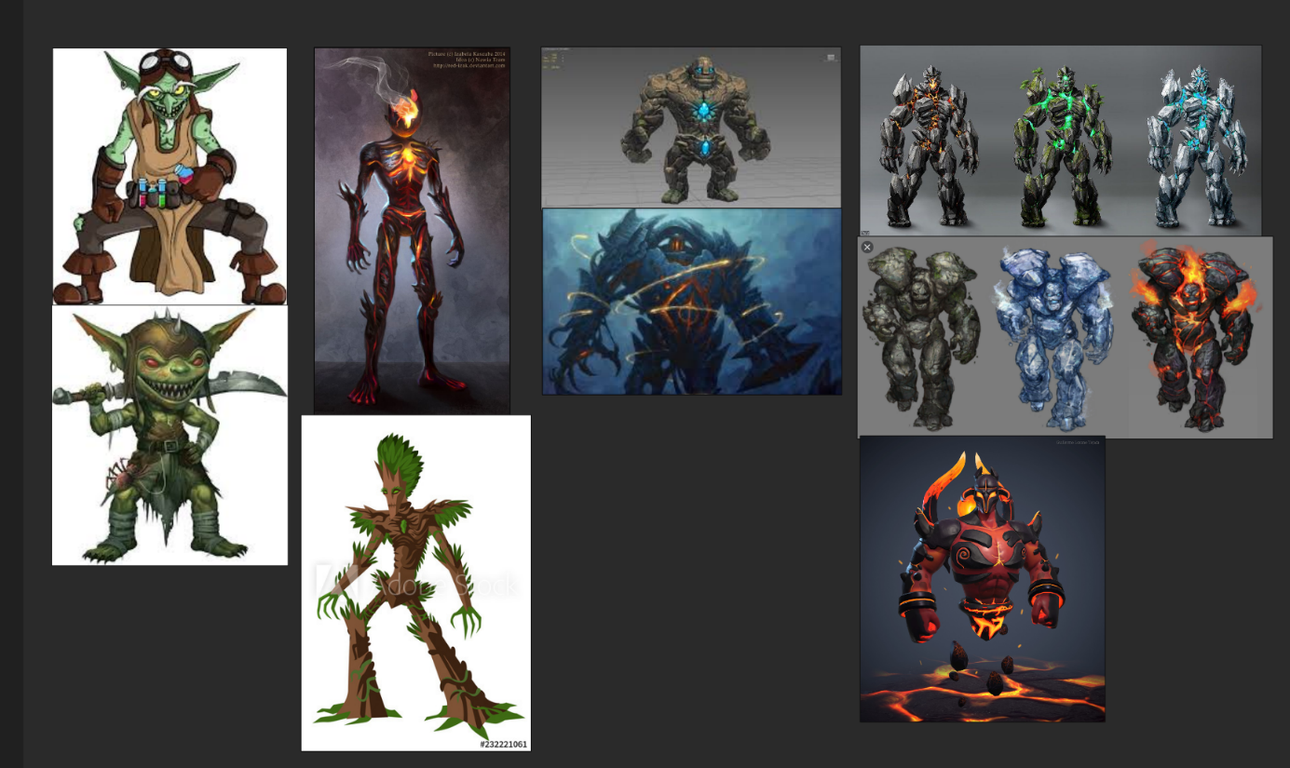

Elemental origin = based on island

Golem everywhere  
goblins everywhere

UI? Mathijs Sacrificed himself!

Pick-ups:

Meer attack %  
meer attackspeed %  
life orb

boss items upgraden weapons:

Double shot 20%,   
explosion on hit chance 10%,   
enemies can drop mines when killed,  
life on hit,  
slow bullets/1.5 attackspeed,  
execute below 10% hp  
laser on hit for nearby enemies,  
CRITS,  
half hp, double damage,  
double damage/breaks after being hit,

Main menu

Start  
options  
controls?  
exit

Spawning

Enemies spawn around you after 10 sec of starting game.

Stages

After every boss level enemies get stronger.