GDD

Type: Shooter  
Style: Stylized  
Setting: fantasy  
first-person

Levels: Floating islands based on biome

Island arena, plains(forest)/desert/arena for boss colosseum  
boss elk 3e island

Weapons:  
pistol: medium-medium  
sniper: low firerate-highdamage  
watergun: high firerate-lowdamage

Characters:  
elemental(fire, nature, water): ranged / slow but versatile  
goblin: melee / tiny and fast  
golem with elemental crystal: melee /heavy slow tank

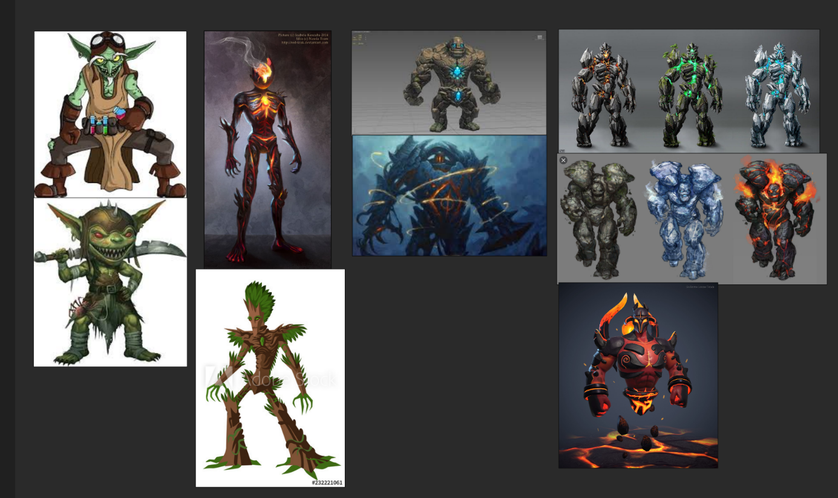

Elemental origin = based on island

Golem everywhere  
goblins everywhere

UI? Mathijs Sacrificed himself!

Main menu

Start  
options  
controls?  
exit

Spawning

Enemies spawn around you after 10 sec of starting game.

Stages

After every boss level enemies get stronger.