**Optional Project Specification**

**1) Problem to solve**

Given a keypad, where number 2 stands for letter a or b or c, and number 3 stands for d or e or f , etc, as defined on keypad of a old cell phone.

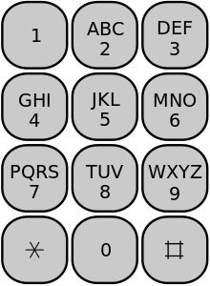

Given a standard dictionary **D**, which provides only **one** service -- where you can check whether a string of letters comprise a valid English word or not.

**Input:** A sequence of **N** numbers denoted by **S**, such as **S**= {2, 3, 4} with **N** = 3, And the dictionary **D** and the letters that each digit stands for.

**Output**: all possible valid English words represented by the input sequence of digits **S** according to the provided dictionary **D**.

**2) Specifics**

1. You have to construct the tree in your memory as we learned in class, for example, the tree below is built for input sequence S={2, 3, 5, …. 6}. So that the original problem will be transformed into another problem where you have to first find all paths in the tree below. Then you check the string associated with each path.

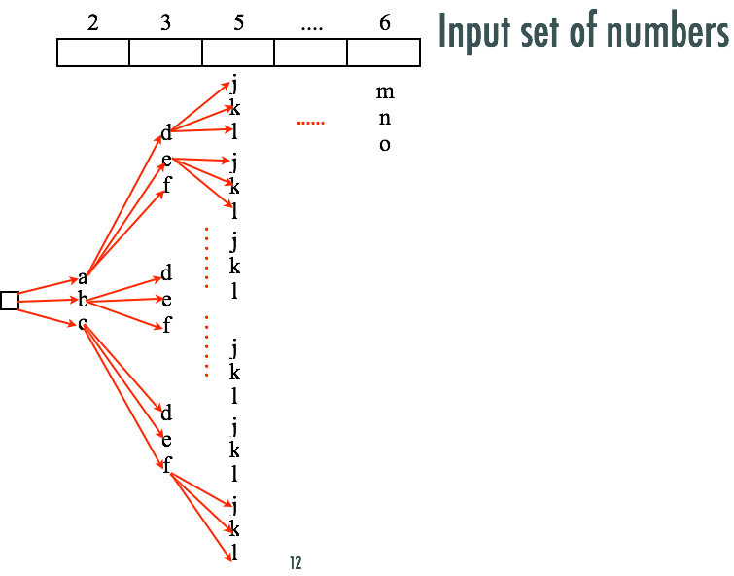

1. Given a list of English words in a text file, you have to implement the dictionary in two ways, in order to fast index a word in a dictionary, i.e. Hashing and Prefix Tree.

You are allowed to use the built-in HashTable class in your code. You have to test your project against both dictionary implementations.

1. Pleas analyze the time complexity of your algorithm if users enter N digits. Specifically, the time cost for constructing the tree, the time cost for dictionary searching, and the cost for solving the entire problem of N digits of input.
2. At least you have to implement a user interface that allows users to enter some digits on the **standard input**, then your program outputs all possible English words on **standard output** for the input sequence. A GUI is **not** required.
3. Write a project report in PDF format. The report includes:

1) your answers to question (c) above.

2) Please search online references regarding the concept of Exhaustive Search. What is Exhaustive Search? Which part of this project falls into Exhaustive Search?

3) Please search online references regarding the concept of Branch and Bound. What is Branch and bound?

4) If you use the Prefix Tree to implement the dictionary, can you use the prefix tree property to accelerate your algorithm together with Branch and Bound? and How? please illustrate with a specific example and use a diagram if necessary.

5) Please include at least 5 different runs of your program with different input sequences. Please catch any errors so that your program will not crash.

1. Please organize your source code, so that the users are able to compile all your source code on the command line using **javac *.java** and Run your program with a command **java Tester**
2. **If you successfully implemented both the Exhaustive Search solution and the Branch and Bound solution, as we discussed in the classroom, (you compared the time cost of these two solutions and your two solutions produced correct answers) you will get 20% bonus on top of 100%.**

**3) To turn in**: Please wrap up all your source code and the project report into a single zip file, and turn in the single zip on Canvas, under the Assignment section. Please name your zip file using the convention we used before.