|  |  |
| --- | --- |
| A picture containing green  Description automatically generated  Week #11 Assignment  2% Individual Assignment | Triggers and 1NF  Mark Morell  Database Management – Fall 2019 |

# Assignment Type:

# Individual – Prepare and submit your results independently

# Date Due:

# Thursday, November 21st by the end of the day

# Instructions:

# Please submit your assignment electronically through eConestoga.

# Assignments should be submitted as Microsoft Word files using the course coversheet format. You **MUST** include your query as text in the Word document as well as a **FULL screenshot** of your SSMS screen (screen capture the entire application screen including the title bar through the bottom of the window). Multiple screenshots may be required.

# If you are using external sources (images, text, etc.) you must reference them as part of your assignment and not copy them as-is.

# Best practice is to research your answers and then write the response to the question in your own words.

# Please include the question number with your responses.

# Late Assignment Penalty:

|  |  |
| --- | --- |
| Days Late | Penalty % |
| 1 | 5 |
| 2 | 10 |
| 3 | 20 |
| 4 | 40 |
| 5 | 60 |
| 6 | 80 |
| 7 | 100 |

**Answer1:**

**a.**

USE Costume

GO

CREATE TABLE dbo.LowCostumeInventory (

id INT IDENTITY NOT NULL,

costumeId INT NOT NULL,

lowInventorySince DATETIME2 NOT NULL,

CONSTRAINT PK_id PRIMARY KEY (id)

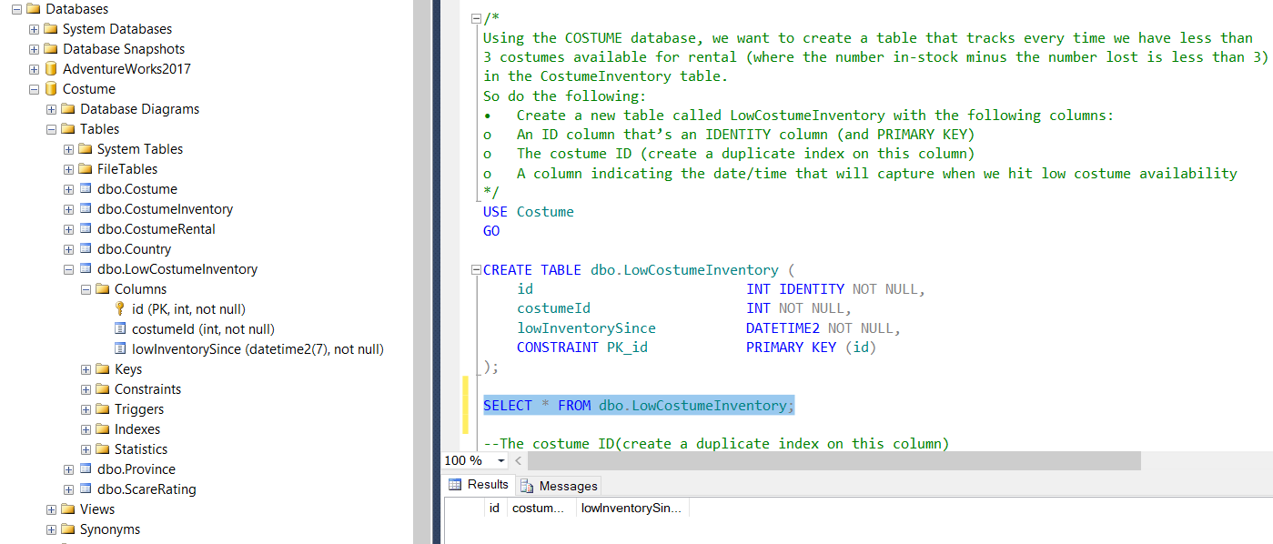);

--The costume ID(create a duplicate index on this column)

USE Costume

GO

CREATE INDEX IX_COSTUME ON dbo.LowCostumeInventory(costumeId);

CREATE INDEX IX_COSTUME_DUP ON dbo.LowCostumeInventory(costumeId);

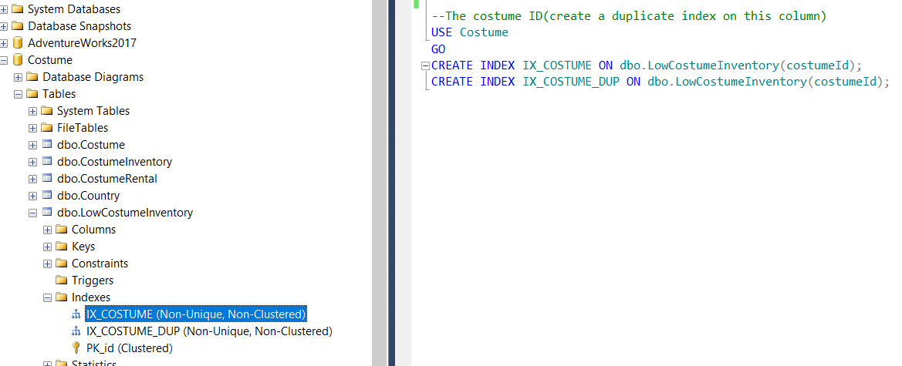

**Answer1b.**

USE COSTUME

GO

CREATE TRIGGER TR_UPINS_CostumeInventoryManage

ON dbo.CostumeInventory

AFTER INSERT, UPDATE, DELETE

AS

BEGIN

SET NOCOUNT ON;

DECLARE @count AS INT;

IF (SELECT SUM(i.numberInStock - i.numberLost) FROM inserted i ) < 3

BEGIN

INSERT INTO dbo.LowCostumeInventory

SELECT i.costumeID, GETDATE() FROM inserted i

END

END;

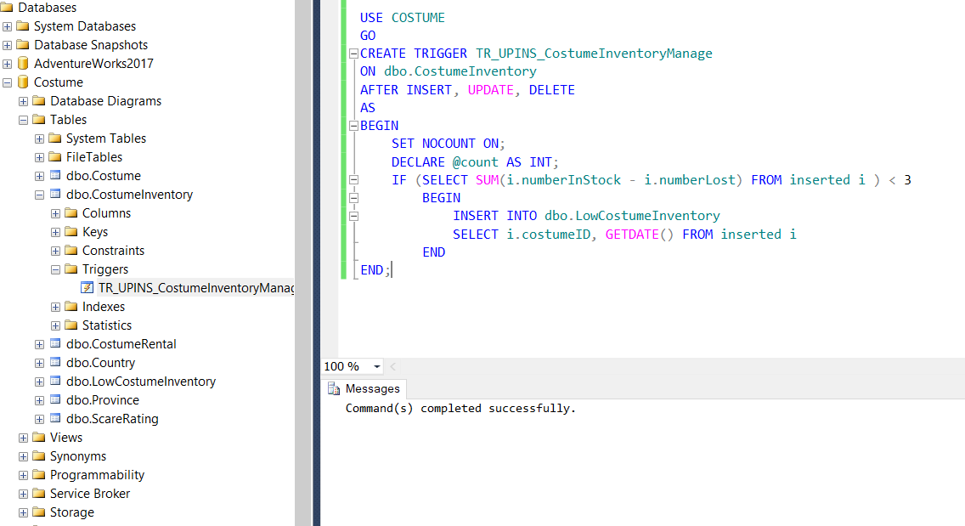

**Answer1c.**

--Successful Trigger

UPDATE CostumeInventory

SET numberInStock = '4'

WHERE costumeId = '4'

--Check

SELECT * FROM dbo.LowCostumeInventory;

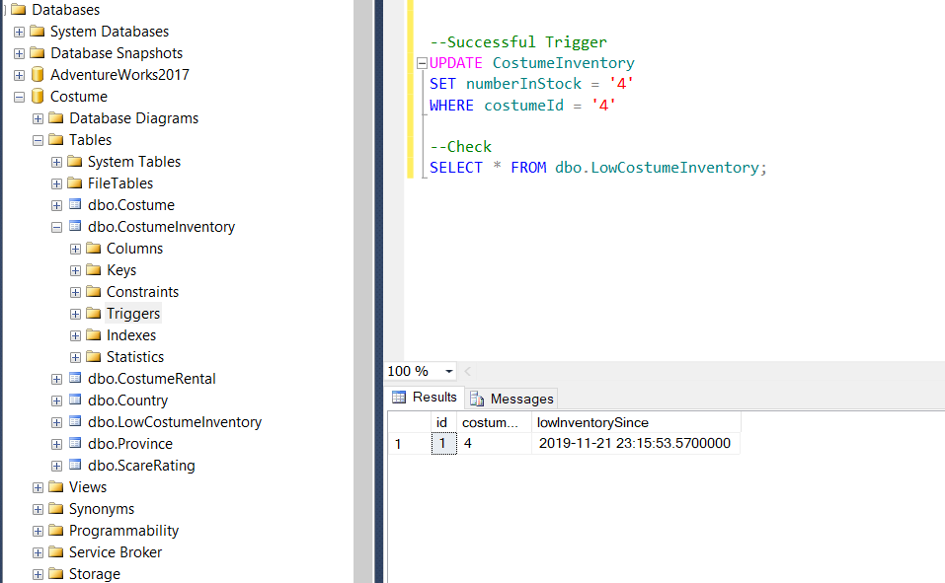

--UnSuccessful Trigger

UPDATE CostumeInventory

SET numberInStock = '40'

WHERE costumeId = '5'

--Check

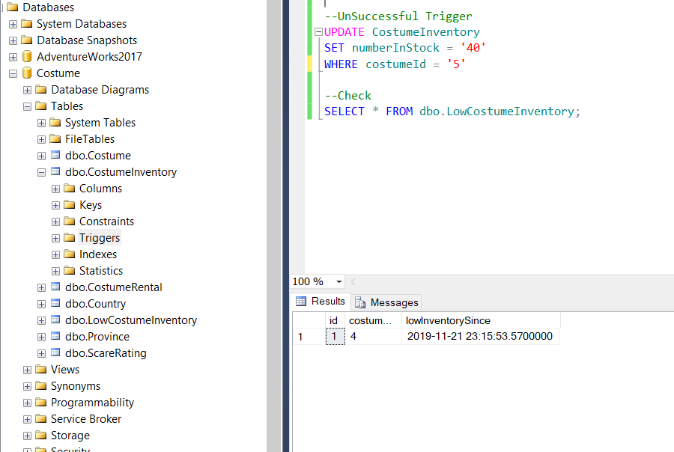SELECT * FROM dbo.LowCostumeInventory;

**Answer2**: 1N breakdown of given table.

**Product:**

|  |  |  |
| --- | --- | --- |
| ProductID | ProductName | Description |
| 1 | Volleyball | Soft-touch |
| 2 | Football | 8-lace design |
| 3 | Soccer Ball | Junior Size |
| 4 | Tennis Ball | Standard |
| 5 | Racquetball | Blue Dot |

**ProductPrice:**

|  |  |
| --- | --- |
| ProductID | Cost |
| 1 | $39.99 |
| 2 | $45.99 |
| 3 | $29.97 |
| 4 | $4.99 |
| 5 | $7.97 |

**ProductColour:**

|  |  |
| --- | --- |
| ProductID | Colour |
| 1 | White |
| 1 | Green |
| 1 | Blue/Yellow |
| 2 | Brown |
| 2 | Orange |
| 2 | Blue/White |
| 3 | Red/White |
| 3 | Red |
| 4 | Yellow |
| 5 | Black |
| 5 | Purple |