

# IT Assignment Coversheet

**Course**: PROG8080 – Database Management

Program Coordinator: David Allison

Professor/Instructor: Mark Morell

Assignment #: 2

Assignment Type:  Individual  Pair  Team

Date Submitted: September 19th, 2019

# **Student Information**

|  |  |
| --- | --- |
| Name | Uploaded (for instructor) |
| Chaitanya Uttarwar |  |
| Aparna Tomar |  |
| Saim Ahmad |  |
| Zeefa Karim |  |
|  |  |

# 

|  |  |  |  |  |  |
| --- | --- | --- | --- | --- | --- |
| **Programming & SQL Standards - 1% each** | | | |  | |
|  | P1 Meaningful Identifiers | |  | P20 Code Module Size and Focus | |
|  | P2 Prefixes & Hungarian Notation | |  | P21 Single Point of Exit | |
|  | P3 Identifier Case Conventions | |  | P22 Disabled Code & Misleading | |
|  | P4 Header Comments | |  | P23 Each Class in a File Named | |
|  | P5 Method Comments | |  | P24 Class Organization | |
|  | P9 "Magic" Numbers and Strings | |  | P25 Unwise Coding Practice | |
|  | P10 Constant Scope | |  | SQL1 Table Names | |
|  | P11 Indentation | |  | SQL2 Column Names | |
|  | P12 Line Length and Wrapping | |  | SQL3 Keywords & Function Names | |
|  | P13 Blank Lines | |  | SQL4 Header Comments | |
|  | P14 Code Crowding | |  | SQL5 Output Messages | |
|  | P15 Space Around Binary Operators | |  | SQL6 Implementation Comments | |
|  | P16 Space After Delimiters | |  | SQL7 Formatting | |
|  | P17 Curly Brace Alignment | |  | SQL8 Subquery IN and = | |
|  | P19 Global Variables | |  |  | |
|  | |  | | **Late Assignments** | |
| **Days Late** | **Penalty %** |
| **Base Mark:** | |  | | 1 | 5 |
| **Standards Penalties: - %** | | - | | 2 | 10 |
| **Late Penalties: - %** | | - | | 3 | 20 |
| **Final Mark:** | |  | | 4 | 40 |
|  | |  | | 5 | 60 |
| 6 | 80 |
| 7 | 100 |
|  |  |

# IT Standards Marking Sheet

## **Answer1:**

|  |  |  |
| --- | --- | --- |
| Data in Question | T-SQL Data Type | Why? |
| A list of street addresses for businesses | NVARCHAR/NCHAR | Unicode NVARCHAR is chosen because address could have characters from other languages or region. Some addresses are longer than others. Therefore, both NVARCHAR and NCHAR could be used as datatype. For NCHAR, character limit can be set high. |
| A picture from Twitter | IMAGE | Image data type is chosen as data in question is a picture of not too big size. |
| A list of car license plate numbers | NCHAR | Number of Characters in a license plates are fairly limited. |
| A list of holidays | DATE | Date need to displayed, therefore DATE data type is chosen. |
| A list of prices for movie rentals | SMALLMONEY | Value will be in dollar and it is expected to be couple of hundred bucks at max. |
| The answer to the question “Did you eat lunch today?” | CHAR/NCHAR | Answer to this question has following possibilities:  ‘Yes’ or ‘YES’ or ‘Y’ or ‘No’ or ‘NO’ or ‘N’. Therefore, the answer could have at most 3 characters. |

**Answer 2**

## **What is the precision and scale of the following numbers:**

1. 22573.41 🡺 **Precision**: 7 **Scale**: 2
2. 527 **🡪** **Precision**: 3 **Scale**: 0

## **What is the length of the following strings (between the quotation marks):**

1. “I’ll_Be_Back!” 🡪 13
2. “Friends don’t let friends drink and drive” 🡪 41

## **Answer 3:**

1. What are the various candidate keys for this table?

**Unique Candidate Key(s):**

1. hockeyID
2. jerseyNumber
3. mainTeam + fullName + birthDate.
4. Are each of these keys’ natural keys or surrogate keys?
   1. **Surrogate Key**: hockeyID
   2. **Natural Key:** jerseyNumber
5. What would make the best choice for the primary key and why?

In our opinion, it will be ideal to go with **hockeyID** as **primary key** of the table in question. It is a surrogate key as well. As it is a surrogate key, uniqueness of record is guaranteed.

We can also go with **jerseyNumber** but uniqueness of jersey number is not guaranteed. Player can decide to change their jersey number and let the administrators know. With the uncertainty that player is going to stick with their Jersey Number, there is no point in going ahead with jerseyNumber as primary key.

## **Question 4:**

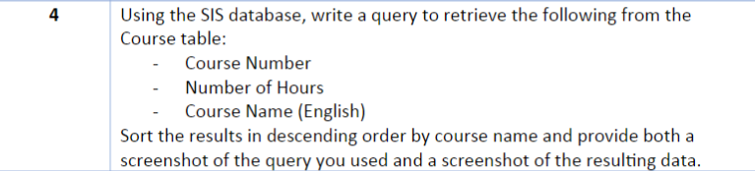

**Solution**

**Query:**

*Select   
number as ‘Course Number’,  
hours as ‘Number of Hours’,  
name as ‘Course Name’  
from dbo.Course  
order by name desc*

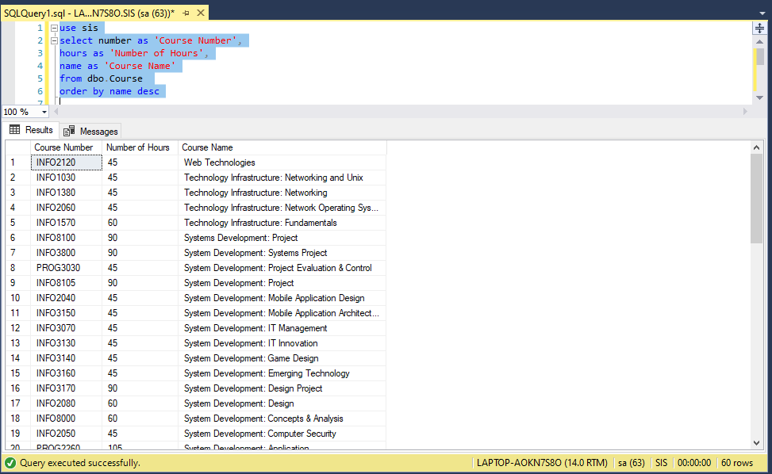

**Question 5**

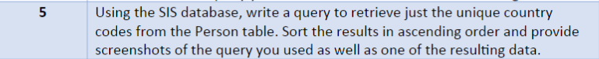

**Solution**

**Query:**

*Select  
DISTINCT countryCode  
from dbo.Person  
order by countryCode*

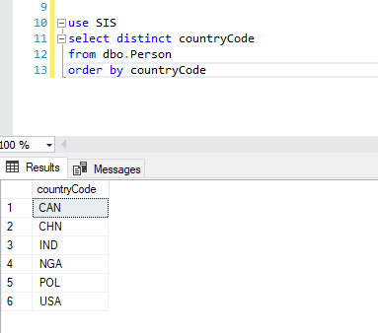

## **Question 6**

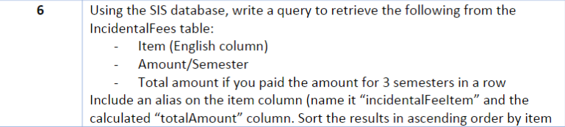

**Solution**

**Query:**

*SELECT  
item as ‘IncedentalFeeItem’,  
amountPerSemester,  
amountPerSemester*3 as ‘totalAmount’  
from dbo.IncidentalFee  
order by item*

