

# IT Assignment Coversheet

**Course**: PROG8080 – Database Management

Program Coordinator: David Allison

Professor/Instructor: Mark Morell

Assignment #: 5

Assignment Type:  Individual  Pair  Team

Date Submitted: October 10th, 2019

# **Student Information**

|  |  |
| --- | --- |
| Name | Uploaded (for instructor) |
| Aparna Tomar |  |

# 

|  |  |  |  |  |  |
| --- | --- | --- | --- | --- | --- |
| **Programming & SQL Standards - 1% each** | | | |  | |
|  | P1 Meaningful Identifiers | |  | P20 Code Module Size and Focus | |
|  | P2 Prefixes & Hungarian Notation | |  | P21 Single Point of Exit | |
|  | P3 Identifier Case Conventions | |  | P22 Disabled Code & Misleading | |
|  | P4 Header Comments | |  | P23 Each Class in a File Named | |
|  | P5 Method Comments | |  | P24 Class Organization | |
|  | P9 "Magic" Numbers and Strings | |  | P25 Unwise Coding Practice | |
|  | P10 Constant Scope | |  | SQL1 Table Names | |
|  | P11 Indentation | |  | SQL2 Column Names | |
|  | P12 Line Length and Wrapping | |  | SQL3 Keywords & Function Names | |
|  | P13 Blank Lines | |  | SQL4 Header Comments | |
|  | P14 Code Crowding | |  | SQL5 Output Messages | |
|  | P15 Space Around Binary Operators | |  | SQL6 Implementation Comments | |
|  | P16 Space After Delimiters | |  | SQL7 Formatting | |
|  | P17 Curly Brace Alignment | |  | SQL8 Subquery IN and = | |
|  | P19 Global Variables | |  |  | |
|  | |  | | **Late Assignments** | |
| **Days Late** | **Penalty %** |
| **Base Mark:** | |  | | 1 | 5 |
| **Standards Penalties: - %** | | - | | 2 | 10 |
| **Late Penalties: - %** | | - | | 3 | 20 |
| **Final Mark:** | |  | | 4 | 40 |
|  | |  | | 5 | 60 |
| 6 | 80 |
| 7 | 100 |
|  |  |

# IT Standards Marking Sheet

|  |  |  |
| --- | --- | --- |
| Question # | Question | Score |
| 1 | Retrieve data from the HumanResrouces.Employee table for employees who have taken **less than 8 hours of vacation** (VacationHours). Show the following information in the results:   * Employee ID * Job Title * Gender converted for entries for “Male” and “Female” * The “SalariedFlag” column displayed as:   + 1 = “Salaried”   + 0 = “Non-Salaried”   + Anything Else = “Unknown” * Vacation Hours   Order the data in a way that makes sense to you and include a comment to describe why you decided to sort it the way you did | 3 |
| 2 | Using a subquery in the *SELECT* portion of your query, retrieve a list of Product names from the Production.Product table that are **Red** in colour and get the **total quantity** of those products ordered from the Sales.SalesOrderDetail table. Sort your results in descending order by total quantity ordered. | 2 |
| 3 | Using a **NOT IN** subquery in the *WHERE* portion of your query, retrieve a list of the following data:   * Product Name * Product Number * Product Weight   From the Production.Product table. Get only products that are **Black** that **do NOT** have any sales in the Sales.SalesOrderDetail table. Order your results in ascending order by product name. | 3 |
| 4 | Re-write the exact same query as #3 above using a **NOT EXISTS** subquery | 2 |
| 5 | Write a SQL statement to change the phone number in the Person.PersonPhone number for the person with the ID of 305 to 555-867-5309. Also change the ModifiedDate in the record to the current date and time. | 2 |
| 6 | Write a set of SQL statements in a **transaction** to:   1. Delete entries in the Person.PersonPhone table where the phone number starts with the numbers 703 2. Delete entries in the Person.EmailAddress table where the email address starts with “AB” and the Email Address ID is greater than 5000   Commit the transaction | 3 |
|  | **Total** | **15** |

**Ans1:**

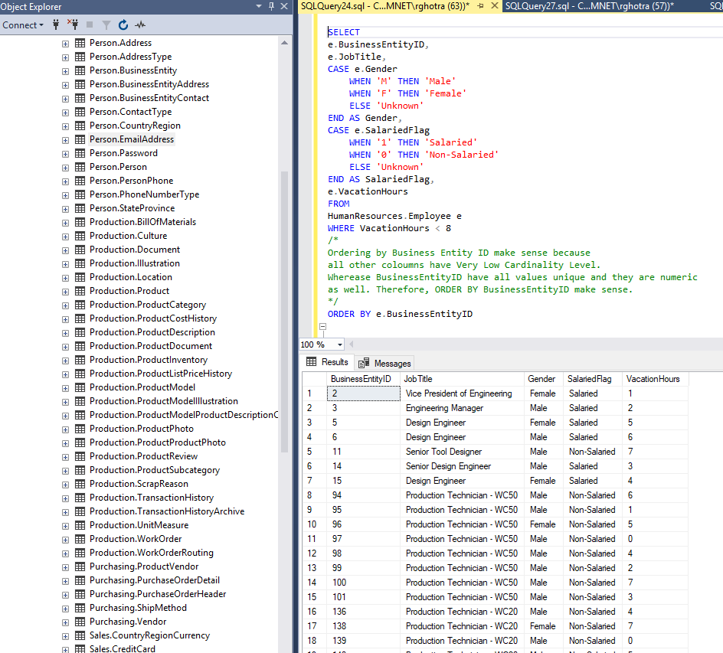

**Ans2:**

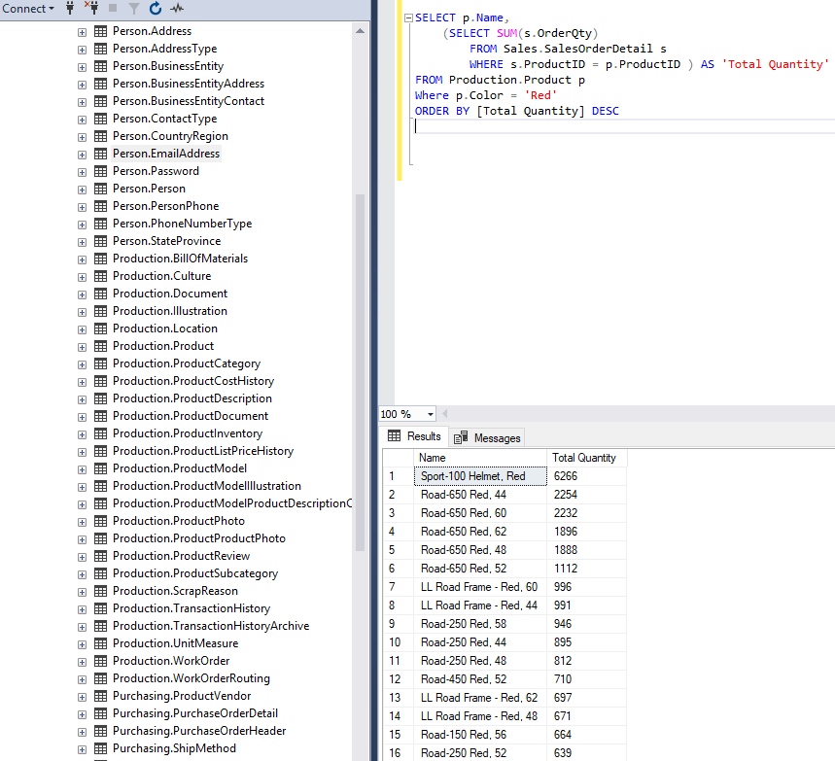

**Ans3**

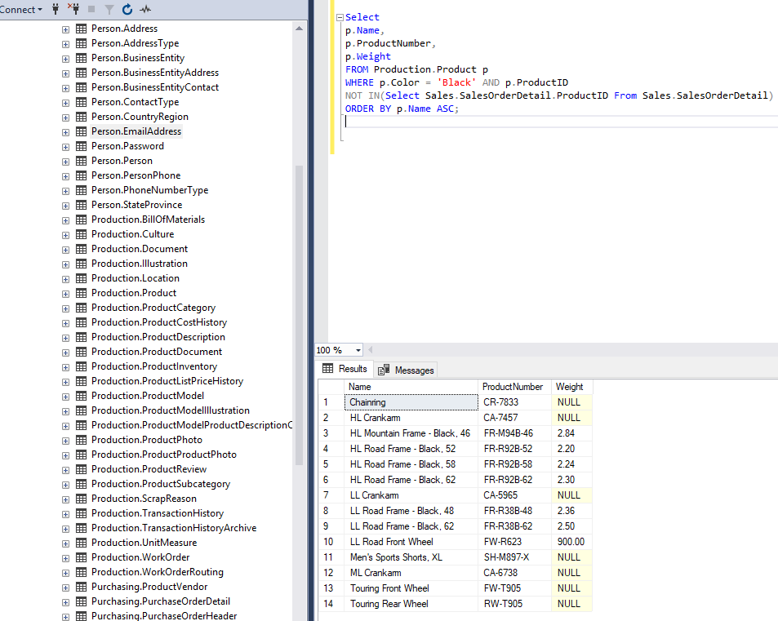

**Ans4:**

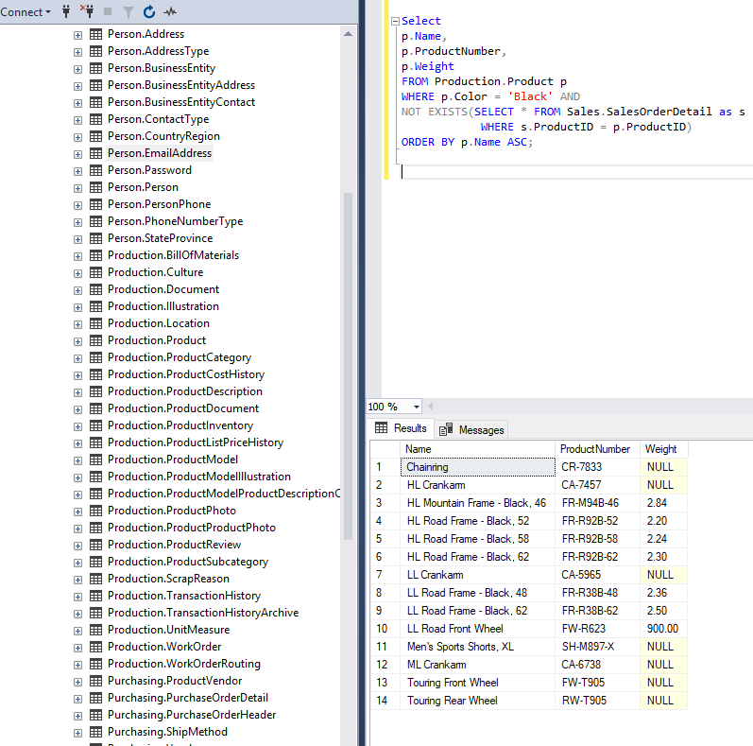

**Ans5:**

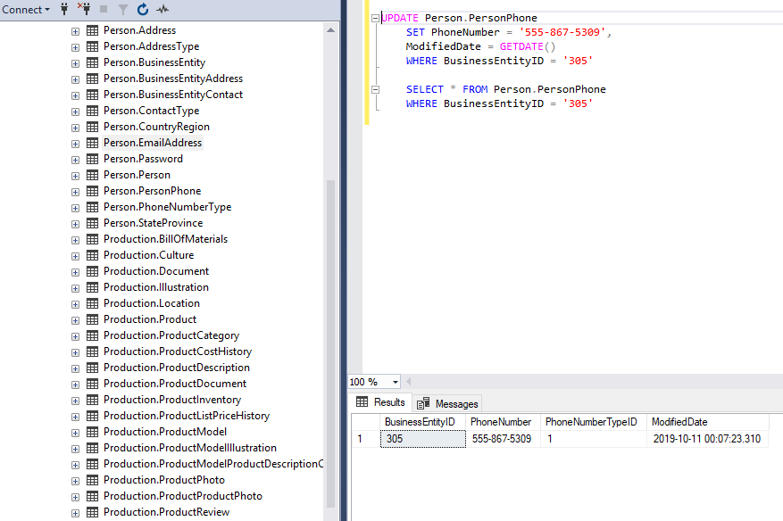

**Ans6:**

