Laboratorijske vježbe iz predmeta Vizualizacija Podataka

Anto Tufeković, FERIT, Osijek, 2020.

Zadatak 1

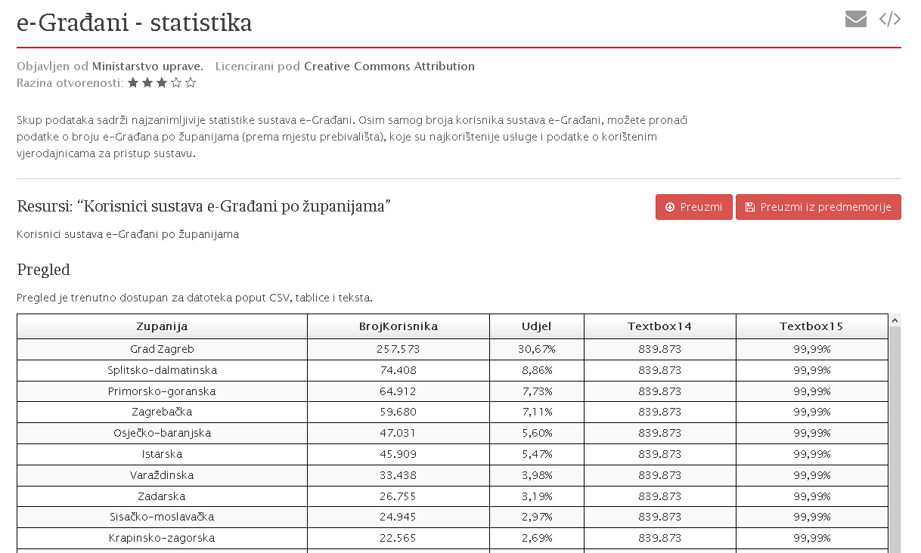

Dobijemo csv oblika:

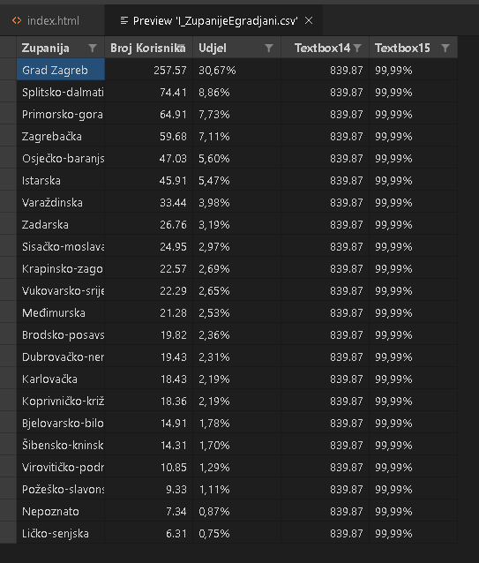

Ne trebaju nam zadnja dva stupca te na kraju imamo:

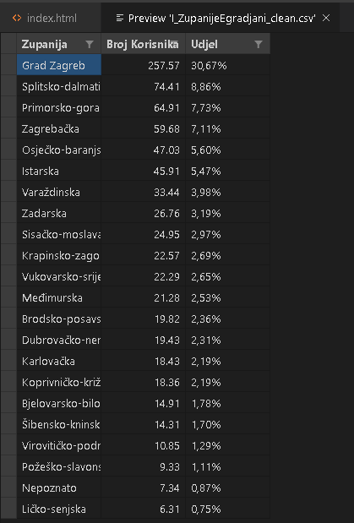

Moramo to pretvoriti u JSON oblik. To postižemo koristeći python skriptu:

|  |
| --- |
| import pandas as pd  data = pd.read_csv("I_ZupanijeEgradjani.csv")  print(data)  data.to_json("I_ZupanijeEgradjani_clean.json") |

Nakon pokretanja skripte dobijemo:

|  |
| --- |
| data = {              "Zupanija": {                  0: "Grad Zagreb",                  1: "Splitsko-dalmatinska",                  2: "Primorsko-goranska",                  3: "Zagreba\u010dka",                  4: "Osje\u010dko-baranjska",                  5: "Istarska",                  6: "Vara\u017edinska",                  7: "Zadarska",                  8: "Sisa\u010dko-moslava\u010dka",                  9: "Krapinsko-zagorska",                  10: "Vukovarsko-srijemska",                  11: "Me\u0111imurska",                  12: "Brodsko-posavska",                  13: "Dubrova\u010dko-neretvanska",                  14: "Karlova\u010dka",                  15: "Koprivni\u010dko-kri\u017eeva\u010dka",                  16: "Bjelovarsko-bilogorska",                  17: "\u0160ibensko-kninska",                  18: "Viroviti\u010dko-podravska",                  19: "Po\u017ee\u0161ko-slavonska",                  20: "Nepoznato",                  21: "Li\u010dko-senjska"              }, "BrojKorisnika": {                  0: 257.573,                  1: 74.408,                  2: 64.912,                  3: 59.68,                  4: 47.031,                  5: 45.909,                  6: 33.438,                  7: 26.755,                  8: 24.945,                  9: 22.565,                  10: 22.289,                  11: 21.279,                  12: 19.819,                  13: 19.427,                  14: 18.433,                  15: 18.362,                  16: 14.912,                  17: 14.309,                  18: 10.846,                  19: 9.33,                  20: 7.341,                  21: 6.31              }, "Udjel": {                  0: "30,67%",                  1: "8,86%",                  2: "7,73%",                  3: "7,11%",                  4: "5,60%",                  5: "5,47%",                  6: "3,98%",                  7: "3,19%",                  8: "2,97%",                  9: "2,69%",                  10: "2,65%",                  11: "2,53%",                  12: "2,36%",                  13: "2,31%",                  14: "2,19%",                  15: "2,19%",                  16: "1,78%",                  17: "1,70%",                  18: "1,29%",                  19: "1,11%",                  20: "0,87%",                  21: "0,75%"              }          } |

Što su naši podatci u pravilnom JSON obliku. Nije moguće korisitit DataWrangler bez ulogiranja pa ga nisam koristio. Podatci se moraju staviti unutar <script> elementa jer inace internet pretraživač odbija učitati ako se .json datoteka nalazi u istoj lokaciji kao i .html datoteka!

Zadatak 2.

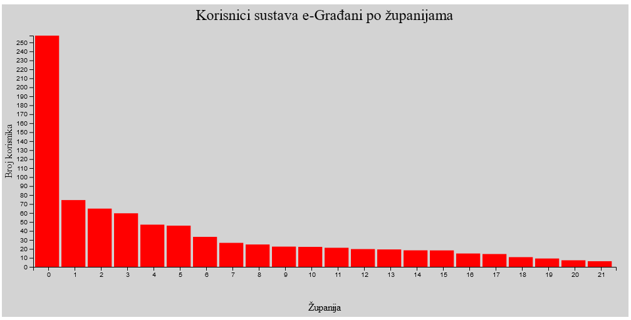

Kod:

|  |
| --- |
| <!DOCTYPE html>  <html lang="en">  <head>      <meta charset="UTF-8">      <meta name="viewport" content="width=device-width, initial-scale=1.0">      <title>LV2</title>      <script src="https://d3js.org/d3.v5.min.js"></script>  </head>  <body>      <script>          data = {              "Zupanija": {                  0: "Grad Zagreb",                  1: "Splitsko-dalmatinska",                  2: "Primorsko-goranska",                  3: "Zagreba\u010dka",                  4: "Osje\u010dko-baranjska",                  5: "Istarska",                  6: "Vara\u017edinska",                  7: "Zadarska",                  8: "Sisa\u010dko-moslava\u010dka",                  9: "Krapinsko-zagorska",                  10: "Vukovarsko-srijemska",                  11: "Me\u0111imurska",                  12: "Brodsko-posavska",                  13: "Dubrova\u010dko-neretvanska",                  14: "Karlova\u010dka",                  15: "Koprivni\u010dko-kri\u017eeva\u010dka",                  16: "Bjelovarsko-bilogorska",                  17: "\u0160ibensko-kninska",                  18: "Viroviti\u010dko-podravska",                  19: "Po\u017ee\u0161ko-slavonska",                  20: "Nepoznato",                  21: "Li\u010dko-senjska"              }, "BrojKorisnika": {                  0: 257.573,                  1: 74.408,                  2: 64.912,                  3: 59.68,                  4: 47.031,                  5: 45.909,                  6: 33.438,                  7: 26.755,                  8: 24.945,                  9: 22.565,                  10: 22.289,                  11: 21.279,                  12: 19.819,                  13: 19.427,                  14: 18.433,                  15: 18.362,                  16: 14.912,                  17: 14.309,                  18: 10.846,                  19: 9.33,                  20: 7.341,                  21: 6.31              }, "Udjel": {                  0: "30,67%",                  1: "8,86%",                  2: "7,73%",                  3: "7,11%",                  4: "5,60%",                  5: "5,47%",                  6: "3,98%",                  7: "3,19%",                  8: "2,97%",                  9: "2,69%",                  10: "2,65%",                  11: "2,53%",                  12: "2,36%",                  13: "2,31%",                  14: "2,19%",                  15: "2,19%",                  16: "1,78%",                  17: "1,70%",                  18: "1,29%",                  19: "1,11%",                  20: "0,87%",                  21: "0,75%"              }          }          console.log(Object.values(data.BrojKorisnika));          console.log(Object.keys(data.BrojKorisnika).map(Number));          var margin = {              top: 50,              bottom: 80,              left: 50,              right: 20          };          var width = 1000 - margin.left - margin.right;          var height = 500 - margin.top - margin.bottom;          var barPadding = 4;          var barWidth = width/Object.keys(data.Zupanija).length - barPadding;          var x = d3.scaleBand().domain(Object.keys(data.BrojKorisnika).map(Number)).rangeRound([0,width]);          var y = d3.scaleLinear().domain([0,d3.max(Object.values(data.BrojKorisnika))]).range([height,0]);          var svg = d3.select("body")              .append("svg")              .attr("width", width + margin.left + margin.right)              .attr("height", height + margin.top + margin.bottom)              .style("background-color", "lightgray")              .append("g")              .attr("transform","translate(" + margin.left + "," + margin.top + ")");          //var xAxis = d3.svg.axis().scale(x).orient("bottom").tickFormat(function(d,i){return i+1});          var xAxis = d3.axisBottom(x).tickValues(x.domain());          //var yAxis = d3.svg.axis().scale(y).orient(left).ticks(data.BrojKorisnika.length);          var yAxis = d3.axisLeft(y).ticks(Object.values(data.BrojKorisnika).length);          svg.append("g")              .attr("class","x axis")              .attr("transform","translate(0," + height + ")")              .call(xAxis)              .selectAll("text")              .style("text-anchor","middle");          svg.append("g")              .append("text")              .attr("transform", "translate(" + (width/2) + " ," + (height + margin.top + 20) + ")")              .style("text-anchor", "middle")              .text("Županija");          svg.append("g")              .attr("class", "y axis")              .call(yAxis)          svg.append("g")              .append("text")              .attr("transform", "rotate(-90)")              .attr("y", 0 - margin.left)              .attr("x",0 - (height / 2))              .attr("dy", "1em")              .style("text-anchor", "middle")              .text("Broj korisnika");            svg.append("g")              .append("text")              .attr("x",(width/2))              .attr("y",0-(margin.top/2))              .attr("text-anchor","middle")              .style("font-size","1.5em")              .text("Korisnici sustava e-Građani po županijama")          var barchart = svg.selectAll("rect")              .data(Object.values(data.BrojKorisnika))              .enter()              .append("rect")              .attr("x",function(d,i){return x(i);})              .attr("y",y)              .attr("height",function(d){return height - y(d);})              .attr("width",barWidth)              .attr("fill","red")      </script>  </body>  </html> |

Zadatak 3.

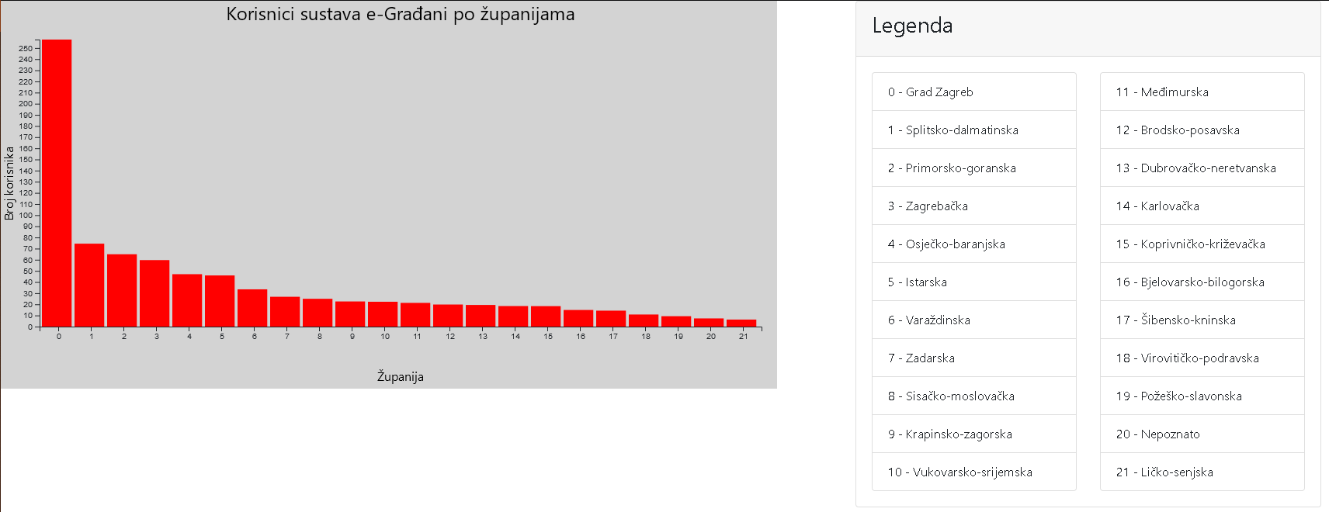

Dodana je legenda za pojašnjenje x-osi.

U prethodnom zadatku je naveden kod za dodavanje x i y-osi te njihovih naziva.

Zadatak 4.

Vlastita ordinalna skala

|  |
| --- |
| var colors = d3.scaleOrdinal().range(['red','green','blue','purple','yellow'  ,'cyan','darkgray','black','white','pink']); |

Sadrži 10 članova te koristi se npr. na sljedeće načine:

|  |
| --- |
| var barchart = svg.selectAll("rect")                      .data(Object.values(data.BrojKorisnika))                      .enter()                      .append("rect")                      .attr("x",function(d,i){return x(i);})                      .attr("y",y)                      .attr("height",function(d){return height - y(d);})                      .attr("width",barWidth)                      .attr("fill",function(d,i){return colors(i)}) |

* Ovo je za bojanje bar-ova u grafu

|  |
| --- |
| <script>  var temp = "border-width: thick; border-color: ";  d3.selectAll("li")  .data([0,1,2,3,4,5,6,7,8,9,10,11,12,13,14,15,16,17,18,19,20,21])  .attr("style", function(d,i){return temp + colors(i)});  </script> |

* Ovo je za bojanje legende za x-os

Zadatak 5.

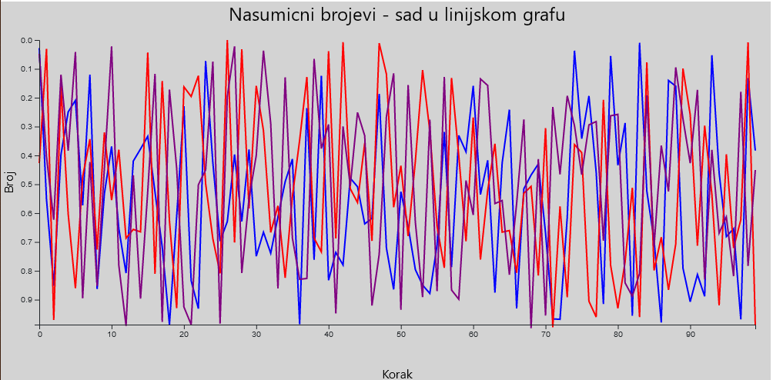

Dodan je novi <div> element za novi svg graf, cijeli kod zadatka:

|  |
| --- |
| <div class="col-xl-12" id="svg_container2">      <script>          data1 = {              "0": {                  "0": 0.0280378689,                  "1": 0.5518955433,                  "2": 0.8512988665,                  "3": 0.3968983578,                  "4": 0.249146832,                  "5": 0.2093681998,                  "6": 0.5727880831,                  "7": 0.1201912418,                  "8": 0.8628530742,                  "9": 0.5333268858,                  "10": 0.3687153161,                  "11": 0.6538727759,                  "12": 0.8078153887,                  "13": 0.4197556208,                  "14": 0.377651126,                  "15": 0.3337643621,                  "16": 0.5267649565,                  "17": 0.7175105002,                  "18": 0.9864028735,                  "19": 0.6102315664,                  "20": 0.2295322259,                  "21": 0.8339455801,                  "22": 0.930938561,                  "23": 0.0728939006,                  "24": 0.425135286,                  "25": 0.6971020868,                  "26": 0.6293313586,                  "27": 0.3971657321,                  "28": 0.6287390032,                  "29": 0.3793754276,                  "30": 0.7493823758,                  "31": 0.666131164,                  "32": 0.7389671035,                  "33": 0.6129762618,                  "34": 0.4911304955,                  "35": 0.4124688468,                  "36": 0.9850433558,                  "37": 0.2360797011,                  "38": 0.7613893612,                  "39": 0.1237601776,                  "40": 0.832591392,                  "41": 0.7360319489,                  "42": 0.7796671841,                  "43": 0.4787814749,                  "44": 0.5084159912,                  "45": 0.637229801,                  "46": 0.6179689452,                  "47": 0.1868821914,                  "48": 0.7209582149,                  "49": 0.8644251343,                  "50": 0.5254868517,                  "51": 0.6466381194,                  "52": 0.7957904081,                  "53": 0.8494974208,                  "54": 0.878321115,                  "55": 0.7106119825,                  "56": 0.3187087849,                  "57": 0.7867898896,                  "58": 0.3308140032,                  "59": 0.387418028,                  "60": 0.1591088911,                  "61": 0.5356251733,                  "62": 0.4170890851,                  "63": 0.8755763111,                  "64": 0.4263469153,                  "65": 0.241232969,                  "66": 0.9303117638,                  "67": 0.5157697331,                  "68": 0.468056651,                  "69": 0.4296852348,                  "70": 0.6686992662,                  "71": 0.9665469003,                  "72": 0.9681020126,                  "73": 0.6141797443,                  "74": 0.0371462335,                  "75": 0.3419359343,                  "76": 0.1939450036,                  "77": 0.4578738771,                  "78": 0.9147250627,                  "79": 0.0556947323,                  "80": 0.4343741528,                  "81": 0.2877075594,                  "82": 0.9559092216,                  "83": 0.0097537512,                  "84": 0.5232755766,                  "85": 0.6926092601,                  "86": 0.979032414,                  "87": 0.1402672616,                  "88": 0.1600033296,                  "89": 0.7907210674,                  "90": 0.9069615512,                  "91": 0.8128246006,                  "92": 0.8882836481,                  "93": 0.052874965,                  "94": 0.4600339096,                  "95": 0.681255983,                  "96": 0.6539152468,                  "97": 0.9685057035,                  "98": 0.1318570794,                  "99": 0.3832844887              }          }          data2 = {              "0": {                  "0": 0.4264990092,                  "1": 0.0305212559,                  "2": 0.9704347047,                  "3": 0.160641736,                  "4": 0.60367127,                  "5": 0.8602696223,                  "6": 0.4738176526,                  "7": 0.3436766084,                  "8": 0.7263490199,                  "9": 0.3204304712,                  "10": 0.5548425695,                  "11": 0.3800567445,                  "12": 0.6868252775,                  "13": 0.656447787,                  "14": 0.6649218386,                  "15": 0.0432501555,                  "16": 0.8106665989,                  "17": 0.1419500889,                  "18": 0.6263884743,                  "19": 0.929287531,                  "20": 0.1624389894,                  "21": 0.1958629022,                  "22": 0.1238140287,                  "23": 0.4974621611,                  "24": 0.6886793833,                  "25": 0.8087987492,                  "26": 0.0000835236,                  "27": 0.7016469382,                  "28": 0.0323093473,                  "29": 0.583914273,                  "30": 0.1587239176,                  "31": 0.3142217685,                  "32": 0.6669182155,                  "33": 0.5746582399,                  "34": 0.8239924985,                  "35": 0.5421083712,                  "36": 0.3472196064,                  "37": 0.1282328464,                  "38": 0.6865651407,                  "39": 0.7341773295,                  "40": 0.0385454066,                  "41": 0.6877911504,                  "42": 0.007136976,                  "43": 0.5153227048,                  "44": 0.5631738278,                  "45": 0.3569055069,                  "46": 0.6960215071,                  "47": 0.0108422227,                  "48": 0.1184463061,                  "49": 0.5794494614,                  "50": 0.4357093064,                  "51": 0.6796601204,                  "52": 0.4199136068,                  "53": 0.1044500008,                  "54": 0.315452007,                  "55": 0.645515792,                  "56": 0.7895303797,                  "57": 0.131291479,                  "58": 0.3993920975,                  "59": 0.6976495525,                  "60": 0.2685246338,                  "61": 0.761036231,                  "62": 0.5216675554,                  "63": 0.3593234427,                  "64": 0.6658552415,                  "65": 0.6603351115,                  "66": 0.8068750512,                  "67": 0.5310254063,                  "68": 0.5074796308,                  "69": 0.816234109,                  "70": 0.3050470519,                  "71": 0.9953843733,                  "72": 0.5765594012,                  "73": 0.8915551425,                  "74": 0.3624758112,                  "75": 0.3902463082,                  "76": 0.9054525006,                  "77": 0.9600677139,                  "78": 0.2073604845,                  "79": 0.7811454221,                  "80": 0.9297146806,                  "81": 0.7685855243,                  "82": 0.5120106232,                  "83": 0.9601802254,                  "84": 0.0770772391,                  "85": 0.7985941454,                  "86": 0.6837225993,                  "87": 0.8659507857,                  "88": 0.7070436769,                  "89": 0.0989471902,                  "90": 0.2591647336,                  "91": 0.712988162,                  "92": 0.2970615905,                  "93": 0.5357862324,                  "94": 0.9196454387,                  "95": 0.3958056413,                  "96": 0.7206012006,                  "97": 0.6226995395,                  "98": 0.007786265,                  "99": 0.9893491968              }          }          data3 = {              "0": {                  "0": 0.0479354484,                  "1": 0.4041874379,                  "2": 0.6229554257,                  "3": 0.1203409617,                  "4": 0.3839493681,                  "5": 0.0412983273,                  "6": 0.8949954895,                  "7": 0.4225242021,                  "8": 0.8523734656,                  "9": 0.4460182752,                  "10": 0.0219304359,                  "11": 0.7809368479,                  "12": 0.9907244735,                  "13": 0.4689694824,                  "14": 0.8965579885,                  "15": 0.5239689691,                  "16": 0.1173547673,                  "17": 0.976821394,                  "18": 0.1718117066,                  "19": 0.4447804576,                  "20": 0.9251656991,                  "21": 0.9860895511,                  "22": 0.5014126973,                  "23": 0.4505325142,                  "24": 0.075026595,                  "25": 0.9830667387,                  "26": 0.1951646445,                  "27": 0.0221988022,                  "28": 0.8076124802,                  "29": 0.5494812621,                  "30": 0.400435127,                  "31": 0.0369890525,                  "32": 0.2889968384,                  "33": 0.8607360229,                  "34": 0.129376081,                  "35": 0.6865401178,                  "36": 0.8292769062,                  "37": 0.8265179828,                  "38": 0.0653529458,                  "39": 0.3760291495,                  "40": 0.2926186806,                  "41": 0.9477287589,                  "42": 0.2993598824,                  "43": 0.5053213241,                  "44": 0.2511530037,                  "45": 0.3318419115,                  "46": 0.9203370565,                  "47": 0.7425082278,                  "48": 0.2657765592,                  "49": 0.1154258452,                  "50": 0.9347734963,                  "51": 0.1561347188,                  "52": 0.6312239349,                  "53": 0.8909654732,                  "54": 0.2760242378,                  "55": 0.870583816,                  "56": 0.1278575879,                  "57": 0.8664182345,                  "58": 0.8983137499,                  "59": 0.4869684837,                  "60": 0.6063171863,                  "61": 0.134927541,                  "62": 0.1574947704,                  "63": 0.5668919178,                  "64": 0.5563404267,                  "65": 0.813239779,                  "66": 0.5669990629,                  "67": 0.275187172,                  "68": 0.998838164,                  "69": 0.4126242566,                  "70": 0.9547571346,                  "71": 0.2321425685,                  "72": 0.4653730722,                  "73": 0.1933759614,                  "74": 0.2969564128,                  "75": 0.4670064281,                  "76": 0.2941565482,                  "77": 0.2826043607,                  "78": 0.6954138652,                  "79": 0.2625891336,                  "80": 0.2577063176,                  "81": 0.8418400789,                  "82": 0.888028269,                  "83": 0.8089727657,                  "84": 0.1917557218,                  "85": 0.7170923313,                  "86": 0.3658588433,                  "87": 0.5247081636,                  "88": 0.0946605723,                  "89": 0.2728534682,                  "90": 0.4268240971,                  "91": 0.1729971885,                  "92": 0.8305381166,                  "93": 0.3807651411,                  "94": 0.6691418423,                  "95": 0.6135161241,                  "96": 0.8185385949,                  "97": 0.179313133,                  "98": 0.7826875531,                  "99": 0.4507236501              }          }          var margin = {              top: 50,              bottom: 80,              left: 50,              right: 20          };          var width = 1000 - margin.left - margin.right;          var height = 500 - margin.top - margin.bottom;          var svg = d3.select("#svg_container2")              .append("svg")              .attr("width", width + margin.left + margin.right)              .attr("height", height + margin.top + margin.bottom)              .style("background-color", "lightgray")              .append("g")              .attr("transform", "translate(" + margin.left + "," + margin.top + ")");          var x = d3.scaleLinear().domain([0,d3.max(Object.keys(data1[0]))]).range([0,width]);          var y = d3.scaleLinear().domain([0,d3.max(Object.values(data1[0]))]).range([0,height]);          var valueLine1 = d3.line().x(function(d,i) {return x(i)}).y(function(d) {return y(d)});          var valueLine2 = d3.line().x(function(d,i) {return x(i)}).y(function(d) {return y(d)});          var valueLine3 = d3.line().x(function(d,i) {return x(i)}).y(function(d) {return y(d)});          svg.append("path")              .attr("class","line")              .style("stroke","blue")              .style("fill","none")              .style("stroke-width","2")              .attr("d",valueLine1(Object.values(data1[0])));            svg.append("path")              .data(Object.values(data2[0]))              .attr("class","line")              .style("stroke","red")              .style("stroke-width","2")              .style("fill","none")              .attr("d",valueLine2(Object.values(data2[0])));            svg.append("path")              .data(Object.values(data3[0]))              .attr("class","line")              .style("stroke","purple")              .style("fill","none")              .style("stroke-width","2")              .attr("d",valueLine3(Object.values(data3[0])));            svg.append("g")              .attr("transform","translate (0," + height + ")")              .call(d3.axisBottom(x))              .selectAll("text")              .style("text-anchor","middle");            svg.append("g")              .call(d3.axisLeft(y));            svg.append("g")              .append("text")              .attr("transform", "translate(" + (width / 2) + " ," + (height + margin.top + 20) + ")")              .style("text-anchor", "middle")              .text("Korak");          svg.append("g")              .append("text")              .attr("transform", "rotate(-90)")              .attr("y", 0 - margin.left)              .attr("x", 0 - (height / 2))              .attr("dy", "1em")              .style("text-anchor", "middle")              .text("Broj");          svg.append("g")              .append("text")              .attr("x", (width / 2))              .attr("y", 0 - (margin.top / 2))              .attr("text-anchor", "middle")              .style("font-size", "1.5em")              .text("Nasumicni brojevi - sad u linijskom grafu")      </script>  </div> |

Zadatak 6.

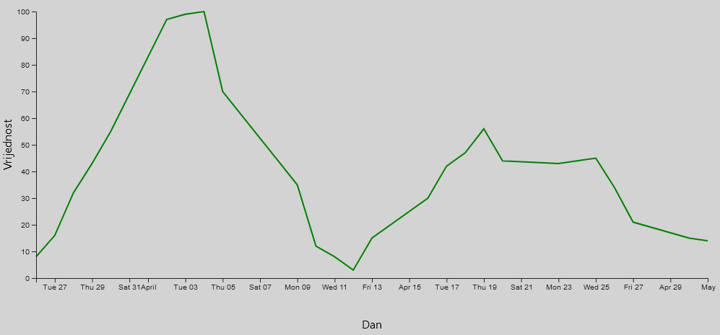

Kod zajendo sa korištenim podatcima:

|  |
| --- |
| <div class="row">          <div class="col-xl-12" id="svg_container3">              <script>                  data = [                      {                          "date": "1-May-12",                          "value": 14                      },                      {                          "date": "30-Apr-12",                          "value": 15                      },                      {                          "date": "27-Apr-12",                          "value": 21                      },                      {                          "date": "26-Apr-12",                          "value": 34                      },                      {                          "date": "25-Apr-12",                          "value": 45                      },                      {                          "date": "24-Apr-12",                          "value": 44                      },                      {                          "date": "23-Apr-12",                          "value": 43                      },                      {                          "date": "20-Apr-12",                          "value": 44                      },                      {                          "date": "19-Apr-12",                          "value": 56                      },                      {                          "date": "18-Apr-12",                          "value": 47                      },                      {                          "date": "17-Apr-12",                          "value": 42                      },                      {                          "date": "16-Apr-12",                          "value": 30                      },                      {                          "date": "13-Apr-12",                          "value": 15                      },                      {                          "date": "12-Apr-12",                          "value": 3                      },                      {                          "date": "11-Apr-12",                          "value": 8                      },                      {                          "date": "10-Apr-12",                          "value": 12                      },                      {                          "date": "9-Apr-12",                          "value": 35                      },                      {                          "date": "5-Apr-12",                          "value": 70                      },                      {                          "date": "4-Apr-12",                          "value": 100                      },                      {                          "date": "3-Apr-12",                          "value": 99                      },                      {                          "date": "2-Apr-12",                          "value": 97                      },                      {                          "date": "30-Mar-12",                          "value": 55                      },                      {                          "date": "29-Mar-12",                          "value": 43                      },                      {                          "date": "28-Mar-12",                          "value": 32                      },                      {                          "date": "27-Mar-12",                          "value": 16                      },                      {                          "date": "26-Mar-12",                          "value": 8                      }                  ]                  var width = 1000 - margin.left - margin.right;                  var height = 500 - margin.top - margin.bottom;                  var svg = d3.select("#svg_container2")                      .append("svg")                      .attr("width", width + margin.left + margin.right)                      .attr("height", height + margin.top + margin.bottom)                      .style("background-color", "lightgray")                      .append("g")                      .attr("transform", "translate(" + margin.left + "," + margin.top + ")");                  var parseTime = d3.timeParse("%d-%b-%y");                  var x = d3.scaleTime().range([0, width]);                  var y = d3.scaleLinear().range([height, 0]);                  var valueLine = d3.line()                      .x(function (d) { return x(d.date) })                      .y(function (d) { return y(d.value) });                  Object.keys(data).forEach(function(key){                      data[key].date = parseTime(data[key].date);                      data[key].value = +data[key].value;                  })                  console.log(data);                  x.domain(d3.extent(data, function (d) { return d.date; }));                  y.domain([0, d3.max(data, function(d) {return d.value;})]);                  console.log(valueLine(data));                  svg.append("path")                      .attr("class", "line")                      .style("stroke", "green")                      .style("fill", "none")                      .style("stroke-width", "2")                      .attr("d", valueLine(data));                  svg.append("g")                      .attr("transform", "translate (0," + height + ")")                      .call(d3.axisBottom(x));                  svg.append("g")                      .call(d3.axisLeft(y));                    svg.append("g")                      .append("text")                      .attr("transform", "translate(" + (width / 2) + " ," + (height + margin.top + 20) + ")")                      .style("text-anchor", "middle")                      .text("Dan");                  svg.append("g")                      .append("text")                      .attr("transform", "rotate(-90)")                      .attr("y", 0 - margin.left)                      .attr("x", 0 - (height / 2))                      .attr("dy", "1em")                      .style("text-anchor", "middle")                      .text("Vrijednost");              </script>          </div>      </div> |