Overview
20 containers with samples, 18 with cattle-slurry, 2 ammonium carbonate standards
9 with packed soil, 9 with soil collected on field experiment day with surface preserved
3 types of treatments, H₂SO₄, acetic acid and no acid (untreated)

Sample Naming Convention
Field soils = F
Packed soils = P

H₂SO₄ treatment = H₂SO₄
Acetic acid treatment = AA
No treatment = U

Number relates to container/jar
Ie. Sample in container 18 will be described as 18.F.AA

Experimental Setup
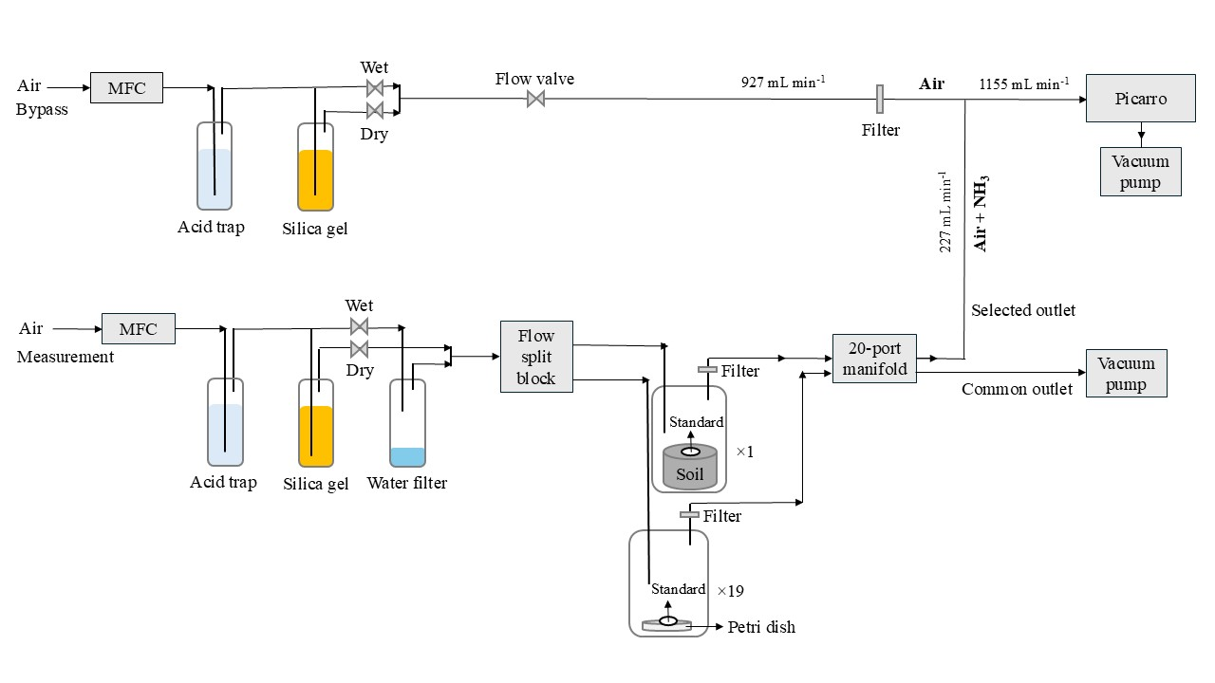

Day -2 Sample labeling
- Create labels for long analysis samples

Day -1: Prepare samples, cattle slurry, analysis and setup
Tasks are in prioritized order
Samples: F needs to be collected, P needs to be packed, STD prepare solution
Slurry: Collect and acidify H₂SO₄ and AA + untreated. Check pH before and after!
Analysis: field-soil water content analysis, slurry TAN analysis, slurry DM analysis, STD ammonia content analysis.
Setup: check flows, prepare acid-trap, test Picarro-cycle, change Any Desk code

Collect cattle slurry and soil-samples, test soil water content
Remember to calibrate the pH meter
Collect cattle slurry
- Stored in building close to L30
- Grap a large bucketful, remember to mix it! will be weighed in the lab $≈$ 1.5-2 L
Collect soil samples
- Building connected to main Foulum building PV24
- Cellar
- Cooling room number 1012?
- Reol 8 kasse 139
- From cattle experiment - 2025-10-28
Test of F-soil water content
- L32
- Weigh 3 aluminum containers, weigh soil from 3 F-samples in container, put into oven.
- Meanwhile, check whether the red lids can be easily removed without spilling soil
- Take out of oven and weigh again after 24 h.

Collect container for tests
- Containers most likely in L32
- 6 large 100 mL containers, long-term storage
- 9 small, tests on the day

Slurry acidification:
500 g of slurry per treatment
- Check pH beforehand and afterwards, as triplicates
H₂SO₄
Using same weight as large-scale will require 0.79 mL 95% wt. H₂SO₄ (check detailed calculations)
All added at once. Or over time $100 μL$ (except last addition) each time with 1-minute intervals between addition
AA
$100 μL$ each time, wait for 1 minute and measure pH, until similar to H₂SO₄ slurry.
Storage
- 100 mL$·$2 of each for long-term storage
- Rest, use for analysis same day, when done store in closed container in cooler.

Slurry TAN and DM analysis
As triplicates for each slurry treatment.
- Coordinate with Janni in the interval 11:00-14:00

Field soil preparation
- Choose 9 samples, mark the sides, remove the top and film them. Leave them for next day - on the lab table clearly marked

Packed soil preparation
- Collect soil from outside storage at Biogas-plant
- Sieve the soil by removing stones and similar - allows the clumps of soil. Mix afterwards.
- Mark a soil for scratching the surface 2 mm
- 37.5 g soil per packing (150 g in total)

Packing procedure
- Weigh the soil and pack it (use the right stamp, largest to smallest!)
- Scratch the soil evenly
- Add water
- Repeat 4 times

Storage
- Mark and film the samples
- Store on lab table, clearly marked

Standard preparation
- 2.27 ammonium carbonate (NH₄HCO₃) and 20 g potato starch, 100 mL milli-Q water
- Dissolved starch in 60 $℃$, sufficient milli-Q water
- At room temperature, add the ammonium carbonate, adjust volume to 100 mL
- Measure exact nitrogen content [g_{N} / L] using ammonium test kit
- Store in cooler.

Setup preparation
- Start the pump Tune flows to 0.225 L/min
- Set up valve-cycles and test the changes.
- Change Any Desk password to windtunnel
Acid trap:
2.5 L total
0.05 M H₂SO₄, use approx. 6.85 mL

Soil analysis
Do only one test, don’t want to sacrifice more soil-samples than necessary
Can also be done the next day if time is short
- 20 g soil
- 20 mL dem. Water
- Shake tube
- Centrifuge for 12 min, 4200 RPM - remember counterweight
- Measure pH of supernatant (liquid fraction)

Day 1: Start of the experiment

Setup tests and slurry assessment before starting
- Ensure all sample-flows are 0.225 L/min, before experimental start
- Ensure valve-shifts work as intended
- Note time-delay between picaro and actual time
- Measure pH of slurries as triplicates

Start the experiment, prepare current sample
Exchange red plastic lid, with petri-dish
Approx 2-3 min before valve shift, remove plastic-wrap from current sample
Add 2 g of needed slurry as drops, in small as droplets
Add to Picarro setup
Note picaro-time for the shift, and the flow of the sample stream, and bypass

Day: 2-6: Extract data via Any desk
Download yesterday’s raw Picarro file into own folder via Any Desk
Repeat for next day

Day 7: End of the experiment
Note Picarro-time for the end of the experiment.
Download raw Picarro file for the final day.
Note bypass and sample flows, is expected to have a slight decrease - an average between start and end will be used.
Remove the samples from the setup, can most likely dilute and put into sink.

Calculation details

Slurry acidification:
Amount of H₂SO₄
$$\frac{0.18 kg_{acid}}{60.05·{10}^{-3} t_{slurry}}=\frac{2.99·kg_{acid}}{t_{slurry}}$$
If using 500 g in lab:
$$m\left(H_{2}SO_{4}\right)= 0.500 kg_{slurry}·{10}^{-3}\frac{t_{slurry}}{kg_{slurry}}·2.99\frac{kg_{acid}}{t_{slurry}}=0.001495·kg_{acid}·{10}^{3}=1.495 g$$
$$ρ\left(H_{2}SO_{4} 95 \%wt\right)=1.8837\frac{g}{mL}$$
$$V=\frac{m}{ρ}=\frac{1.495 g}{1.8837\frac{g}{mL}}=0.79·mL$$

Packed soils
Amount of soil to use:
Bulk density of soil during the field experiment: $1.50\frac{g}{cm^{3}}±0.09\frac{g}{cm^{3}}$
$$V_{sample}=100 cm^{3}$$
$$m_{soil, sample}=100 cm^{3}\left(1.50\frac{g}{cm^{3}}±0.09\frac{g}{cm^{3}}\right)=150 g±9 g$$
$$m_{soil, pack}=\frac{150 g±9 g}{4}=37.5 g ±2.25 g$$
Amount of water to add
Field gravimetric water content:
$$U_{field, cattle, dry}=\frac{m_{water}}{m_{soil}}= 0.17\frac{g_{water}}{g_{soil}}$$

Agro soil has 15.5 % water content calculated on a “wet” basis
$$U_{ agro, wet}=\frac{m_{water}}{\left(m_{soil}+m_{water}\right)}=0.155$$
$$U_{agro,dry}=\frac{0.155}{\left(1-0.155\right)}=0.183$$
Conversion - redefine mass of water:
$$U_{wet}\left(m_{soil}+m_{water}\right)=m_{water}$$
$$U_{wet}m_{soil}+U_{water}m_{water}=m_{water}$$
$$U_{wet}m_{soil}=m_{water}-U_{wet}m_{water}$$
$$U_{wet}m_{soil}=m_{water}(1-U_{wet)}$$
$$\frac{U_{wet}m_{soil}}{(1-U_{wet)}}$$
Insert into Dry definition
$$U_{dry}=\frac{m_{water}}{m_{soil}}=\frac{\left(\frac{U_{water}m_{soil}}{1-U_{water}}\right)}{m_{soil}}=\frac{U_{water}}{(1-U_{water})}$$

Setup - Acid trap
$$C_{1}V_{1}=C_{2}V_{2}$$
$$C_{2}=0.05 M$$
$$V_{2}=V_{water}+V_{1}=2.5 L$$

If using is 95 %Wt. H₂SO₄:
$$ρ_{solution}=1.84 g mL^{-1}$$
For 1000 mL
$$m_{solution}=1884 g$$
$$m_{H2SO4}=1884 g·0.96=1808.64·g$$
$$n_{H2SO4 }=\frac{1808.64·g}{98.079 g mol^{-1}}=18.4406·mol$$
$$V_{1}=\frac{C_{2}V_{2}}{C_{1}}=\frac{0.05 M·2.5 L}{18.24 M}·{10}^{3}\frac{mL}{L}=6.85307·mL$$
$$V_{water}=2500 mL-6.85307·mL=2493.15·mL$$
$$V_{1}=\frac{C_{2}V_{2}}{C_{1}}=\frac{0.05 M·1 L}{18.4406 M}·{10}^{3}\frac{mL}{L}=2.71141·mL$$

