412/612 HOMEWORK 3

Examine the **tips** data frame of the reshape2 package.

Install.packages(“reshape2”)

library(reshape2)

library(ggplot2)

View(**tips**)

?tips

*Be sure to provide all r code that produces the requested plots/output. Submit all results using rmardown.*  Please submit two files; an Rmarkdow file and a Word file.

***1****.*

One of the variables of the **tips** data frame is **size**. Using the command **?tips,** provide a definition for **size.**

**2.**

Use and show R code that will produce the bar graph below

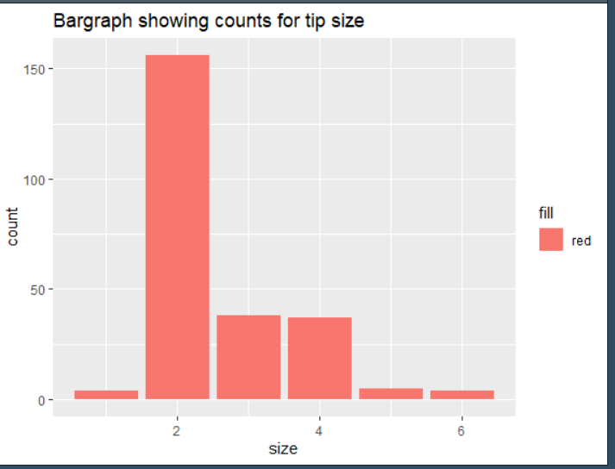

**3.**

Use and show R code to produce a stacked bar graph that shows regions for the variable **size** with respect to the categorical variable **day**. An image of the stacked bar graph is provided below.

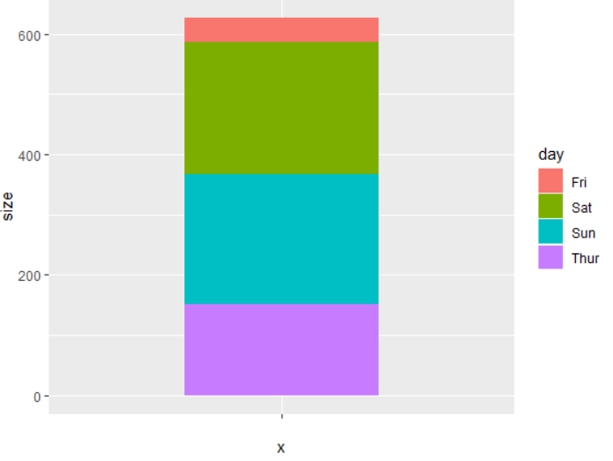

**4.**

Now use and show R code to create a pie chart using the same variables in problem 3

**5**.

**Using the variables of the data frame**, create a scatter plot showing a relationship between the total bill and the tip percentage of the total bill.

**x** = the total bill, **y** = tip/total bill (tip divided by total bill)

Use your scatter plot from problem 5 to produce the following plots for 6 ,7, and 8.

**6.**

**Facet** the scatter plot over the variable **day** using two rows.

On what day do you have the most extreme outlier?

**7.**

**Facet** the scatter plot over the two variables **time** and **size** using two rows.

For what size and at what time is the scatter plot most populated?

**8.**

Now, go back to problem 7, provide code that will change the day abbreviations in your facet output . i. e. Fri -> Friday, Sat -> Saturday …