# **push() and pop() it!**

Description

Push() and pop() are always used together. In a line of code the push() function is always stated first, and must be ended with the pop() function for it to work. If a push() is stated without the pop() it won’t result in a code error, you just won’t return to your previous settings.

**push();** When this function is called, it saves the current drawing style settings and transformations

**pop();** When this function is called, it restores the settings and transformations saved in the push() function

These functions are relevant to get more control in your code, they allow you to add new content with new styling and transformations without being affected by the previous. Afterwards you can return to the previous settings by using the pop() function.

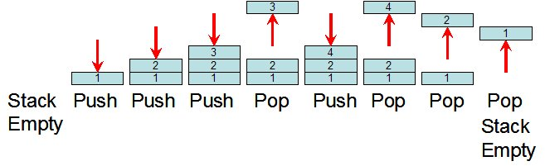Simple model

**1: push() & pop() link**

The push() function can be used several times in a row and will continuously be storing the previous made settings. The important thing to remember when using it more than once, is that when you finally use the pop() function it will only restore the newest push() stated in the link. For every pop() stated, you move one push() back in the link as showed in the model (1) (can partly be compared to the use of - opening and closing - curly brackets when stating the starting and endings of several functions). This will be further visualized in the following example (2), to help get a better understanding of the function.

Example

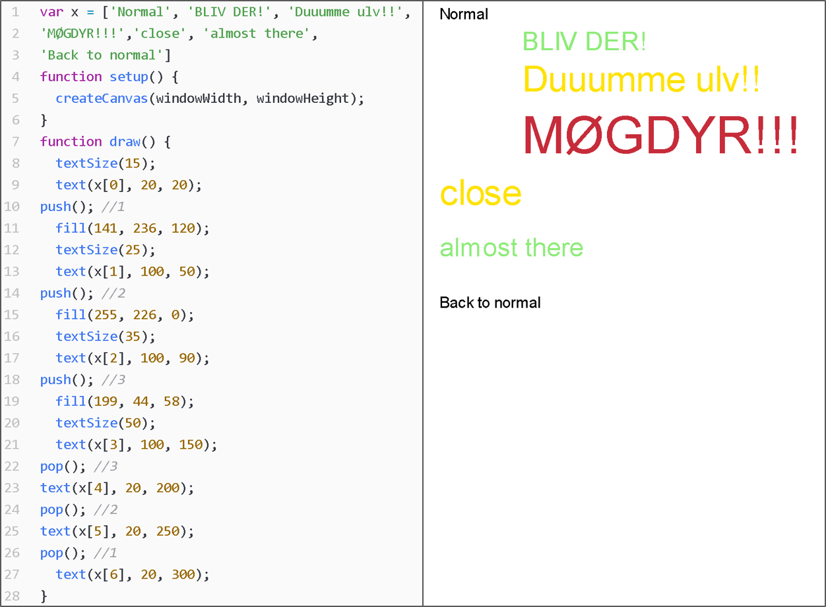

**2: Example in code**

Functions to work with

The push() function can store information from the following functions: fill(), stroke(), tint(), strokeWeight(), strokeCap(), strokeJoin(), imageMode(), rectMode(), ellipseMode(), colorMode(), textAlign(), textFont(), textMode(), textSize(), textLeading().

References

1. P5 reference list on push() – link: <https://p5js.org/reference/#/p5/push>
2. P5 reference list on pop() – link: <https://p5js.org/reference/#/p5/pop>
3. Simple model – image link: <https://goo.gl/ZrCGXf>
4. The coding train, 91: Transformation pt1 – video link: <https://youtu.be/o9sgjuh-CBM>