**Linux Basics Assignment**

**1. Creating and Renaming Files/Directories**

Commands Used:

mkdir test_dir

cd test_dir

touch example.txt

mv example.txt renamed_example.txt

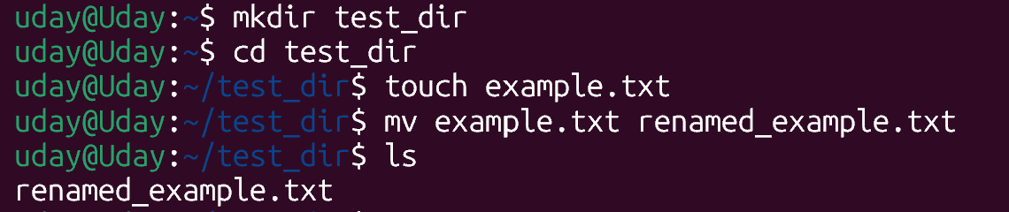

**Explanation:**

* **mkdir**: Creates a new directory.
* **touch**: Makes an empty file.
* **mv**: Renames or moves files.

**2. Viewing File Contents**

Commands Used:

cat /etc/passwd

head -n 5 /etc/passwd

tail -n 5 /etc/passwd

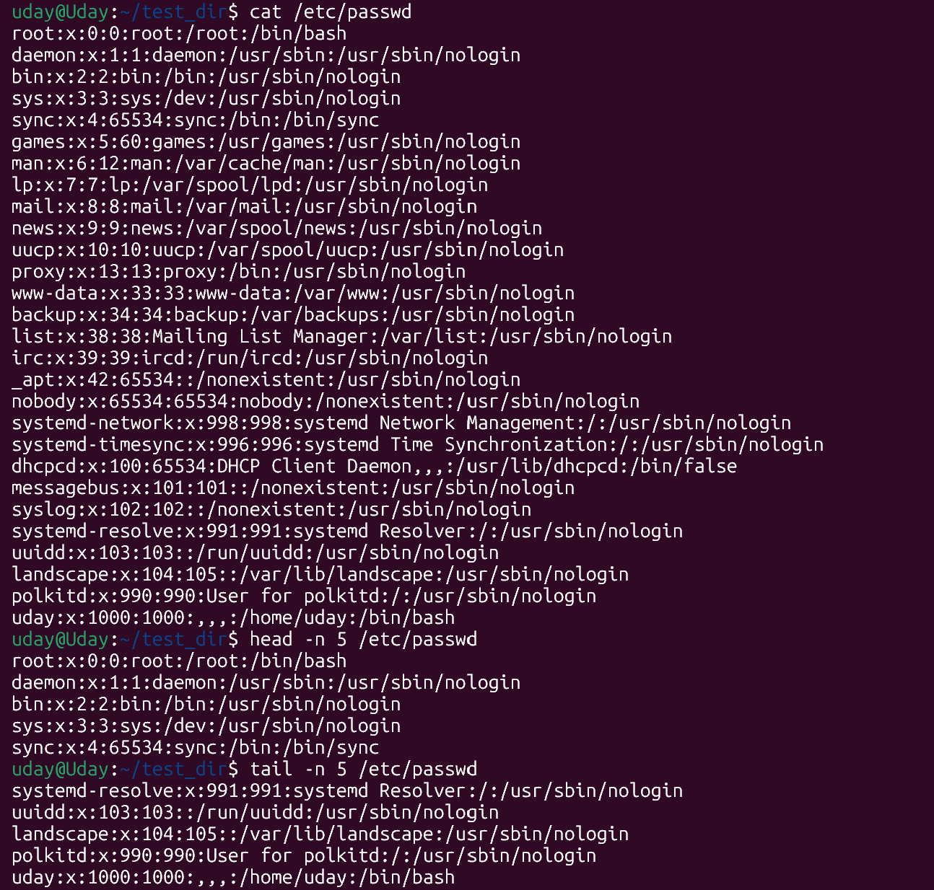

**Explanation:**

* **/etc/passwd**: User account info.
* **cat, head, tail**: View file contents.

**3. Searching for Patterns**

Command Used:

grep "root" /etc/passwd



**Explanation:**

* **grep**: Searches for "root" in the file.

**4. Zipping and Unzipping**

Commands Used:

cd ..

zip -r test_dir.zip test_dir

mkdir unzipped_dir

unzip test_dir.zip -d unzipped_dir

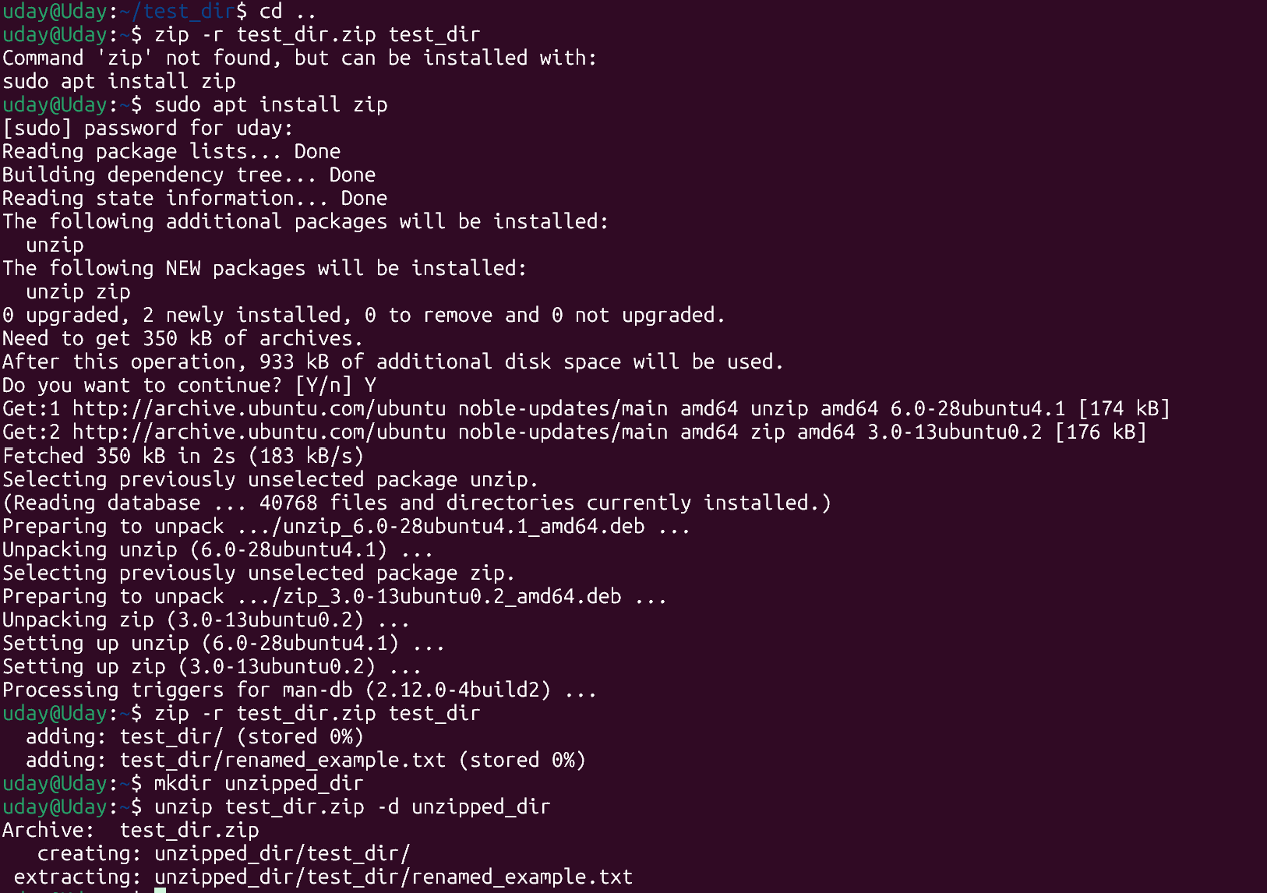

**Explanation:**

* **zip -r**: Compresses directory.
* **unzip -d**: Extracts to directory.

**5. Downloading Files**

Command Used:

wget https://raw.githubusercontent.com/git/git/master/README.md

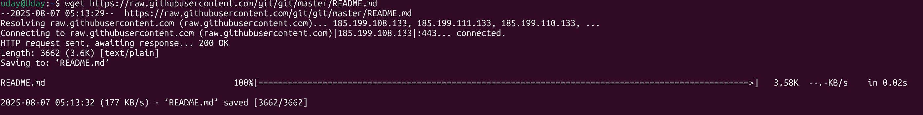

**Explanation:**

* **wget**: Downloads files from the web.

**6. Changing Permissions**

Commands Used:

touch secure.txt

chmod 444 secure.txt



**Explanation:**

* **chmod 444**: Read-only for all users.

**7. Working with Environment Variables**

Commands Used:

export MY_VAR="Hello, Linux!"

echo $MY_VAR



**Explanation:**

* **export**: Sets environment variable.
* **echo**: Displays its value.