Advanced Sustainability in Air Power Services
In-Service Sustainable Aircraft Operations, Maintenance and Lifecycle Decisions
Sustainable Aviation & Performance
From knowledge to better decisions
Course status: Complete English master for a fully online, self-paced, no-video course. It includes learner-facing copy, digital interactions, assessment logic, labs, visual briefs, answer keys and implementation requirements.
Important: This educational course does not replace approved maintenance data, flight manuals, operational procedures, airworthiness instructions, customer requirements, legal registers, environmental permits or corporate positions. Safety, airworthiness, security and authorised mission requirements remain the first decision gates.

Course card copy for the Hub
Field | English master copy
Title | Advanced Sustainability in Air Power Services
Subtitle | In-Service Sustainable Aircraft Operations, Maintenance and Lifecycle Decisions
Card description | Build evidence-based in-service decisions that improve environmental performance, resource efficiency and resilience without compromising safety or mission readiness.
Primary CTA | Start the course
Secondary CTA | View learning outcomes
Level | Advanced internal specialisation
Format | 100% online, self-paced, text-first, no video
Estimated duration | 10-12 hours

Why the original proposal needed strengthening
The proposed six-module architecture is sound, but its content was still closer to a syllabus than to a deployable course. Most theory sections were short placeholders; several interactions had only one sample question; some lists and answer fields were empty; and the governance section treated civil aviation frameworks as broadly applicable without a robust Air Power scope check.
Observed weakness | Risk for the learner | Correction in this master
Short screen copy without conceptual depth | Learners recognise terms but cannot make decisions | Expanded theory, decision rules, worked examples and evidence limitations
Commercial-airline assumptions dominate | Low relevance for Air Power Services | Fictitious Air Power fleet cases, mission-readiness trade-offs and defence governance
Sustainability benefits presented as automatic | Greenwashing and weak business cases | Baseline, boundary, functional unit, uncertainty and attribution controls
Open activities without scoring logic | Not genuinely self-paced or scalable | Auto-graded options, model answers, feedback and self-assessment rubrics
Framework names without applicability analysis | Compliance misunderstandings | Civil/state distinction and an explicit verify-applicability rule
No complete capstone or downloadable tools | Knowledge does not transfer to work | Six labs, reusable canvases, a final roadmap and a claims checklist

Course purpose and audience
This course develops the ability to make better in-service decisions across aircraft operations, support engineering, maintenance, materials, logistics, digital services, programme management, customer services, performance and environmental management. It is designed for Airbus Defence and Space / Air Power Services audiences while retaining selected civil-aviation references where they provide useful methods or comparable evidence.
- Support engineering, continuing airworthiness and maintenance programme teams
- Maintenance, Repair and Overhaul (MRO), technical services and working-party teams
- Material services, spares, supply chain, logistics and procurement
- Digital, data, innovation and performance teams
- Programme, services, contracts and customer-facing teams
- Environment, sustainability, quality, safety and management-system specialists
- Managers who prioritise in-service improvements or approve business cases

Learning outcomes
By the end of the course, learners will be able to:
- Define an appropriate lifecycle boundary and functional unit for an in-service sustainability decision.
- Diagnose operational, maintenance, logistics and facility hotspots without losing safety, airworthiness or mission requirements.
- Quantify direct fuel and carbon effects and distinguish them from lifecycle, non-CO2 and enabling effects.
- Build an evidence-based case for condition-based, predictive or digital support solutions, including assurance and rebound risks.
- Compare retrofit, life-extension, replacement and retirement scenarios using lifecycle and circular-economy reasoning.
- Map civil, defence, environmental-management and corporate governance frameworks to their correct scope.
- Create a prioritised in-service roadmap with owners, baselines, KPIs, evidence and review triggers.
- Communicate sustainability claims with sufficient precision to avoid vague, exaggerated or unsubstantiated conclusions.

Learning design and workload
Component | Time | Online learning design
Orientation and diagnostic | 20 min | Scope, disclaimer and ungraded diagnostic
Module 1 | 80 min | Lifecycle boundary, hotspots, decision gate and lab
Module 2 | 100 min | Operational levers, CCO/CDO, PBN, calculations and scenario
Module 3 | 110 min | MRO footprint, waste hierarchy, hotspot walkdown and check
Module 4 | 100 min | Predictive maintenance, digital value chain, assurance and lab
Module 5 | 110 min | Retrofit, life extension, retirement, EoL and scenario model
Module 6 | 100 min | Governance, measurement, claims control and roadmap
Capstone | 60 min | Integrated Air Power portfolio and roadmap
Final assessment | 30 min | Randomised summative knowledge check
Total | Approx. 11 h 50 min | Within the agreed 10-12 hour range

Completion and assessment model
- Diagnostic: ungraded; used to activate prior knowledge.
- Module checks: five questions per module; 80% required; unlimited retakes.
- Labs: completion required; open responses use model answers and learner self-checks.
- Capstone: a four-action roadmap assessed with a transparent rubric; optional Hub peer review.
- Final assessment: 18 questions drawn from a larger pool; 80% required; answer order randomised.
- Certificate rule: all modules viewed, all labs completed, capstone self-check submitted and final assessment passed.

Evidence and anti-greenwashing rules used throughout
Rule | Learner question
Baseline | Compared with what, over which period, and under which operating conditions?
Boundary | Which lifecycle stages, organisations, energy sources and logistics are included?
Functional unit | Per flight hour, mission, aircraft-year, maintenance input or delivered availability?
Attribution | Did the action cause the change, contribute to it, or merely occur at the same time?
Absolute and intensity data | Did total impact fall, or only impact per unit of activity?
Trade-offs | Did waste, energy, water, risk, inventory, noise or another impact increase elsewhere?
Uncertainty | Which values are measured, estimated, modelled or assumed?
Applicability | Is this a legal requirement, a voluntary framework, a customer request or an internal objective?
Language | Would a reasonable reader understand the limitation without reading a footnote?

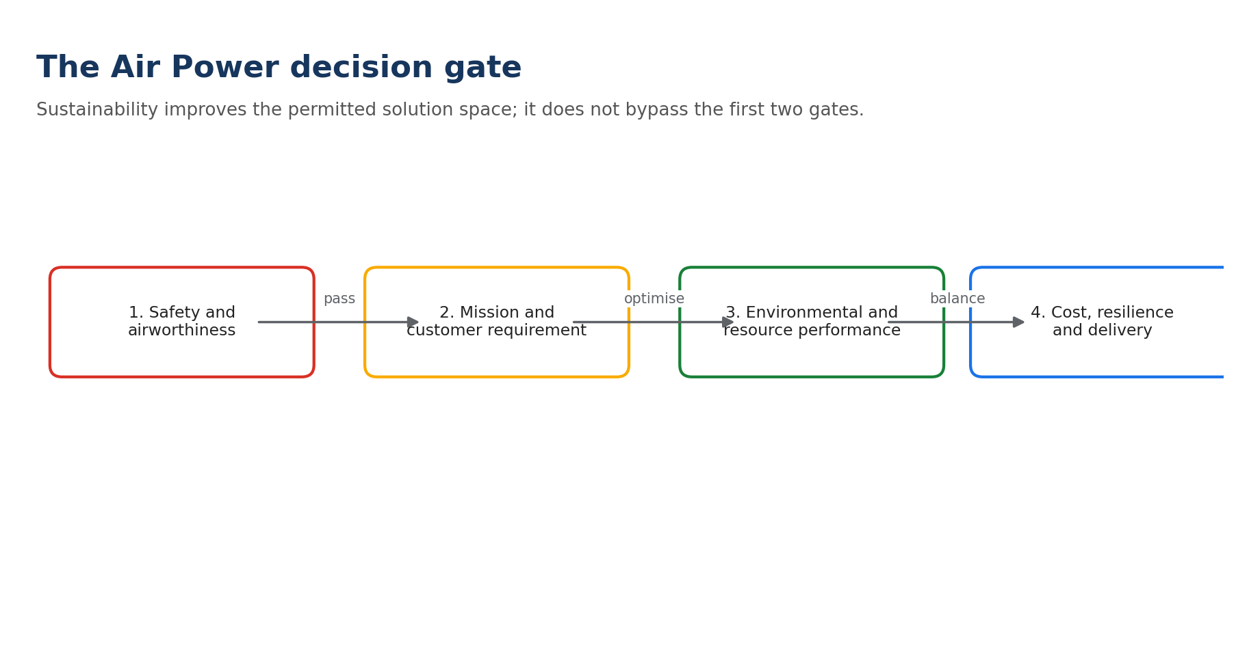
Original course diagram. Apply this sequence before optimising any in-service decision.

Recurring fictitious case: the Orion Support Unit
The six modules follow a fictitious unit supporting twelve twin-engine transport aircraft from a main operating base and two temporary deployments. The unit must maintain high availability under variable demand. Its challenges include urgent spares transport, ageing ground-support equipment, energy-intensive hangars, calendar-based inspections, incomplete data and a future retrofit decision.
Data protection: All Orion data are fictional. Learners must not enter classified, export-controlled, customer-sensitive or operationally sensitive data into the course, Hub comments or unapproved digital tools.

Orientation diagnostic
Present these five statements as an ungraded confidence check: Not yet / Partly / Confident. Repeat the check after the final assessment.
- I can define a defensible boundary for an in-service environmental comparison.
- I can distinguish direct MRO impacts from the performance that maintenance enables.
- I can challenge a claimed digital sustainability benefit with the right evidence questions.
- I can compare retrofit and replacement without assuming that newer is always better.
- I can turn a sustainability ambition into a measurable in-service roadmap.

Module 1 | In-Service Systems, Lifecycle Boundaries and Decision Quality
Estimated time: 80 minutes | Theory: 40 | Interactions: 15 | Lab: 20 | Check: 5
Module question: How can we decide what matters without drawing the system boundary too narrowly?
Hero visual brief: Use an approved internal photograph showing an in-service aircraft, maintenance team and support equipment in the same frame. Avoid a generic passenger-cabin image.

Learning outcomes
- Map the main aircraft lifecycle stages and the flows that connect them.
- Define the in-service boundary for a specific decision and select a meaningful functional unit.
- Distinguish climate, resource, waste, pollution, social, economic and resilience hotspots.
- Use the Air Power decision gate to frame sustainability after safety, airworthiness and mission requirements.
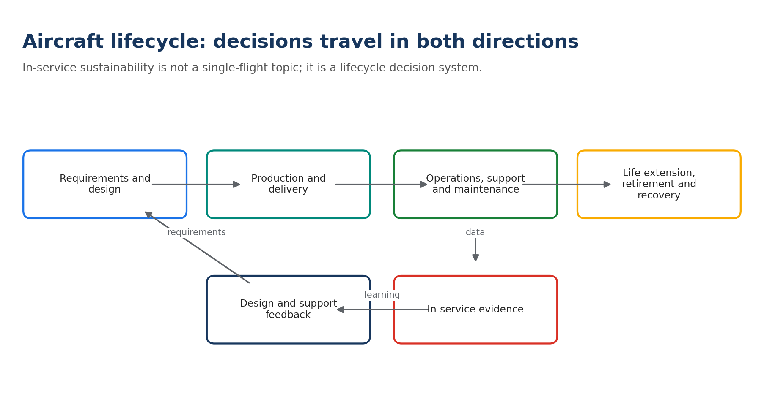
Lifecycle view used in Module 1. Feedback from service shapes future requirements and support solutions.

1.1 Sustainability is a decision property, not an aircraft label
An aircraft is not simply 'sustainable' or 'unsustainable'. Sustainability performance depends on the service delivered, the comparison being made, the period considered, the operating context and the impacts included. A decision may reduce fuel per flight hour while increasing total flying hours. It may avoid premature part replacement while increasing inspection energy. It may improve availability while requiring more inventory. The correct question is therefore not 'Is this solution sustainable?' but 'Compared with which credible alternative, what changes, for whom, over which boundary and with what evidence?'
The EASA study of the Maintenance and Production domain treats the aircraft lifecycle as a connected system involving design, production, use and maintenance, decommissioning, parts recovery, dismantling and material treatment. It also notes that fuel-burn emissions are the dominant environmental impact over an aircraft life, while maintenance, production and end-of-life remain important because they create direct impacts and influence aircraft performance, reuse and recoverability. [R1]
Key distinction: The largest climate hotspot is not automatically the only decision priority. Different impact categories can have different hotspots.

1.2 Set the boundary before collecting data
A boundary defines what is inside the assessment. A narrow operational boundary may include fuel loaded and burned during a mission. A support-system boundary may add maintenance facilities, consumables, spares, transport and ground-support equipment. A lifecycle boundary may also include the manufacture of replacement parts, retrofit embodiment, storage, retirement and end-of-life treatment. The boundary should be wide enough to capture material trade-offs and narrow enough to support the decision.
Decision | Minimum useful boundary | Likely missing if too narrow
Optimise a flight profile | Planning, taxi, climb, cruise, descent and relevant constraints | ATC restrictions, weather, payload, diversion risk and technical condition
Change a maintenance interval | Inspection, findings, removals, reliability, downtime, parts and logistics | Safety evidence, failure consequences, induced work and unscheduled response
Adopt predictive maintenance | Sensors, data platform, model, decision, intervention and verified outcome | False alerts, data energy, cyber controls and unchanged work processes
Install a retrofit | Embodiment plus remaining service life and affected operation | Installation impact, downtime, mass, maintenance burden and utilisation
Extend or retire an aircraft | Comparable delivered service over the decision horizon | Replacement production, spares, storage, recovery, obsolescence and EoL

1.3 Choose a functional unit that represents delivered service
A functional unit is the reference against which alternatives are compared. Total annual emissions are useful for organisational inventories, but they do not by themselves explain why performance changed. Intensity metrics can normalise activity but can hide growth. Advanced analysis normally needs both.
Functional unit | Useful for | Caution
Per flight hour | Technical and operational trends | Missions may differ in payload and profile
Per mission completed | Readiness and service delivery | Define comparable mission classes
Per aircraft-year | Fleet support and facilities | Adjust for utilisation and fleet mix
Per scheduled check | MRO process performance | Check scope and findings vary
Per available aircraft-day | Availability-resource relationship | Can reward unused standby capacity
Absolute annual impact | Targets and inventories | Does not separate activity from efficiency

M1-A1 | Boundary Builder
Interaction | Estimated time | Completion
Multi-select with feedback | 7 min | Online; auto-graded or model-answer comparison

Select every item that should be inside the first comparison.
Prompt: Orion is considering replacing a calendar-based component removal with an approved condition-based decision. Which items belong in the assessment?
- A. Removed components and their remaining useful condition
- B. Sensor, data and platform requirements
- C. Unscheduled failure and operational disruption risk
- D. Emergency logistics and replacement-parts demand
- E. Office paper used by an unrelated department
- F. Safety case, maintenance approval and human decision process
Correct / model answer: A, B, C, D and F.
Feedback: A valid comparison follows the entire causal chain. Item E is outside the decision boundary unless evidence shows a material connection.

1.4 Diagnose hotspots using multiple lenses
A hotspot is an activity, flow or decision that makes a material contribution to an impact or creates a strong opportunity to change it. Hotspot screening should consider at least seven lenses: climate; energy and materials; water; waste and hazardous substances; noise and local pollution; people and safety; and economic resilience. Climate impact also extends beyond carbon dioxide. Aviation non-CO2 effects include nitrogen oxides, particulate matter, sulphur oxides, water vapour and effects associated with contrail-cirrus formation. Scientific uncertainty remains significant, so a simple fuel-to-CO2 calculation must not be presented as the complete climate footprint. [R2]
For Air Power Services, readiness and sustainability can reinforce one another: better technical condition can avoid inefficient operation; first-time-right maintenance can reduce repeat work; repair and controlled reuse can avoid new material; reliable forecasting can reduce emergency transport. They can also conflict: urgent aircraft-on-ground response may require air freight; redundancy can increase inventory; dispersal can duplicate equipment; and severe mission constraints can limit fuel-optimal routing. The purpose of systems thinking is to make these tensions visible rather than to force an environmental answer.

M1-A2 | Hotspot or Distraction?
Interaction | Estimated time | Completion
Card classification | 8 min | Online; auto-graded or model-answer comparison

Classify each card as a likely hotspot, a possible trade-off, or insufficient information.
Prompt: Orion reports lower fuel per flight hour but higher total fuel use. At the same time, urgent spare shipments doubled.
- Lower fuel per flight hour
- Higher annual flying activity
- Urgent spare shipments
- A new sustainability logo on the dashboard
Correct / model answer: Fuel intensity is a performance signal; higher activity explains potential absolute growth; urgent shipments are a trade-off hotspot; the logo is not evidence.
Feedback: Absolute and intensity metrics answer different questions. Communications cannot substitute for operational data.

1.5 Apply the decision gate
Every proposed improvement must first satisfy approved safety, airworthiness, security and mission requirements. Sustainability analysis then searches the permitted solution space for options that reduce resource use or impact while delivering the required service. NATO's climate and security approach similarly links mitigation and adaptation with continued operational effectiveness, personnel safety and a credible defence posture. [R9]

Decision hierarchy. Environmental optimisation begins after safety, airworthiness and authorised mission requirements are satisfied.

M1-LAB | Orion Boundary and Hotspot Canvas
Interaction | Estimated time | Completion
Downloadable worksheet + model comparison | 20 min | Online; auto-graded or model-answer comparison

Complete the Module 1 canvas in the learner workbook.
Prompt: Define the decision, service requirement, alternatives, boundary, functional unit, five material flows, two trade-offs, two stakeholders and one evidence gap for Orion's condition-based maintenance proposal.
Correct / model answer: A strong response compares approved calendar-based and condition-based approaches over the same aircraft-years or missions; includes intervention, findings, failures, parts, downtime, logistics and digital infrastructure; and identifies safety approval and data quality as critical evidence.
Feedback: Use the self-check: comparable alternatives; explicit boundary; meaningful functional unit; both direct and enabled effects; at least one trade-off; no claim stronger than the evidence.

Module knowledge check
The learning platform should present five questions in random order. Required score: 80%. Retakes are allowed; answer order should be shuffled.

Question 1
Why is 'per mission completed' sometimes more useful than 'per flight hour'?
- A. It always produces a lower number
- B. It links impact to delivered service when mission classes are comparable
- C. It removes the need for absolute data
- D. It is required by CORSIA for military flights
Answer: B
Feedback: A functional unit should represent the service being compared. It does not replace absolute totals, and CORSIA does not apply to military/state flights.

Question 2
Which statement best reflects lifecycle hotspot thinking?
- A. The largest CO2 source is the only relevant impact
- B. All lifecycle stages contribute equally
- C. Hotspots differ by impact category, boundary and decision
- D. Maintenance has no environmental relevance because flight fuel dominates
Answer: C
Feedback: Fuel burn often dominates climate impact, while maintenance, materials, waste, pollution and end-of-life can be material for other categories and can influence operational performance.

Question 3
What must happen before environmental optimisation?
- A. A public net-zero commitment
- B. Approval of the option against safety, airworthiness, security and mission requirements
- C. A reduction in annual activity
- D. Purchase of carbon offsets
Answer: B
Feedback: Sustainability is optimised inside the technically and operationally permitted solution space.

Question 4
A 4% reduction in fuel per flight hour accompanies a 10% increase in flight hours. What can be concluded immediately?
- A. Total fuel definitely fell
- B. Total fuel definitely rose by 10%
- C. Intensity improved, but absolute fuel must be calculated
- D. The programme achieved net zero
Answer: C
Feedback: Intensity and activity must be combined before making an absolute claim.

Question 5
Which is a complete digital-maintenance boundary?
- A. The prediction model only
- B. Sensors and cloud storage only
- C. Data, model, decision, authorised action and verified outcome
- D. The number of dashboard users
Answer: C
Feedback: A prediction creates no sustainability benefit unless it changes a decision and produces a verified outcome.
Module takeaway: A credible in-service sustainability decision starts with service, alternatives, boundary and functional unit - not with a preferred technology or claim.
Evidence base: [R1], [R2], [R9], [R10], [R17], [R18].

Module 2 | Sustainable Flight Operations and Navigation
Estimated time: 100 minutes | Theory: 45 | Interactions: 20 | Lab: 30 | Check: 5
Module question: Which operational changes reduce impact in practice, and under what constraints?
Hero visual brief: Use an approved Air Power flight-operations image with visible mission-planning or air-traffic context. Do not imply that a photographed flight used a specific efficiency measure.

Learning outcomes
- Explain how planning, payload, fuel, taxi, route, speed, altitude and vertical profile influence fuel and emissions.
- Describe Continuous Climb Operations (CCO), Continuous Descent Operations (CDO) and Performance-Based Navigation (PBN) without presenting their benefits as unconditional.
- Calculate direct carbon-dioxide effects from a change in Jet-A/Jet-A1 fuel using a transparent factor.
- Evaluate an Air Power operational scenario using safety, mission, weather, airspace, noise and resilience constraints.
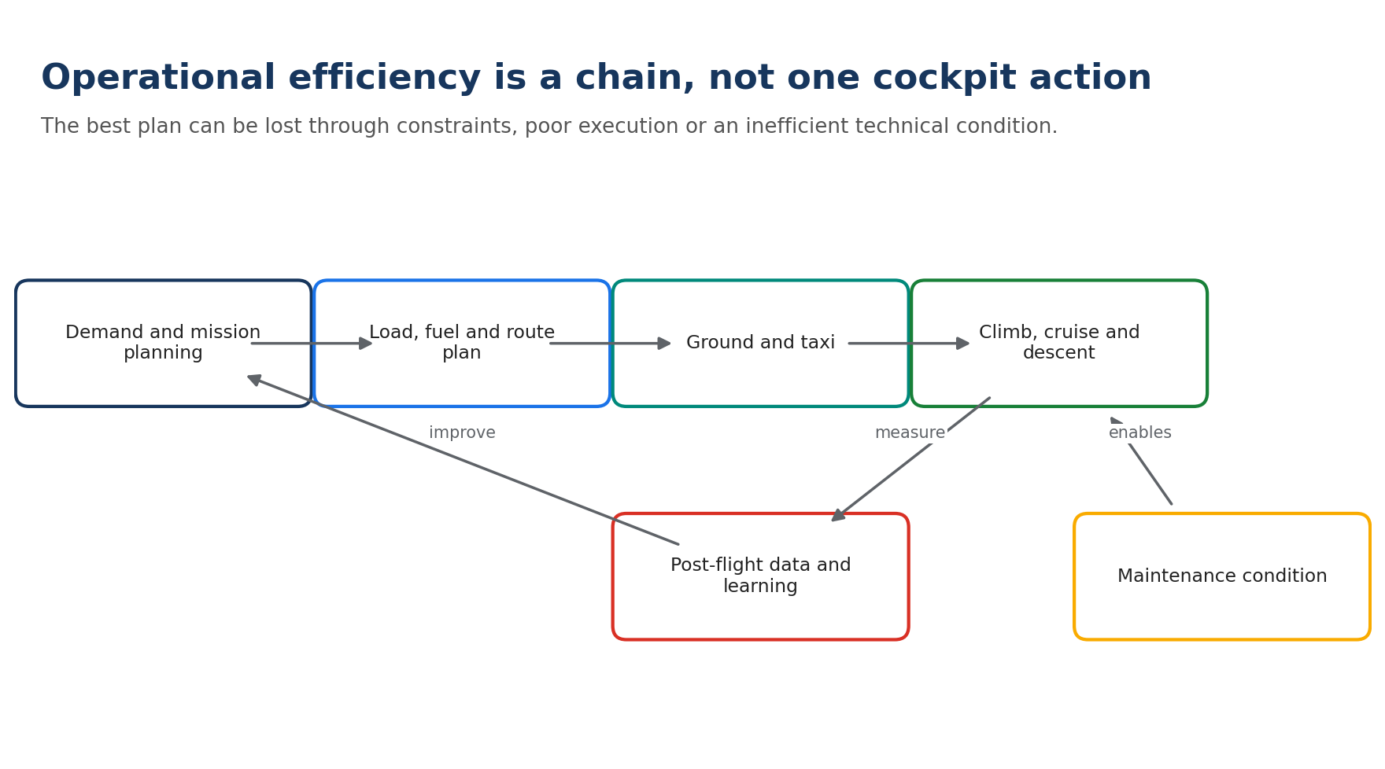
Operational efficiency chain. Planning, technical condition and post-flight learning influence the result.

2.1 Start with the mission and remove avoidable demand
Operational efficiency begins before engine start. The first question is whether the required service can be delivered with less avoidable demand: a consolidated movement, better deployment planning, more accurate payload information, reduced repositioning, or a simulator where it genuinely meets the training objective. Demand management must never be used to understate an operational requirement; it seeks avoidable activity, not mission denial.
Once demand is established, teams can optimise the plan: payload and centre-of-gravity information, contingency fuel within approved rules, route and altitude, weather avoidance, ground power, engine run time, taxi and departure sequence. ICAO defines operations broadly, from planning and airport activity through the complete flight, and identifies operational improvements as a short- to medium-term component of its climate strategy. [R4]
Lever | Mechanism | Constraint or trade-off to test
Payload and onboard mass | Lower mass can reduce required thrust and fuel | Mission equipment, reserves and centre of gravity
Fuel planning | Avoids unnecessary carried mass | Approved reserves, alternates, uncertainty and resilience
Ground power and engine run | Reduces fuel burn and local emissions | Equipment availability, grid mix and readiness
Taxi | Reduces engine-on time | Safety, congestion, aircraft/equipment approval
Route and altitude | Reduces distance or improves specific range | Airspace, weather, threat, diplomatic and ATC constraints
Speed | May reduce fuel if moved toward optimum | Time-critical task, scheduling and envelope
Technical condition | Clean/rigged systems can protect efficiency | Maintenance burden and approved tolerances

2.2 Vertical and horizontal flight efficiency
Continuous Climb Operations (CCO) and Continuous Descent Operations (CDO) aim to reduce intermediate level segments and keep aircraft closer to efficient thrust and configuration. EUROCONTROL describes these techniques as enabled by airspace design, procedure design and Air Traffic Control (ATC). Its network analysis estimated substantial potential fuel, carbon and noise benefits, but also states that universal implementation is not possible because of safety, weather, capacity and controller-workload constraints. [R5]
Performance-Based Navigation (PBN) defines navigation performance requirements rather than tying every route to specific ground-based aids. Through Area Navigation (RNAV) and Required Navigation Performance (RNP) specifications, PBN can enable flexible and vertically optimised paths, reduce fuel and noise, and improve predictable access. These are capabilities, not guarantees: the realised outcome depends on procedure design, equipage, approvals, traffic management, weather and actual track flown. [R6]

M2-A1 | Continuous or Conventional?
Interaction | Estimated time | Completion
Branching decision | 8 min | Online; auto-graded or model-answer comparison

Choose the preferred profile, then review the constraint branch.
Prompt: Orion can use a continuous descent profile with low thrust, or a step-down profile with two level segments. Both are approved. Traffic is light and weather is stable.
- A. Continuous descent
- B. Step-down descent
- C. Either option has identical effects
Correct / model answer: A, under the stated conditions.
Feedback: CDO is likely to reduce fuel and noise because level segments and thrust are reduced. If traffic, weather, separation or mission constraints change, the preferred profile may no longer be available.

2.3 Measure what the operation actually changed
Fuel is a strong operational indicator because it links directly to cost and combustion carbon dioxide. For Jet-A and Jet-A1, ICAO uses a fuel conversion factor of 3.16 kilograms of CO2 per kilogram of fuel in CORSIA calculations. [R20] This is a tank-to-wake combustion factor. It is not a complete lifecycle carbon footprint and does not include aviation non-CO2 climate effects.
Worked calculation: If an approved planning change saves 120 kg of Jet-A1 per mission, direct combustion CO2 avoided is 120 x 3.16 = 379.2 kg CO2 per mission. At 240 comparable missions, the estimated direct effect is 91.0 t CO2. Report the factor, mission count and comparison conditions.
Noise and local air quality require different metrics. Fuel savings cannot be assumed to reduce noise at every location; a route change can move exposure between communities. A higher flight path may reduce local noise while changing fuel. Measures should therefore be evaluated against the material impact and affected stakeholder rather than compressed into one unsupported score.

M2-A2 | CO2 Calculation
Interaction | Estimated time | Completion
Numeric input | 7 min | Online; auto-graded or model-answer comparison

Enter the direct combustion CO2 result in tonnes to one decimal place.
Prompt: A route improvement saves 85 kg of Jet-A1 on each of 310 comparable flights. Use 3.16 kg CO2 per kg fuel.
Correct / model answer: 83.3 t CO2 (85 x 310 x 3.16 / 1,000).
Feedback: This is a direct combustion estimate. Do not label it a full lifecycle or total climate benefit.

2.4 Mission readiness can change the optimal answer
Commercial efficiency logic cannot simply be copied into state or military aviation. A mission may require a time window, threat-avoidance route, diplomatic clearance, training objective, reserve policy or rapid re-tasking capacity. An apparently inefficient route can be necessary. The analytical task is to distinguish required constraints from avoidable inefficiency and to document why the chosen option remains the best permitted solution.
Question | Evidence to capture
Was the mission requirement met? | Required time, payload, range, task and service level
Were safety and airworthiness conditions met? | Approved procedure, configuration and limitations
What changed operationally? | Planned versus actual track, level, time, fuel and delays
What external constraints applied? | Weather, ATC, airspace, threat, capacity and alternates
Was fuel saved absolutely and per unit? | Total fuel plus fuel per comparable mission/hour
Were impacts displaced? | Noise location, extra ground activity, logistics or maintenance

M2-LAB | Orion Sortie Profile Challenge
Interaction | Estimated time | Completion
Scenario worksheet + model answer | 30 min | Online; auto-graded or model-answer comparison

Use the learner workbook to compare three options and select one.
Prompt: A routine training sortie has a flexible arrival window. Option A is the historical route with step-down descent. Option B is 3% shorter and supports CDO but needs coordination. Option C is 5% shorter but reduces contingency time below the approved plan. Identify the admissible options, estimate direct CO2 for a stated fuel baseline and propose three KPIs.
Correct / model answer: Option C is inadmissible because it fails the approved contingency requirement. Option B is the preferred candidate if coordination is feasible. KPIs should include actual fuel per comparable sortie, CDO achievement/level-flight time and absolute annual fuel, with context for weather, ATC and payload.
Feedback: A strong answer rejects an unsafe/non-compliant option before calculating benefits, distinguishes plan from actual performance and includes both intensity and absolute data.

Module knowledge check
The learning platform should present five questions in random order. Required score: 80%. Retakes are allowed; answer order should be shuffled.

Question 1
What does a CDO primarily seek to reduce?
- A. All maintenance activity
- B. Intermediate level segments and unnecessary thrust during descent
- C. Required fuel reserves
- D. Aircraft mass at manufacture
Answer: B
Feedback: CDO aims for a continuous, low-thrust descent where operational conditions permit.

Question 2
Which claim is correctly bounded?
- A. The route change made the mission sustainable
- B. The route change eliminated climate impact
- C. Measured fuel fell 2.1% on comparable missions; estimated direct CO2 used the ICAO 3.16 factor
- D. PBN always reduces fuel by the same percentage
Answer: C
Feedback: It states the measured change, comparison basis and calculation factor without extending the claim beyond the evidence.

Question 3
What is PBN?
- A. A carbon-offset scheme
- B. Navigation based on specified performance requirements
- C. A predictive-maintenance algorithm
- D. A military-fuel standard
Answer: B
Feedback: PBN harmonises navigation performance specifications and can enable more flexible routes and procedures.

Question 4
Which factor converts 1,000 kg of Jet-A1 into direct combustion CO2 for this course?
- A. 0.316
- B. 1.00
- C. 3.16
- D. 31.6
Answer: C
Feedback: 1,000 kg fuel x 3.16 = 3,160 kg CO2. The result is not a full lifecycle climate footprint.

Question 5
A shorter route conflicts with an approved mission reserve. What is the correct first response?
- A. Select it because fuel is lower
- B. Remove the reserve from the analysis
- C. Reject or redesign the option so the approved requirement is met
- D. Count an offset
Answer: C
Feedback: Environmental optimisation cannot override the approved safety or mission requirement.
Module takeaway: Operational measures are valuable because they can act on aircraft already in service, but realised benefits must be measured against actual constraints and comparable missions.
Evidence base: [R2], [R4], [R5], [R6], [R20].

Module 3 | Sustainable Maintenance, MRO and Material Support
Estimated time: 110 minutes | Theory: 50 | Interactions: 20 | Lab: 35 | Check: 5
Module question: How can maintenance protect readiness and aircraft efficiency while reducing its own footprint?
Hero visual brief: Use an approved photograph of real maintenance work, with people, tooling and material flows visible. Avoid staged 'green' props or unverified environmental symbolism.

Learning outcomes
- Explain the direct and enabling sustainability effects of maintenance.
- Identify MRO hotspots across facilities, processes, materials, logistics, waste and people.
- Apply prevention, substitution, reuse/repair and waste-hierarchy logic within approved technical requirements.
- Design a balanced maintenance KPI set that includes reliability, resources, waste, exposure and first-time-right performance.
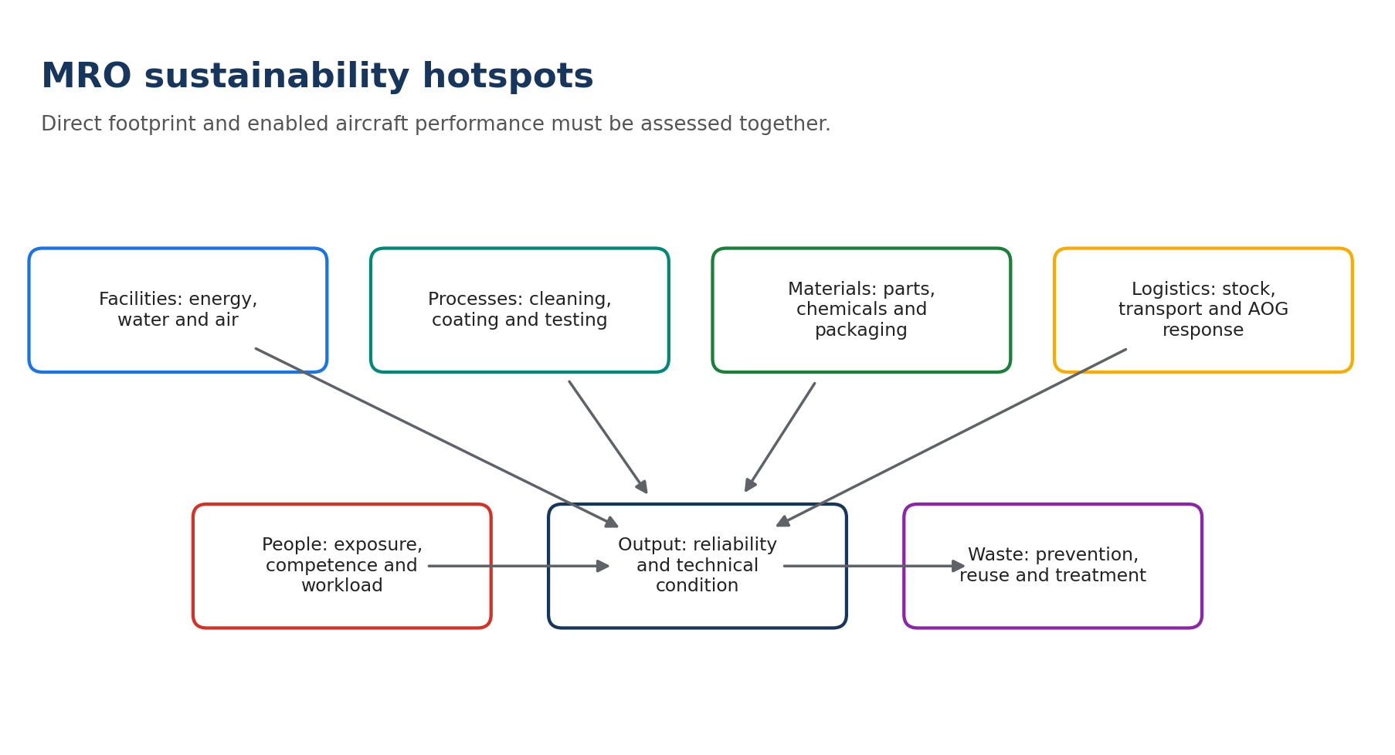
MRO hotspot map. Direct resource use and enabled technical performance belong in the same decision system.

3.1 Maintenance is both a footprint and an enabler
Maintenance consumes energy, water, parts, chemicals, consumables, packaging and labour; it also produces wastewater, emissions and waste. At the same time, maintenance preserves airworthiness, reliability and technical condition. A well-maintained aircraft can avoid performance deterioration, repeat defects, premature removals and emergency logistics. Sustainable maintenance therefore cannot mean 'less maintenance'. It means the right approved task, at the right time, with the right resources, producing the intended technical outcome.
EASA's M&P study highlights maintenance impacts from energy use, maintenance products, spare parts and waste, and notes that time pressure, safety and reliability dominate the MRO environment. The practical opportunity is to integrate environmental performance into the existing technical culture rather than create a competing priority. [R1] Research on sustainable engine maintenance likewise argues for simultaneous reliability, economic, environmental and social performance. [R17]
Do not say: 'We reduced maintenance to reduce environmental impact.' Say what task was changed, the approved technical basis, the reliability result and the measured resource effect.

3.2 Follow the physical work: a practical hotspot walkdown
A useful MRO assessment follows the job from input to output. What arrives? Which facilities and utilities are used? Which steps create value, waiting, rework or loss? Which parts and substances enter the process? Which emissions and wastes leave? What transport is triggered? Did the work restore the required technical condition first time?
Hotspot area | Typical evidence | Improvement examples to test
Hangar and workshop energy | Metering, load profile, temperature, compressed air | Zoning, controls, leak repair, efficient equipment
Water and effluent | Process water, quality parameters, discharge route | Closed-loop cleaning, dry methods, segregation
Chemicals and VOC | Safety Data Sheets, use rate, emissions, exposure | Approved substitution, dosing, enclosed application
Parts and consumables | Issue, scrap, shelf-life expiry, packaging | Repair, controlled reuse, better forecasting, return loops
Waste | Type, hazardous status, weight, treatment route | Prevent, segregate, reuse, recycle, compliant disposal
Testing and engine runs | Duration, fuel/energy, repeat tests | First-time-right preparation, sequence and equipment
Logistics | Mode, distance, urgency, consolidation | Forecasting, pooling, local capability, packaging loops
People | Exposure, ergonomics, competence, workload | Substitution, engineering controls, standard work, training

M3-A1 | Find the Hidden Hotspot
Interaction | Estimated time | Completion
Image hotspot / text alternative | 8 min | Online; auto-graded or model-answer comparison

Select the five items that deserve first investigation in the described hangar.
Prompt: The hangar has doors open during conditioning, compressed-air leaks, mixed hazardous/non-hazardous waste, repeated cleaning, unused lighting and one new recycling poster.
- A. Open doors while conditioning
- B. Compressed-air leaks
- C. Mixed waste
- D. Repeated cleaning
- E. Unused lighting
- F. The poster's colour
Correct / model answer: A, B, C, D and E.
Feedback: The poster may support communication but does not itself change a material flow. Start with measured or observable losses.

3.3 Use the hierarchy: prevent before treating
The EU waste hierarchy prioritises prevention, preparation for reuse, recycling, other recovery and disposal. [R21] In an aviation context, prevention can include first-time-right work, better shelf-life management, avoiding contamination, correct dosing and extending the approved useful life of tooling or packaging. Reuse and repair require traceability, technical acceptance and appropriate status control. Recycling is valuable but comes after opportunities to avoid the waste in the first place.
Hazardous substances require an additional control hierarchy: eliminate the need where possible; substitute with an approved less-hazardous option; use engineering controls; define administrative controls and competence; and use personal protective equipment as the final layer. Substitution must be assessed for technical performance, corrosion, compatibility, airworthiness, worker exposure, waste route and lifecycle trade-offs. A water-based product is not automatically better if it increases energy, water treatment or repeat work.

M3-A2 | Better Practice or Rebound?
Interaction | Estimated time | Completion
Scenario choice | 7 min | Online; auto-graded or model-answer comparison

Choose the most defensible next step.
Prompt: A proposed solvent substitute has lower volatile organic compound content but requires twice the drying energy and has not completed material-compatibility approval.
- A. Deploy immediately because VOC is lower
- B. Reject permanently
- C. Complete technical approval and compare total process effects before deployment
- D. Call the process zero-impact
Correct / model answer: C.
Feedback: One improved attribute is not enough. Technical compatibility and process-level trade-offs must be evaluated.

3.4 Reliability, availability and sustainability: use a balanced dashboard
A single environmental KPI can drive the wrong behaviour. Fewer part removals may look positive until unscheduled failures rise. Lower inventory may increase emergency transport. A balanced dashboard links technical outcome, service delivery, resource use and control quality.
Dimension | Example KPI | Interpretation guardrail
Safety/technical | Repeat defects; findings; approved task compliance | Never trade for environmental gain
Reliability | Mean time between unscheduled removals | Segment by component and operating context
Availability | Aircraft-days available / required | Avoid rewarding unused standby capacity
First-time-right | Jobs closed without repeat work | Define the verification window
Parts | New parts issued per 1,000 flight hours | Include repairable and serviceable returns
Energy | kWh per comparable check or labour hour | Show absolute energy and weather/context
Waste | kg hazardous waste per comparable input | Do not combine unlike waste solely by mass
Chemicals | Litres or kg per task family | Include concentration and hazard class
Logistics | Emergency shipments and transport CO2e | Document calculation method and exclusions

3.5 Compliance case: halon and technical transition
Environmental compliance can create a fleet-support transition rather than a simple replacement task. EASA reported that EU-registered in-service aircraft, or aircraft operated by EU-registered operators within the relevant scope, had to use halon-free portable extinguishers after the applicable milestone. [R19] A robust support response would check aircraft and operator scope, approved equipment, configuration control, supply availability, removed-unit treatment, training and customer communication. The lesson is not the specific date; it is the need to connect environmental law, airworthiness, material support and execution evidence.

M3-LAB | MRO Hotspot Walkdown
Interaction | Estimated time | Completion
Downloadable audit-style worksheet | 35 min | Online; auto-graded or model-answer comparison

Complete one process walkdown using fictional Orion data.
Prompt: The Orion wheel-and-brake workshop records rising solvent use, expired consumables, two repeat cleaning cycles, mixed metal/contaminated waste and frequent urgent part transport. Identify six evidence requests, three quick wins, two technical approvals and five KPIs.
Correct / model answer: Evidence should cover task volume, solvent per task, repeat-work causes, shelf-life losses, waste classification/treatment, and transport urgency. Quick wins can include standard dosing, stock rotation and waste segregation. Product substitution and process changes require technical and environmental approval. KPIs should balance first-time-right, solvent, expired stock, hazardous waste and emergency shipments.
Feedback: Do not propose a generic awareness campaign as the main action when physical losses and control failures are visible. Assign an owner and a verification method to every action.

Module knowledge check
The learning platform should present five questions in random order. Required score: 80%. Retakes are allowed; answer order should be shuffled.

Question 1
What is the best definition of sustainable aircraft maintenance?
- A. The minimum possible maintenance
- B. Approved maintenance that delivers the required technical outcome while improving lifecycle environmental, social and economic performance
- C. Recycling all removed parts
- D. Using products labelled eco-friendly
Answer: B
Feedback: The technical outcome and approved basis are essential; resource performance is optimised around them.

Question 2
Which action is highest in the waste hierarchy?
- A. Landfill
- B. Energy recovery
- C. Recycling
- D. Preventing the waste
Answer: D
Feedback: Prevention is preferred because no waste treatment is required.

Question 3
Why can a very low spare inventory be environmentally counterproductive?
- A. Inventory has no environmental effect
- B. It may increase aircraft-on-ground events and emergency transport
- C. It always increases shelf-life
- D. It eliminates repair
Answer: B
Feedback: Inventory optimisation must consider resilience, obsolescence and urgent-logistics risk together.

Question 4
Which KPI pair is most balanced?
- A. Waste mass only
- B. Recycling rate and poster count
- C. Hazardous waste per check and repeat defects
- D. Number of sustainability meetings only
Answer: C
Feedback: It combines a direct environmental output with the technical outcome that could reveal harmful under-maintenance or rework.

Question 5
A less-hazardous chemical requires more energy and causes repeat work. What is the correct conclusion?
- A. It is automatically sustainable
- B. It is automatically prohibited
- C. The process trade-off and technical performance must be assessed
- D. Energy is outside the maintenance boundary
Answer: C
Feedback: Substitution decisions require a multi-impact and technical comparison.
Module takeaway: The most effective MRO actions prevent defects, repeat work, premature removals, hazardous exposure, material loss and emergency response while protecting the approved technical outcome.
Evidence base: [R1], [R17], [R18], [R19], [R21], [R22].

Module 4 | Digital Solutions and Data-Driven In-Service Sustainability
Estimated time: 100 minutes | Theory: 45 | Interactions: 20 | Lab: 30 | Check: 5
Module question: When does a digital prediction become a verified sustainability improvement?
Hero visual brief: Use an approved image of aircraft health monitoring, technical data review or remote support. Screens must not expose customer, classified or personally identifiable data.

Learning outcomes
- Distinguish corrective, preventive, condition-based, predictive and prescriptive maintenance.
- Trace a digital use case from data through decision and authorised action to verified outcome.
- Identify data-quality, model, human-factor, cybersecurity, assurance and rebound risks.
- Build a quantified digital value case with a counterfactual, KPI set and benefit-verification plan.
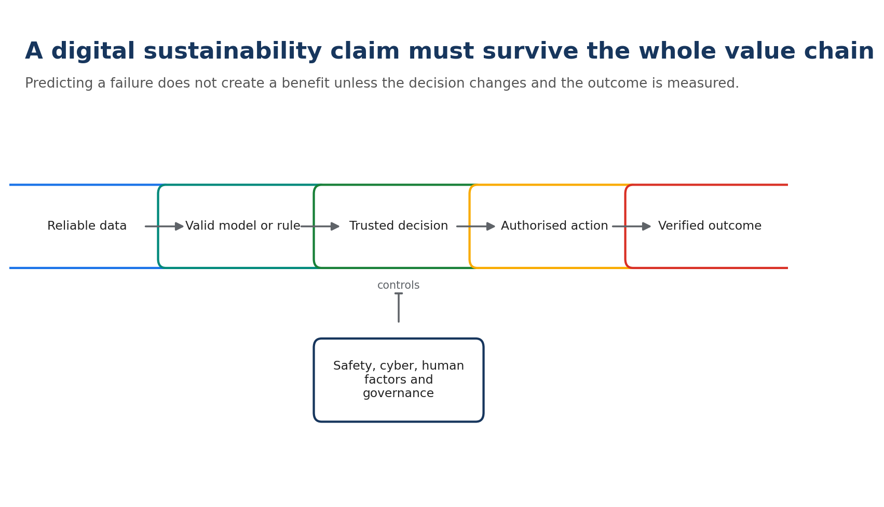
Digital value chain. A weak link prevents a reliable technical or sustainability claim.

4.1 Maintenance strategies are not a maturity contest
Corrective maintenance responds after failure. Preventive maintenance performs approved tasks at defined intervals. Condition-based maintenance uses observed condition to support a task decision. Predictive maintenance estimates a future condition or failure probability. Prescriptive maintenance adds a recommended action or schedule. These approaches can coexist. A simple interval task may remain the safest and most efficient option for one failure mode, while a condition-based task is suitable for another.
Approach | Decision trigger | Potential value | Primary risk
Corrective | Failure | Avoids planned work where run-to-failure is acceptable | Disruption or consequential damage
Preventive | Time, cycles or usage | Predictable control of known deterioration | Unnecessary work or early removal
Condition-based | Observed state or threshold | Intervene when condition justifies it | Poor sensing or threshold design
Predictive | Forecast or remaining useful life | Earlier planning and targeted intervention | False confidence, drift or weak labels
Prescriptive | Optimised recommendation | Balances timing, resources and constraints | Opaque recommendation or automation bias

A systematic review focused on defence fixed-wing sustainment found growing interest in predictive maintenance but also uneven evidence, data and implementation maturity. [R12] NASA research identifies barriers such as data access, validation, trust, certification, business-case uncertainty and integration into maintenance processes. [R13] Therefore, 'AI-enabled' is not a benefit statement.

M4-A1 | Name the Strategy
Interaction | Estimated time | Completion
Matching | 6 min | Online; auto-graded or model-answer comparison

Match each trigger to the maintenance approach.
Prompt: 1) fixed cycle limit; 2) vibration threshold; 3) model forecasts bearing condition in 40 hours; 4) optimiser recommends the lowest-risk maintenance slot.
- Preventive
- Condition-based
- Predictive
- Prescriptive
Correct / model answer: 1 Preventive; 2 Condition-based; 3 Predictive; 4 Prescriptive.
Feedback: The data source alone does not determine the approach; the decision trigger and use of the information do.

4.2 Build the causal chain
A digital system can improve sustainability only if it changes an authorised decision. The causal chain is: reliable data -> valid model or rule -> trusted decision -> approved action -> changed physical outcome -> verified technical and environmental result. Dashboard views, alerts generated or users trained are implementation metrics, not final benefits.
Chain stage | Proof question | Example KPI
Data | Are coverage, labels, context and quality sufficient? | Valid sensor coverage; missing-data rate
Model/rule | Does performance remain valid in the operating domain? | Precision/recall; calibration; drift
Decision | Did the insight change a planned choice? | Accepted recommendations; decision lead time
Action | Was an approved intervention executed? | Tasks rescheduled; planned vs urgent events
Technical outcome | Did reliability/availability improve? | Unscheduled removals; repeat defect rate
Sustainability outcome | Did a physical flow change? | Parts avoided; logistics CO2e; waste; fuel

4.3 Control the risks
A false negative can miss a deteriorating condition; a false positive can trigger unnecessary work and parts. Model drift can follow changes in fleet age, software, mission profile or maintenance practice. Human operators may over-trust or ignore alerts. Cybersecurity and data provenance are essential in connected support systems. EASA's AI Roadmap emphasises a human-centric and trustworthy approach to aviation AI, including safety, ethics, assurance and human factors. [R14]
Digital systems also have their own footprint: sensors, hardware, data transmission, storage, compute and replacement cycles. This footprint may be small relative to avoided aircraft or logistics impacts, but it must be screened rather than assumed away. Rebound is also possible: better forecasting can encourage more monitoring, more retained data or more interventions.
Security rule: Use only approved systems and authorised data. Sustainability analysis never justifies moving classified, export-controlled, customer-sensitive or personal data to an unapproved platform.

M4-A2 | Data vs. Decision
Interaction | Estimated time | Completion
Multi-select | 8 min | Online; auto-graded or model-answer comparison

Select the measures that demonstrate a physical outcome, not merely digital activity.
Prompt: Orion's new dashboard generated 2,000 alerts, gained 70 users, reduced ten urgent removals, avoided six emergency shipments and increased data storage by 15%.
- A. Alerts generated
- B. Users
- C. Urgent removals
- D. Emergency shipments
- E. Data storage
Correct / model answer: C and D are outcome indicators; A and B are activity/adoption; E is a potential digital-footprint input.
Feedback: All five are useful, but they answer different questions and must not be conflated.

4.4 Quantify a defensible value case
A value case compares a digital scenario with a credible counterfactual over the same service period. It includes implementation and operating costs, technical benefits, downtime, parts, labour, logistics, environmental flows and risk. Benefit estimates should show measured, modelled and assumed values separately.
Worked calculation: Baseline emergency logistics: 18 events/year x 1.6 t CO2e/event = 28.8 t CO2e. Pilot result: 11 events/year = 17.6 t CO2e. Estimated avoided logistics emissions: 11.2 t CO2e/year. If platform operations add 0.8 t CO2e/year within the chosen boundary, the simplified net estimate is 10.4 t CO2e/year. Both factors and uncertainty must be documented.

M4-LAB | Digital Use-Case Evidence Card
Interaction | Estimated time | Completion
Downloadable business-case canvas | 30 min | Online; auto-graded or model-answer comparison

Complete the seven-stage value chain and risk register.
Prompt: Orion proposes an engine-health model to reduce unscheduled removals. Define the counterfactual, decision user, approved action, six KPIs, two false-alert consequences, two data risks, one cyber control and the method for verifying environmental benefit.
Correct / model answer: The counterfactual is the current preventive/diagnostic process. The decision user is the authorised maintenance/planning function. KPIs span model performance, accepted decisions, planned/urgent removals, availability, parts and emergency logistics. Verification compares comparable pre/post or controlled fleet data and includes platform footprint where material.
Feedback: Reject answers that stop at prediction accuracy. Technical acceptance, work-process change and physical outcome are mandatory links.

Module knowledge check
The learning platform should present five questions in random order. Required score: 80%. Retakes are allowed; answer order should be shuffled.

Question 1
What turns a prediction into a sustainability outcome?
- A. A high number of dashboard views
- B. An authorised decision and action that changes a measured physical flow
- C. Use of a digital twin label
- D. More stored data
Answer: B
Feedback: Digital activity is not equivalent to a verified physical benefit.

Question 2
Which is a model-risk example?
- A. Fleet ageing changes the data distribution and performance falls
- B. A workshop changes its lighting
- C. A route becomes shorter
- D. A part is recycled
Answer: A
Feedback: This is model drift and must be detected and governed.

Question 3
Why should platform energy be screened?
- A. Digital tools always use more energy than aircraft
- B. Digital systems have no footprint
- C. It is part of the lifecycle trade-off and may affect the net benefit
- D. It replaces reliability evidence
Answer: C
Feedback: Its materiality varies, but assuming zero creates an incomplete boundary.

Question 4
Which pair best distinguishes predictive from prescriptive maintenance?
- A. Predictive forecasts; prescriptive recommends an action under constraints
- B. Predictive is approved; prescriptive is never approved
- C. Predictive uses sensors; prescriptive does not
- D. There is no difference
Answer: A
Feedback: Prescriptive capability adds an action recommendation or optimisation layer.

Question 5
What is the correct treatment of classified or customer-sensitive data?
- A. Upload it if the environmental benefit is large
- B. Anonymise informally and use any platform
- C. Use only approved systems, authorised data and defined controls
- D. Put it in Hub comments for peer review
Answer: C
Feedback: Security, export control and customer obligations remain binding.
Module takeaway: Digital sustainability is a verified change in physical outcome, supported by a trustworthy technical and decision chain - not the presence of data, AI or a dashboard.
Evidence base: [R12], [R13], [R14], [R16].

Module 5 | Upgrades, Life Extension, Retirement and Circularity
Estimated time: 110 minutes | Theory: 50 | Interactions: 20 | Lab: 35 | Check: 5
Module question: When is retrofit or life extension better than replacement, and what evidence decides?
Hero visual brief: Use an approved image of a real retrofit, modification embodiment or controlled dismantling activity. Do not use a generic recycling symbol as evidence of aircraft circularity.

Learning outcomes
- Evaluate retrofit benefits over the remaining service horizon, including embodiment and maintenance effects.
- Build comparable life-extension, replacement, storage and retirement scenarios.
- Explain the end-of-life sequence from decommissioning and parts harvesting to material treatment.
- Apply circular-economy priorities without compromising traceability, airworthiness or hazardous-material controls.
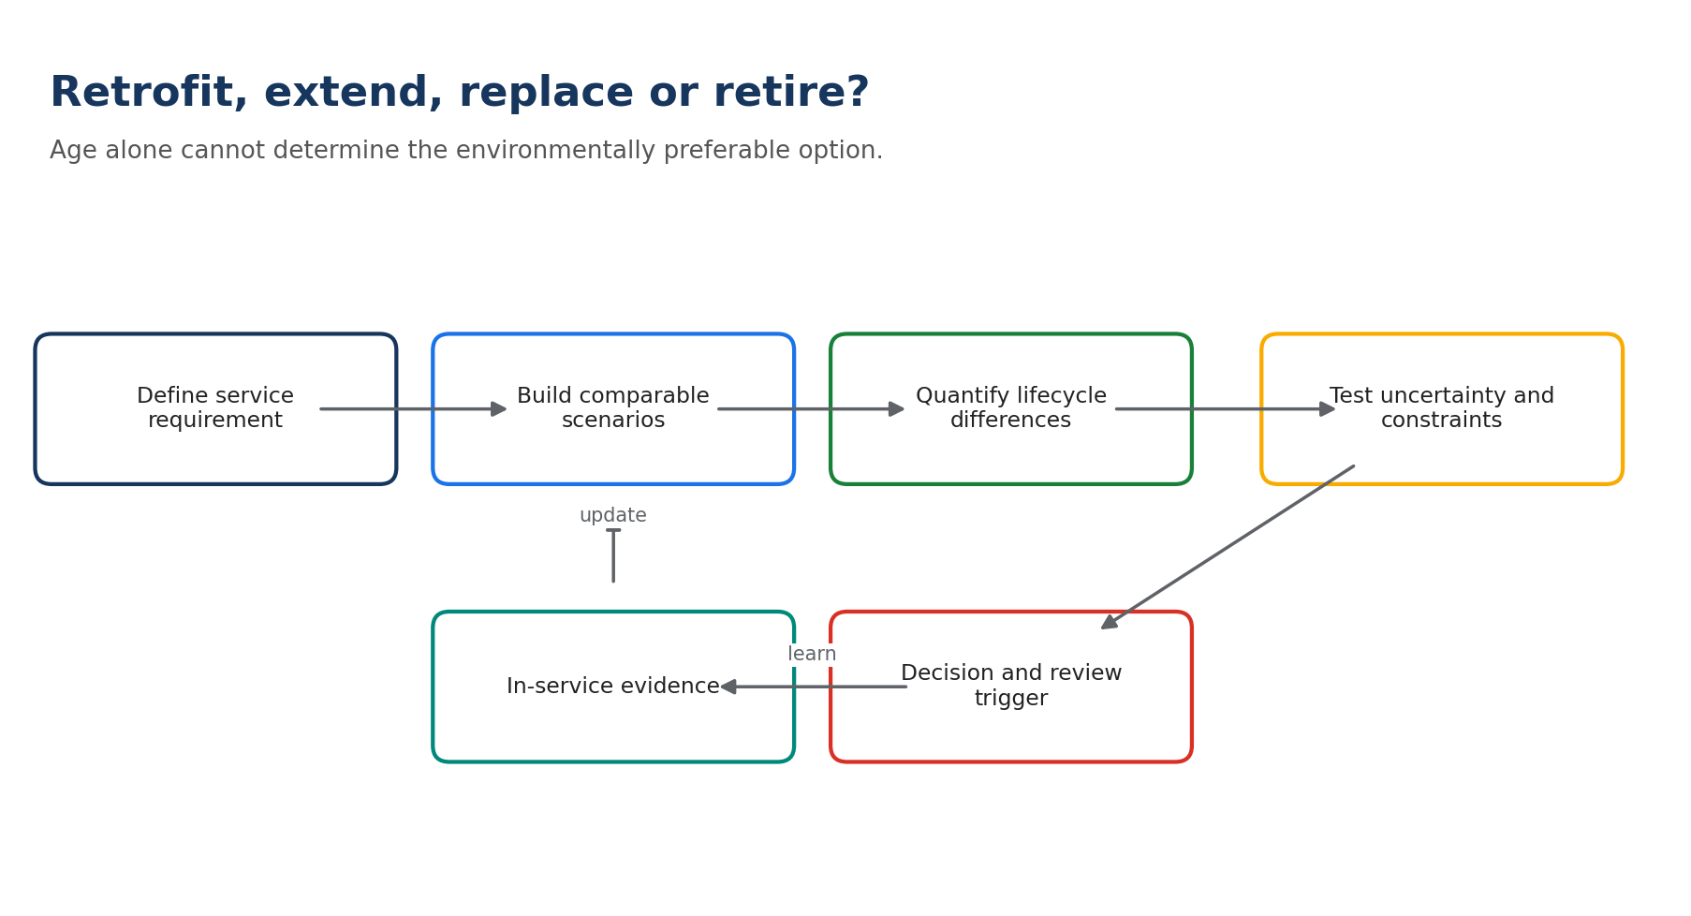
Lifecycle decision process. The correct answer depends on delivered service and comparable scenarios, not aircraft age alone.

5.1 A retrofit is a lifecycle investment
A retrofit modifies an aircraft or support system after delivery. It may improve aerodynamics, mass, systems, mission capability, maintainability, data availability, noise or energy performance. The gross in-service benefit must be compared with design, production, transport, installation, downtime, certification, training, spares and end-of-life effects. Utilisation and remaining life are decisive: a small per-hour saving can become material over intensive use, while the same retrofit may not repay its footprint on a lightly used aircraft.
Retrofit question | Evidence
What service changes? | Capability, availability, performance or risk
What is the baseline? | Current configuration and representative operating data
How long will the benefit run? | Remaining years, hours, cycles and mission mix
What is embodied? | Equipment, materials, manufacture, transport and installation
What else changes? | Mass, drag, maintenance, software, training, spares and downtime
How will benefit be verified? | Pre/post or matched-fleet data and acceptance criteria

Worked calculation: A retrofit saves 2% of an 8 t fuel baseline over 900 comparable missions/year for eight years: 1,152 t fuel. Estimated direct combustion CO2 avoided is 1,152 x 3.16 = 3,640.3 t CO2. If the retrofit's embodied footprint is estimated at 220 t CO2e, subtracting it gives a simplified 3,420.3 t difference - but only if methods, gases and boundaries are comparable.

M5-A1 | Retrofit Break-Even
Interaction | Estimated time | Completion
Numeric + interpretation | 8 min | Online; auto-graded or model-answer comparison

Calculate annual fuel saving and state one limitation.
Prompt: A modification saves 1.5% of 6,500 kg on each of 420 missions per year.
Correct / model answer: 40,950 kg or 40.95 t fuel/year. A limitation could be variable mission profile, unmeasured embodiment, additional mass or uncertain remaining utilisation.
Feedback: A calculation is only the start; its boundary and operating assumptions determine whether it supports a decision.

5.2 Extend, replace, store or retire: compare the same service
An older aircraft can have higher fuel and maintenance needs but avoids immediate production of a replacement. A new aircraft can offer better operational performance but carries manufacturing, delivery, infrastructure and training impacts. Life extension can preserve embodied value but may increase obsolescence, scarcity, downtime or urgent logistics. There is no universal rule that replacement or extension is environmentally preferable.
The scenarios must deliver the same defined service over the same horizon. If a replacement provides different capability or availability, that difference must be made explicit. A break-even analysis estimates when cumulative operational savings exceed the additional embodied and transition impacts, then tests sensitivity to utilisation, fuel saving, maintenance, energy mix and service life.
Scenario | Include | Common omission
Life extension | Retrofit, inspections, spares, obsolescence, efficiency and extra years | Increasing support burden
Replacement | Manufacture, delivery, infrastructure, training and improved operation | Embodied and transition impacts
Storage | Preservation maintenance, land, protection, inspections and return-to-service | Long duration and degradation
Retirement/part-out | Decontamination, traceable parts, dismantling, transport and treatment | Hazardous and composite materials

M5-A2 | No Automatic Answer
Interaction | Estimated time | Completion
Branching scenario | 8 min | Online; auto-graded or model-answer comparison

Choose the correct analytical response.
Prompt: Aircraft A can fly six more years after retrofit. Replacement B is 14% more fuel-efficient but requires new infrastructure. Annual utilisation is uncertain.
- A. Extend because reuse is always circular
- B. Replace because newer is always efficient
- C. Build comparable scenarios and test utilisation, embodiment, support and infrastructure
- D. Decide using aircraft age only
Correct / model answer: C.
Feedback: The uncertainty in utilisation may dominate the result. Neither option can be selected credibly without a comparable service scenario.

5.3 End-of-life begins before dismantling
Aircraft can move from operation to parking, storage, decommissioning, disassembly/part-out, dismantling and material treatment. Decommissioning removes the aircraft from its operational status and prepares it safely. Disassembly recovers identified parts and materials, with status, records, inspection and recertification where applicable. Dismantling separates the remaining structure and materials for recycling, recovery or disposal.
EASA's M&P study describes hazardous-fluid removal, decontamination, parts identification and packaging, material sorting, recycling, energy recovery and landfill. It also notes that aircraft end-of-life is not governed by one dedicated worldwide aircraft law; general waste and hazardous-material rules apply when assets become waste. [R1] EASA highlights eco-design, disassembly, reuse and recyclability as important future improvements. [R15]
Sequence | Control objective
1. Status and decision | Document ownership, configuration, airworthiness and retirement decision
2. Make safe | Defuel, depressurise, isolate energy and control hazardous materials
3. Records and parts plan | Identify reusable/serviceable candidates and required traceability
4. Disassembly/part-out | Remove, inspect, tag, package and route parts correctly
5. Dismantling and sorting | Separate materials and hazardous/non-recyclable fractions
6. Treatment | Prioritise reuse/recycling, then recovery, then compliant disposal
7. Evidence closure | Mass balance, certificates, waste records and lessons for design/support

Circularity is constrained by technical status and material reality. A component cannot return to service because it is physically reusable; it must have the required identity, history, inspection and release. Composite materials can be technically difficult or economically unattractive to recycle. Manufacturer statements such as 'up to' recovery percentages are context-specific and must not be generalised to every aircraft, configuration or treatment route. [R16]

5.4 Defence circularity and strategic resilience
Circularity in defence can also support resilience and strategic autonomy through repair, remanufacturing, reverse logistics, spare-parts management and reduced dependence on critical materials. The European Defence Agency's IF CEED brings governments, industry and research organisations together on these topics. [R11] The opportunity must still be tested against certification, configuration, security, intellectual property and supply continuity.

M5-LAB | Extend, Retrofit, Replace or Retire?
Interaction | Estimated time | Completion
Lifecycle decision worksheet | 35 min | Online; auto-graded or model-answer comparison

Complete the four-scenario comparison and uncertainty test.
Prompt: Orion must support a defined transport service for eight years. Build scenarios for life extension without retrofit, life extension with retrofit, replacement and mixed-fleet transition. Identify boundary, functional unit, ten data needs, five trade-offs, break-even variable and review trigger.
Correct / model answer: Use delivered comparable missions or payload-distance where mission classes allow. Include manufacture/embodiment, retrofit, fuel, maintenance, infrastructure, training, spares, obsolescence, downtime and EoL. Utilisation and fuel-performance difference are key sensitivity variables. A major mission-profile or remaining-life change should trigger review.
Feedback: The model answer does not prescribe one fleet choice. The quality criterion is a comparable, transparent decision model with no automatic 'new' or 'reuse' preference.

Module knowledge check
The learning platform should present five questions in random order. Required score: 80%. Retakes are allowed; answer order should be shuffled.

Question 1
What most strongly affects whether a fuel-saving retrofit repays its embodiment?
- A. Logo colour
- B. Remaining utilisation and realised performance
- C. Aircraft age alone
- D. Recycling rate alone
Answer: B
Feedback: Savings accumulate with use; low utilisation or short remaining life can prevent break-even.

Question 2
Why is 'new aircraft versus old aircraft' an incomplete comparison?
- A. New aircraft have no manufacturing impact
- B. Old aircraft have no operational impact
- C. Alternatives must deliver the same defined service over the same horizon
- D. Age is a sufficient functional unit
Answer: C
Feedback: Different capability, utilisation or availability makes environmental totals non-comparable unless normalised and disclosed.

Question 3
What comes before parts harvesting?
- A. Public sustainability claim
- B. Status decision, safe decommissioning and records plan
- C. Shredding
- D. Landfill
Answer: B
Feedback: Safety, asset status, hazardous-material control and traceability precede removal and routing.

Question 4
Which circular option generally has priority?
- A. Preventing waste or preserving approved useful value
- B. Energy recovery
- C. Landfill
- D. Uncontrolled reuse
Answer: A
Feedback: Prevention and controlled reuse/repair preserve more value, subject to technical and legal controls.

Question 5
What is the correct use of an 'up to 90% recoverable' statement?
- A. Apply it to every aircraft
- B. Treat it as a universal recycling rate
- C. Keep the source, definition and conditions; do not generalise
- D. Convert it directly into CO2 savings
Answer: C
Feedback: Recovery, reuse and recycling are different, and actual results depend on configuration, materials and treatment route.
Module takeaway: Lifecycle decisions require comparable service, complete scenarios and sensitivity analysis. Neither 'newer' nor 'reuse' is automatically the better answer.
Evidence base: [R1], [R11], [R15], [R16], [R20], [R21].

Module 6 | Governance, Measurement and In-Service Roadmapping
Estimated time: 100 minutes | Theory: 45 | Interactions: 20 | Lab: 30 | Check: 5
Module question: How do we turn ambition into governed actions and claims that can survive challenge?
Hero visual brief: Use an approved image of a cross-functional Air Power review: operations, engineering, materials, digital and environment. Avoid public-policy imagery that suggests direct legal scope.

Learning outcomes
- Distinguish global goals, civil-aviation schemes, defence frameworks, environmental law, management systems and corporate objectives.
- Apply an applicability test before presenting a framework as binding.
- Design KPIs with baselines, boundaries, owners, data sources, controls and review rules.
- Build a prioritised in-service roadmap and an evidence-based communication claim.
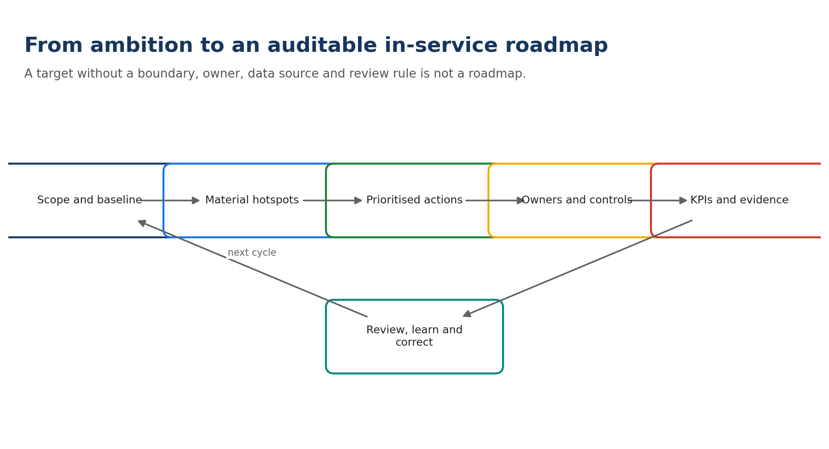
Roadmap governance cycle. Measurement and review connect the action portfolio to real outcomes.

6.1 Governance is a layered system
A framework can be a global aspiration, a legal obligation, a technical standard, a voluntary method, a customer requirement or an internal objective. These categories are not interchangeable. ICAO's Long-Term Global Aspirational Goal (LTAG) is net-zero carbon emissions from international aviation by 2050, but ICAO states that the LTAG does not assign a specific emissions target to an individual State. [R3]
Civil aviation schemes also have defined scope. ICAO's CORSIA monitoring, reporting and verification requirements apply to international civil aviation and exclude police, military, customs and state aircraft flights. [R7] ReFuelEU Aviation applies to defined civil commercial air transport and states that military aircraft and several special operations are outside its scope. [R8] These frameworks may still offer useful concepts, factors or market context, but they must not be described as directly binding on Air Power operations without an applicability check.
Layer | Example | Correct use in this course
Global civil goal | ICAO LTAG | Strategic context; not an individual military-flight obligation
Civil market scheme | CORSIA; ReFuelEU | Apply only after operator/flight/scope verification
Defence policy/method | NATO climate action and GHG methodology | Military-relevant awareness, measurement and mitigation context
Environmental law | Waste, chemicals, permits, facility emissions | Binding where the activity, site and jurisdiction are in scope
Management system | ISO 14001 | Identify aspects, obligations, controls, objectives and improvement
Corporate/customer | Internal objectives, contracts, programme requirements | Translate into owned, measurable in-service actions

NATO's action plan combines awareness, adaptation, mitigation and outreach while maintaining operational effectiveness and defence responsibilities. NATO has also published a methodology for estimating emissions from civilian and military facilities and installations. [R9][R10] For industrial and support activities, an Environmental Management System (EMS) such as ISO 14001 provides a practical governance backbone: environmental aspects, compliance obligations, operational controls, competence, objectives, monitoring and continual improvement. [R22]

M6-A1 | Framework or Obligation?
Interaction | Estimated time | Completion
Matching | 8 min | Online; auto-graded or model-answer comparison

Match each item to the correct category.
Prompt: ICAO LTAG; CORSIA; NATO GHG methodology; site waste permit; ISO 14001 objective.
- Global civil goal
- Civil MRV/offsetting scheme with defined scope
- Defence measurement method
- Site-specific legal control
- Management-system commitment
Correct / model answer: LTAG-global goal; CORSIA-civil scheme; NATO-defence method; permit-site legal control; ISO objective-management-system commitment.
Feedback: The label determines how the item should be applied, governed and communicated.

6.2 Build metrics that can be governed
Every KPI needs a definition, purpose, boundary, unit, baseline, calculation, data owner, quality control, frequency, target and decision rule. Without these fields, two teams can report the same title with different numbers. Leading indicators describe actions or controls that may influence performance; lagging indicators describe results. A credible dashboard needs both.
KPI element | Example
Name and purpose | Emergency shipments - monitor disruption and logistics impact
Boundary | All priority-1 shipments for the defined fleet from dispatch to receiving base
Unit | Events and calculated kg CO2e per aircraft-year
Baseline | Approved representative period; explain abnormal operations
Method | Shipment mass/distance/mode using the named factor source
Owner | Material Support Performance
Control | Monthly reconciliation with logistics records; exception review
Target and trigger | Reduce avoidable events; investigate any three-month adverse trend

6.3 Control sustainability claims
A claim should state the action, result, boundary, period, baseline, method and limitations in language proportionate to the evidence. Avoid vague terms such as green, eco-friendly, clean, zero-impact or sustainable without an explained and substantiated meaning. Do not convert a relative improvement into an absolute reduction, a direct CO2 result into total climate impact, a pilot estimate into an achieved benefit, or a contribution into sole attribution.
Weak claim | Evidence-based alternative
Predictive maintenance makes the fleet sustainable. | In the pilot boundary, the approved process reduced urgent removals from X to Y and estimated emergency-logistics emissions by Z, using the stated method; reliability remained within acceptance criteria.
The retrofit eliminates emissions. | On comparable missions, measured fuel use fell by X%; estimated direct combustion CO2 used the ICAO factor. Embodiment and non-CO2 effects are reported separately.
We recycle 90% of every aircraft. | For the named aircraft and treatment batch, X% by mass was reused, Y% recycled, Z% recovered and W% disposed; definitions and certificates are retained.
CORSIA requires military flights to be net zero. | CORSIA applies to international civil aviation within its scope and excludes military/state aircraft flights; Air Power targets must be traced to the applicable defence, legal, customer or corporate requirement.

M6-A2 | Claim Repair
Interaction | Estimated time | Completion
Rewrite + model answer | 10 min | Online; auto-graded or model-answer comparison

Rewrite the statement so a reasonable reader understands the evidence and limitation.
Prompt: 'Our digital twin cut fleet emissions by 25%.' Pilot data only cover emergency shipments for one component family.
Correct / model answer: During the defined pilot, the digital planning process reduced emergency shipments for the selected component family by 25% versus the stated baseline. The result does not represent total fleet emissions; associated logistics CO2e will be verified using shipment data and the documented method.
Feedback: The repaired claim narrows the subject, names the pilot boundary and separates activity reduction from a still-to-be-verified emissions result.

6.4 Build a prioritised roadmap
A roadmap is a governed portfolio, not a list of ideas. Begin with the baseline and material hotspots. Define the outcome and service guardrails. Generate measures across operations, maintenance, materials, facilities, digital and lifecycle decisions. Screen each measure for technical admissibility, evidence strength, environmental value, readiness benefit, cost, feasibility, dependency and risk. Then assign owners, milestones, KPIs and review triggers.
Criterion | 1 - Low | 3 - Medium | 5 - High
Environmental materiality | Minor flow | Relevant hotspot | Major hotspot with credible mechanism
Mission/readiness value | Potential adverse effect | Neutral/mixed | Improves resilience or availability
Evidence confidence | Assumption only | Pilot/indirect data | Measured and representative
Feasibility | Major unresolved barrier | Manageable dependencies | Ready with owner/resources
Risk/control maturity | Uncontrolled | Controls in development | Approved controls and acceptance

Scores support discussion; they do not replace engineering or managerial judgement. Any option that fails a mandatory safety, airworthiness, security, legal or mission gate is not rescued by a high environmental score.

M6-LAB | In-Service Sustainability Roadmap
Interaction | Estimated time | Completion
Editable roadmap + self-assessment | 30 min | Online; auto-graded or model-answer comparison

Select four actions and complete every roadmap field.
Prompt: Choose from operational profile optimisation, hangar energy controls, solvent-process improvement, repair/return loop, predictive-maintenance pilot, retrofit study and EoL records improvement. Define outcome, owner, milestone, KPI, baseline, evidence, dependency, risk and review trigger.
Correct / model answer: A balanced roadmap normally mixes one near-term operational/process action, one material or facility control, one evidence-building digital/lifecycle action and one governance improvement. Every action must include a service guardrail and a verification method.
Feedback: Use the rubric: scope and baseline 20%; technical/mission integration 20%; materiality and trade-offs 20%; KPI/evidence quality 20%; ownership, milestones and claims precision 20%.

Module knowledge check
The learning platform should present five questions in random order. Required score: 80%. Retakes are allowed; answer order should be shuffled.

Question 1
What is ICAO LTAG?
- A. A specific military-flight emissions limit
- B. A global aspirational goal for net-zero carbon emissions from international aviation by 2050
- C. A waste permit
- D. An aircraft maintenance programme
Answer: B
Feedback: ICAO also states that LTAG does not assign a specific reduction obligation to an individual State.

Question 2
Are military/state aircraft flights inside CORSIA scope?
- A. Always
- B. Only in Europe
- C. No, they are excluded
- D. Only below 5,700 kg
Answer: C
Feedback: ICAO states that CORSIA applies to international civil aviation and excludes military/state aircraft flights.

Question 3
Which KPI definition is most complete?
- A. Reduce waste
- B. Waste per year
- C. Hazardous waste kg per comparable heavy-check input, with named boundary, baseline, owner, method and review trigger
- D. Number of green ideas
Answer: C
Feedback: A governed KPI defines the calculation and how it will be used.

Question 4
Which statement is a greenwashing risk?
- A. Measured fuel fell 2% on comparable missions
- B. The pilot estimate uses stated assumptions
- C. Our AI makes maintenance zero-impact
- D. Reliability remained within the defined acceptance range
Answer: C
Feedback: It is absolute, vague and unsupported; digital activity cannot eliminate all maintenance impact.

Question 5
What happens to an action that fails a mandatory safety gate?
- A. A high environmental score can compensate
- B. It is excluded or redesigned
- C. It becomes voluntary
- D. It is communicated as a pilot
Answer: B
Feedback: Mandatory gates are not weighted trade-offs.
Module takeaway: Governance means knowing what applies, defining how performance is measured, assigning ownership and communicating no more than the evidence can support.
Evidence base: [R3], [R7], [R8], [R9], [R10], [R22].

Integrated Capstone | Orion 24-Month In-Service Portfolio
Estimated time: 60 minutes | Completion required | Optional peer review

Scenario
Orion must maintain the required availability of twelve transport aircraft while improving resource and environmental performance. The last representative year shows:
Indicator | Baseline
Flying activity | 3,600 flight hours; mixed training, transport and deployment support
Fuel | 9,800 t Jet-A1; fuel per comparable mission varies by 18%
Availability | Required 75%; achieved 73%
Maintenance | 28 unscheduled removals; 11 linked to one monitored component family
Logistics | 42 emergency shipments; 19 by air
Facilities | Hangar energy 4.2 GWh; weak sub-metering
Materials | EUR 0.9M expired/obsolete stock; incomplete return-loop data
Waste | 96 t total; 21 t hazardous; repeat cleaning contributes to solvent waste
Lifecycle | A retrofit decision is required for six high-utilisation aircraft
Governance | Different teams use inconsistent KPI definitions

Candidate actions
- Standardise post-flight fuel and mission-context data; test two approved profile improvements.
- Install hangar sub-metering and repair compressed-air/conditioning control losses.
- Redesign the solvent-cleaning process after technical and environmental validation.
- Pilot a component-health model with authorised decision rules and a benefit-verification plan.
- Create a repair/return and shelf-life control loop for selected high-value spares.
- Run a four-scenario retrofit/life-extension assessment for the six aircraft.
- Define an end-of-life and parts-traceability data package for future retirement decisions.
- Publish a campaign claiming the Orion fleet is 'green' before results are available.

Learner task
- Reject any inadmissible action and explain the gate it fails.
- Select four actions for the 24-month portfolio.
- For each action, define the decision boundary, service guardrail and impact mechanism.
- Complete owner, milestone, baseline, KPI, data source, target, dependency, risk and review trigger.
- Write one evidence-based internal claim for the portfolio and one statement that must not be used.
- Complete the rubric and identify the weakest evidence area.

Capstone rubric
Criterion | Weight | Full-credit evidence
Boundary and comparison | 20% | Comparable alternatives, service requirement, functional unit and material flows
Safety and mission integration | 20% | Mandatory gates, guardrails and operational constraints are explicit
Lifecycle and trade-offs | 20% | Direct, enabling, displaced and embodied effects are considered
Measurement and evidence | 20% | KPI definitions, baseline, data quality, uncertainty and verification are credible
Roadmap and communication | 20% | Owners, milestones, controls, review triggers and precise claims are complete

Model portfolio - one defensible answer
A strong portfolio could combine actions 1, 2, 4 and 6: operational measurement/optimisation, facility controls, a governed predictive-maintenance pilot and a retrofit/life-extension assessment. Actions 3, 5 and 7 may also be strong depending on verified materiality and resources. Action 8 must be rejected because it creates an unsupported claim before results exist.
There is deliberately no single correct four-action set. The portfolio is successful when it addresses material hotspots, preserves availability and technical requirements, builds evidence where uncertainty is high, and can be delivered with clear ownership.

Optional Hub peer review
Learners may post a non-sensitive version of one roadmap action and respond to one colleague using three prompts: What is strong? What boundary or trade-off is missing? What evidence would make the claim decision-ready? Peer review is developmental and does not affect completion.
Security: Post only fictional or approved non-sensitive content. Do not share operational patterns, customer data, classified information, export-controlled information or internal targets not approved for the audience.

Final Assessment Bank
Platform configuration: randomly draw 18 questions, with at least two from each module. Shuffle answer order. Required score: 80%. Permit retakes and show feedback after submission.

FA-01 | M1
What should be defined before a sustainability comparison begins?
- A. Preferred technology
- B. Service, alternatives, boundary and functional unit
- C. Marketing claim
- D. Offset price
Answer: B
Feedback: These elements make the alternatives comparable and determine the data required.

FA-02 | M1
Why report both absolute and intensity indicators?
- A. To make the result larger
- B. To separate total impact from activity-normalised performance
- C. To avoid a baseline
- D. Because they are identical
Answer: B
Feedback: Intensity can improve while total impact rises, or vice versa.

FA-03 | M1
Which statement correctly treats non-CO2 effects?
- A. They are included automatically in fuel x 3.16
- B. They include NOx, particles, water vapour and contrail-related effects with uncertainty
- C. They matter only in manufacturing
- D. They are identical to CO2
Answer: B
Feedback: The direct CO2 factor does not represent total aviation climate impact.

FA-04 | M2
When is a CDO most likely to deliver its intended benefit?
- A. When approved and supported by traffic, weather, airspace and procedure conditions
- B. On every arrival without exception
- C. Only after retirement
- D. When fuel reserves are removed
Answer: A
Feedback: Realised benefit depends on operational conditions and constraints.

FA-05 | M2
What is the estimated direct CO2 from burning 500 kg Jet-A1 using the course factor?
- A. 158 kg
- B. 500 kg
- C. 1,580 kg
- D. 15,800 kg
Answer: C
Feedback: 500 x 3.16 = 1,580 kg CO2.

FA-06 | M2
What is the correct treatment of a mission-driven longer route?
- A. Call it waste without context
- B. Document the required constraint and optimise remaining permitted choices
- C. Remove the mission requirement
- D. Exclude fuel
Answer: B
Feedback: The analysis distinguishes required constraints from avoidable inefficiency.

FA-07 | M3
Which action best represents prevention?
- A. Landfill
- B. Burning waste for energy
- C. Eliminating repeat cleaning through first-time-right control
- D. Mixing waste
Answer: C
Feedback: The waste never arises when the process succeeds first time.

FA-08 | M3
Why include repeat defects beside waste per check?
- A. To combine unrelated data
- B. To detect whether lower resource use is harming technical outcomes or causing rework
- C. To remove airworthiness controls
- D. To prove recycling
Answer: B
Feedback: Balanced metrics protect the technical service while environmental performance is improved.

FA-09 | M3
What must an approved chemical substitution consider?
- A. Label colour only
- B. VOC only
- C. Technical compatibility, exposure, energy/water, waste and repeat work
- D. Price only
Answer: C
Feedback: A single improved attribute cannot represent the whole process.

FA-10 | M4
What is an adoption metric rather than a final benefit metric?
- A. Unscheduled removals
- B. Emergency shipments
- C. Dashboard users
- D. Parts avoided
Answer: C
Feedback: Usage shows adoption; it does not prove a physical outcome.

FA-11 | M4
Which is a false-positive consequence?
- A. A real failure is missed
- B. Unnecessary maintenance is triggered
- C. Data are encrypted
- D. A retrofit saves fuel
Answer: B
Feedback: A false positive can increase work, parts and downtime.

FA-12 | M4
What belongs in a digital counterfactual?
- A. A world with no maintenance
- B. The credible current or alternative process over the same service period
- C. Only the software price
- D. A public claim
Answer: B
Feedback: Benefits are the difference between comparable scenarios.

FA-13 | M5
What is a retrofit's gross in-service benefit compared against?
- A. Nothing
- B. Embodiment, installation, downtime and changed support over remaining life
- C. Recycling logos
- D. Aircraft age only
Answer: B
Feedback: The lifecycle investment and operational benefit must share a comparable boundary.

FA-14 | M5
What makes a recovered component eligible for return to service?
- A. Physical appearance alone
- B. Required identity, history, inspection and authorised release
- C. High recycling value
- D. A sustainability target
Answer: B
Feedback: Circularity does not replace airworthiness and traceability.

FA-15 | M5
Why can composite content reduce future recovery performance?
- A. Composites are always hazardous
- B. Recycling routes can be technically and economically less mature than for metals
- C. Metals cannot be recycled
- D. Composites have no mass
Answer: B
Feedback: Actual recovery depends on material composition and available treatment routes.

FA-16 | M6
Which statement about CORSIA is correct?
- A. It automatically covers military flights
- B. It applies to international civil aviation within scope and excludes military/state flights
- C. It is an ISO standard
- D. It is an MRO permit
Answer: B
Feedback: Applicability must be checked before treating a civil framework as a requirement.

FA-17 | M6
What is a leading indicator?
- A. A control or activity expected to influence later performance
- B. A guaranteed outcome
- C. A lifecycle claim
- D. A legal exemption
Answer: A
Feedback: Leading indicators track implementation or control; lagging indicators track results.

FA-18 | M6
Which claim is acceptable?
- A. Zero-impact maintenance
- B. Our fleet is green
- C. In the defined pilot, emergency shipments fell from X to Y; calculated logistics CO2e used the stated method
- D. AI eliminated climate change
Answer: C
Feedback: It names the boundary, result and method without exaggeration.

Digital Implementation Specification

Course structure in the Hub
Level | Component | Recommended behaviour
Course | Landing page | Title, outcomes, duration, disclaimer, diagnostic and Start CTA
Module | Module card | 18-24 word description, time, progress and Continue CTA
Lesson | Text-first screen | 250-450 words with visual anchor every 2-3 screens
Interaction | Inline activity | Immediate feedback, keyboard operation and text alternative
Lab | Download/workbook | Editable response plus model answer and self-check
Assessment | Question set | Random order, retry, accessible feedback and recorded score
Completion | Summary | Outcome recap, capstone, final assessment and resources

Module card microcopy
Module | Card description
1 | Frame lifecycle boundaries, hotspots and functional units so in-service decisions compare the right alternatives and expose material trade-offs.
2 | Optimise flight planning and profiles using measured fuel, CO2 and operational constraints instead of generic efficiency assumptions.
3 | Reduce MRO resource loss and hazardous impacts while protecting reliability, first-time-right performance and aircraft availability.
4 | Turn data, predictive maintenance and digital twins into verified outcomes through trustworthy decisions, controls and benefit measurement.
5 | Compare retrofit, life extension, replacement and retirement through consistent service scenarios, circularity controls and uncertainty analysis.
6 | Translate governance into applicable requirements, auditable KPIs, precise claims and an owned in-service sustainability roadmap.

Accessibility requirements
- Meet WCAG 2.2 AA for the course interface where supported by the platform.
- Provide text alternatives for every diagram and image; decorative images should be marked decorative.
- Do not encode meaning by colour alone. Pair colour with text, icons or patterns.
- All interactions must work with keyboard and screen readers; drag-and-drop needs a select/move alternative.
- Use descriptive link text and a visible focus state.
- Provide immediate feedback in text, not audio alone.
- Avoid timed questions; if timing is used, allow extension or disablement.
- Use readable line length, consistent heading order and plain-language instructions.
- Calculations must show units and allow decimal-format tolerance.

Visual system
The published Hub experience should be photo-led and professional. Use approved internal Air Power images with accurate captions. Pair photographs with original explanatory diagrams; do not use aircraft imagery as proof of an environmental claim. Avoid generic leaves, globes, green colour washes and decorative sustainability symbols.

Source and review controls
- Display a short source list at the end of each module and the full reference list in course resources.
- Assign a content owner and technical reviewer for operations, maintenance, digital, lifecycle and governance sections.
- Review legal and regulatory statements before publication and on a defined cycle.
- Treat public figures as contextual evidence, not Airbus performance data.
- Replace fictional Orion values only with approved, correctly classified and audience-authorised data.
- Record the claim wording, calculation method, data source and approval where course examples are adapted into communications.

Analytics that support learning
Signal | Use | Do not infer
Completion by screen/module | Find navigation or workload barriers | Understanding by itself
Question error patterns | Identify misconceptions and revise feedback | Employee performance outside course scope
Lab self-check ratings | Locate confidence/evidence gaps | Verified operational competence
Retry rate | Assess question clarity and learning difficulty | Lack of motivation without context
Optional discussion themes | Identify topics for follow-up content | Official policy or representative employee opinion

Downloadable Toolkit - Master Templates
The learner workbook contains clean versions of these tools. The fields below are the authoring master and model-answer basis.

Tool 1 | Boundary and Hotspot Canvas
Field | Learner entry
Decision and owner
Required service / mission outcome
Mandatory gates
Alternative A / B
Time horizon
Boundary
Functional unit
Material flows and hotspots
Trade-offs and displaced effects
Evidence gaps and review trigger

Tool 2 | Operational Measure Evidence Card
Field | Learner entry
Approved operational change
Comparable mission class
Baseline and actual data
Fuel and direct CO2 calculation
Weather/ATC/airspace/mission constraints
Noise/local effect
Absolute and intensity KPIs
Verification and owner

Tool 3 | MRO Hotspot Walkdown
Process step | Input | Loss/impact | Technical control | Action | KPI

Tool 4 | Digital Use-Case Evidence Card
Chain stage | Definition and evidence | Risk/control | KPI
Counterfactual
Data
Model/rule
Decision
Authorised action
Technical outcome
Sustainability outcome
Benefit verification

Tool 5 | Lifecycle Scenario Comparator
Element | Extend | Retrofit | Replace | Retire/mixed
Delivered service
Hours/cycles/missions
Operational fuel/energy
Maintenance and spares
Embodied/transition impact
Infrastructure/training
Downtime/availability
EoL/recovery
Uncertainty

Tool 6 | In-Service Roadmap
Action | Owner | Baseline | KPI/target | Milestone | Risk/control | Evidence/review

Tool 7 | Sustainability Claim Check
Check | Yes/No | Evidence or correction
The compared alternative and baseline are explicit.
The boundary and functional unit are explicit.
Measured, modelled and assumed values are distinguished.
Absolute and intensity effects are not confused.
Direct CO2 is not presented as total climate impact.
Trade-offs and displaced effects were screened.
The framework or legal requirement is actually applicable.
The action is not given sole attribution without evidence.
Words such as green, clean, zero or sustainable are avoided or defined.
A reasonable reader can understand limitations without hidden qualifications.

Glossary
Absolute impact. Total impact over a defined period or boundary, not divided by activity.
Aircraft-on-ground (AOG). A condition in which an aircraft cannot return to service until required action is completed.
Air Traffic Control (ATC). Service that manages aircraft movement and separation in controlled airspace and at aerodromes.
Air Traffic Management (ATM). The wider system for managing air traffic and airspace safely and efficiently.
Baseline. The defined reference against which change is assessed.
Carbon dioxide equivalent (CO2e). A common unit expressing different greenhouse gases according to a stated global-warming metric.
Condition-based maintenance. Maintenance decisions triggered by evidence of asset condition within an approved process.
Continuous Climb Operations (CCO). Climb technique that minimises intermediate level segments where conditions permit.
Continuous Descent Operations (CDO). Descent technique that minimises level segments and unnecessary thrust where conditions permit.
Carbon Offsetting and Reduction Scheme for International Aviation (CORSIA). ICAO scheme for international civil aviation with defined monitoring, reporting, verification and offsetting scope.
Counterfactual. The credible alternative scenario used to estimate what would have happened without the intervention.
Digital twin. A data-connected digital representation of a physical asset, process or system used for analysis or decision support.
Direct combustion CO2. Carbon dioxide produced by fuel combustion; it is not the complete lifecycle or non-CO2 climate impact.
End-of-life (EoL). Activities from retirement/decommissioning through parts recovery, dismantling, material treatment and disposal.
Environmental Management System (EMS). A structured system for managing environmental aspects, obligations, controls, objectives and improvement.
Functional unit. The quantified reference service used to compare alternatives.
Greenwashing. A misleading impression that an organisation, product, service or action has better environmental performance than evidence supports.
Hotspot. A material source of impact or a strong leverage point within the defined system.
Intensity indicator. Impact divided by a unit of activity or service.
International Civil Aviation Organization (ICAO). United Nations specialised agency that develops global civil aviation standards, policies and guidance.
Life Cycle Assessment (LCA). Method for evaluating environmental impacts across defined lifecycle stages and a specified functional unit.
Long-Term Global Aspirational Goal (LTAG). ICAO goal of net-zero carbon emissions from international aviation by 2050; not an individual State target.
Maintenance, Repair and Overhaul (MRO). Organisations and activities that inspect, maintain, repair and overhaul aircraft, engines, components and systems.
Mission readiness. The ability to deliver the authorised mission or service at the required time and performance.
Non-CO2 effects. Climate effects associated with aviation emissions and processes other than carbon dioxide, including NOx, particles, water vapour and contrail-related effects.
Performance-Based Navigation (PBN). Navigation based on specified performance requirements, including RNAV and RNP applications.
Predictive maintenance. Use of data and models to forecast future condition, failure probability or remaining useful life.
Prescriptive maintenance. Decision support that recommends a maintenance action or schedule under defined objectives and constraints.
Rebound effect. A benefit that is partly or fully offset by increased activity, new resource demand or unintended behaviour.
ReFuelEU Aviation. European Union regulation for sustainable aviation fuel supply and use in defined civil-commercial scope; military aircraft are outside that scope.
Reliability. Probability that an item performs its required function under stated conditions for a stated period.
Remaining useful life (RUL). Estimated time or usage before an asset reaches a defined condition or limit.
Required Navigation Performance (RNP). PBN navigation specification that includes onboard performance monitoring and alerting.
Safety Data Sheet (SDS). Document describing hazards, handling, controls and emergency information for a chemical product.
Sustainable Aviation Fuel (SAF). Aviation fuel meeting a defined sustainability and lifecycle methodology; benefits depend on pathway, accounting and scope.
System boundary. The processes, organisations, lifecycle stages and flows included in an assessment.
Volatile Organic Compound (VOC). Organic compound that can evaporate and contribute to air emissions; regulatory definitions vary.
Waste hierarchy. Priority order of prevention, preparation for reuse, recycling, other recovery and disposal.

References and Further Reading
Public sources support the theory and examples. They do not represent internal Airbus performance data or automatically determine legal applicability. Verify current versions before publication.
[R1] European Union Aviation Safety Agency (EASA). Assessment of the environmental sustainability status in the Aviation Maintenance and Production Organisation Domain
[R2] EASA, European Environment Agency and EUROCONTROL. European Aviation Environmental Report 2025
[R3] International Civil Aviation Organization (ICAO). Long-Term Global Aspirational Goal for international aviation
[R4] ICAO. Operational Measures
[R5] EUROCONTROL. Continuous climb and descent operations (CCO/CDO)
[R6] ICAO. Performance-Based Navigation overview
[R7] ICAO. CORSIA Frequently Asked Questions
[R8] European Union. Regulation (EU) 2023/2405 - ReFuelEU Aviation
[R9] North Atlantic Treaty Organization (NATO). Climate Change and Security Action Plan
[R10] NATO. Greenhouse Gases Emission Mapping and Analytical Methodology
[R11] European Defence Agency (EDA). Incubation Forum for Circular Economy in European Defence (IF CEED)
[R12] Scott, M. J. et al.. A systematic literature review of predictive maintenance for defence fixed-wing aircraft sustainment and operations
[R13] National Aeronautics and Space Administration (NASA). An analysis of barriers preventing widespread adoption of predictive and prescriptive maintenance in aviation
[R14] EASA. Artificial Intelligence Roadmap 2.0 - A human-centric approach to AI in aviation
[R15] EASA. Sustainability in the end-of-life phase of aircraft
[R16] Airbus. The life cycle of an aircraft - Operating life
[R17] Keivanpour, S. and Ait Kadi, D.. A sustainable approach to Aircraft Engine Maintenance
[R18] Alavi, S. H.. Future-Proofing Sustainable Aircraft Maintenance
[R19] EASA. End-of-year milestone on phase-out of halon portable extinguishers
[R20] ICAO. CORSIA CO2 Estimation and Reporting Tool: design, development and validation
[R21] European Union. Directive 2008/98/EC on waste (Waste Framework Directive)
[R22] International Organization for Standardization (ISO). ISO 14001 - Environmental management systems

Research notes applied to the course
- Fuel burn is presented as a dominant lifecycle climate driver without claiming that it is the hotspot for every environmental category. [R1][R2]
- EUROCONTROL CCO/CDO benefits are presented as network potential with explicit operational constraints, not guaranteed savings. [R5]
- The ICAO 3.16 factor is labelled as direct combustion CO2 for Jet-A/Jet-A1, not a full lifecycle or total climate factor. [R20]
- Predictive-maintenance claims require evidence from decision and outcome, reflecting documented aviation adoption barriers. [R12][R13]
- CORSIA and ReFuelEU scope distinctions prevent civil requirements from being incorrectly imposed on military/state operations. [R7][R8]
- End-of-life recovery is separated into reuse, recycling, recovery and disposal; context-specific percentages are not generalised. [R1][R15][R16]
- Defence sustainability is connected to operational effectiveness, resilience and controlled measurement through NATO and EDA sources. [R9][R10][R11]

