Advanced Sustainability in Air Power Services - Learner Workbook
Labs, decision canvases and capstone
Sustainable Aviation & Performance
From knowledge to better decisions
Use: Complete the workbook with fictional, public or specifically authorised information only. Do not enter classified, customer-sensitive, export-controlled or personal data.

How to use this workbook
- Save a personal working copy before starting.
- Complete each lab after its corresponding module.
- Compare your response with the model feedback in the online course.
- Use the claims checklist before submitting the capstone.
- Keep operational, customer and security-sensitive information outside this workbook unless the storage location and audience are authorised.

Diagnostic
I can define a defensible boundary for an in-service environmental comparison.
Before: Not yet / Partly / Confident After: Not yet / Partly / Confident
I can distinguish direct MRO impacts from the performance that maintenance enables.
Before: Not yet / Partly / Confident After: Not yet / Partly / Confident
I can challenge a claimed digital sustainability benefit with the right evidence questions.
Before: Not yet / Partly / Confident After: Not yet / Partly / Confident
I can compare retrofit and replacement without assuming that newer is always better.
Before: Not yet / Partly / Confident After: Not yet / Partly / Confident
I can turn a sustainability ambition into a measurable in-service roadmap.
Before: Not yet / Partly / Confident After: Not yet / Partly / Confident

Module 1 Lab | Boundary and Hotspot Canvas
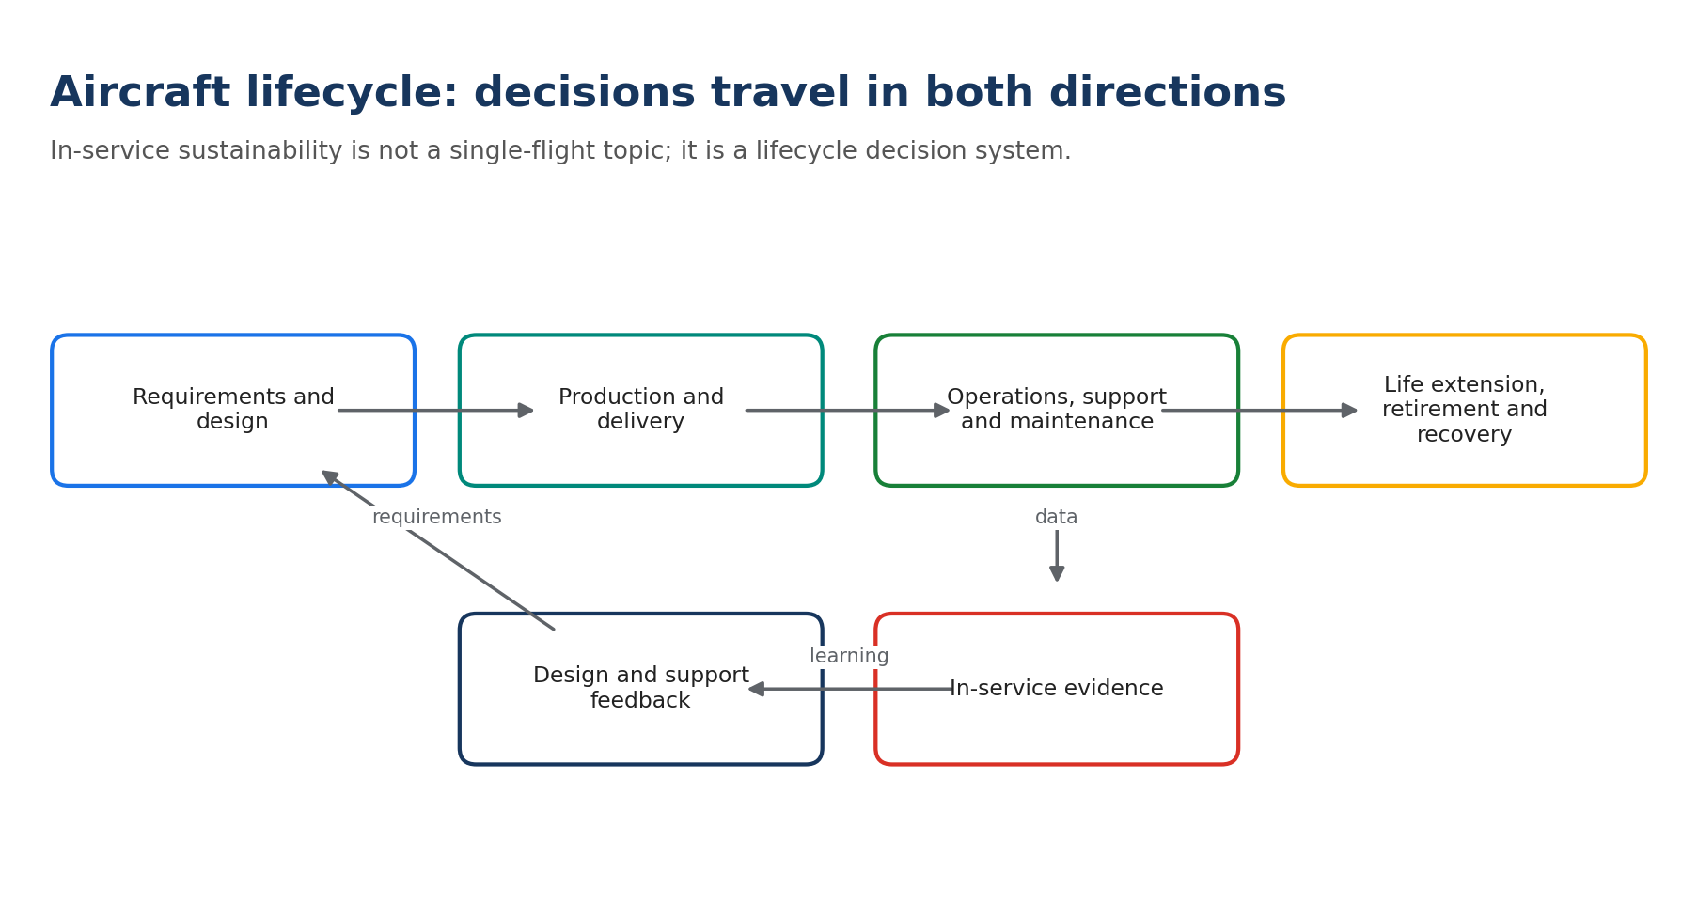
Field | Learner response
Decision and decision owner
Required service / mission outcome
Mandatory safety, airworthiness, security and mission gates
Alternative A
Alternative B
Time horizon
System boundary
Functional unit
Five material flows or hotspots
Two trade-offs or displaced effects
Stakeholders affected
Evidence gaps
Review trigger

Self-check
- I compared credible alternatives that deliver the required service.
- I applied mandatory safety, airworthiness, security, legal and mission gates first.
- I stated the boundary, functional unit, baseline and evidence limitations.
- I included at least one trade-off or displaced effect.
- My proposed claim is no stronger than the evidence.

Module 2 Lab | Sortie Profile Challenge
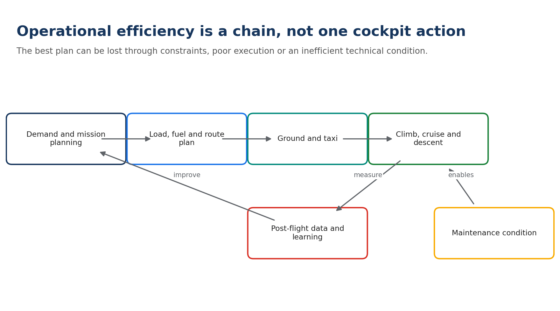
Field | Learner response
Comparable mission class
Required service and constraints
Admissible options
Rejected option and gate
Fuel baseline and proposed change
Direct CO2 calculation and factor
Noise/local-air-quality consideration
Absolute KPI
Intensity KPI
Operational-context KPI
Owner and verification period

Self-check
- I compared credible alternatives that deliver the required service.
- I applied mandatory safety, airworthiness, security, legal and mission gates first.
- I stated the boundary, functional unit, baseline and evidence limitations.
- I included at least one trade-off or displaced effect.
- My proposed claim is no stronger than the evidence.

Module 3 Lab | MRO Hotspot Walkdown
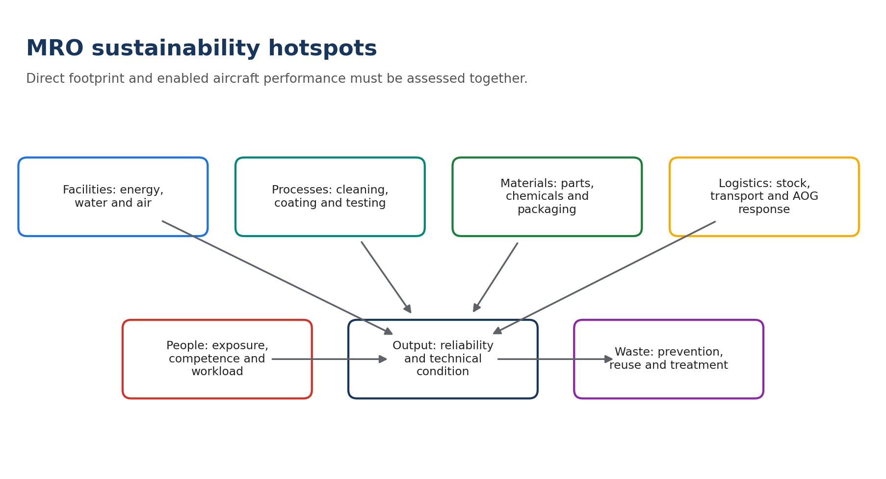
Field | Learner response
Process and functional output
Task volume / comparable input
Energy, water and facility inputs
Parts, chemicals and consumables
Waste, emissions and effluent
Rework / repeat work
Logistics and urgency
Worker exposure / human factors
Quick wins within current approval
Changes requiring technical approval
Balanced KPI set

Self-check
- I compared credible alternatives that deliver the required service.
- I applied mandatory safety, airworthiness, security, legal and mission gates first.
- I stated the boundary, functional unit, baseline and evidence limitations.
- I included at least one trade-off or displaced effect.
- My proposed claim is no stronger than the evidence.

Module 4 Lab | Digital Use-Case Evidence Card
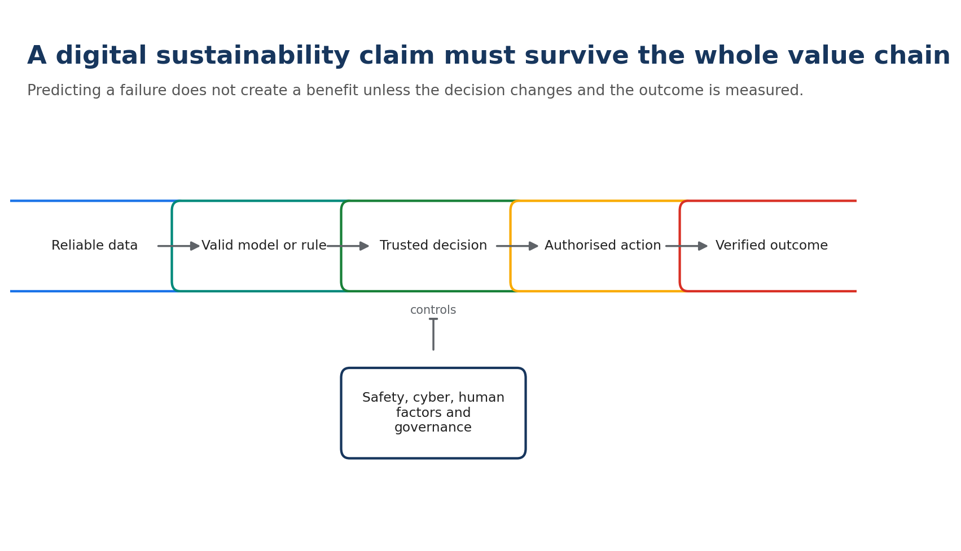
Field | Learner response
Problem and credible counterfactual
Decision user
Data and quality controls
Model/rule and validation
Authorised decision and action
Technical outcome
Environmental/resource outcome
False-positive consequence
False-negative consequence
Cyber/data-governance control
Digital footprint / rebound screen
Benefit-verification method

Self-check
- I compared credible alternatives that deliver the required service.
- I applied mandatory safety, airworthiness, security, legal and mission gates first.
- I stated the boundary, functional unit, baseline and evidence limitations.
- I included at least one trade-off or displaced effect.
- My proposed claim is no stronger than the evidence.

Module 5 Lab | Lifecycle Scenario Comparator
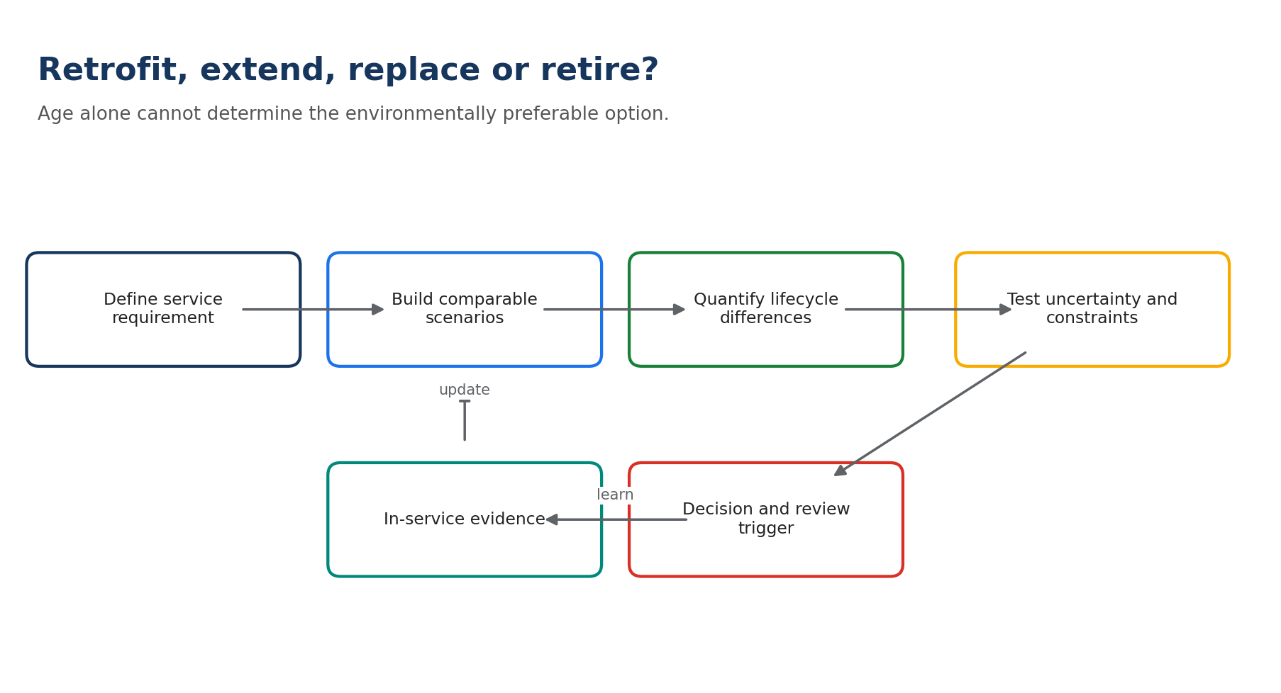
Field | Learner response
Required service over the decision horizon
Functional unit
Extend without retrofit
Extend with retrofit
Replace
Retire or mixed transition
Operational fuel/energy
Maintenance, spares and obsolescence
Embodied and transition impacts
Infrastructure, training and downtime
End-of-life and recovery
Key uncertainty / sensitivity
Decision review trigger

Self-check
- I compared credible alternatives that deliver the required service.
- I applied mandatory safety, airworthiness, security, legal and mission gates first.
- I stated the boundary, functional unit, baseline and evidence limitations.
- I included at least one trade-off or displaced effect.
- My proposed claim is no stronger than the evidence.

Module 6 Lab | In-Service Roadmap
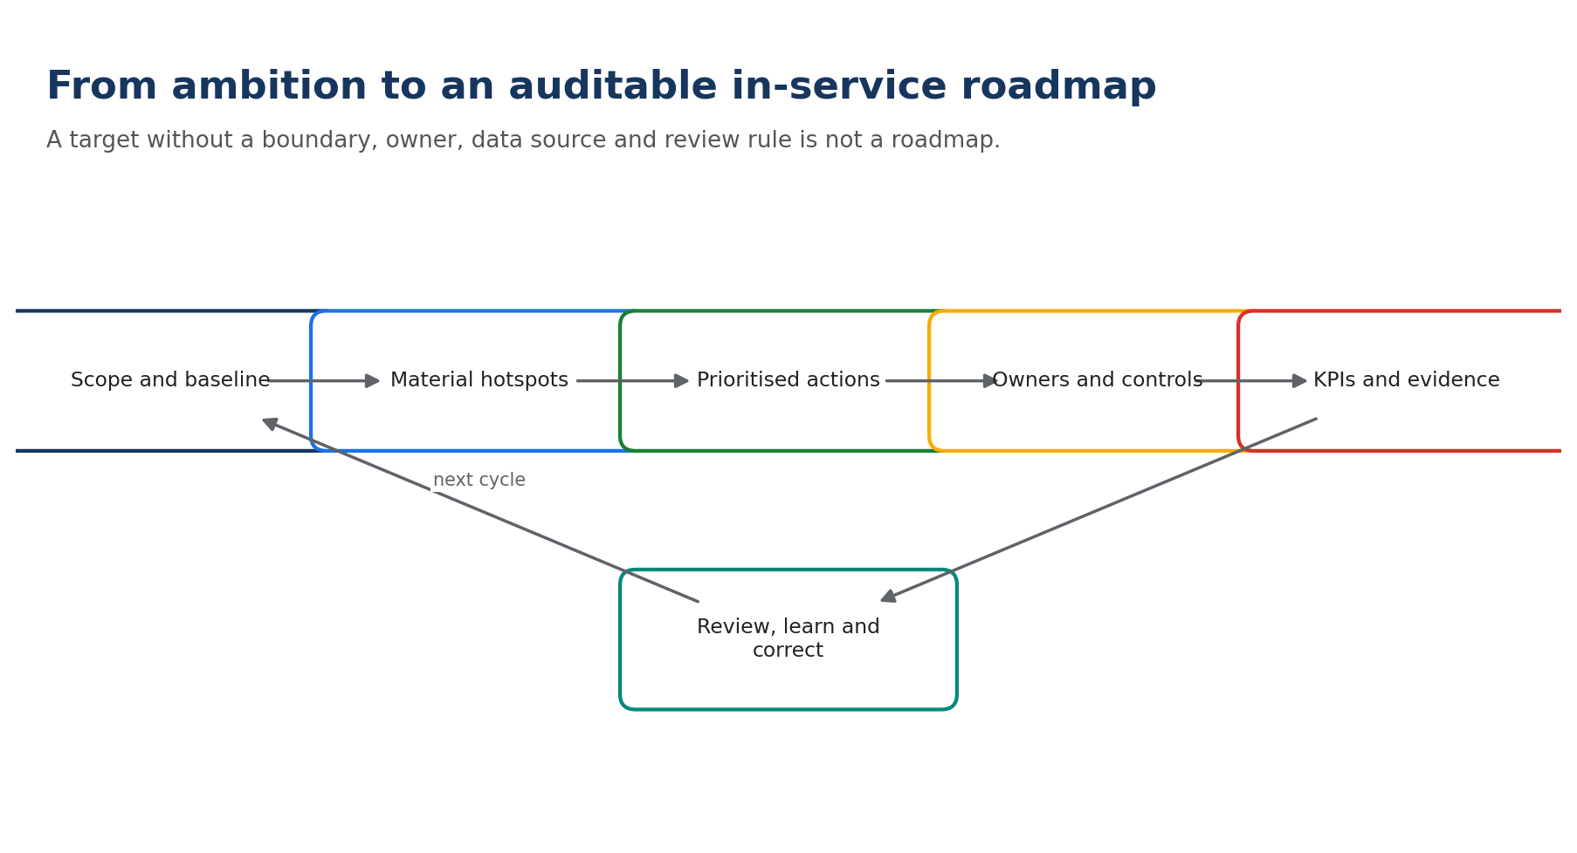
Field | Learner response
Roadmap scope and baseline
Material hotspots
Mandatory gates
Action portfolio logic
Owners and resources
KPIs, targets and data sources
Dependencies and risks
Milestones
Review and escalation triggers
Evidence-based communication claim

Self-check
- I compared credible alternatives that deliver the required service.
- I applied mandatory safety, airworthiness, security, legal and mission gates first.
- I stated the boundary, functional unit, baseline and evidence limitations.
- I included at least one trade-off or displaced effect.
- My proposed claim is no stronger than the evidence.

Capstone | Orion 24-Month Portfolio
Select four actions from the course scenario and complete the roadmap. Reject any inadmissible action before scoring.
Action | Owner | Outcome/guardrail | Baseline | KPI/target | Milestone | Risk/control | Review

Portfolio claim
Evidence-based claim:

Claim that must not be used:

Capstone self-assessment
Criterion | Score 1-5 | Evidence / improvement
Boundary and comparison
Safety and mission integration
Lifecycle and trade-offs
Measurement and evidence
Roadmap and communication

Sustainability Claim Check
Check | Yes/No | Evidence or correction
Compared alternative and baseline are explicit.
Boundary and functional unit are explicit.
Measured, modelled and assumed values are distinguished.
Absolute and intensity effects are not confused.
Direct CO2 is not presented as total climate impact.
Trade-offs and displaced effects were screened.
The framework or legal requirement is applicable.
Attribution is proportionate to evidence.
Vague terms such as green, clean, zero or sustainable are avoided or defined.
Limitations are understandable without hidden qualifications.

Notes
________________________________________________________________________________
________________________________________________________________________________
________________________________________________________________________________
________________________________________________________________________________
________________________________________________________________________________
________________________________________________________________________________
________________________________________________________________________________
________________________________________________________________________________
________________________________________________________________________________
________________________________________________________________________________
________________________________________________________________________________
________________________________________________________________________________
________________________________________________________________________________
________________________________________________________________________________
________________________________________________________________________________
________________________________________________________________________________
________________________________________________________________________________
________________________________________________________________________________
________________________________________________________________________________
________________________________________________________________________________
________________________________________________________________________________
________________________________________________________________________________
________________________________________________________________________________
________________________________________________________________________________
________________________________________________________________________________
________________________________________________________________________________
________________________________________________________________________________
________________________________________________________________________________
________________________________________________________________________________
________________________________________________________________________________

