# Linux常用软件安装

# 课程目标

## 熟练使用Linux常用命令

## 熟练修改Linux的基本配置

## 熟练在Linux上安装JDK、Tomcat、MySQL软件

# 修改Linux的基本配置

1. 修改主机名

vi /etc/sysconfig/network

|  |
| --- |
| NETWORKING=yes  HOSTNAME=server1.itcast.cn |

1. 修改ip地址

vi /etc/sysconfig/network-scripts/ifcfg-eth0

|  |
| --- |
| DEVICE=eth0  TYPE=Ethernet  ONBOOT=yes  BOOTPROTO=static  IPADDR=192.168.0.101  NETMASK=255.255.255.0 |

service network restart

1. 修改ip地址和主机名的映射关系

vi /etc/hosts

|  |
| --- |
| 127.0.0.1 localhost localhost.localdomain localhost4 localhost4.localdomain4  ::1 localhost localhost.localdomain localhost6 localhost6.localdomain6  192.168.0.101 server1.itcast.cn |

1. 关闭iptables并设置其开机启动/不启动

service iptables stop

chkconfig iptables on

chkconfig iptables off

# 安装JDK

1. 上传jdk-7u45-linux-x64.tar.gz到Linux上
2. 解压jdk到/usr/local目录

tar -zxvf jdk-7u45-linux-x64.tar.gz -C /usr/local/

1. 设置环境变量，在/etc/profile文件最后追加相关内容

vi /etc/profile

|  |
| --- |
| export JAVA_HOME=/usr/local/jdk1.7.0_45  export PATH=$PATH:$JAVA_HOME/bin |

1. 刷新环境变量

source /etc/profile

1. 测试java命令是否可用

java -version

# 安装Tomcat

1. 上传apache-tomcat-7.0.68.tar.gz到Linux上
2. 解压tomcat

tar -zxvf apache-tomcat-7.0.68.tar.gz -C /usr/local/

1. 启动tomcat

/usr/local/apache-tomcat-7.0.68/bin/startup.sh

1. 查看tomcat进程是否启动

jps



1. 查看tomcat进程端口

netstat -anpt | grep 2465

1. 通过浏览器访问tomcat

<http://192.168.0.101:8080/>

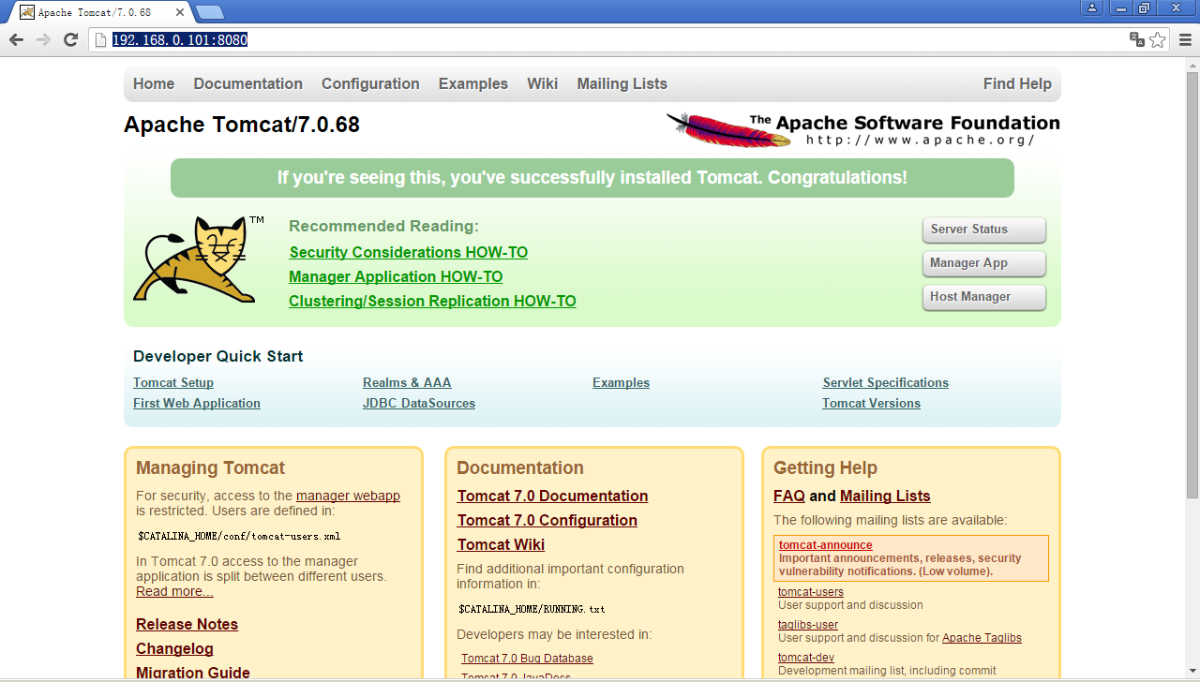

# 安装MySQL

1. 上传MySQL-server-5.5.48-1.linux2.6.x86_64.rpm、MySQL-client-5.5.48-1.linux2.6.x86_64.rpm到Linux上
2. 使用rpm命令安装MySQL-server-5.5.48-1.linux2.6.x86_64.rpm，缺少perl依赖

rpm -ivh MySQL-server-5.5.48-1.linux2.6.x86_64.rpm



1. 安装perl依赖，上传6个perl相关的rpm包



rpm -ivh perl-*

1. 再安装MySQL-server，rpm包冲突

rpm -ivh MySQL-server-5.5.48-1.linux2.6.x86_64.rpm



1. 卸载冲突的rpm包

rpm -e mysql-libs-5.1.73-5.el6_6.x86_64 --nodeps

1. 再安装MySQL-client和MySQL-server

rpm -ivh MySQL-client-5.5.48-1.linux2.6.x86_64.rpm

rpm -ivh MySQL-server-5.5.48-1.linux2.6.x86_64.rpm

1. 启动MySQL服务，然后初始化MySQL

service mysql start

/usr/bin/mysql_secure_installation

1. 测试MySQL

mysql -u root -p