Digital toolbox for humanities installation guide:

Introduction:

This guide will help you prepare for the workshop. The only thing we need to have done before hand, is installing miniconda. Which in short, is the program that we will be working in during the workshop. Miniconda consists of our programming language python and it is also an environment manager, but more on that later:

**Windows guide:**

Step 1:

Navigate to <https://docs.conda.io/en/latest/miniconda.html> and pick the Python 3.8 installer for your system.

Step 2:

The installer should look like this: 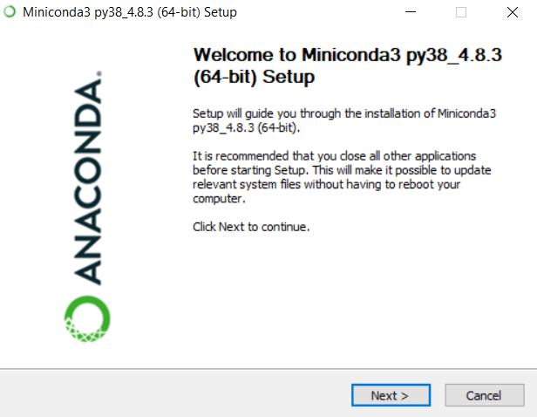

Press “Next” and “I Agree”:

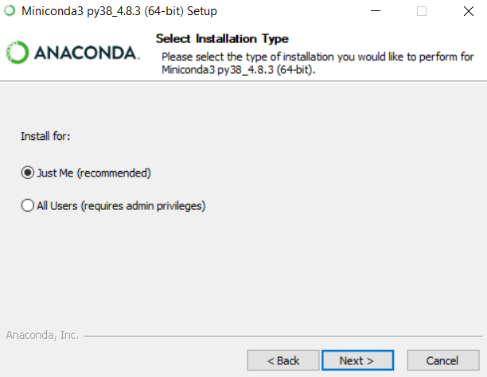

Here you should go with the recommended “Just me” installation.

On the next page of the installation guide, please remember where you installed the program. It could be an idea to write it down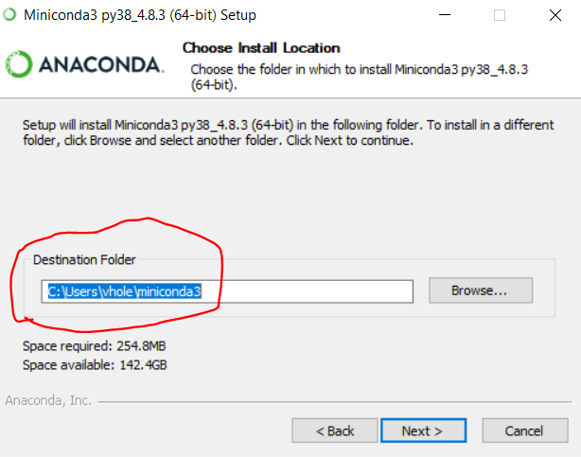

On the last page before installing, check that only the last of the two options are selected: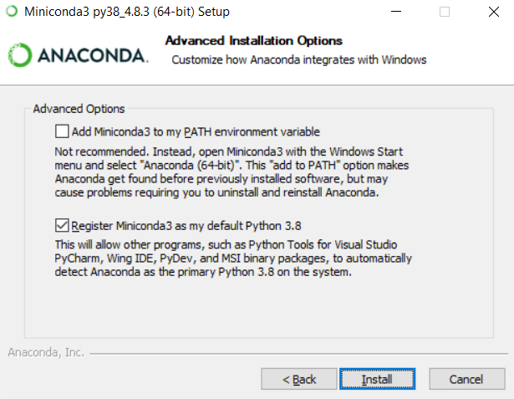

**Mac guide:**

Step 1:

Navigate to <https://docs.conda.io/en/latest/miniconda.html> and pick the Python 3.8 installer for your system. Here you should choose the pkg-file and install it as you would with any other program

Step 2:

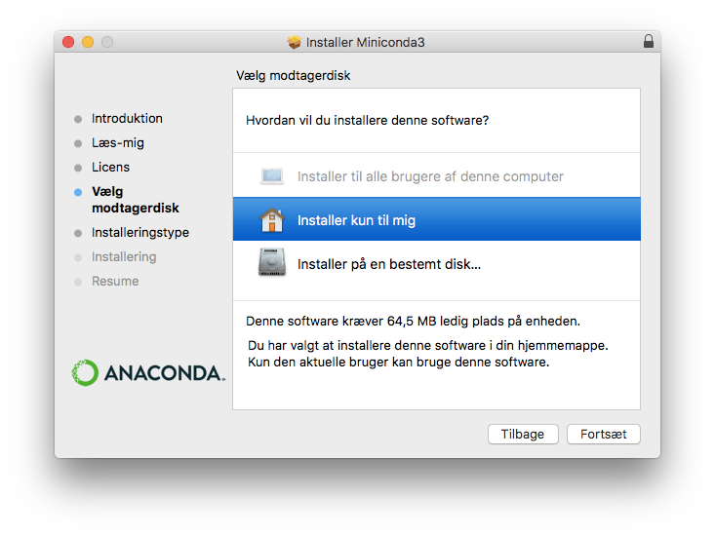Install it for yourself

That is it. You are now ready for the course