Discussion 9: Concurrency, Mutability, and HOFs

**Higher Order Functions**

1. A higher order function is a function that takes in a ____________ as input.
2. What does the  block do? _____________________________________________
3. What does the  block do? _____________________________________________
4. What is the difference between them? _____________________________________________

**Exercise #1:** Write the higher order function  that takes in a reporter function (domain: text | range: text) and a list of words and reports a sentence containing the output of the function on each of the words. You may **not** use the “map” block in your solution.

Ex: .

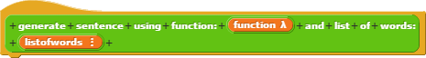

_________________________________________________

_________________________________________________

_________________________________________________

_________________________________________________

**Functions as Data:**

1. What does the grey ring in Snap! do? ________________________________________________

**Exercise #2**: Given four blocks: , , , and , write a block  that uses these four functions as data to make the sprite make N random moves of size SIZE around the stage. You may **not** use “if/else” blocks.



_________________________________________________

_________________________________________________

_________________________________________________

_________________________________________________

**Concurrency:**

Cat, dog, and dragon are trying to withdraw from the same bank account from three different ATMs. The account starts with a balance, noted in the global variable balance.

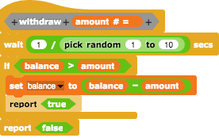

For the scripts below, what are all the possible combinations (not permutations) that could result? You may not need all the blanks.

**Example:**

Dog: True/False

Cat: True/False

Dragon: True/False

Balance: ###

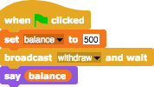

**Dog Dragon Cat**



|  |  |  |  |  |  |  |
| --- | --- | --- | --- | --- | --- | --- |
|  |  |  |  |  |  |  |

Which concurrency issue does this problem exemplify? ________________