Kingsmen

|  |  |  |
| --- | --- | --- |
| **NAME** | **#** | **MEASUREMENT** |
| AURELIO | 9 |  |
| BERNARDO | 30 |  |
| CABALLAR | 7 |  |
| CALUB | 16 |  |
| DALAYOAN | 8 |  |
| DELSON | 14 |  |
| ESTRELLADO | 2 |  |
| MACALANDA | 0 |  |
| MARFIL | 6 |  |
| ORPILLA | 5 |  |
| QUEZADA | 18 |  |
| RAMIREZ | 13 |  |
| VILORIA | 17 |  |

Extra Jersey

|  |  |  |
| --- | --- | --- |
| PAGAYONAN | 6 |  |
| ROMERO | 21 |  |
| SISON | 6 |  |

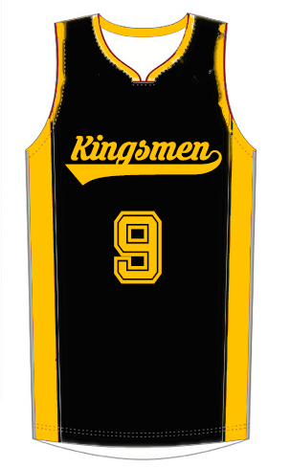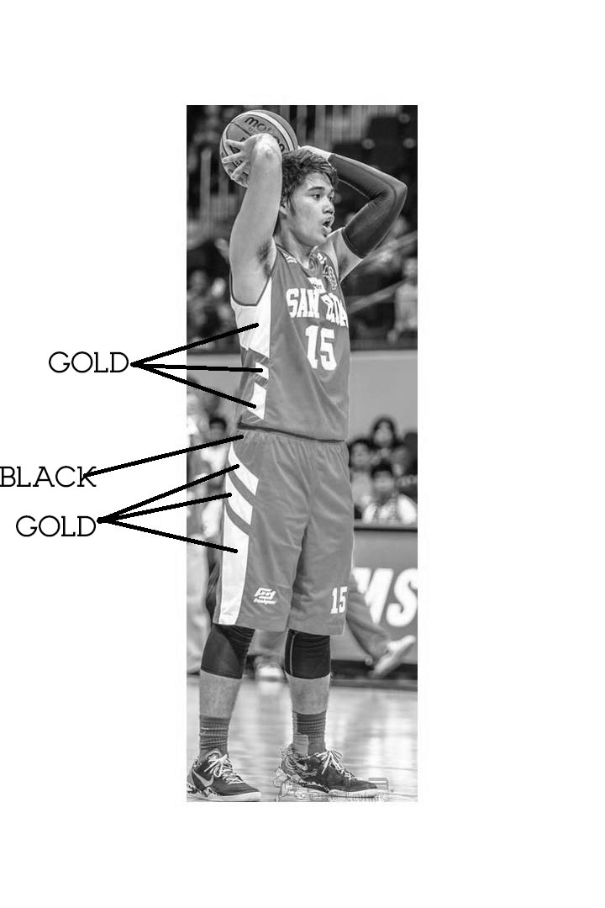

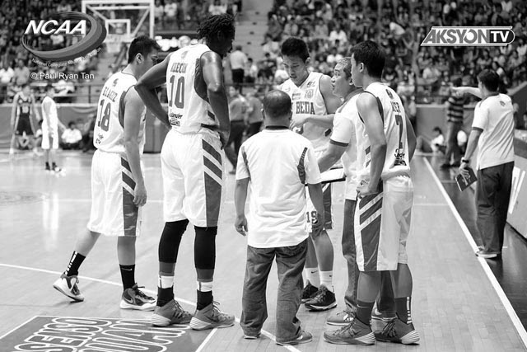

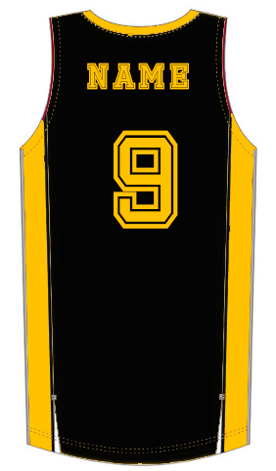

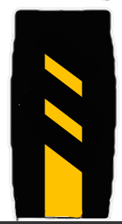

FRONT