آزمایش 6: نیم-پروژه

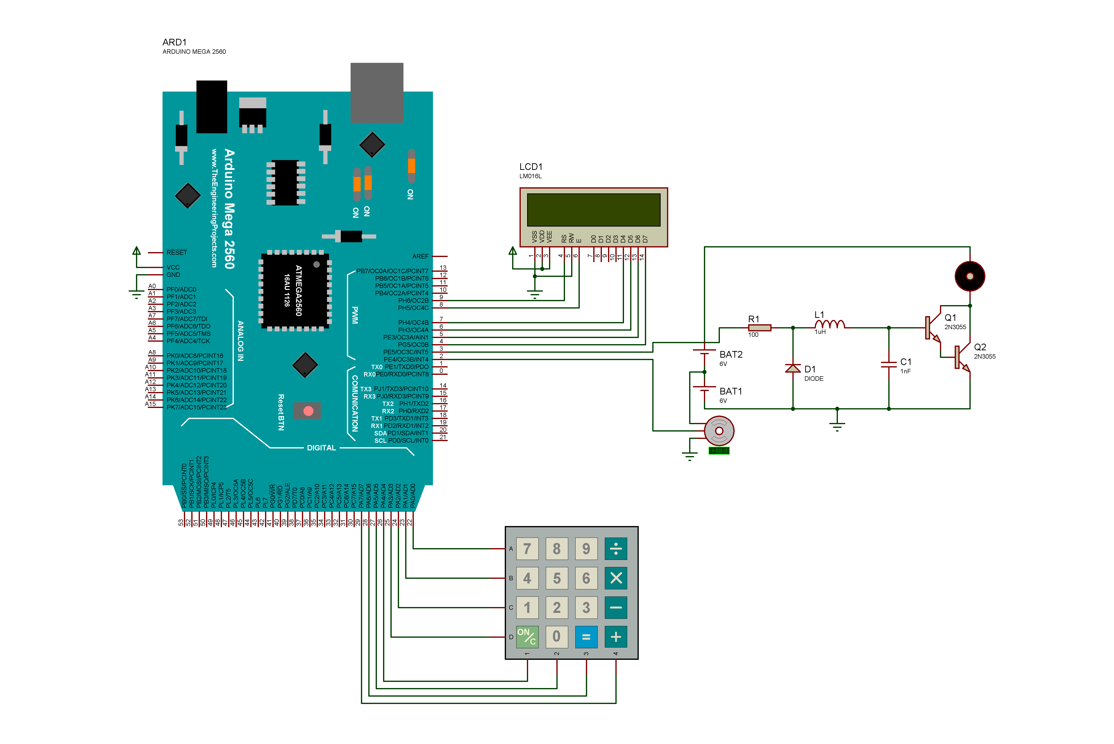

1. *#include* <math.h>
2. *#include* <Servo.h>
3. *#include* <Keypad.h>
4. *#include* <LiquidCrystal.h>
6. *#define* SPEED_PIN 3
7. *#define* INCLINE_PIN 2
8. *#define* SPD_STEP 16
9. *#define* INC_STEP 3
10. *#define* MIN_INC -6
11. *#define* MAX_INC 30
13. Servo rampServo;
14. short spd;
15. short lastSpd;
16. float inc;
17. float lastInc;
18. bool reset;
19. bool negInc;
21. const byte ROWS = 4;
22. const byte COLS = 4;
23. const char keys[ROWS][COLS] = {
24. {'7','8','9', 'F'},
25. {'4','5','6', 'L'},
26. {'1','2','3', 'U'},
27. {'S','0','I', 'D'}
28. };
29. const byte rowPins[ROWS] = {22, 23, 24, 25};
30. const byte colPins[COLS] = {26, 27, 28, 29};
31. Keypad keypad = Keypad( makeKeymap(keys), rowPins, colPins, ROWS, COLS );
33. *#define* RS_PIN 9
34. *#define* EN_PIN 8
35. *#define* D4_PIN 7
36. *#define* D5_PIN 6
37. *#define* D6_PIN 5
38. *#define* D7_PIN 4
39. *#define* NUM_COL 10
40. LiquidCrystal lcd (RS_PIN, EN_PIN, D4_PIN, D5_PIN, D6_PIN, D7_PIN);
42. uint8_t MODE; *//0: +/- input, 1:numeric speed, 2:numeric incline*
44. void setup() {
45. pinMode(SPEED_PIN, OUTPUT);
46. spd = 0;
47. lastSpd = spd;
48. analogWrite(SPEED_PIN, spd);
49. pinMode(INCLINE_PIN, OUTPUT);
50. rampServo.attach(INCLINE_PIN, 1000, 2000);
51. inc = 0;
52. lastInc = inc;
53. setIncline();
55. lcd.begin(16,2);
56. setLCD();
57. MODE = 0;
58. }
60. void loop() {
61. char key = keypad.getKey();
63. if (key){
64. if(MODE == 0) {
65. switch(key) {
66. case 'F':
67. spd++;
68. setSpeed();
69. break;
70. case 'L':
71. spd--;
72. setSpeed();
73. break;
74. case 'U':
75. inc += INC_STEP;
76. setIncline();
77. break;
78. case 'D':
79. inc -= INC_STEP;
80. setIncline();
81. break;
82. case 'S':
83. MODE = 1;
84. reset = false;
85. break;
86. case 'I':
87. MODE = 2;
88. reset = false;
89. break;
90. }
91. } else if(MODE == 1 && (key >= '0' && key <= '9' || key == 'S')) {
92. if(key == 'S') {
93. MODE = 0;
94. setSpeed();
95. } else if(reset && spd > 9) {
96. spd = 256/SPD_STEP;
97. setSpeed();
98. MODE = 0;
99. } else {
100. if(!reset) {
101. reset = true;
102. spd = 0;
103. }
104. spd *= 10;
105. spd += key - '0';
106. lcd.setCursor(NUM_COL, 0);
107. lcd.print(spd);
108. lcd.print(" ");
109. }
111. } else if(MODE == 2 && (key >= '0' && key <= '9' || key =='U' || key == 'I')) {
112. if(key == 'I') {
113. MODE = 0;
114. setIncline();
115. }else if(reset && (inc > 9 || inc < 0)) {
116. if(inc > 9)
117. inc = MAX_INC;
118. else
119. inc = MIN_INC;
120. setIncline();
121. MODE = 0;
122. } else {
123. if(!reset) {
124. reset = true;
125. inc = 0;
126. if(key == 'U')
127. negInc = true;
128. else
129. negInc = false;
130. }
131. if(key != 'U') {
132. inc *= 10;
133. if(negInc)
134. inc -= key - '0';
135. else
136. inc += key - '0';
137. }
138. lcd.setCursor(NUM_COL, 1);
139. if(inc == 0 && negInc)
140. lcd.print('-');
141. lcd.print((int)inc);
142. lcd.print("% ");
143. }
145. }
146. }
148. }
150. void setIncline() {
151. if(inc > MAX_INC)
152. inc = MAX_INC;
153. else if(inc < MIN_INC)
154. inc = MIN_INC;
155. float finalInc = inc;
156. int sgn = 1;
157. if(lastInc > inc)
158. sgn = -1;
159. for(inc = lastInc; fabs(inc - finalInc) >= 3; inc += sgn) {
160. rampServo.write(map(atan(inc/100)*180/PI*8.94, -30, 150, 0, 180));
161. if((int)(inc-finalInc) % 5 == 0)
162. setLCD();
163. delay(50);
164. }
165. inc = finalInc;
166. rampServo.write(map(atan(inc/100)*180/PI*8.94, -30, 150, 0, 180));
167. setLCD();
168. lastInc = inc;
169. }
171. uint8_t safeMult(short a, short b) {
172. if(a < 0 || b < 0)
173. return 0;
174. if(a*b > 255)
175. return 255;
176. return a*b;
177. }
179. void setSpeed() {
180. int finalSpd = spd;
181. int sgn = 1;
182. if(finalSpd < lastSpd)
183. sgn = -1;
184. for(spd = lastSpd; spd >= 0 && spd <= 16 && spd != finalSpd; spd += sgn) {
185. analogWrite(SPEED_PIN, safeMult(spd, SPD_STEP));
186. if((int)(spd-finalSpd) % 4 == 0)
187. setLCD();
188. delay(100);
189. }
190. spd = finalSpd;
191. if(spd*SPD_STEP > 255) {
192. spd = 256/SPD_STEP;
193. } else if(spd < 0) {
194. spd = 0;
195. }
196. analogWrite(SPEED_PIN, safeMult(spd, SPD_STEP));
197. lastSpd = spd;
198. setLCD();
199. }
201. void setLCD() {
202. lcd.clear();
203. lcd.setCursor(0,0);
204. lcd.print("Speed:");
205. lcd.setCursor(NUM_COL, 0);
206. lcd.print(spd);
207. lcd.setCursor(0, 1);
208. lcd.print("Incline:");
209. lcd.setCursor(NUM_COL, 1);
210. lcd.print((int)inc);
211. lcd.write('%');
212. }