SHELL AND ITS TYPES

- INTRODUCTION
A shell is a command-line interface (CLI) that allows users to interact with an operating system. It acts as a bridge between the user and the system kernel, enabling execution of commands, automation, and system management. Shells can vary in terms of use cases, command syntax, power and control over system and scripting capabilities.

This document compares some of the most commonly used shells:
- Command prompt (cmd)
- Bash
- Powershell
- Anaconda Prompt

- OVERVIEW OF EACH SHELL

2.1) Command Prompt (cmd)
- It is the default shell in Windows (older and basic versions)
- Uses simple DOS (Disk Operating System) style commands (text-based instructions used to interact OS with CLI)
- Quite limited scripting capability as compared to modern ones
- Example commands are – dir, cd, copy
- Limited use cases such as basic file operations, running legacy programs and simple batch scripts
- Overall, it has limited automation and system control, hence not used widely
- Interface
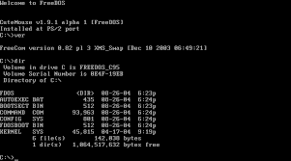

2.2) Bash
- It is the default shell for Linux and macOS systems
- Highly powerful and widely used in development and servers
- Few example commands are – ls, cd, grep, chmod
- Has strong control over system processes, permissions and scripting
- Main use cases are – system administration, software development and automation via shell scripts
- Interface
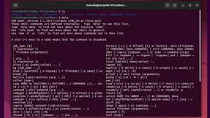

2.3) Powershell
- This is an advanced shell developed by Microsoft
- Completely object oriented and works with structured data (not just text)
- Example commands – Get-ChildItem (lists files), Set-Location (changing directory), Get-Process (view running processes)
- Unlike cmd, this has deep system control, access to .NET framework and contains advanced scripting and automation
- Major use cases are – windows system administration, automation and DevOps and managing cloud services
- Interface
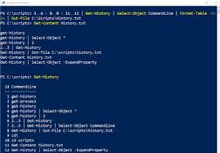

2.4) Anaconda Prompt
- This is built on top of cmd/Powershell but pre-configured for Python environments
- Comes with Anaconda distributions for python
- Few Example commands – conda create -n myenv python=3.10, conda activate myenv, pip install numpy
- Mainly has specialized power for python ecosystem, not for general system control
- Major use cases include data science and machine learning, managing python environments, running notebooks and scripts
- Interface
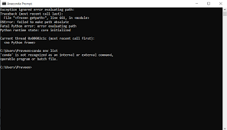

- CONCLUSION

Different shells serve different purposes. While cmd is simple and beginner-friendly, Bash and PowerShell provide far greater control and automation capabilities. Anaconda Prompt is specialized for Python workflows, making it essential for data science but less useful for general system tasks.

