<https://forums.ni.com/t5/LabVIEW/Create-LabView-dll-library/td-p/3654193?profile.language=en>

**Note**:

*get python version* :

>> import platform

>> import sys

>> print(sys.version)  
>> print(platform.architecture())

**

*3.6.1 (v3.6.1:69c0db5, Mar 21 2017, 17:54:52) [MSC v.1900 32 bit (Intel)]*

*('32bit', 'WindowsPE')*

**LW Source code image**

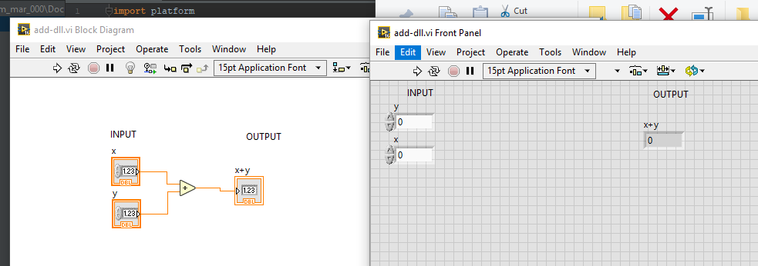

**Header file**

**adlib.h**

#include "extcode.h"

#pragma pack(push)

#pragma pack(1)

#ifdef __cplusplus

extern "C" {

#endif

/*!

* addXY

*/

**double __cdecl addXY(double x, double y);**

MgErr __cdecl LVDLLStatus(char *errStr, int errStrLen, void *module);

#ifdef __cplusplus

} // extern "C"

#endif

#pragma pack(pop)

**Python Source code v1.0**

import platform  
import sys  
import ctypes  
  
print(sys.version)  
print(platform.architecture())  
  
print("\nSTART")  
dlURL = "C:\\Users\\m_mar_000\\Documents\\work files\\4dot\\4dot\\LV-project\\DLL-library-LW\\III pokus - add\\DLL-files\\add-dll\\myAddLib\\addLib.dll"  
dl = ctypes.cdll.LoadLibrary(dlURL)  
X = 2  
Y = 2  
**OUT** = dl.addXY(X, Y)  
print("Using DLL library \n%s" % dlURL)  
print("\n\t 2 + 2 = 4")  
**print("\n\t %d + %d = %d" % (X, Y, OUT))**print("\nEND")

**COMAND LINE OUTPU>**

3.6.1 (v3.6.1:69c0db5, Mar 21 2017, 17:54:52) [MSC v.1900 32 bit (Intel)]

('32bit', 'WindowsPE')

START

Using DLL library

C:\Users\m_mar_000\Documents\work files\4dot\4dot\LV-project\DLL-library-LW\III pokus - add\DLL-files\add-dll\myAddLib\addLib.dll

2 + 2 = 4

**2 + 2 = 0**

END

**Process finished with exit code 0**