**NOT PRIORITIZED YET**

**Rød = droppet**

**Lyserød = skippet for nu (universiteter med knap så fede kurser)**

**Gul = skrevet på prioriteret liste, men muligvis ikke færdig**

**Grøn = på liste, nok færdig**

**First priority**

**Name:**

**Student ID Number:**

**Name of University: University of Vermont**

**EMAIL SENT**

Exchange students are unlikely to be able to enroll in any Theater or Art/Art Studio courses. Courses in psychology are also limited, and upper-level undergraduate courses may be restricted to exchange students. Students are responsible for the payment of lab fees, late book fees for the library, housing damage fees, physical education/PEAC fees, music fees, physical therapy services, etc.

[**http://catalogue.uvm.edu/pdf/2019-20\_undergraduate.pdf**](http://catalogue.uvm.edu/pdf/2019-20_undergraduate.pdf)

|  |  |  |  |  |
| --- | --- | --- | --- | --- |
| **SELECTED COURSES ABROAD** | | | | **AU COURSES** |
| Course Code | Course Title | Credit Points | Course Level | AU course that the course abroad replaces\* |
| NSCI 111  **NSCI 112** | [Exploring Neuroscience](https://www.uvm.edu/academics/courses/?subject=NSCI&number=111&term=202001&section&action=Search) In-depth survey of neuroscience topics, including neuron function, the anatomical and functional organization of the nervous system, and diseases of the nervous system. Prerequisites: PSYS 001; CHEM 023 or CHEM 031; and one of the following pairs of courses: BIOL 001 and BIOL 002, BCOR 011 and BCOR 012, or ANPS 019 and ANPS 020.  **Exploring Neurosci Laboratory.** | 3 credits | Bachelor | ITTU |
| **PSYS 115** | **Biopsychology**  Biological bases of behavior: classical and contemporary issues, including introduction to nervous system, behavioral effects of drugs, chemical bases of behavioral disorders. Prerequisites: PSYS 001 or BIOL 001. | 3 credits | Bachelor | ITTU |
| **PSYS 001.** | **Intro to Psychological Science.**  Introduction to the entire field, emphasizing the behavior of the normal adult human being. | 3 credits | Bachelor | ITTU |
| **PSYS 170** | **Abnormal Psychology**  Describing and defining abnormal behavior; models of etiology; research evidence for biological and social models; methods of intervention and prevention. Prerequisite: PSYS 001. | 3 credits | Bachelor | ITTU |
| **PSYS 214** | **Adv Cognitive Neuroscience.**  Cognitive Neuroscience studies thinking processes (e.g., attention, memory, problem solving) by investigating brain function. Focuses on dominant theories and relevant empirical data including a focus on non-invasive brain imaging of humans. Prerequisites: PSYS 053; PSYS 111 or PSYS 115 or NSCI 111. | 3 credits | Bachelor | ITTU |

|  |  |  |  |  |
| --- | --- | --- | --- | --- |
| **PSYS 215.** | **Physiological Psychology**  Structure and function of mammalian nervous system, emphasizing neurological correlates of sensory experience and perception. Individual laboratory experience. Prerequisites: PSYS 053; PSYS 115 or NSCI 111. | 3 credits | Bachelor | ITTU |
| **PSYS 216.** | **Psychopharmacology**  Effects of drugs (both medical and recreational) on behavior. Topics such as drug effects on learning, memory, motivation, perception, emotions, and aggression. Prerequisites: PSYS 053; PSYS 115 or NSCI 111. | 3 credits | Bachelor | ITTU |

**Additional:**

**PSYS 218. Hormones and Behavior. 3 Credits.**

A study of the involvement of hormones in cognition, emotion, the stress response, circadian and homeostatic mechanisms that affect mental state, psychopathology, and reproductive behavior. Prerequisites: PSYS 053; PSYS 115 or NSCI 110 or NSCI 111.

**PSYS 219. Sel Topics Behavioral Neurosci. 3 Credits.**

Selected topics examining the role of the central nervous system in determining behavior, including innate behaviors, arousal, motivation, learning, and memory. Prerequisites: PSYS 053; PSYS 115 or NSCI 111.

**PSYS 232. Self and Social Cognition. 3 Credits.**

An advanced course in social psychology that covers theory and research on the self and social cognition. Prerequisites: PSYS 053 and PSYS 130.

**PSYS 240. Organizational Psychology. 3 Credits.**

Study of the psychological impact of macro and micro features  
of organizations upon leadership, decision making, workforce diversity, group process, conflict, and organizational performances. Prerequisite: PSYS 053; and PSYS 111 or PSYS 130 or PSYS 150 or PSYS 170.

**PSYS 252. Emotional Devlmt & Temperament. 3 Credits.**

Development of emotion and temperament from infancy through middle childhood, including links between these topics and physiology, and context (e.g. attachment, parenting, family conflict). Prerequisites: PSYS 053 and PSYS 150.

NEUROSCIENCE

**NSCI 222. Cellular Neurophysiology. 3 Credits.**

Fundamentals of cellular neurophysiology through lecture, independent student reading and faculty-led group discussions of journal articles. Prerequisites: NSCI 110 or, NSCI 111 and NSCI 112, or Instructor Permission.

**NSCI 225. Human Neuroanatomy. 0 or 3 Credits.**

Functional anatomy of the human nervous system and its cells. Focus on both peripheral and central nervous system. Lectures and laboratory (gross and microscopic anatomy). Prerequisite: Instructor permission.

**NSCI 230. Comparative Neurobiology. 3 Credits.**

Examination of the cellular mechanisms that underlie selective motor and sensory abilities, and unique behaviors that have evolved in various species. Discussion and student presentations. Prerequisite: ASCI 141 or BIOL 106 or NSCI 111 or PSYS 115 or Instructor permission.

**NSCI 255. Neuroregeneration. 3 Credits.**

An analysis of the cellular and molecular processes involved in injury, responses to damage, and differences in the capacity of specific neural tissues to regenerate. Prerequisite: NSCI 111.

**NSCI 261. Neurobiology. 3 Credits.**

Focus on molecular and cellular aspects of the nervous system. Electrical signaling, synaptic transmission, signal transduction, neural development, plasticity, and diseases. Prerequisites: BIOL 103 or ANPS 019 & ANPS 020.

**NSCI 270. Diseases of the Nervous System. 3 Credits.**

Senior level, seminar-style capstone course in which students bring together information learned in other courses for an in-depth study of disease states of the nervous system. Pre/co-requisites: NSCI 110 and Senior standing.

**EC 138. Game Theory. 3 Credits.**

Formal analysis of strategic interactions, in which decisions are based on the possible reactions of others, with applications to business, politics, and human relationships. Prerequisites: EC 011, EC 012.

**EC 011. Principles of Macroeconomics. 3 Credits.**

Introduction to economic concepts, institutions, and analysis, particularly as related to the economy as a whole. May be taught with traditional approach or with strong mathematical emphasis.

**EC 012. Principles of Microeconomics. 3 Credits.**

Study of individual economic units with particular emphasis on market interactions among firms and households.

**CHEM 023. Outline of General Chemistry. 0 or 4 Credits.**

One-semester survey of principles and concepts of general chemistry, topics covered include bonding, mole ratios, equilibrium, and nuclear chemistry. May not be taken for credit concurrently with, or following receipt of, credit for CHEM 025, CHEM 031, or CHEM 035.

**CHEM 031. General Chemistry 1. 0 or 4 Credits.**

First semester of a two-semester sequence. Topics include matter, stoichiometry, gas laws, thermochemistry, quantum theory, atomic structure, electronic configurations, bonding, and intermolecular forces. May not be taken for credit concurrently with, or following receipt of, credit for, CHEM 023, CHEM 025 or CHEM 035.

**BIOL 001. Principles of Biology. 0 or 4 Credits.**

Principles of cellular biochemistry; cell biology; genetics and evolution. Topics: biochemistry; metabolism, cell structure/function; respiration; photosynthesis; molecular, Mendelian and population genetics; genetics of evolution. Credit not given for both BIOL 001 and BCOR 011.

**BIOL 002. Principles of Biology. 0 or 4 Credits.**

Principles of organismal biology; nature of scientific inquiry, plant form and function, pollination ecology, animal phylogeny illustrated by comparative anatomy and physiology; animal behavior. Credit not given for both BIOL 002 and BCOR 012.

**BCOR 011. Exploring Biology. 0 or 4 Credits.**

Exploring biology from cells to organisms. Topics include origins of life, ancestral organisms, uni- and multi- cellular energetics, evolution of respiration and metabolism, and the genetic code. Credit not given for both BCOR 011 and BIOL 001.

**BCOR 012. Exploring Biology. 0 or 4 Credits.**

An evolutionary perspective to exploring biology. Topics include: patterns of inheritance, Darwinian evolution, evolution of biodiversity, ecology of organisms, human effects on biological systems. Credit not given for both BCOR 012 and BIOL 002.

**BCOR 103. Molecular and Cell Biology. 0 or 4 Credits.**

Explores the fundamental processes of life. Topics include cellular metabolism; structure and function of organelles; cell cycle; signal transduction; biology of cancer. May not be taken concurrently with, or following receipt of, BIOL 106. Prerequisites: BIOL 001 or BCOR 011, and BIOL 002 or BCOR 012; or BCOR 021; and also CHEM 031 or CHEM 035 or CHEM 051, and CHEM 032 or CHEM 036 or CHEM 052. CHEM 141, BCOR 101 recommended.

**Courses**

**ANPS 019. Ugr Hum Anatomy & Physiology. 4 Credits.**

Two-semester lecture course with credit given upon completion of each semester. Structure and function of human body will be presented in a three lecture/week format with an additional online lab component. Completion of additional self-study units will

be required. Required of all PRNU DIET, NFS, PE, ME, RADT, NMT, MLS, AT, EXMS and BSCI students; others with Instructor permission.

**ANPS 020. Ugr Hum Anatomy & Physiology. 4 Credits.**

Two-semester lecture course with credit given upon completion of each semester. Structure and function of human body will be presented in a three lecture/week format with an additional online lab component. Completion of additional self-study units will be required. Required of all PRNU, DIET, NFS, PE, ME, RADT, NMT, MLS, AT, EXMS and BSCI students; others with Instructor permission. Prerequisite: ANPS 019.

Response from office:

Thank you for the email, and all great questions! In terms of course levels: 001-099 is considered to be introductory level, 100-199 intermediate, 200-299 advanced, and 300+ is graduate-level. **PSYS 214 would therefore be considered to be an advanced level course and will most likely not be open to exchange students.**

As you will see in the Course Registration section of our website (found [here](https://www.uvm.edu/oie/yourexchange)), certain academic disciplines, including Psychology, have specific department contacts that you need to email in order to gain access into the courses. We have linked those on our website, and when you click on it, it will open up a template email that you can modify and send.

For Neuroscience, you will need to email the instructors directly. If you navigate to the [course directory](https://www.uvm.edu/academics/courses/?subject=POLS&number=157&term=202001&section&action=Search) and search for a specific course and click on the title of it (it’s a blue hyperlink) it will give you more information, including instructor name and email. Use that to reach out to the instructor. You should include in the subject line something like: Exchange Student Seeking Courses in Neuroscience. In the email you should introduce yourself and explain a little bit about your background and the course you want to register for.

From what I can see, the only course that you listed below that does *not* have a prerequisite is PSYS 001. I encourage you to keep reading the course registration section of our website (linked above) and please do reach out to us with any further questions.

Are you hoping to come to UVM on exchange in Fall 2020? I just want to reinforce that not all courses are offered every semester, so you may see some being offered for Spring 2020 that will not available in the fall. No need to start contacting the instructors/departments yet as you have not applied/been accepted into the program yet.

**Second priority**

**Name: Karoline Engstrøm Poulsen**

**Student ID Number:**

**Name of University: Macquaire university, Sydney**

**Session 1: feb - june**

**Psych and cog science**

[**https://www.mq.edu.au/study/find-a-course/psychology-and-cognitive-science/\_**](https://www.mq.edu.au/study/find-a-course/psychology-and-cognitive-science/_)

**QUESTIONS: can COGS1000 and COGS1005 be taken independently? (as I will only go 1 semester)**

**How does your credit system work? I have read that 12 credits = 30 ects, but most subjects I have found are 10 credits, how can I combine subjects to obtain what transfers to 30 ects?**

**Are there any restrictions on admission to specific courses I should be aware of? (I haven’t encountered any in my research so far, but many universitites have restrictions on what courses the offer exchange students)**

**EMAIL SENT**

**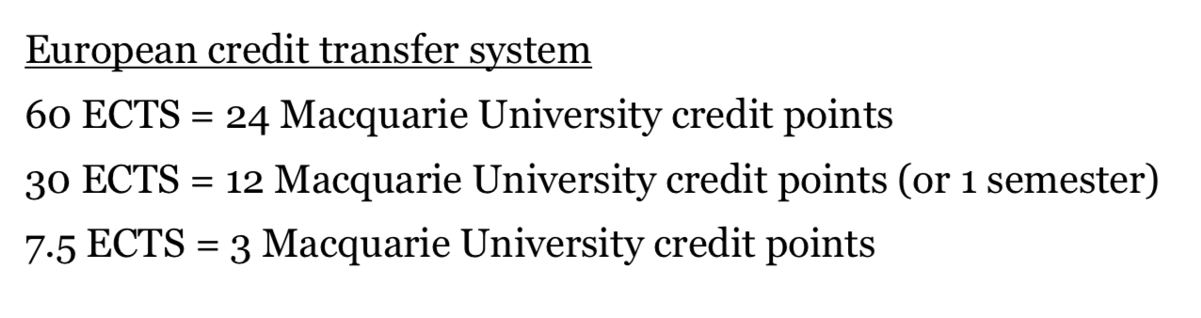**

|  |  |  |  |  |
| --- | --- | --- | --- | --- |
| **SELECTED COURSES ABROAD** | | | | **AU COURSES** |
| Course Code | Course Title | Credit Points | Course Level | AU course that the course abroad replaces\* |
| Cogs1000 or COGS1005 | Introduction to neuroscience 1  This unit forms a 2-unit sequence with COGS1005 and provides an intensive introduction to the fundamentals of modern neuroscience, with a focus on the structure and function of the human brain. Topics include neuroanatomy, neural signalling, plasticity, and development. Tutorials include hands-on research activities in which students will have the opportunity to act as both researchers and experimental participants. | 10 credits | Bachelor | ITTU |
| COGS3020 | Computational neuroscience | 10 credits | Bachelor | ITTU |
| COGS1010 | Delusions of mind and brain  Session 1  This unit is designed to provide you with an understanding of the basic cognitive disorders and higher-level delusions that can arise either developmentally or as a result of brain injury. You will learn about the characteristic features of these disorders and delusions, and about how the patterns of symptoms displayed can be accounted for in terms of models of normal cognitive processing. Where relevant, you will be familiarised with theories about the underlying causes of the conditions, and with experimental investigations of the efficacy of particular treatments. Patterns of similarities and differences of conditions will be critically examined. Conditions covered include: dyslexia, specific language impairment (SLI), aphasia, agnosia, amnesia, autism, synaesthesia, auditory hallucination, delusion and schizophrenia. | 10 credits | Bachelor | ITTU |
| COGS3030 | Human neuroimaging  Session 2  The human brain is among the most complex and powerful information processing systems known. Since the emergence of cognitive neuroscience as a field several decades ago, an impressive range of methods have been developed to investigate the structure and function of the human brain. In this unit, students will learn key principles of a range of functional neuroimaging techniques including functional magnetic resonance imaging (fMRI), electroencephalography (EEG), magnetoencephalography (MEG), functional near infrared spectroscopy (fNIRS), and functional transcranial doppler ultrasound (fTCD). The unit focuses on conceptual and methodological issues surrounding these techniques, giving students the opportunity to think critically about the advantages and disadvantages of each technique for addressing research questions in the field of cognitive neuroscience. The unit will also cover clinical applications of neuroimaging such as its use for investigating autism and schizophrenia. | 10 cp | Bachelor | ITTU |
| COGS3210 | Advanced topics on cognitive science  Session 1 | 10 cp |  |  |
| PSYU2236 | Biopsychology and learning  Session 2 |  |  |  |
| PSYU2234 | Social and personality psychology |  |  |  |
| PSYU2235 | Developmental psychology |  |  |  |
| ECON2015 | Behavioral economics  Session 2 |  |  |  |
| ECON1020 | Principles of economy 1  Session 1+2 |  |  |  |
| BIOL 2230 | Neurophysiology  Ses 1  Harder pre reqs |  |  |  |

****

human biology <http://handbook.mq.edu.au/2019/Units/UGUnit/BIOL108>

bio basis of behavior <http://handbook.mq.edu.au/2019/Units/UGUnit/BIOL122> s2

neurophysiology!!! <http://handbook.mq.edu.au/2019/Units/UGUnit/BIOL257>

neuroanatomy <http://handbook.mq.edu.au/2019/Units/UGUnit/HLTH214>

**SVAR FRA OFFICE**

You cannot take COGS1000 and COGS1005 in the same session as they offered in different semesters.

Our restricted unit list is also getting updated, so these subjects may be on the 'restricted list.' This means you may not be able to undertake them.

As of 2019 12 credits= 30 ECTS, however as of 2020, 40 credits= 30 ECTS. This is because the value of one subject has changed from 3 credits to 10 credits.

You can take up to 40 credits per semester. However, please be aware that the units you select must be available in the session you intend to study:

Session 1: Feb-Jul

Session 2: Jul-Dec

All of the prerequisites for each subject can be found in our handbook:

<https://coursehandbook.mq.edu.au/>

**Restricetd courses:**

[**https://www.mq.edu.au/study/international-students/how-to-apply/study-abroad-and-exchange/restricted-units**](https://www.mq.edu.au/study/international-students/how-to-apply/study-abroad-and-exchange/restricted-units)

**can ikke hjælpe med pre-reqs før application**

As of 2019 12 credits= 30 ECTS, however as of 2020, 40 credits= 30 ECTS. This is because the value of one subject has changed from 3 credits to 10 credits.

You can take up to 40 credits per semester. However, please be aware that the units you select must be available in the session you intend to study:

Session 1: Feb-Jul

Session 2: Jul-Dec

All of the prerequisites for each subject can be found in our handbook:

<https://coursehandbook.mq.edu.au/>

**Third priority**

**Name: Karoline Engstrøm Poulsen**

**Student ID Number:**

**Name of University: UTS, Sydney**

**Virker generelt ikke til der er særligt mange interessante kurser**

**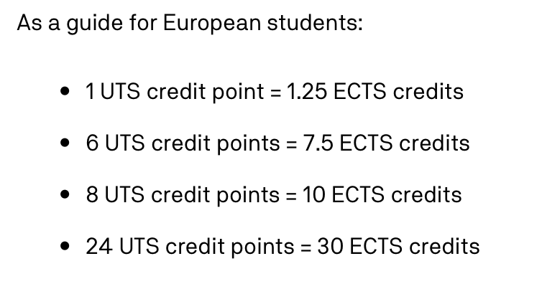**

|  |  |  |  |  |
| --- | --- | --- | --- | --- |
| **SELECTED COURSES ABROAD** | | | | **AU COURSES** |
| Course Code | Course Title | Credit Points | Course Level | AU course that the course abroad replaces\* |
| 65111 | Chemistry 1 (autumn and spring) | 7.5 ECTS | Bachelor | ITTU |
| 91161 | Cell biology and genetics (Level 1) | 7.5 ECTS | Bachelor | ITTU |

**Firth priority**

**Name: Karoline Engstrøm Poulsen**

**Student ID Number:**

**Name of University: RMIT, Melbourne**

**Lots of science**

**Doesn’t look too exciting.**

**Psychology:**

[**https://www.rmit.edu.au/study-with-us/levels-of-study/undergraduate-study/bachelor-degrees/bachelor-of-social-science-psychology-bp112/bp112auscy**](https://www.rmit.edu.au/study-with-us/levels-of-study/undergraduate-study/bachelor-degrees/bachelor-of-social-science-psychology-bp112/bp112auscy)

****

|  |  |  |  |  |
| --- | --- | --- | --- | --- |
| **SELECTED COURSES ABROAD** | | | | **AU COURSES** |
| Course Code | Course Title | Credit Points | Course Level | AU course that the course abroad replaces\* |
| BIOL1131 | Neuroscience (no pre-req) | 12 points | Bachelor | ITTU |
| BIOL2374 | Principles of human biology (pre req none) | 12 cp | Bachelor | ITTU |
| ONPS2423 | Introduction to Medical Biochemistry | 12 cp | Bachelor | ITTU |
| BESC1123/BESC1122/BESC1121/BESC1380 | Principles of psychology | 12 cp | Bachelor | ITTU |
| BESC1190 | Biological psychology | 12 cp |  |  |

# DEAKIN

Pre approved courses: <https://www.deakin.edu.au/international-students/study-abroad-and-exchange/academic-information/pre-approved-study-options>

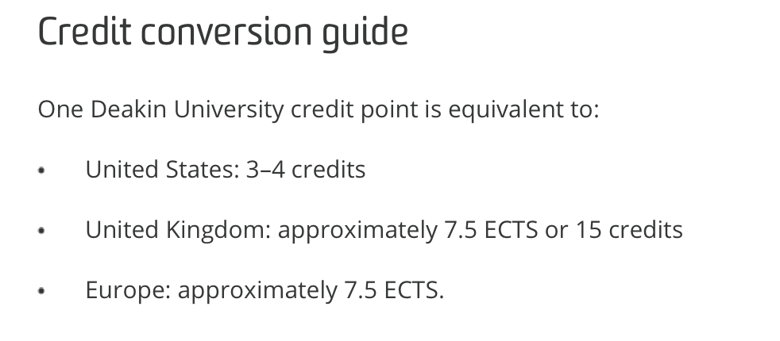

You can find our credit conversion table here: <https://www.deakin.edu.au/international-students/study-abroad-and-exchange/academic-information>

Generally 4 subjects at Deakin (1 Deakin credit each) will equate to 30 ECTS, I would recommend you confirm the credit conversion with your home university to ensure they have assess the credit with the same weighting.

Trimester 1: feb- June

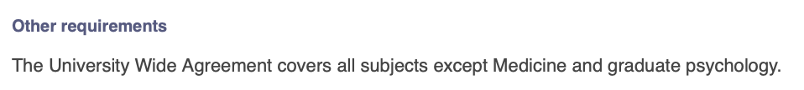

Heller ikke verdens bredeste uvalg af kurser

Pre approved courses:

https://www.deakin.edu.au/international-students/study-abroad-and-exchange/academic-information/pre-approved-study-options?fbclid=IwAR2L5E07iHnCCqYSTxXj22QBHDT2QtzH0D5DmGDk1sPRJT5e5A2wkENEI44

|  |  |  |  |  |
| --- | --- | --- | --- | --- |
| **SELECTED COURSES ABROAD** | | | | **AU COURSES** |
| Course Code | Course Title | Credit Points | Course Level | AU course that the course abroad replaces\* |
| SLE111 (preapproved, no pre reqs) | |  |  | | --- | --- | |  | Cells and Genes (co-requisite SLE010, worth zero credit points) | | ? | Bachelor | ITTU |
| HPS203 | The human mind (pre approved) | 1 credit | Bachelor | ITTU |
| HPS204 | Human social behavior | 1 credit | Bachelor | ITTU |
| HPS 310 | Brain biology bahvior | 1 credit |  |  |
| SIT114 | Introduction to Artificial Intelligence | 1 |  |  |

Pre approved:

cells and genes <https://www.deakin.edu.au/current-students-courses/unit.php?unit=SLE111&year=2020&return_to=%2Fcurrent-students-courses%2Fcourse.php%3Fcourse%3DS320%26version%3D4%26year%3D2020>

human biology: <https://www.deakin.edu.au/current-students-courses/detail.php?customer_cd=C&service_item=S320&version_number=4&element_cd=MAJORS-STRUCTURE&sub_item_number=14&year=2020&return_to=%2Fcurrent-students-courses%2Fcourse.php%3Fcourse%3DS320%26version%3D4%26year%3D2020>

AI course

<https://www.deakin.edu.au/current-students-courses/course.php?course=S308&version=1&year=2020#OVERVIEW>

Intro to AI: <https://www.deakin.edu.au/current-students-courses/unit.php?unit=SIT114&year=2020&return_to=%2Fcurrent-students-courses%2Fcourse.php%3Fcourse%3DS308%26version%3D1%26year%3D2020>

Email from office:

Unfortunately we are unable to pre-assess the units you would like to take. The main thing we will look at is the pre-requisite units, the best thing you can do is to look at the unit pre-requisites and review the unit outline for the pre-requisite unit. If you have completed a unit or combination of units you believe are equivalent (of the unit learning outcomes) this will have a high chance of approval on assessment. If you haven’t completed any units that are similar then the units would not be approved.

If a unit has a cohort rule (locked in to students from a particular course) there is a lower chance of this being approved as the unit will likely have an enrolment quota. Please note that medicine (HMM coded) optometry (HMO coded) and nursing (HNN coded) will not be approved for study abroad or exchange students.

Apologies I cannot assist with any pre-approved/assessed units, I do hope this information assists. Having more units approved by your home university in your application to Deakin will give you the best chance at having required units approved.

# University of western Australia – perth

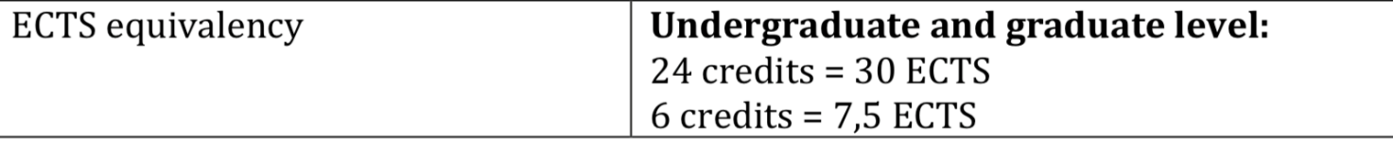



|  |  |  |  |  |
| --- | --- | --- | --- | --- |
| **SELECTED COURSES ABROAD** | | | | **AU COURSES** |
| Course Code | Course Title | Credit Points | Course Level | AU course that the course abroad replaces\* |
| **ANHB2217** | **Human Neurobiology** Semester 1 | 6 points | Bachelor | ITTU |
| SCIE1106 | **Molecular Biology of the Cell** Sem2 | 6 cp | Bachelor | ITTU |
| **PHYL2002 (**PHYL2245?) | **Physiology of Cells** Sem 2 | 6 cp | Bachelor | ITTU |
| NEUR3310 | Neuroscience  Sem 1 | 6 cp | Bachelor | ITTU |
| **MKTG1204** | **Consumer Behaviour** No pre req, sem 1+2 | 6 cp |  |  |
| **MKTG1203** | **Introduction to Marketing** Sem 1+2 | 6 |  |  |
| **NEUR1001** | **Neuroscience in Society** Sem 2  No pre req | 6 |  |  |

Response form office:

A standard unit at UWA is worth 6 credits, most exchange/study abroad students are required to take a total of 24 credits each semester (or 4 units). If you are needing to do an extra unit you will need to pay for that extra unit you need to do. Fees information can be found here; <https://www.uwa.edu.au/study/courses-and-careers/study-abroad-and-student-exchange/completing-exchange-at-uwa> Please note our 2020 fees are not out yet. But to add one more unit it would cost you around $3,425.

The first number that appears in the code indicates which level the unit is. For example PLNT2201 is a 2nd year unit. Undergraduate units will begin with either 1 – 3. Anything beginning with a 4 or above is postgraduate and will require completion of an applicable bachelor degree

If you are unsure what units to take I would suggest selecting a unit with a 1 as the first number. I always suggest if you are unsure add it to your study list and just have back ups if it does not get approved.

I hope this information helps, if you have any questions please do not hesitate to contact me.

CAN HELP PRE-ASSES, BUT NEED APPLICATION!

UPDATE: will help pre-assess, I have sent course descriptions + transcripts.

# The University of New South Wales Kensington, Sydney, Australia

EMAIL SENT

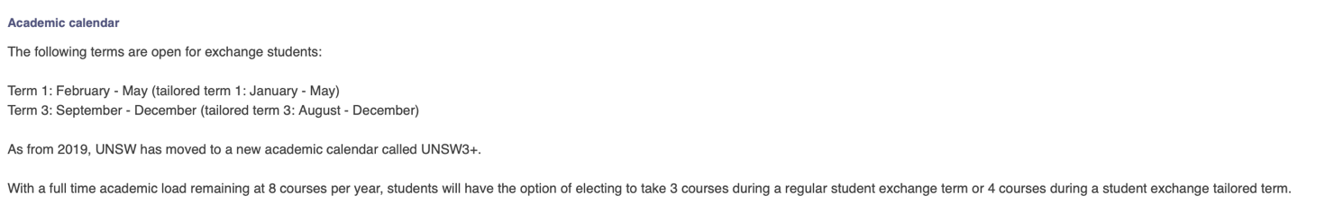

|  |  |  |  |  |
| --- | --- | --- | --- | --- |
| **SELECTED COURSES ABROAD** | | | | **AU COURSES** |
| Course Code | Course Title | Credit Points | Course Level | AU course that the course abroad replaces\* |
| **NEUR2201** | **Neuroscience Fundamentals** Term 2 | 6 points | Bachelor | ITTU |
| BABS1201 | **Molecules, Cells and Genes** Term 1 | 6 points | Bachelor | ITTU |
| **PHSL2101** | **Physiology 1A** Term 1 | 6 points | Bachelor | ITTU |
| **ANAT3411** | **Neuroanatomy** | 6 p | Bachelor | ITTU |
| **NEUR3221** | **Neurophysiology** T2 |  |  |  |
| **NEUR3121** | **Molecular and Cellular Neuroscience** T1 | 6 |  |  |
| **PSYC3051** | **Physiological Psychology** | 6 |  |  |
| **PHAR3202** | **Neuropharmacology** Term 2 | 6 |  |  |
| **PSYC2061** | **Social and Developmental Psychology** |  |  |  |
| PSYC3301 | **Psychology and Law** Term 2 | 6 |  |  |
| **PSYC3241** | **Psychobiology of Memory and Motivation****Term 1** | 6 |  |  |
| **PSYC3211** | **Cognitive Science****Term 1** | 6 |  |  |
| **PSYC3121** | **Social Psychology****Term 3** | 6 |  |  |
| **PSYC3221** | **Vision and Brain** Term 1 | 6 |  |  |
| **Psyc2081** | **Learning and Physiological Psychology** **(this is a prereq for many others (3000 levels)) – don’t know if I fulfill it**  Term 2 | 6 |  |  |
| **PSYC5101** | **Innovative Mind** Online - postgraduate | 6 |  |  |

NO RESPONSE

# Australian national university

EMAIL on web SENT

Sem 1 feb-june

OBS course catalogue siger ikke noget om pre reqs

|  |  |  |  |  |
| --- | --- | --- | --- | --- |
| **SELECTED COURSES ABROAD** | | | | **AU COURSES** |
| Course Code | Course Title | Credit Points | Course Level | AU course that the course abroad replaces\* |
| **Psyc3016** | **Neuropsychology and Cognitive Neuroscience**  Semester 1 | 6 points | Bachelor | ITTU |
| NEUR3101 | **Cellular Neuroscience**  Sem 1 | 6 cp | Bachelor | ITTU |
| **NEUR3112** | **Systems Neuroscience**  Sem 2 | 6 cp | Bachelor | ITTU |
| PSYC3015 | **Visual and Cognitive Neuroscience**  Sem 2 | 6 cp | Bachelor | ITTU |
| **Psych2007** | **Biological Basis of Behaviour**  Sem 2 | 6 cp |  |  |
| **Psyc3025** | **Psychopathology Across the Lifespan**  **Sem 1** | 6 |  |  |
| **Psych2001** | Social psychology  Sem2 | 6 |  |  |
| **Biol1004** | **Biology 2: Molecular and Cell Biology**  Sem 2 | 6 |  |  |
| **Chem1101** | **Chemistry 1**  **Sem 1** | 6 |  |  |
| **BIOL2117** | **Cell Biology** | 6 |  |  |
| **Econ2013** | **Behavioral Economics**  **Sem 2** | 6 |  |  |
| **Econ2141** | Strategic Thinking: An introduction to Game Theory | 6 |  |  |

# University Wollongong

Autumn sem feb-june

Can’t find pre reqs

|  |  |  |  |  |
| --- | --- | --- | --- | --- |
| **SELECTED COURSES ABROAD** | | | | **AU COURSES** |
| Course Code | Course Title | Credit Points | Course Level | AU course that the course abroad replaces\* |
| PSYC234 | Biological Psychology and Learning  Autumn sem | 6 points | Bachelor | ITTU |
| PSYC231 | Personality  Autumn sem | 6 cp | Bachelor | ITTU |
| PSYC327 | Advanced Topics in Cognition | 6 cp | Bachelor | ITTU |
| PSYC330 | Social Behaviour and Individual Differences  autumn | 6 cp | Bachelor | ITTU |
| **Psyc121** | Foundations of psychology | 6 cp |  |  |
| **MKTG1203** | **Introduction to Marketing** Sem 1+2 | 6 |  |  |
| **NEUR1001** | **Neuroscience in Society** Sem 2  No pre req | 6 |  |  |
| **Chem101** | Chemistry 1A: Introductory Physical & General Chemistry |  |  |  |
| **Medi100** | Human Structure and Function |  |  |  |
| **Biol213** | Principles of Biochemistry |  |  |  |
| **Medi312** | Fundamentals of neuroscience |  |  |  |
| [MARK217](https://solss.uow.edu.au/apir/public_subjectview.subject_info_view?p_subject_code=MARK217) | Consumer behavior |  |  |  |

Biochemistry stuff

<https://documents.uow.edu.au/content/groups/public/@web/@gov/documents/doc/uow261002.pdf>

management and commerce stuff

<https://documents.uow.edu.au/handbook/yr2019/ug/H19005943.html>

course descriptions m pre reqs her:

<https://solss.uow.edu.au/apir/public_subjectview.call_main>

# Canada

OBS mont tremblant for skiing – close to brock, montreal and Ontario!

## Brock University

Email sent on credits and semesters for each course.

BONUS!!! BILLIG ACCOMODATION

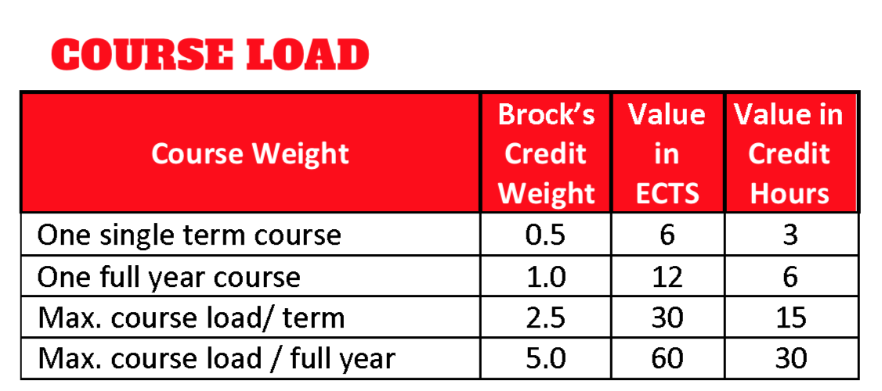

Lastly, each 0.5 credit course at Brock (i.e. NEUR 3P59) is worth about 6 ECTS. A full course load of 5 courses (2.5 Brock credits) would provide you with 30 ECTS for the semester.

Neuro courses: <https://brocku.ca/webcal/2019/undergrad/neur.html#sec8>

Psyc courses: <https://brocku.ca/webcal/2019/undergrad/psyc.html#PSYC_2F23> (der er sygt mange spændende psych fag uden helt vilde pre requisites)

|  |  |  |  |  |
| --- | --- | --- | --- | --- |
| **SELECTED COURSES ABROAD** | | | | **AU COURSES** |
| Course Code | Course Title | Credit Points | Course Level | AU course that the course abroad replaces\* |
| **NEUR 2P36**  / [PSYC 2P36](https://brocku.ca/webcal/2019/undergrad/psyc.html#PSYC_2P36) | **Brain and Behaviour I**  (I should have fulfilled pre req, just some basic psyc) | ?  Same goes for rest | Bachelor | ITTU |
| **NEUR 2P37**  / [PSYC 2P37](https://brocku.ca/webcal/2019/undergrad/psyc.html#PSYC_2P37) | **Brain and Behaviour II** | 12 cp | Bachelor | ITTU |
| **NEUR 3P34**  **/**  [BIOL 3P34](https://brocku.ca/webcal/2019/undergrad/biol.html#BIOL_3P34) | **Neurobiology** | 12 cp | Bachelor | ITTU |
| **NEUR 3P59**  / [PSYC 3P59](https://brocku.ca/webcal/2019/undergrad/psyc.html" \l "PSYC_3P59) | **Introduction to Human Neuropsychology** | 12 cp | Bachelor | ITTU |
| **\*NEUR 3P67/** [PSYC 3P67](https://brocku.ca/webcal/2019/undergrad/psyc.html#PSYC_3P67)) | **Bases of Neuropsychopharmacology** | 12 cp |  |  |
| **NEUR 3P87**  **/** [PSYC 3P87](https://brocku.ca/webcal/2019/undergrad/psyc.html#PSYC_3P87)) | **Behavioural Neuroscience** |  |  |  |
| **NEUR 3P90** | **Investigative Neurobiology** |  |  |  |
| **PSYC 2P35** | **Introduction to Brain and Behaviour II** |  |  |  |
| **Perception 2p49** |  |  |  |  |
| **Cognition 2p20** |  |  |  |  |
| **Fundamentals social psych 2p30** |  |  |  |  |
| **Intro cog neurosci 3p06** |  |  |  |  |
| **PSYC 3F01** | **Facilitating Communication and Critical Thinking in Groups** |  |  |  |
| **PSYC 3P22** | **Social Cognition** |  |  |  |
| **Critical thinking in psychology 3p30** |  |  |  |  |
| **PSYC 3P31** | **Applied Social Psychology (maybe do’'t fulfill prereq** |  |  |  |
| **PSYC 2P30** | **Fundamentals of Social Psychology** |  |  |  |
| **PSYC 3P32** | **The Development of Deception** |  |  |  |
| **PSYC 3P37** | **Human Evolutionary Psychology** |  |  |  |
| **Intro forensic psych 3p53** |  |  |  |  |
| **Children’s thinking** |  |  |  |  |
| **PSYC 3P38** | **Motivation and Emotion** |  |  |  |
| **Psyc 3p50** | **Human Learning** |  |  |  |
| **PSYC 3P75** | **Stress** |  |  |  |
| **Social development 3p77** |  |  |  |  |
| **PSYC 4P20** | **Applied Cognitive Psychology** |  |  |  |
| **PSYC 4P22** | **Advanced Seminar in Human Memory** |  |  |  |
| **PSYC/ neur 4P55** | **Neural Mechanisms, Hormones and Behaviour** |  |  |  |
| **Developmental psychopathology 4p27** |  |  |  |  |
| **PSYC 4P63** | **Human Psychophysiology** |  |  |  |

Response form office:

As a visiting student you would be eligible to take courses from our Psychology and Neuroscience departments, permitting you have the correct background. As a general rule, our courses build upon the material taught in pervious years – this means that courses at the 3rd year level usually require that you have completed the course at the 2nd year level of the same/similar content. A good example would be NEUR 3P59 – Intro to Human Neuropsychology. This course would require that you have already completed the introductory neuroscience courses (NEUR 2P36 and NEUR 2P37).

At this time it is too early to tell which courses will be offered in our Winter 2021 semester (January-April 2021). This information is made available in late May/June of 2020 so be sure to check back to see exactly what will be offered during your intended study period. For a list of what is currently being offered this year, you can check out this link and review courses in “D3” which is our code for the winter semester: <https://brocku.ca/guides-and-timetables/timetables/?session=fw&type=ug&level=all>

.---

I’d be happy to take a look at the course outline of your Cognitive neuroscience course and provide some feedback – send it over and I’ll review it with our advisors.

If you do not meet the pre-requisite requirements, unfortunately you would not be able to enroll in both the upper level course and its pre-requisite simultaneously. We would need to explore alternative options at that point.

Lastly, our 4th year courses are still at the undergraduate level and would be available to you if you meet the requirements, and there is sufficient space.

<http://www.concordia.ca/academics/undergraduate/calendar.html>

**Science College** – Science College courses are not available for exchange students.

**Sociology & Anthropology** – ANTH 495 (the Honours Seminar), and ANTH 620 are restricted. SOCI 402, SOCI 403, SOCI 409, SOCI410, SOCI 415 and SOCI 495 are not available to exchange students, and permission from the Program Director is required to register for 300 and 400 level courses. SOAN 800, 820 and 840 are restricted.

**Psychology** (PSYC) – PSYC 311, 490, 491, 485, and 495 are restricted. 200 level courses are available, 300 and 400 level courses are limited. The MA and PhD Programs in Psychology, as well as the Clinical Diploma in Psychology are not available to exchange students. Statistics courses PSYC601 and PSYC 734, and the Special Topic Seminars PSYC 721-727 may be taken with permission of the Department and instructor.

restricted courses: <https://www.concordia.ca/content/dam/concordia/offices/ci/docs/Restricted%20Course%20List%202019-2020.pdf>

COURSES:

All level 200 courses have no pre reqs

**PSYC 221      *Foundations of Personality***(3 credits)

**PSYC 222      *Person and Society***(3 credits)

**PSYC 223      *Motivation and Emotion in Daily Life***(3 credits)

**PSYC 230      *Womb to Tomb: Psychological Transitions Across the Lifespan***(3 credits)

**PSYC 240      *Foundations of Psychopathology***(3 credits)

**PSYC 242      *Psychology and the Law***(3 credits)

**PSYC 255      *Brain and Behaviour***(3 credits)

**PSYC 264      *Perception and Cognition in Daily Life*** (3 credits)

**PSYC 325      *Fundamentals of Social Psychology***(3 credits) (pre reqs in research design and stats)

**PSYC 355      *Fundamentals of Behavioural Neurobiology*** (3 credits)

**PSYC 445      *Human Neuropsychology*** (3 credits)

**PSYC 446      *Stress*** (3 credits)

**PSYC 451      *Neurobiology of Learning and Memory*** (3 credits)

**PSYC 452      *Neurobiology of Sensation and Perception*** (3 credits)

**PSYC 453      *Neurobiology of Motivated Behaviour*** (3 credits)

**PSYC 450      *Neurobiology of Drug Abuse and Addiction*** (3 credits)

**PSYC 455      *Neuropharmacology***(3 credits) (DEN HER SER FED UD)

**PSYC 458      *Behavioural Neuroscience Advanced Issues***(3 credits)  
Prerequisite: PSYC 310, 315; and permission of the Department.

**PSYC 462      *Memory and Attention***(3 credits)  
Prerequisite: PSYC 310, 315, 364.

**PSYC 464      *Judgment and Decision Making***(3 credits)  
Prerequisite: PSYC 310, 315, 364.

**PSYC 468      *Cognitive Science Advanced Issues***(3 credits)  
Prerequisite: PSYC 310, 315;

**MARK 201      *Introduction to Marketing*** (3 credits)

**MARK 305      *Consumer Behaviour*** (3 credits)  
Prerequisite: COMM 223 or 224 or MARK 201.

**BIOL 200      *Fundamentals of Human Biology*** (3 credits)

**BIOL 201      *Introductory Biology*** (3 credits)

**BIOL 202      *General Biology*** (3 credits)

**BIOL 266      *Cell Biology*** (3 credits

BSc behavioral neuroscience

<http://www.concordia.ca/academics/undergraduate/behavioural-neuroscience.html>

## Dalhousie, nova scoatia, Canada

Spring semester: January – April.

**Other requirements**

Most classes are open to exchange students, but there are some restrictions (Faculties of Dentistry, Health Professions, and Medicine, the School of Planning, plus most Engineering classes). The agreement does not cover graduate courses.

**Full-time course load according to host institution**

Dalhousie defines a full-time load as is 15 credit hours (5 courses) per semester, which is the approximate equivalent of 30 ECTS credits.

Neuro stuff: <https://academiccalendar.dal.ca/Catalog/ViewCatalog.aspx?pageid=viewcatalog&catalogid=81&chapterid=4550&topicgroupid=19255&loaduseredits=False>

Psych stuff <https://academiccalendar.dal.ca/~/Catalog/ViewCatalog.aspx?pageid=viewcatalog&catalogid=81&topicgroupid=19281>

Couldn’t find precise semesters as I couldn’t access timetable.

OBS ret mange courses har en seemingly identisk component i psykologisk fakultet.

Psych stuff . contains some info on semesters

<https://www.dal.ca/faculty/science/psychology_neuroscience/programs/psyc-program/Psychology_Course_Offerings.html>

|  |  |  |  |  |
| --- | --- | --- | --- | --- |
| **SELECTED COURSES ABROAD** | | | | **AU COURSES** |
| Course Code | Course Title | Credit Points | Course Level | AU course that the course abroad replaces\* |
| **NESC 2007** | **Neuroscience Principles and Methods** |  |  |  |
| **NESC 2140** | Learning | 3 points | Bachelor | ITTU |
| **NESC 2150** | **Perceptual Processes** | 3 cp | Bachelor | ITTU |
| **NESC 2160** | **Animal Behaviour** | 3 cp | Bachelor | ITTU |
| **NESC 2470!!! den her lyder fed** | **Systems Neuroscience** | 3 cp | Bachelor | ITTU |
| **NESC 2570   Den her lyder fed** | **Cellular Neuroscience** | 3cp |  |  |
| **NESC 3043** | **Neurobiology of Learning** | 3 |  |  |
| **NESC 3044** | **Laboratory Methods of Learning and Conditioning** | 6 |  |  |
| **NESC 3161** | **Measuring Behaviour** |  |  |  |
| **NESC 3165** | **Neuroethology** |  |  |  |
| **NESC 3440   Neuroanatomy** | **Neuroanatomy** |  |  |  |
| **NESC 3770** | **Behavioural Neuroscience** |  |  |  |
| **NESC 3775** | **Behavioural Neuroscience Laboratory** |  |  |  |
| **NESC 3790** | **Neurolinguistics** |  |  |  |
| **NESC 3970** | **Molecular neuroscience** |  |  |  |
| **There are some advanced topic courses, e.g.**  **NESC 4130** | **Topics in Cognition**  **(NESC 4160   Topics in Behavioural Biology** )  **NESC 4177   Theoretical Neuroscience** |  |  |  |
| **NESC 4705** | **Neurotechnology Innovation, Commercialization, and Entrepreneurship** |  |  |  |
| **NESC 4740** | **Topics in the Neurobiology of Learning and Memory** |  |  |  |
| **PSYO 1011  / PSYO 1021 / PSYO 1031** | **Introduction to Psychology and Neuroscience I: From Neuron to Person** |  |  |  |
| **PSYO 1012 / 1022 / 1032** | **Introduction to Psychology and Neuroscience II: From Social Interaction to Psychopathology** |  |  |  |

* Psych stuff:  Three courses selected from:  
  PSYO 2080.03: Social Psychology  
  PSYO 2090.03: Developmental Psychology  
  PSYO 2130.03: Introduction to Cognitive Psychology PSYO 2140.03: Learning  
  PSYO 2150.03: Perceptual Processes  
  PSYO 2160.03: Animal Behaviour  
  PSYO 2220.03: Abnormal Behaviour  
  PSYO 2570.03: Cellular Neuroscience

**Winter semester:**

**NESC 2160 Animal Behaviour** 6 ects hver

**NESC 2470 Systems Neuroscience**

**NESC 3051 Sensory Neuroscience I: Vision**

**NESC 3165 Neuroethology**

**NESC 3170   Hormones and Behaviour**

**PSYO 2080 Social Psychology**

**PSYO 2090 Developmental Psychology**

**PSYO 2470 Systems Neuroscience**

**PHYL 1002   Human Physiology 2**

**BIOL 1011 Principles of Biology II**

**CSCI 1108   Introduction to Experimental Robotics**

**CSCI 2203   Data Science for Everyone**

**PSYO 3162 Adv. Anim. Behaviour**

Response from office:

Most of the information you’re hoping for can be found on the [Academic Timetable](https://dalonline.dal.ca/PROD/fysktime.P_DisplaySchedule). The 2020/21 timetable will not be available for some time, but the current one can provide a great deal of similar information. On the timetable, you can find how many credits each course is worth, as well as the prerequisites, and the semester in which it is offered. Do keep in mind that the current timetable is for the 2019/20 academic year and so it is possible that courses may be offered in a different semester next year. When you are looking at the timetable, you can find the credit hours for each course under the heading ‘Cr Hrs’, and the term in which the course is offered this year under ‘Enrolment Info’. Our ‘Spring’ term is called ‘Winter’, so if you are hoping to do your exchange in that term, that is what you are looking for!

As an exchange student, you would be required to take a minimum of 3 courses per semester, but are permitted to take up to 5 courses per semester.

* A full course load is 5 courses or 2.5 credits/15 credit hours
* Most single term courses are worth 0.5 credits or 3 credit hours

In terms of course load, you are correct. Generally 15 credit hours at Dalhousie is equivalent to 30 ECTS. This would be something you will need to confirm with your advisor at Aarhus once they assess the courses you will be taking at Dalhousie.

The two courses you mentioned (NESC 2570 and NESC 3970) can be offered in the same semester. Since 2570 is a prerequisite for 3970, however, it is unlikely that the instructors would allow you to take them simultaneously. It is always possible to make that request, however, since it is up to them, ultimately.

In terms of prerequisites, as an exchange student, you may require an override in order to register for your courses, since our system does not know which courses you have taken at your home university. To do this, once you are admitted, you will contact the professor directly to request an override.  If this is the case you must contact the professor of the class directly to request an override. Often, they like to see a copy of your transcript so that they can assess whether or not they feel you are prepared to take the course. This is not something we are able to do at the International Centre, since the permission needs to come from the professor directly, but we are always willing to support you throughout this process.

## University of Manitoba, Canada

Autumn semester 2020

* All subjects Arts (BA+MA) (University Wide)
* The following faculties are currently open for exchange students:   
  Agriculture and Food Sciences, Arts, Engineering, Environment, Earth and Resources, Human Ecology, Kinesiology and Recreation Management, Science, and Social Work.   
    
  Faculty Exclusions on university wide agreement:   
  The following faculties do not accept exchange students: Music, Dentistry, Medicine and Business.   
    
  The following faculties may strictly limit the number of courses open to exchange students:   
  Architecture, Engineering, Education, School of Fine Arts and Law.

Autumn semester: September – December.   
Spring semester: January – April.

Der står instruction language er engleks, men virker til der er ret meget på fransk.

Courses:

Kan ikke finde ren neuro, men der er psychology, biology, physiology, etc

<https://aurora.umanitoba.ca/banprod/bwckschd.p_get_crse_unsec>

generelt svært at finde pre-reqs

[**Behaviour Modification Principles - 50657 - PSYC 2440 - D01**](https://aurora.umanitoba.ca/banprod/bwckschd.p_disp_detail_sched?term_in=202010&crn_in=50657)

[**Comparative Psychology - 55949 - PSYC 2510 - A02**](https://aurora.umanitoba.ca/banprod/bwckschd.p_disp_detail_sched?term_in=202010&crn_in=55949)

[**Psychology of Personality - 52545 - PSYC 2530 - A01**](https://aurora.umanitoba.ca/banprod/bwckschd.p_disp_detail_sched?term_in=202010&crn_in=52545)

[**Social Psychology - 55950 - PSYC 2540 - A02**](https://aurora.umanitoba.ca/banprod/bwckschd.p_disp_detail_sched?term_in=202010&crn_in=55950)

[**Behaviour Modification Applications - 52546 - PSYC 3150 - A01**](https://aurora.umanitoba.ca/banprod/bwckschd.p_disp_detail_sched?term_in=202010&crn_in=52546)

[**Perception and Attention - 59304 - PSYC 3160 - A01**](https://aurora.umanitoba.ca/banprod/bwckschd.p_disp_detail_sched?term_in=202010&crn_in=59304)

[**Neurobiology of Learning and Memory - 58522 - PSYC 3530 - T05**](https://aurora.umanitoba.ca/banprod/bwckschd.p_disp_detail_sched?term_in=202010&crn_in=58522)

[**Psychological Measurement and Assessment - 51866 - PSYC 3630 - B01**](https://aurora.umanitoba.ca/banprod/bwckschd.p_disp_detail_sched?term_in=202010&crn_in=51866)

[**Applied Behaviour Analysis in Developmental Disabilities - 57134 - PSYC 4510 - A01**](https://aurora.umanitoba.ca/banprod/bwckschd.p_disp_detail_sched?term_in=202010&crn_in=57134)

**[Affective Neuroscience - 58524 - PSYC 4540 - T01](https://aurora.umanitoba.ca/banprod/bwckschd.p_disp_detail_sched?term_in=202010&crn_in=58524)**

[**Biology: Foundations of Life - 51567 - BIOL 1000 - A01**](https://aurora.umanitoba.ca/banprod/bwckschd.p_disp_detail_sched?term_in=202010&crn_in=51567)

[**Biology: Biological Diversity and Interaction - 58957 - BIOL 1010 - A01**](https://aurora.umanitoba.ca/banprod/bwckschd.p_disp_detail_sched?term_in=202010&crn_in=58957)

[**Physiology of the Human Body - 51369 - BIOL 1412 - A02**](https://aurora.umanitoba.ca/banprod/bwckschd.p_disp_detail_sched?term_in=202010&crn_in=51369)

[**Physiology of the Human Body - 51372 - BIOL 1412 - B01**](https://aurora.umanitoba.ca/banprod/bwckschd.p_disp_detail_sched?term_in=202010&crn_in=51372)

[**Genetics 1 - 51362 - BIOL 2500 - A01**](https://aurora.umanitoba.ca/banprod/bwckschd.p_disp_detail_sched?term_in=202010&crn_in=51362)

## University of Ottawa, Canada

The university wide agreement does not cover Medicine, Psychology, Education, and Management.

Autumn Semester: September – December.   
Spring Semester: January – April.

Credits: If your faculty uses the European Credit Transfer System (ECTS), you should be aware that, generally speaking, the Civil Law Section course load for one academic year (undergraduate level - Licence) corresponds to 30 credits (60 under the ECTS). The course load for one term is equal to 15 credits (30 under the ECTS).

**Instruction languages**

* English
* French

Has neuroscience department, but looks pretty advanced (judged form course numbers, they seem high

<https://catalogue.uottawa.ca/en/courses/nsc/>

physiology:

<https://catalogue.uottawa.ca/en/courses/phs/>

psychology: but I can’t choose this

<https://catalogue.uottawa.ca/en/courses/psy/>

economics

<https://catalogue.uottawa.ca/en/courses/eco/>

**CMM 3350 Principles of Neurobiology (3 units)**

**CMM 4360 The dynamical brain: experimental and computational approaches to neural networks (3 units)**

**CMM 5111 Computational Cell Biology (3 units)**

**ANP 1105 Human Anatomy and Physiology I (3 units)**

**BIO 1109 Principles of Biology (3 units)**

**BIO 1140 Introduction to Cell Biology (3 units)**

**BCH 1100 Elements of Biochemistry (3 units)**

**Response from office:**

The main restrictions for students wishing to study Psychology are at the Master's level, so if you're at the unergraduate level, it won't be very restricted. You can see the [list of restricted courses here for Psychology](https://international.uottawa.ca/sites/international.uottawa.ca/files/fss_-restrictions_2019-2020_final.pdf) (English follows French).

In terms of the course prerequisites, they are listed under each course in the [course catalogue](https://catalogue.uottawa.ca/en/courses/) in the grey band. If there is no course listed, it would indicate that there is no prerequisite. The number of credits is also indicated next to the title of the course. We typically convert our credits as 1:2 ECTS, so to have 30 ECTS, you would need 5 courses (worth 15 credits/units). You will need to confirm with your home institution to confirm their conversion, of course, but that's how we convert ECTS for our own students.

If you're at the undergraduate level, you can access courses from the 1000-4000 level, but level 5000+ are graduate courses. The courses you've selected in CMM (Cellular and Molecular Medicine) and ANP (Anatomy and Physiology) would not be available to you, as they are offered by the Faculty of Medicine, but the courses in BIO and BCH would be available as they do not appear on the list of [restricted courses for science](https://international.uottawa.ca/sites/international.uottawa.ca/files/sciences_-_restrictions_2019-2020_0.pdf). A note about BIO1109 - this is a non-credit makeup course for students who have not taken Biology as a subject in their secondary school prior to university, so it would be best to avoid this course.

I hope that helps with the start of your research! If you have any more questions, you are welcome to contact me here again and I will gladly help.

## University of western Ontario, Canada

Autumn semester 2020

* All subjects Arts (BA) (University Wide)

Certain programs at Western have limited enrollment. Courses in the following departments are sometimes limited, and not always available to exchange students:   
  
- Management and Organizational Studies   
- Economics   
- Education – not available to any exchange student; Western’s program is one year only.   
- Kinesiology   
- Psychology   
- Political Science – upper year courses have limited enrollment   
  
The following programs and schools are closed to exchange students:   
- Richard Ivey School of Business   
- Medicine and Dentistry   
- Law

**Full-time course load according to host institution**

UWO defines a full-time load as 2,0-2,5 credits per semester. Students can take a maximum of 5 and a minimum of 4 classes per term.

**Academic calendar**

Autumn semester: September – December.  = first term!  
Spring semester: January – April. = second term!

NOTE: Applicants for undergraduate courses are not required to pass a language test.

Psychology courses:

<http://www.westerncalendar.uwo.ca/Courses.cfm?Subject=PSYCHOL&SelectedCalendar=Live&ArchiveID=>

they have some interesting psych courses, not too heavy pre reqs

#### **Suffixes**

| **no suffix** | 1.0 course not designated as an essay course |
| --- | --- |
| **A** | 0.5 course offered in first term |
| **B** | 0.5 course offered in second term |
| **A/B** | 0.5 course offered in first and/or second term |
| **E** | 1.0 essay course |
| **F** | 0.5 essay course offered in first term |
| **G** | 0.5 essay course offered in second term |
| **F/G** | 0.5 essay course offered in first and/or second term |

#### [**Psychology 2221A/B INTRODUCTION TO BIOLOGICAL BASIS OF BEHAVIOUR**](http://www.westerncalendar.uwo.ca/Courses.cfm?Subject=PSYCHOL&SelectedCalendar=Live&ArchiveID=#collapse_BRESC_003797_3)

#### [**Psychology 2280E METHOD AND THEORY IN LEARNING AND MOTIVATION**](http://www.westerncalendar.uwo.ca/Courses.cfm?Subject=PSYCHOL&SelectedCalendar=Live&ArchiveID=#collapse_HURON_010784_2)

#### [**Psychology 2210A/B INTRODUCTION TO ANIMAL COGNITION**](http://www.westerncalendar.uwo.ca/Courses.cfm?Subject=PSYCHOL&SelectedCalendar=Live&ArchiveID=#collapse_BRESC_009436_4)

#### [**Psychology 2220A/B INTRODUCTION TO BEHAVIOURAL AND COGNITIVE NEUROSCIENCE**](http://www.westerncalendar.uwo.ca/Courses.cfm?Subject=PSYCHOL&SelectedCalendar=Live&ArchiveID=#collapse_MAIN_010222_1)

#### [**Psychology 2221A/B INTRODUCTION TO BIOLOGICAL BASIS OF BEHAVIOUR**](http://www.westerncalendar.uwo.ca/Courses.cfm?Subject=PSYCHOL&SelectedCalendar=Live&ArchiveID=#collapse_BRESC_003797_3)

#### [**Psychology 2310A/B ABNORMAL PSYCHOLOGY**](http://www.westerncalendar.uwo.ca/Courses.cfm?Subject=PSYCHOL&SelectedCalendar=Live&ArchiveID=#collapse_MAIN_024299_1)

#### [**Psychology 2410A/B INTRODUCTION TO DEVELOPMENTAL PSYCHOLOGY**](http://www.westerncalendar.uwo.ca/Courses.cfm?Subject=PSYCHOL&SelectedCalendar=Live&ArchiveID=#collapse_MAIN_006880_1)

#### [**Psychology 2712F/G INTRODUCTION TO SOCIAL PSYCHOLOGY**](http://www.westerncalendar.uwo.ca/Courses.cfm?Subject=PSYCHOL&SelectedCalendar=Live&ArchiveID=#collapse_KINGS_009023_1)

#### [**Psychology 3138F/G HUMAN MEMORY**](http://www.westerncalendar.uwo.ca/Courses.cfm?Subject=PSYCHOL&SelectedCalendar=Live&ArchiveID=#collapse_MAIN_007275_1)

#### [**Psychology 3209F/G NEUROSCIENCE OF MOTIVATION AND EMOTION**](http://www.westerncalendar.uwo.ca/Courses.cfm?Subject=PSYCHOL&SelectedCalendar=Live&ArchiveID=#collapse_MAIN_005363_1)

#### [**Psychology 3215F/G SEX DIFFERENCES AND BEHAVIOURAL NEUROSCIENCE**](http://www.westerncalendar.uwo.ca/Courses.cfm?Subject=PSYCHOL&SelectedCalendar=Live&ArchiveID=#collapse_BRESC_023717_1)

#### [**Psychology 3221F/G ANIMAL BEHAVIOR**](http://www.westerncalendar.uwo.ca/Courses.cfm?Subject=PSYCHOL&SelectedCalendar=Live&ArchiveID=#collapse_MAIN_005173_1)

#### [**Psychology 3222F/G INTRODUCTION TO NEUROIMAGING RESEARCH IN PSYCHOLOGY**](http://www.westerncalendar.uwo.ca/Courses.cfm?Subject=PSYCHOL&SelectedCalendar=Live&ArchiveID=#collapse_HURON_029081_1)

#### [**Psychology 3226A/B HORMONES AND BEHAVIOUR**](http://www.westerncalendar.uwo.ca/Courses.cfm?Subject=PSYCHOL&SelectedCalendar=Live&ArchiveID=#collapse_MAIN_009779_1)

#### [**Psychology 3227A/B NEUROPSYCHOLOGY: BRAIN INJURY DIAGNOSIS, TREATMENT & RECOVERY**](http://www.westerncalendar.uwo.ca/Courses.cfm?Subject=PSYCHOL&SelectedCalendar=Live&ArchiveID=#collapse_HURON_023155_1)

#### [**Psychology 3228A/B EVOLUTION AND PSYCHOLOGY: THE SCIENCE OF HUMAN NATURE**](http://www.westerncalendar.uwo.ca/Courses.cfm?Subject=PSYCHOL&SelectedCalendar=Live&ArchiveID=#collapse_MAIN_027156_1)

#### [**Psychology 3229A/B EVOLUTION AND HUMAN BEHAVIOUR**](http://www.westerncalendar.uwo.ca/Courses.cfm?Subject=PSYCHOL&SelectedCalendar=Live&ArchiveID=#collapse_BRESC_010082_3)

#### [**Psychology 3230F/G COGNITIVE NEUROSCIENCE OF MUSIC**](http://www.westerncalendar.uwo.ca/Courses.cfm?Subject=PSYCHOL&SelectedCalendar=Live&ArchiveID=#collapse_MAIN_024302_1)

#### [**Psychology 3254A/B THE BRAIN, FOOD AND EATING**](http://www.westerncalendar.uwo.ca/Courses.cfm?Subject=PSYCHOL&SelectedCalendar=Live&ArchiveID=#collapse_BRESC_029200_1)

#### [**Psychology 3295F/G SPECIAL TOPICS IN BEHAVIORAL AND COGNITIVE NEUROSCIENCE**](http://www.westerncalendar.uwo.ca/Courses.cfm?Subject=PSYCHOL&SelectedCalendar=Live&ArchiveID=#collapse_MAIN_024187_1)

#### [**Psychology 3304G HUMAN LEARNING. BEHAVIOR MODIFICATION**](http://www.westerncalendar.uwo.ca/Courses.cfm?Subject=PSYCHOL&SelectedCalendar=Live&ArchiveID=#collapse_HURON_011227_2)

#### [**Psychology 3350F/G ADOLESCENT RISK BEHAVIOUR**](http://www.westerncalendar.uwo.ca/Courses.cfm?Subject=PSYCHOL&SelectedCalendar=Live&ArchiveID=#collapse_HURON_027166_1)

#### [**Psychology 3440F/G DEVELOPMENTAL COGNITIVE NEUROSCIENCE**](http://www.westerncalendar.uwo.ca/Courses.cfm?Subject=PSYCHOL&SelectedCalendar=Live&ArchiveID=#collapse_MAIN_021084_1)

#### [**Psychology 3441F/G FRONTAL CORTEX AND THE DEVELOPMENT OF COGNITIVE CONTROL**](http://www.westerncalendar.uwo.ca/Courses.cfm?Subject=PSYCHOL&SelectedCalendar=Live&ArchiveID=#collapse_MAIN_021085_1)

#### [**Psychology 3443F/G DEVELOPMENT OF THE MATHEMATICAL BRAIN**](http://www.westerncalendar.uwo.ca/Courses.cfm?Subject=PSYCHOL&SelectedCalendar=Live&ArchiveID=#collapse_MAIN_021087_1)

#### [**Psychology 3444F/G DEVELOPMENT OF THE SOCIAL BRAIN**](http://www.westerncalendar.uwo.ca/Courses.cfm?Subject=PSYCHOL&SelectedCalendar=Live&ArchiveID=#collapse_MAIN_026634_1)

#### [**Psychology 3485F/G RESEARCH IN DEVELOPMENTAL COGNITIVE NEUROSCIENCE**](http://www.westerncalendar.uwo.ca/Courses.cfm?Subject=PSYCHOL&SelectedCalendar=Live&ArchiveID=#collapse_MAIN_020331_1)

#### [**Psychology 4295F/G SPECIAL TOPICS IN BEHAVIOURAL AND COGNITIVE NEUROSCIENCE**](http://www.westerncalendar.uwo.ca/Courses.cfm?Subject=PSYCHOL&SelectedCalendar=Live&ArchiveID=#collapse_MAIN_006479_1)

#### [**Neuroscience 3000F/G CURRENT TOPICS IN NEUROSCIENCE**](http://www.westerncalendar.uwo.ca/Courses.cfm?Subject=NEURO&SelectedCalendar=Live&ArchiveID=#collapse_MAIN_023915_1)

KUN OP TIL 4999 code (ingen graduate courses)

limited neuroscience

response from office:

Hi Anna,

Thanks for your email and interest in our programs. Exchange students are welcome to take courses in Psychology while they are at Western. For reference, PSYCH1000-2099 are considered open courses, meaning there are no prerequisites or restrictions on enrollment. PSYCH3000-4999 require an academic background in Psychology and priority is given to Western students. Exchange students are still able to enroll in these courses, pending available space and an assessment of your transcript by our partners in that department.

Generally speaking, biology courses also require a background in biology or a related field. As with upper level Psychology courses, we can work with the department to assess your transcript for prerequisite needs if you would like to enroll in a particular course.

With regards to course timing and semesters, note that the course suffix will indicate the semester in which it is offered. A and F courses are 0.5 credits in the Fall, B and G are 0.5 credits in the Winter (Jan-April), and E courses and courses with no suffix run the entire year. Therefore, if you plan to be at Western for the Winter only, you will want to enroll in B and G courses. Exact course offerings are subject to change, but you can find the current listings on the [Course Timetable](https://studentservices.uwo.ca/secure/timetables/mastertt/ttindex.cfm), and all historical course offerings on the [Academic Calendar](http://www.westerncalendar.uwo.ca/Courses.cfm?SelectedCalendar=Live&ArchiveID=).

30 ECTS would be the equivalent to 2.5 credits at Western. I hope this is helpful, and please feel free to be in touch with any additional questions.

Response 2:

The best way to sort out pre-requisites to see the information listed for each course. If there are pre-requisites, the Western course number will be listed and you can review what that course covers as compared to your home institution. Full course information can be found here: <http://www.westerncalendar.uwo.ca/Courses.cfm?SelectedCalendar=Live&ArchiveID>=

I will note that previous exchange students wanting to study psychology have not had any issues enrolling in upper level courses, our department tends to be relatively flexible for incoming students who have a background in the field at their home institution. The specifics of your qualifications would be determined closer to your arrival on campus, as the department will want to see an updated transcript at that time to see your studies and courses taken. If you have any questions about a specific course or pre-requisite, feel free to reach out and we can find more information, but hopefully this gives you a good sense of what to expect.

UPDATE: har sendt transcripts og særligt spændende kurser, håber på hjælp til pre reqs

# Netherlands

## Erasmus Universiteit Rotterdam

Autumn semester 2020

* All subjects Arts (BA) (Erasmus+)

Erasmus University of Rotterdam   
Autumn Semester: September - December.   
Spring Semester: January - June

* **Academic comments**
* All subjects Arts: Partner faculty is the Erasmus School of History, Culture and Communication, offering courses from their 'BA program History', and their BA program 'International Bachelor Arts and Culture Studies'. <https://www.eur.nl/en/eshcc/electives-arts-culture-2019-2020> Please note that their 'Media and Communication' programme is not covered by the agreement. Coordinator Lene Lykke Christensen.   
    
  Information, Media, Dig. Des., Journ. (BA): The Media and Communication programme is covered by the agreement. Coordinator: Lise Hansen   
    
  International Business Communication: Partner faculty is the Erasmus School of History, Culture and Communication. The agreement covers the Media and Communication programme. Coordinator Lene Lykke Christensen

# Exchange possibilities

<https://www.eur.nl/en/exchange-possibilities#Courses>

Erasmus University Rotterdam (EUR) offers international students in their third year of university the possibility to participate in specialised non-degree courses as an exchange student.

As an exchange student, you can take non-degree courses within the framework of a bilateral agreement or an exchange programme such as the Erasmus+ programme of the European Commission. In order to offer students from different continents the chance to participate in an academic exchange, EUR has established a [large network of partner universities](https://www.eur.nl/en/exchange-possibilities).

Students who have gone on exchange programmes to other universities all over the world have found that they present unique and exciting opportunities to experience what other cultures and academic environments have to offer, even as they continue to move ahead with their studies. Doing an exchange programme at EUR is an exciting way of gaining a broader view of the world.

* [Application procedure](https://www.eur.nl/en/exchange-possibilities#Application)
* [Courses for students coming from Erasmus+ partner universities](https://www.eur.nl/en/exchange-possibilities#Courses)

## Universiteit Utrecht Utrecht, Netherlands

Autumn semester 2020

* All subjects Arts (BA+MA) (Erasmus+)
* German Studies (BA) (Erasmus+)

**Academic calendar**

Autumn Semester: September - January   
Spring Semester: February - April

Course information: humanities = ikke spændende kurser (måske et par I lingvistik)

<https://www.uu.nl/en/education/exchange-and-visiting-students/course-information/faculty-of-humanities>

* Har nogle spændende kurser (dog meget begrænset udvalg) i social + behavioral sciences
* <https://www.uu.nl/en/education/exchange-students-social-and-behavioural-sciences/courses-for-bachelors-students-spring>

## Vrije Universiteit Amsterdam

Autumn semester 2020

* Anthropology (BA+MA), Human Security (MA) (Erasmus+)
* All subjects Arts (BA+MA) except Educ. and Antrop. (Erasmus+)
* **Academic comments**
* The agreement includes all Arts disciplines with the exception of journalism and language studies. It consists of two specific parts:   
  Anthropology students: course selection corresponding to 30 ECTS must be chosen from the social sciences.   
  All other Arts students: courses selection corresponding to 30 ECTS must be chosen from the humanities.   
  PLEASE NOTE: All minors (inter-disciplinary course packages) are only offered in the Fall semester.
* **Academic calendar**
* Autumn Semester: September - January   
  Spring Semester: February – June

(but these are probably not applicable to humanities section)

Mind and brain elective package – but only in fall

<https://minor.vu.nl/en/programmes-a-z/brain-and-mind/index.aspx>

psychology and brain elective package – fall only

<https://minor.vu.nl/en/programmes-a-z/psychology-and-the-Brain/index.aspx?_ga=2.126862863.344268320.1573394149-1096557613.1573394149>

<https://minor.vu.nl/en/programmes-a-z/genes-brain-and-behavior/index.aspx?_ga=2.235716867.344268320.1573394149-1096557613.1573394149>

neuroscience – fall only

<https://minor.vu.nl/en/programmes-a-z/neuro-sciences/index.aspx?_ga=2.196931118.344268320.1573394149-1096557613.1573394149>

course lisitng:

<https://studiegids.vu.nl/en/exchange/2019-2020?_ga=2.235716867.344268320.1573394149-1096557613.1573394149#study-program>

HUMANITY COURSES

<https://studiegids.vu.nl/en/exchange/2019-2020/W_BA_PNEU> neuroethics in philosphy

<https://studiegids.vu.nl/en/exchange/2019-2020/L_AABACIW109> psycholinguistics

<https://studiegids.vu.nl/en/exchange/2019-2020/L_ETBACIW102> international communication

other faculties:

<https://studiegids.vu.nl/en/exchange/2019-2020/E_BK3_JDM> judgement and decision making

<https://studiegids.vu.nl/en/exchange/2019-2020/AB_1051> neuronal networks and behavior

# New Zealand

Autumn semester 2020

* All subjects Arts (BA+MA) (University Wide)

Pretty heavy restrictions and limited admission to psychology

# USA tjek med sofie om vi kan få 2 semestre

## University of Washington

Time table: <https://www.washington.edu/students/timeschd/archive/>

if you want to attend full-time, you should sign up for a schedule of courses that totals 12-17 credits. If you are on financial aid, or are an international student, or a student athlete, you must register for at least 12 credits.

UW defines a full-time load as a minimum of 12 credits per quarter as an undergraduate student

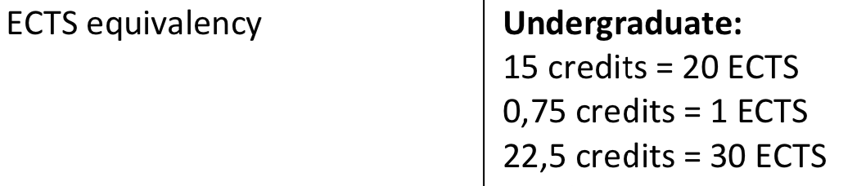

COURSES

Neuroscience courses:

<http://www.washington.edu/students/crscat/neusci.html>

psych stuff

<http://www.washington.edu/students/crscat/psych.html>

many psych courses seem to be offered year round, and many it does not say anything about when they’re offered.

OBS psychology courses are competitive to get into, and own are prioritized first (but economics also listed, and oliver ørskov took those, sooo?)

|  |  |  |  |  |
| --- | --- | --- | --- | --- |
| **SELECTED COURSES ABROAD** | | | | **AU COURSES** |
| Course Code | Course Title | Credit Points | Course Level | AU course that the course abroad replaces\* |
| **NEUSCI 301**  **winter** | **Introduction to Cellular and Molecular Neuroscienc**  Prereq: BIOL 220 | 3 or 5 | Bachelor | ITTU |
| **NEUSCI 302**  autumn | **Introduction to Systems and Behavioral Neuroscience**  (neusi 301 pre req) | 3 or 5 | Bachelor | ITTU |
| **NEUSCI 198**  (autumn) | **The Biology of Human Consciousness** | 5 | Bachelor | ITTU |
| **NEUSCI 401**  **spring** | **Systems Neuroscience**  **Prereq neusci 301** | 3 | Bachelor | ITTU |
| **NEUSCI 403**  winter | **Computational Models for Cognitive Neuroscience**  Pre-req: neusci 401 | 3 | Bachelor | ITTU |
| **NEUSCI 404**  **spring** | **Neuropharmacology** | 3 |  |  |
| **NEUSCI 440** | **Topics in Current Neurosience Research** | 3 | Bachelor | ITTU |
| **PSYCH 200** | **Comparative Animal Behavior** | 3 | Bachelor | ITTU |
| **PSYCH 202**  **Year round** | **Biopsychology (5)** | 5 | Bachelor | ITTU |
| **PSYCH 205** | **Behavior Disorders (5)** | 5 | Bachelor | ITTU |
| **PSYCH 245** | **Introduction to Social Psychology** | 5 | Bachelor | ITTU |
| **PSYCH 291** | **Principles of Applied Animal Behavior** | 3 | Bachelor | ITTU |
| **PSYCH 302**  **All year** | **Neuroscience of the Mind**  **Prereq:**  PSYCH 101; PSYCH 202; PSYCH 209 | 3 | Bachelor | ITTU |
| **PSYCH 322** | **Introduction to Drugs and Behavior**  **Prereq psych202** | 3 | Bachelor | ITTU |
| **PSYCH 331** | **Laboratory in Human Cognition** | 5 | Bachelor | ITTU |
| **PSYCH 332** | **Neurobehavioral Lab** | 5 | Bachelor | ITTU |
| **PSYCH 357** | **Psychobiology of Women** | 5 | Bachelor | ITTU |
| **PSYCH 400** | **Learning** | 5 | Bachelor | ITTU |
| **PSYCH 403** | **Motivation** | 5 | Bachelor | ITTU |
| **PSYCH 408** | **Neuroethology** | 5 | Bachelor | ITTU |
| **PSYCH 414** | **Cognitive Development** | 5 | Bachelor | ITTU |
| **PSYCH 421** | **Neural Basis of Behavior** | 5 | Bachelor | ITTU |
| **PSYCH 426** | **Neurobiology of Learning and Memory** | 4 | Bachelor | ITTU |
| **PSYCH 427** | **Behavioral Endocrinology** | 5 | Bachelor | ITTU |
| **PSYCH 429** | **Brain Anatomy for the Behavioral Scientist** | 1 | Bachelor | ITTU |
| **PSYCH 430** | **Development of Brain Connections** | 4 | Bachelor | ITTU |
| **PSYCH 432** | **Visual Neuroscience** | 4 | Bachelor | ITTU |
| **PSYCH 462** | **Human Memory (5)** | 5 | Bachelor | ITTU |
| **PSYCH 463** | **Implicit and Unconscious Cognition (3)** | 3 | Bachelor | ITTU |
| **PSYCH 466** | **Psychology of Judgment and Decision Making (5)** | 5 | Bachelor | ITTU |
| **PSYCH 469** | **Psychology of Reasoning (4)** | 4 | Bachelor | ITTU |
| **PSYCH 471** | **Cognition In the Real World** | 3 | Bachelor | ITTU |
| **MKTG 450** | **Consumer Behavior (4)** | 4 | Bachelor | ITTU |
| **MKTG 301** | **Marketing Concepts (4)** | 4 | Bachelor | ITTU |

Response form office:

Typically, we cannot pre-assess if the courses you have taken abroad will transfer directly. We’ll examine your official transcript and award transfer credits after you are accepted to the UW. UW students generally earn 45 credits per year.

## University of South Carolina

Autumn semester 2020

* All subjects Arts (BA) (University Wide)

**Academic calendar**

Fall Semester: mid-August to mid-December   
Spring Semester: early January to early May

**Course catalogue**

Students may enroll in any course for which they meet the prerequisite. Courses are offered on a per semester basis only.There are some course restrictions in the following fields: law, medicine, nursing, some exercise science, and International Business.

Neuroscience minor:

<http://bulletin.sc.edu/preview_program.php?catoid=88&poid=5585&returnto=2552>

psych courses: <http://bulletin.sc.edu/content.php?catoid=88&navoid=2555#acalog_template_course_filter>

CANØT FIND SEMESTERS FOR EACH COURSE

|  |  |  |  |  |  |  |
| --- | --- | --- | --- | --- | --- | --- |
| **SELECTED COURSES ABROAD** | | | | | **AU COURSES** | |
| Course Code | Course Title | Credit Points | Course Level | AU course that the course abroad replaces\* | |
| **PSYC 360** | **Applied Psychology** | 3 cp |  |  | |
| **PSYC 410** | **Behavioral or mental disorders** | 3 or 5? | Bachelor | ITTU | |
| **PSYC 455** | **Introduction to Neuroscience** | 5? | Bachelor | ITTU | |
| **PSYC 460** | **Brain and Behavior** | 3 cp | Bachelor | ITTU | |
| **PSYC 470** | **Introduction to Language Sciences** |  |  |  | |
| **PSYC 501** | **Human Factors Psychology** |  |  |  | |
| * Psych 503 | **Psychology of drug use and effects** |  |  |  | |
| PSYC 570 - | Neuroscience Laboratory |  |  |  | |
| **PSYC 571** | **Cognitive Neuroscience Laboratory** |  |  |  | |
| **SCHC 101** | **Principles of Biology** | 4 |  |  | |
| BIOL 242 | **Human Physiology** |  |  |  | |
| BIOL 243 | **Human Anatomy and Physiology I** |  |  |  | |
| **BIOL 120 - Human Biology** |  | 3 |  |  | |

## University of Oklahoma

Autumn semester 2020

* All subjects Arts (BA+MA) (University Wide)
* **Full-time course load according to host institution**
* OU defines a full-time load as 12 hours (typically 4 classes) per semester. Up to 15 credit hours.

**Academic calendar**

Autumn semester: late August – December.   
Spring semester: mid-January – early May.

Courses:

Psych: <http://ou-public.courseleaf.com/courses/psy/>

|  |  |  |  |  |
| --- | --- | --- | --- | --- |
| **SELECTED COURSES ABROAD** | | | | **AU COURSES** |
| Course Code | Course Title | Credit Points | Course Level | AU course that the course abroad replaces\* |
| **PSY 3613. Developmental Psychology: Infancy through Adolescence** | **PSY 3613. Developmental Psychology: Infancy through Adolescence** | 3 points | Bachelor | ITTU |
| **PSY 3703. Social Psychology.** | **PSY 3703. Social Psychology.** | 3 cp | Bachelor | ITTU |
| **PSY 3803. Physiological Psychology.** | **PSY 3803. Physiological Psychology.** | 3 cp | Bachelor | ITTU |
| **PSY 4243. Decision Making and Problem Solving.** | **PSY 4243. Decision Making and Problem Solving.** | 3cp | Bachelor | ITTU |
| **PSY G4253. Selected Topics in Cognitive Science.** | **PSY G4253. Selected Topics in Cognitive Science.** | 3 cp |  |  |
| **PSY 4263. Psychology and Law.** | **PSY 4263. Psychology and Law.** | 3 |  |  |
| **PSY G4313. Motivation.** | **PSY G4313. Motivation.** | 3 |  |  |
| **PSY G4703. Psychology of Leadership.** | **PSY G4703. Psychology of Leadership.** |  |  |  |
| **PSY 5203. Survey in Cognitive Psychology.** | **PSY 5203. Survey in Cognitive Psychology.** |  |  |  |
| **MGT 3013. Principles of Organization and Management.** | **MGT 3013. Principles of Organization and Management.** |  |  |  |
| **MGT 3133. Leadership.** |  |  |  |  |
| **BIOL 1013. Introduction to Biology.** |  | 3 |  |  |
| **BIOL 1124. Intro Biol: Molecule/Cell/Phys.** |  |  |  |  |
| **BIOL 2124. Human Physiology.** |  |  |  |  |
| **CHEM 1305. Fundamentals of General Chemistry** |  |  |  |  |

Svar fra office: I am glad to hear of your excitement over attending OU!

You have asked a lot of good questions! I highlighted them below to be sure I address all of them. I am not sure what course catalog you are using to research courses at OU, or what part of OU’s website you are reviewing so I will direct you to our [exchange website](http://www.ou.edu/cis/iss/students/exchange). I hope it will be most helpful.

[Here](http://www.ou.edu/cis/iss/students/exchange/enrollment-academics) is the information on courses and what is acceptable and what is not. (make sure to click through all the accordion pages)

The courses you listed below are acceptable courses to take. You are not restricted to one discipline, but can take courses in almost any college or department on OU’s Norman campus. For example if you want to take PSY courses and a DANC course, that is fine. I don’t know if your home university will grant you credit for anything not aligned with your major, but you are allowed to take courses outside your course of study while at OU.

If you use [ClassNav](https://classnav.ou.edu/) to search for courses you need to filter by semester. Our fall semester runs from mid-August to mid-December, and our spring semester runs from mid-January to mid-May. The summer semester is not part of the exchange program. The courses for next fall 2020 are not released yet. The fall schedule of course offerings will likely be released early in 2020, so at this time I cannot tell you which of the courses you listed below will be available during the semester you are here. I am sorry I do not know why some are labeled irreg. because I am not sure what course catalog you are referring to, but it likely means the course is not offered on a regular basis. Most courses required for a degree are offered at lease once an academic year, but some courses are electives that cover very specific topics and may only be offered every once in a while.

US academic credit hours relate to the ECTS in a 1:2 ratio, meaning 1 credit hour is usually equal to 2 ECTS credits. If you take 15 credit hours at OU in one semester you will likely receive 30 ECTS. Your home university will be responsible for equating your courses from OU.

If you are nominated by your university to the University of Oklahoma’s exchange program, after the application process, you will be asked to submit course requests for the semester you will be attending. You will also submit a transcript of courses you have already taken. I use that transcript to get approval for the courses you requested, so make sure when you are searching for courses that you see the prerequisites on your transcript. That can be tedious, but if you look up the courses listed as prerequisites for a course, make sure you have a taken a class with the same or similar content. The idea is to be sure when you arrive at OU and begin taking your classes that you are not lost.

I also want to make you aware that exchange students are not first in line to enroll in courses. So sometimes when you request a course, by the time your enrollment window opens it could be full. For this reason, and because sometimes students request courses they are not qualified for, I ask for 8 course requests. I will probably only enroll you in five, but I need more than five requests because some may not work out. The courses you request cannot be guaranteed until you are actually enrolled in them.

I hope I have addressed all of your concerns. Please review the website and let me know if you have additional questions. You can email me instead of admissions. I am the Exchange Student Coordinator and your best resource for exchange program information.

## University of mississipi

Autumn semester 2020

* All subjects Arts (BA+MA) (University Wide)
* **Full-time course load according to host institution**
* 30 ECTS correspond to 12 credits (undergraduate) or 9 credits (graduate)
* **Academic calendar**
* Fall semester: End of August - Medio December   
    
  Spring semester: End of January - Medio May
* University of Mississippi offers on-campus housing.
* On-campus housing is guaranteed. Students will be placed in a contemporary residence hall. These are double occupancy rooms (shared bedrooms). Residents in our contemporary halls enjoy in-room bathrooms, study rooms on each floor, conference rooms, community kitchens, and lounges with TVs on each floor.

IMPORTANT INFO ON AVAILABLE COURSES

<https://studyabroad.olemiss.edu/index.cfm?FuseAction=Abroad.ViewLink&Parent_ID=0C64CA47-5056-BA1F-7103C1DBD4F35BA8&Link_ID=0C69FCE4-5056-BA1F-711964ED4DA8D1AE>

Normally, classes meet 1 to 3 days per week, and students earn 3 hours of credit for each successfully completed class.

|  |  |  |  |  |
| --- | --- | --- | --- | --- |
| **SELECTED COURSES ABROAD** | | | | **AU COURSES** |
| Course Code | Course Title | Credit Points | Course Level | AU course that the course abroad replaces\* |
| * [Psy 201: General Psychology](http://catalog.olemiss.edu/liberal-arts/psychology/psy-201) |  | 3 cp | Bachelor | ITTU |
| Psy 215: Psychology of Instructional Technology |  | 3 cp | Bachelor | ITTU |
| Psy 309: Learning |  | 3 cp | Bachelor | ITTU |
| * [Psy 311: Abnormal Psychology](http://catalog.olemiss.edu/liberal-arts/psychology/psy-311) |  | 3 cp | Bachelor | ITTU |
| Psy 313: Experimental Analysis of Behavior |  | 3 cp | Bachelor | ITTU |
| * [Psy 315: Personality](http://catalog.olemiss.edu/liberal-arts/psychology/psy-315) |  | 3 cp | Bachelor | ITTU |
| Psy 319: Brain and Behavior |  | 3 cp | Bachelor | ITTU |
| * [Psy 320: Cognitive Psychology](http://catalog.olemiss.edu/liberal-arts/psychology/psy-320) |  | 3 cp | Bachelor | ITTU |
| * [Psy 322: Drugs and Behavior](http://catalog.olemiss.edu/liberal-arts/psychology/psy-322) |  | 3 cp | Bachelor | ITTU |
| Psy 323: Applied Behavior Analysi |  | 3 cp | Bachelor | ITTU |
| Psy 324: Science of Emotion |  | 3 cp | Bachelor | ITTU |
| Psy 327: Psychology and Law |  | 3 cp | Bachelor | ITTU |
| * [Psy 344: Moral Psychology](http://catalog.olemiss.edu/liberal-arts/psychology/psy-344) |  | 3 cp | Bachelor | ITTU |
| Psy 390: Lab in Psy: Behavioral Neuroscience |  | 3 cp | Bachelor | ITTU |
| * [Psy 505: Conditioning and Learning](http://catalog.olemiss.edu/liberal-arts/psychology/psy-505) |  | 3 cp | Bachelor | ITTU |
| * [Psy 532: Attention and Consciousness](http://catalog.olemiss.edu/liberal-arts/psychology/psy-532) |  | 3 cp | Bachelor | ITTU |
| Psy 715: Physiological Psychology |  | 3 cp | Bachelor | ITTU |
| Psy 716: Psychopharmacology |  | 3 cp | Bachelor | ITTU |
| * [Psy 713: Advanced Social Cognition](http://catalog.olemiss.edu/liberal-arts/psychology/psy-713) |  | 3 cp | Bachelor | ITTU |
| * [Psy 394: Lab in Psy: Cognition and Perception](http://catalog.olemiss.edu/liberal-arts/psychology/psy-394) |  | 3 cp | Bachelor | ITTU |
| Psy 511: The Neural Basis of Learning & Memory |  | 3 cp | Bachelor | ITTU |
| * [Chem 105: General Chemistry I](http://catalog.olemiss.edu/liberal-arts/chemistry-biochemistry/chem-105) |  | 3 cp | Bachelor | ITTU |
| Bisc 160: Biological Sciences I |  | 3 cp | Bachelor | ITTU |

30 ECTS correspond to 12 credits (undergraduate) or 9 credits (graduate)

Svar fra office:

Of all the courses you have listed below, there are no restrictions. Students who are undergraduates have to stay in the 100-400 level and can take some 500 level courses. Our restrictions in the science/psychology fields are mainly just the pharmacy program and the medical school program, which is based in Jackson, Mississippi. If you have any questions about other courses and your ability to take them, let me know.

Each semester may be different so I can't 100% guarantee what will be offered in Spring 2021, but of the courses you have listed below, the following are offered this upcoming spring semester: Psy 215, Psy 309, Psy 319, Psy 323, Psy 324, and Psy 511. Bisc 160 is a course only offered in the fall - its counterpart, Bisc 162 is offered in the spring. Psy 313, 327, and 390 happen to not be offered this upcoming spring.

f you want to look at the courses that were available this Fall 2019 semester and which courses are offered in the Spring 2020 semester, follow the steps below:

1. Go to [my.olemiss.edu](http://my.olemiss.edu)
2. In the "Academics" box, click "Course Schedule"
3. Choose the semester (Fall or Spring) and the year you would like to look at. (ex. Spring semester 2019-2020)
4. Search for courses by department or by entering key words (Psychology is Psy, Biology is Bisc, let me know if you need help finding other departments).

If you search for a course using the directions above, you'll see their prerequisites. Some psychology courses are available only after taking the introductory General Psychology (Psy 201) course, while other have more extensive prerequisites. Once you apply and submit course requests, I ask each department to look over the requests along with student transcripts to determine if the prerequisites are met. As a result, I can't determine if you are eligible for a course, only the department can. But you can simply look at the prerequisites of a course and your transcript to see if you have taken courses similar to the prerequisite!

 Yes, you will be able to get 30 ECTS credits easily. International visiting students are required by their visa status to take a minimum of 12 credit hours (typically 4 courses). Many students whose English is really good, as I'm assuming yours is being Danish, take up to 18 credit hours (typically 6 courses). Thus, you will for sure be able to get 30 ECTS credits.

Vedr: om man kan kontakte folk om man opfylder pre reqs:

Sure, if you search for the department within our university, find and email the administrative assistant, the Assistant to the Dean, or the professor of a course. They should be able to help you or they will let you know who you can ask!

## University of Massachusetts Boston, United States

Fall semester: September - December   
Spring semester: Late January - May

Autumn semester 2020

* All subjects Arts (BA+MA) (University Wide)

**Full-time course load according to host institution**

12 credits (4 courses) for undergraduates, and 9 credits (3 courses) for graduate students.

Courses:

Has cogsci minor!!

<https://www.umb.edu/editor_uploads/images/cla_p_z/CogSciMinorFlyerMain.pdf>

can’t find semesters for each course

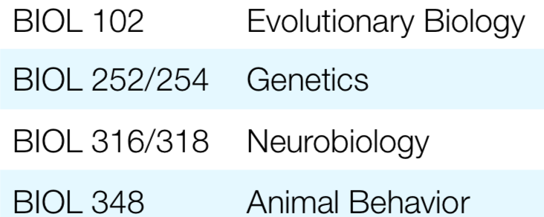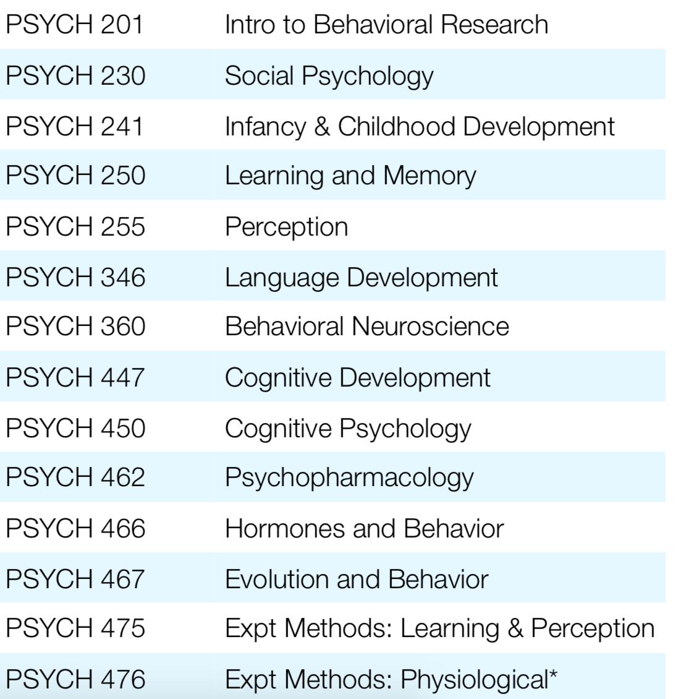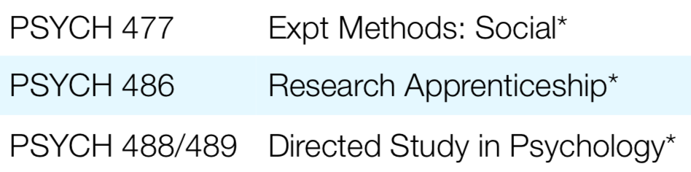

### ACDTSP 005 - Psychopharmacology

3 - 4 Credit(s) | Lecture |   
Course can be counted for credit once  
  
**Description:**  
This course introduces the participant to the basic principles of pharmacology, anatomy and physiology.  
  
**Enrollment Requirements:**  
Department consent

|  |
| --- |
| CS 220 - Applied Discrete Mathematics |

|  |  |  |  |  |
| --- | --- | --- | --- | --- |
| **SELECTED COURSES ABROAD** | | | | **AU COURSES** |
| Course Code | Course Title | Credit Points | Course Level | AU course that the course abroad replaces\* |
| * [BIOL111](http://catalog.olemiss.edu/liberal-arts/psychology/psy-201) | General Biology I | 4 |  |  |
| BIOL101 | The Basis of Life(simpler, inteded for humanities) | 3 or 5? | Bachelor | ITTU |
| BIOL207 | Anatomy and Physiology I Prereq BIOL111 | 5? | Bachelor | ITTU |
| CHEM 130 | Physiological Chemistry (no seemign pre reqs) | 3 cp | Bachelor | ITTU |
| CS 470 | An Introduction to Artificial Intelligence Prerequisites: [CS 220](http://catalog.umb.edu/content.php?catoid=28&catoid=28&navoid=3011&filter%5Bitem_type%5D=3&filter%5Bonly_active%5D=1&filter%5B3%5D=1&filter%5Bcpage%5D=8#tt828) and [CS 310](http://catalog.umb.edu/content.php?catoid=28&catoid=28&navoid=3011&filter%5Bitem_type%5D=3&filter%5Bonly_active%5D=1&filter%5B3%5D=1&filter%5Bcpage%5D=8#tt4517) | 3 cp | Bachelor | ITTU |
| ECON 406 | Introduction to Behavioral Economics Prerequisite: [ECON 201](http://catalog.umb.edu/content.php?catoid=28&catoid=28&navoid=3011&filter%5Bitem_type%5D=3&filter%5Bonly_active%5D=1&filter%5B3%5D=1&filter%5Bcpage%5D=9#tt5953) | 3cp |  |  |
| PSYCH 250 | Learning and Memory Pre req:  [PSYCH 100](http://catalog.umb.edu/content.php?filter%5B27%5D=PSYCH&filter%5B29%5D=&filter%5Bcourse_type%5D=-1&filter%5Bkeyword%5D=&filter%5B32%5D=1&filter%5Bcpage%5D=1&cur_cat_oid=28&expand=&navoid=3011&search_database=Filter#tt3725) or [PSYCH 101](http://catalog.umb.edu/content.php?filter%5B27%5D=PSYCH&filter%5B29%5D=&filter%5Bcourse_type%5D=-1&filter%5Bkeyword%5D=&filter%5B32%5D=1&filter%5Bcpage%5D=1&cur_cat_oid=28&expand=&navoid=3011&search_database=Filter#tt6930) |  |  |  |
| PSYCH 302 | Human Motives and Emotions |  |  |  |
| PSYCH 360 | Behavioral Neuroscience  * [PSYCH 100](http://catalog.umb.edu/content.php?filter%5B27%5D=PSYCH&filter%5B29%5D=&filter%5Bcourse_type%5D=-1&filter%5Bkeyword%5D=&filter%5B32%5D=1&filter%5Bcpage%5D=1&cur_cat_oid=28&expand=&navoid=3011&search_database=Filter#tt6398) or [PSYCH 101](http://catalog.umb.edu/content.php?filter%5B27%5D=PSYCH&filter%5B29%5D=&filter%5Bcourse_type%5D=-1&filter%5Bkeyword%5D=&filter%5B32%5D=1&filter%5Bcpage%5D=1&cur_cat_oid=28&expand=&navoid=3011&search_database=Filter#tt649)  and * PSYCH 105 or any BIOL course |  |  |  |
| PSYCH 415 | Psychological Trauma: Individual and Society Prerequisites: [PSYCH 201](http://catalog.umb.edu/content.php?filter%5B27%5D=PSYCH&filter%5B29%5D=&filter%5Bcourse_type%5D=-1&filter%5Bkeyword%5D=&filter%5B32%5D=1&filter%5Bcpage%5D=1&cur_cat_oid=28&expand=&navoid=3011&search_database=Filter#tt8939) and [PSYCH 215](http://catalog.umb.edu/content.php?filter%5B27%5D=PSYCH&filter%5B29%5D=&filter%5Bcourse_type%5D=-1&filter%5Bkeyword%5D=&filter%5B32%5D=1&filter%5Bcpage%5D=1&cur_cat_oid=28&expand=&navoid=3011&search_database=Filter#tt4816) |  |  |  |
| PSYCH 447 | * [PSYCH 241](http://catalog.umb.edu/content.php?filter%5B27%5D=PSYCH&filter%5B29%5D=&filter%5Bcourse_type%5D=-1&filter%5Bkeyword%5D=&filter%5B32%5D=1&filter%5Bcpage%5D=1&cur_cat_oid=28&expand=&navoid=3011&search_database=Filter#tt7330) or * [PSYCH 250](http://catalog.umb.edu/content.php?filter%5B27%5D=PSYCH&filter%5B29%5D=&filter%5Bcourse_type%5D=-1&filter%5Bkeyword%5D=&filter%5B32%5D=1&filter%5Bcpage%5D=1&cur_cat_oid=28&expand=&navoid=3011&search_database=Filter#tt8804) or * [PSYCH 201](http://catalog.umb.edu/content.php?filter%5B27%5D=PSYCH&filter%5B29%5D=&filter%5Bcourse_type%5D=-1&filter%5Bkeyword%5D=&filter%5B32%5D=1&filter%5Bcpage%5D=1&cur_cat_oid=28&expand=&navoid=3011&search_database=Filter#tt9187) and [PSYCH 242](http://catalog.umb.edu/content.php?filter%5B27%5D=PSYCH&filter%5B29%5D=&filter%5Bcourse_type%5D=-1&filter%5Bkeyword%5D=&filter%5B32%5D=1&filter%5Bcpage%5D=1&cur_cat_oid=28&expand=&navoid=3011&search_database=Filter#tt6572)  Cognitive Development |  |  |  |
| PSYCH 460 | The Neuropsychology of Higher Cognitive Processes |  |  |  |
| PSYCH 462 | Psychopharmacology  * [PSYCH 201](http://catalog.umb.edu/content.php?filter%5B27%5D=PSYCH&filter%5B29%5D=&filter%5Bcourse_type%5D=-1&filter%5Bkeyword%5D=&filter%5B32%5D=1&filter%5Bcpage%5D=1&cur_cat_oid=28&expand=&navoid=3011&search_database=Filter#tt1168) and * [PSYCH 360](http://catalog.umb.edu/content.php?filter%5B27%5D=PSYCH&filter%5B29%5D=&filter%5Bcourse_type%5D=-1&filter%5Bkeyword%5D=&filter%5B32%5D=1&filter%5Bcpage%5D=1&cur_cat_oid=28&expand=&navoid=3011&search_database=Filter#tt592) or equivalent |  |  |  |
| PSYCH 464 | Biological Rhythms in Brain and Behavior  * [PSYCH 201](http://catalog.umb.edu/content.php?filter%5B27%5D=PSYCH&filter%5B29%5D=&filter%5Bcourse_type%5D=-1&filter%5Bkeyword%5D=&filter%5B32%5D=1&filter%5Bcpage%5D=1&cur_cat_oid=28&expand=&navoid=3011&search_database=Filter#tt4378) and * [PSYCH 360](http://catalog.umb.edu/content.php?filter%5B27%5D=PSYCH&filter%5B29%5D=&filter%5Bcourse_type%5D=-1&filter%5Bkeyword%5D=&filter%5B32%5D=1&filter%5Bcpage%5D=1&cur_cat_oid=28&expand=&navoid=3011&search_database=Filter#tt5607) or [BIOL 316](http://catalog.umb.edu/content.php?filter%5B27%5D=PSYCH&filter%5B29%5D=&filter%5Bcourse_type%5D=-1&filter%5Bkeyword%5D=&filter%5B32%5D=1&filter%5Bcpage%5D=1&cur_cat_oid=28&expand=&navoid=3011&search_database=Filter#tt4824) |  |  |  |
| PSYCH 476 | Experimental Methods: Physiological  * [PSYCH 201](http://catalog.umb.edu/content.php?filter%5B27%5D=PSYCH&filter%5B29%5D=&filter%5Bcourse_type%5D=-1&filter%5Bkeyword%5D=&filter%5B32%5D=1&filter%5Bcpage%5D=1&cur_cat_oid=28&expand=&navoid=3011&search_database=Filter#tt9982) and * [PSYCH 360](http://catalog.umb.edu/content.php?filter%5B27%5D=PSYCH&filter%5B29%5D=&filter%5Bcourse_type%5D=-1&filter%5Bkeyword%5D=&filter%5B32%5D=1&filter%5Bcpage%5D=1&cur_cat_oid=28&expand=&navoid=3011&search_database=Filter#tt5306) or [BIOL 112](http://catalog.umb.edu/content.php?filter%5B27%5D=PSYCH&filter%5B29%5D=&filter%5Bcourse_type%5D=-1&filter%5Bkeyword%5D=&filter%5B32%5D=1&filter%5Bcpage%5D=1&cur_cat_oid=28&expand=&navoid=3011&search_database=Filter#tt7677) |  |  |  |

## University of California, Santa Cruz

**Academic Calendar**

University of California, Santa Cruz uses quarters instead of semesters. Students are required to take courses corresponding to at least 20 ECTS points per quarter, it is not recommend to try and complete more that 25 ECTS. Students will normally only be selected to go for a single quarter, though students nominated to go in the Spring semester at DTU can choose to either go abroad in the winter or the fall quarter at UCSC.

Fall Quarter: mid-September to mid-December

Winter Quarter: start-January to late-March

Spring quarter: start-April to mid-June

## University of california (the big mumbo-jumbo of campuses) DEPENDS IF 2 QUARTERS POSSIBLE FOR NON BERKELEY AND MERCED – update fra Aske, det er det ikke ☹(((

**Academic calendar**

An academic year at UC, Berkeley and UC, Merced comprises two terms (semesters - each 15 weeks of instruction):   
  
Fall semester (August - December)   
Spring semester (January - May)   
  
All other UC campuses have three terms (quarters - each 10 weeks of instruction):   
  
Fall quarter (September - December), Winter quarter (January - March), and Spring quarter (April - June).

**Undergraduate level:**

1 term (15 credit units) will be transferred with 20 ECTS.  
To obtain 30 ECTS it will be necessary to spend 2 terms at UCLA

**Undergraduate level:**

15 units = 20 ECTS 1 unit = 1,33 ECTS

Fall: Late September - Mid December  
Winter: Early January – Mid March  
Spring: Late March – Mid June

<https://studerende.au.dk/fileadmin/studerende.au.dk/ST/ST_studiekontor/Udlandsophold/ECTS_omregninger/University_of_California__Los_Angeles_til_web.pdf>

## State University of New York, Buffalo State

Autumn semester 2020

* All subjects Arts (BA) (University Wide)

**Grade requirements**

4.0 on the Danish grading scale.

Only undergraduate courses are open to exchange students

**Full-time course load according to host institution**

12 credits equivalent to four courses per semester

**Academic calendar**

Fall semester: Late August - mid-December   
Spring semester: Mid-January - mid-May

OBS!!!! Not sure on credit system!!!!

. A 5 credit (ECTS) course at Aarhus is a 3 credit course at UAlbany.

<https://ualbany.studioabroad.com/index.cfm?FuseAction=Programs.ViewProgram&Program_ID=10308>

courses don’t look very exciting (not many psych courses)

<http://catalog.buffalostate.edu/undergraduate/course-listings.htm>

All these have PSY 101 as pre req

PSY 381 PSYCHOLOGY OF CULTURE   
PSY 382 PSYCHOLOGY OF THE CONSUMER

PSY 304 LEARNING: THEORY AND RESEARCH   
PSY 308 SENSATION AND PERCEPTION   
PSY 321 COMPARATIVE ANIMAL BEHAVIOR   
PSY 330 THE PSYCHOLOGICAL POWER OF LANGUAGE   
PSY 333 BRAIN AND BEHAVIOR   
PSY 340 COGNITIVE PSYCHOLOGY

PSY 375 FORENSIC PSYCHOLOGY

PSY 421 PHYSIOLOGICAL PSYCHOLOGY (Prerequisites: PSY 101 grade of C, and 3 credit hours of psychology.)  
PSY 441 INTRODUCTION TO NEUROPSYCHOLOGY (Prerequisites: PSY 101 Grade of C, and 3 credit hours of psychology.)

PSY 325 SOCIAL BEHAVIOR

Non PSYCH

CRS/UNC 201 FOUNDATIONS OF LEADERSHIP 3

CRS 302 CREATIVE APPROACHES TO PROBLEM SOLVING 3

BUS 360 PRINCIPLES OF MANAGEMENT

COM 302 PRINCIPLES OF JOURNALISM 3

BUS 403 CONSUMER BEHAVIOR

BIO 111 INTRODUCTION TO BIOLOGY 4 (EVERY SEMESTER)

RESPONSE FORM OFFICE

Thank you for writing and I am happy to know that you are interested in UAlbany.  The process of nomination to here for an exchange slot won't be for some time, however, based on your courses, all seems to be ok in terms of accessing relevant courses here. And don't worry, you take a minimum of 15 credits here and that should be equal to 30 in Denmark.

## University of Albany

**Full-time course load according to host institution**

12 credits minimum/19 credits maximum

**Academic calendar**

Fall semester: Late August to mid-December   
Spring semester: Late January to mid-May

Rank: 350-400 I verden (times higher)

Rated highly as “party school”

Psych courses:

<https://www.albany.edu/undergraduate_bulletin/a_psy.html>

psych 210 is stats

211 is experimental psychology

**A PSY 102 Advanced Introduction to Psychology (4)**

200 levels have pre req PSY 101.

**APSY 203 Psychology of Child Developmnt spr**

**A PSY 214/214T Introduction to Biopsychology and Behavioral Neuroscience (3) spring**

**T PSY 214 Honors Introduction to Behavioral Neuroscience (3)**

**APSY 270 Social Psychology spring**

**A PSY 223 Emotional and Social Development (3)**

**APSY 314 Adv Biopsy&Behvrl Neurosci spring**

**A PSY 316 Moral Psychology (3) no**

**A PSY 328 Social Cognition (3) no**

**A PSY 338/338T Abnormal Psychology (3) spring**

**APSY 341 Industrial/Organzational Psych spring**

**A PSY 380/380T Learning (3) spring**

**A PSY 381/381T Memory and Cognition (3) spring**

Prerequisite(s): A PSY 101, 210, and 211.

**PSY 384 Motivation (3) no**

**A PSY 385/385T Evolutionary Psychology (3) no**

**A PSY 387/387T Behavior Genetics (3) no**

**A PSY 388 Introduction to Psychopharmacology (3) spring**

**APSY 389 Addict. & Compul. Behaviors spring**

**APSY 490 Topics in Neuroscience spring**

A BIO 130 (formerly A BIO 121) General Biology: Molecular and Cell Biology and Genetics  
A BIO 131 (formerly A BIO 120) General Biology: Ecology, Evolution, and Physiology

A BIO 217 Cell Biology

**I CSI 311 Principles of Programming Languages (3)**

**I CSI 407 Human Computer Interaction (3)**

**I CSI 431 Data Mining (3)**

**I CSI 435 Artificial Intelligence (3)**

**CSI 436 Machine Learning (3)**

## University of san fransisco

**Credit translation**

15 credits/units = 30 ECTS

**Academic calendar**

Autumn Semester: August - December   
Spring Semester: January - June

NOTE

Departments, programs and courses NOT included in the exchange agreement (referred to as "impacted programs/courses" ) vary from one year to another. When choosing your courses from the SFSU course catalogue, these "impacted programs/courses" must NOT be included in your course selection form.   
  
The following programs and courses are "impacted" for 2019/20 and do NOT accept exchange students:   
  
Journalism Broadcasting and Electronic Arts Communication (BECA)   
Fashion Design and Merchandising, Interior Design, Design and Industry   
Dietetics   
American Language Institute   
Drawing, Painting and Sculpture   
School of Nursing   
School of Music and Dance: Individual Instruments (including Voice and   
Composition)   
School of Education

NOTE biletral agreement – research more when you find out what it means! ) MEANS ONLY ARTS!!!

## Roanoke

Also bilateral

**Full-time course load according to host institution**

The standard workload is 4 units in each semester = 30 ECTS.

**Academic calendar**

Autumn semester: Ultimo August - medio December   
Spring semester: Medio January - primo May

## North Park University Chicago, United States

Also bilateral

## MAUI network

Autumn semester 2020

* All subjects Arts (BA+MA) (University Wide)

**Other requirements**

You have to have passed two years of your studies at the time of departure.

Stor liste, vend tilbage (der er mange universiteter inkluderet)

UNIER i MAUI

### Baylor

CHRISTIAN UNIVERSITY!!!

NEURO

**1106 Introduction to Neuroscience Laboratory**

**1306 Introduction to Neuroscience**

**3111 Laboratory in Cognition (Cross-listed as PSY 3111)**

**3120 Laboratory in Learning and Behavior (Cross-listed as PSY 3120)**

**3123 Laboratory in Sensation and Perception (Cross-listed as PSY 3123)**

**3311 Cognition (Cross-listed as PSY 3311)**

**3320 Learning and Behavior (Cross-listed as PSY 3320)**

**3370 Affective Neuroscience (Cross-listed as PSY 3370)**

**3323 Sensation and Perception (Cross-listed as PSY 3323)**

**3375 Sleep (cross-listed as PSY 3375)**

**4119 Laboratory in Clinical Neuroscience (Cross-listed as PSY 4119)**

**4130 Advanced Laboratory in Neural Science (Cross-listed as PSY 4130)**

**4312 Behavioral Medicine (Cross-listed PSY 4312)**

**4319 Clinical Neuroscience (Cross-listed as PSY 4319)**

**4356 Neuropharmacology**

PSYCH

**3310 Social Psychology**

**3318 Psychology of Memory**

**3330 Psychopathology**

**3355 Drugs and Behavior**

**3380 Forensic Psychology**

## High Point University High Point, United States

= Ser ikke særligt spændende ud m fag + måske kristent?? + sydstat

Spring Semester 2020

* All subjects Arts (BA+MA) (University Wide)

Autumn semester 2020

* All subjects Arts (BA+MA) (University Wide)

**Other requirements**

Exchange students are not restricted in undergraduate course selection; however, some courses have prerequisites and Music, Theatre, and Art & Design courses often require auditions or portfolios. Currently, High Point University is not able to accept exchange students for graduate study.

**Full-time course load according to host institution**

HPU defines a full-time load as minimum 12 credits (3 4-credit classes) and maximum 18 credits per semester. However, most students take 4 classes worth 4 credits each (recommended number of credits for exchange students is 16 credits per term).

**Academic calendar**

Fall Semester: late August - mid-December   
Spring Semester: beginning of January - beginning of May

Also religious university???

Neuro-fag ser ud til at jeg ikke kan vælge dem

BIO 3010  **Principles of Neuroscience** (4 credits w/ lab)

BIO 4200**Neurogenesis: Implications on Human Health and Disease**(4 credit w/ Lab)

BIO 4210  **Molecular Neurobiology**(4 credit w/ Lab)

PSY 3520  **Sensation and Perception**(4 credits)

PSY 4610  **Drugs and Human Behavior** (4 credits)

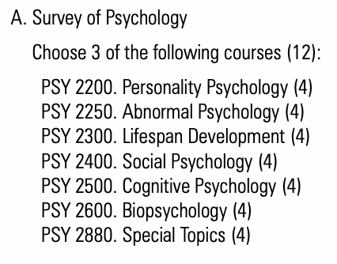

# South Korea

## Seoul National University

Psychology of Judgment and Decision

Tror det her er course descriptions: spotlight search efter psychology

<https://www.useoul.edu/upload/academics/2016_under_social.pdf?ver=2017-06-26>

Rebecca sendte dette, men det er bare meget få kurser?? <http://sugang.snu.ac.kr/sugang/cc/cc200.action> ‘

## Korea university

Autumn semester 2020

* All subjects Arts (BA+MA) (University Wide)

**Other requirements**

Non-available subjects: Medicine, Nursing, Pharmacy, Law, Teacher Education, Information Security and ALL graduate programs at the Business School

Autumn semester 2020

* All subjects Arts (BA+MA) (University Wide)

**Other requirements**

Non-available subjects: Medicine, Nursing, Pharmacy, Law, Teacher Education, Information Security and ALL graduate programs at the Business School

**Full-time course load according to host institution**

Undergraduates: 15 credits per semester

**Academic calendar**

Autumn Semester: September - December   
Spring Semester: March - June

Psychology student: I ended up taking courses in department of education because exchange students weren't allowed to take any of the psychology courses at the university

Psych courses in english:

## Yonsei

Spring: late February - mid/late June

* All subjects Arts (BA+MA) (University Wide)
* Restricted courses/faculties:   
    
  - Medicine / Dentistry / Nursing / Pharmacy   
  - Music   
  - MBA   
  - Law   
  - Courses offered in Songdo International Campus
* Business courses are restricted to business majors only and students can take a maximum of four business courses under School of Business and Office of International Affairs.
* Approximately 40 courses are conducted entirely in English and are made available to   
  exchange/visiting students by the Office of International Affairs and are labeled as   
  “Study Abroad Courses” in course catalogue. Course codes for these courses begin   
  with IEE

## Sogang

**Language requirements**

Courses taught in English:   
Students from non-English speaking countries are recommended to have English proficiency scores equivalent to TOEFL IBT 79, PBT 550, IELTS 6.5 or higher. Students do not need to submit test scores but should have good command of English.   
  
Courses taught in Korean:   
Students are not required to submit proof of Korean Language proficiency. However, it is highly recommended that students have Korean Proficiency equivalent to or higher than TOPIK level 4.

**Instruction languages**

* Korean
* English

**Full-time course load according to host institution**

According to Sogang standards 3-credit undergraduate course is equivalent to 6 ECTS credits and 3 credit graduate course is equivalent to 8 ECTS credits.

**Academic calendar**

Autumn semester: September – December.   
Spring semester: March – June.   
Summer courses are offered from mid June until mid July.

# Singapore

## National university of Singapore

Autumn semester 2020

* All subjects Arts (BA+MA) (University Wide)

**Full-time course load according to host institution**

NUS defines a full-time load as a minimum of 12 modular credits (MCs) (approximately 3 modules) and no more than 20 MCs (approximately 5 modules) per semester.   
  
1 MC is equal to 2.5 hours of study and preparation per week.

**Academic calendar**

Autumn Semester (semester 1) 1: August - November.   
Spring Semester (semester 2): January – April.   
Summer Semester: June - July

<http://www.nus.edu.sg/registrar/info/info/Non-Graduating-Module-Restrictions.pdf> restricted courses

courses open to non-graduating students <http://www.nus.edu.sg/registrar/info/ng/NG-Modules.pdf>

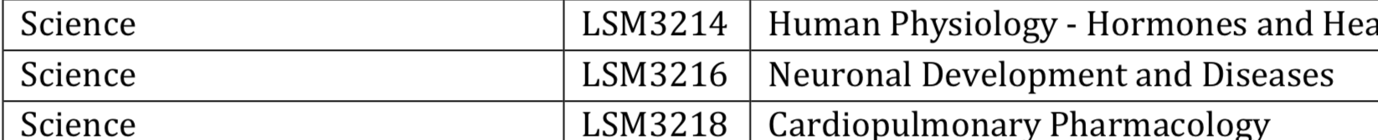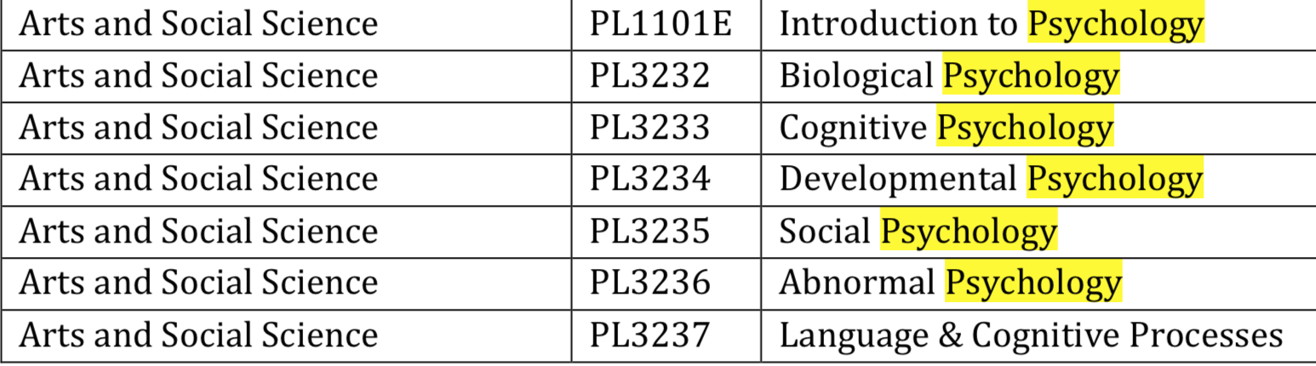

## NTU

Ourses med begrænsinger (enten potager de ikke exchange eller er der limited seats)

<https://www.ntu.edu.sg/Students/Undergraduate/AcademicServices/ExchangeProgrammes/Documents/Courses%20Restriction.pdf>