Food Fighter is a First Person Shooter where you must make as much of a mess as possible while eliminating the competition of other food fight participants. Watch out for the Lunch Lady! You don’t want to get “Sloppy Joed.”

Gameplay takes place in a 3D generic school building environment, with a first person character, controls, and camera. There are four weapon types to collect and use, each with their own effects. Enemies spawn regularly and patrol between waypoints until detecting the player. There is also a pirate non-playable character, the Lunch Lady, who delves out the food used as ammunition. The player can gain or lose ammunition at the Lunch Counter by interacting with the Lunch Lady. Once a Food Fighter has eliminated all of the competition, they have won the food fight.

fps prototype tdd

food fighter

food fighter

fps prototype tdd

Environment/World

Player

Shooting

Enemies (AI)

Interactions

Screens

Game Flow

Non-Goals

Tools

Systems

Systems Diagram

Open Issues

Document Changelist

CONTENTS

Environment/World

Level is an enclosed school cafeteria, with several rows of tables and chairs, and the lunch counter at one end. There are also columns to obscure vision from different angles in the level and a small raised platform near the lunch counter. All models will be constructed from Unity primitives and use only basic materials and lighting.

UI

* 3D Heads Up Display that shows currently equipped weapon and have their own particle effects. Bar displaying how much damage has been taken. UI prompts for when a weapon (ammo) is picked up. UI indication of whether or not a player is carrying a particular weapon (player can only carry one of each weapon at a time). Bars on enemies displaying how much damage they have taken.
* Weapons:
  + Hamburger
    - Splash Damage
  + Ketchup
    - Point Damage
  + Mustard
    - Point Damage
  + Milkshake
    - Splash Damage
* Death Panel
  + High Score
  + Restart Button
  + Quit Button
* Win Panel
  + High Score
  + Restart Button
  + Quit Button

Player

Basic movement will be with the WASD keys on the computer, for forward, left, right, and back, as well as aiming +/-360 degrees horizontally and +/-60 degrees vertically with the mouse. Attacks will be with the left and right mouse button, depending on the currently equipped weapon’s damage type, either splash damage or point damage. Colliders will be used for splash damage and Raycasts will be used for point damage.

Enemies (Artificial Intelligence)

Raycasts will also be used for the enemy AI. Enemies will detect the player as the player enters their line of sight, while patrolling back and forth between waypoints. When the player is detected the enemy will focus towards the player and fire a randomly selected weapon from among the same four weapons the player has access too. Enemies fire rates and fire positions will also be randomized.

Interactions

If the Player takes too much damage, they die, and have to start the level over again.

When the player hits an enemy with one of four weapons (a hamburger, mustard, ketchup, and a milkshake), if that weapon does adequate damage to an enemy, that enemy is destroyed, and another is spawned in a different area of the map. Weapons, which are really ammunition, are acquired either by finding them in different places around the map, or by going to see the Lunch Lady.

The player loses favour with the lunch lady for every missed shot of a given weapon, and she stops supplying the player with ammo relative to their hit/miss ratio, being angered at the player wasting food. If the player attacks the Lunch Lady, or crosses the line of the Lunch Counter, they are attacked by a barrage of food that may damage them enough for the player to lose, but also leaves behind some usable ammo for the player.

The player wins once they have destroyed all enemies set for the level.

Screens

* Main Menu
  + New Game Button
  + Controls Panel
  + Settings Panel
  + Quit Button
* Pause Menu
  + Restart Button
  + Controls
  + Settings
  + Quit Button
* Weapon Selection Screen/Tutorial
  + Prompts to explain briefly how game works. Unlimited choice of weapons upon interacting with Lunch Lady, but she still retaliates if attacked.
* Level Scene
  + First Person View of the Level
  + “Mini-map” (just an overhead view of the level) camera angle.
  + Death Panel
  + Win Panel

Game Flow Diagram

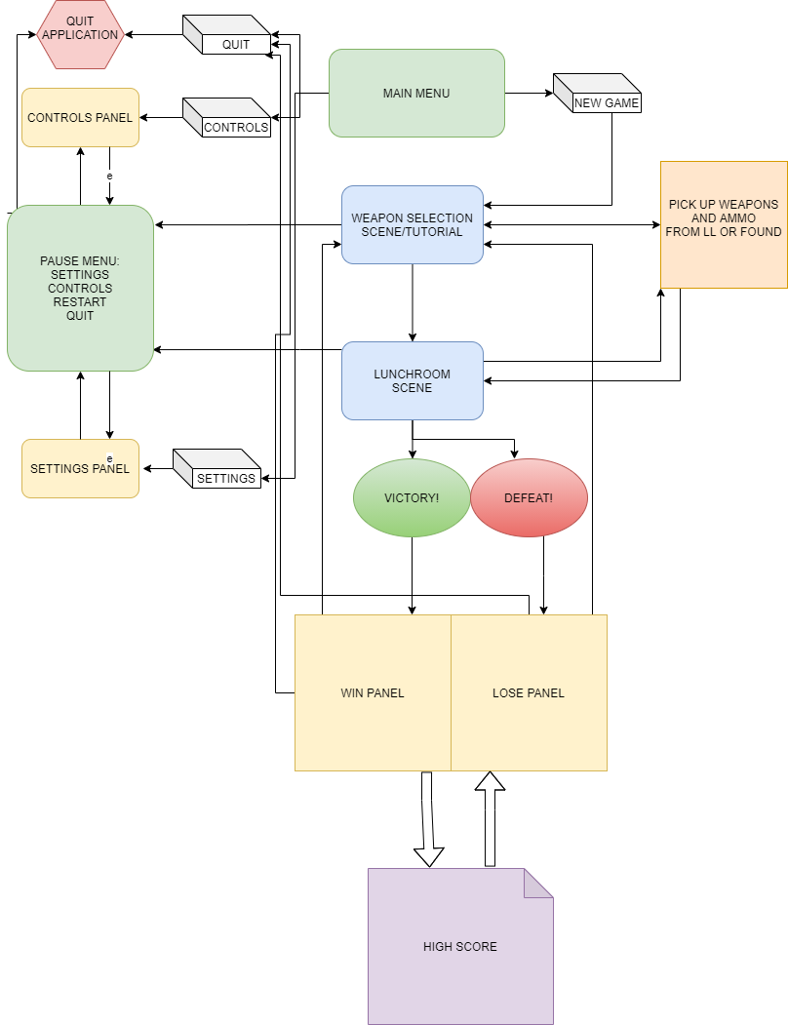

Non-Goals

* More enemy types
* More food (weapon/ammo) types
* More audio (Sound FX/Music)
* More complex interactions with the Lunch Lady
* High quality 3D modelling and lighting
* More game modes than just deathmatch

Tools

**Unity 2020.1.5f1**

I’m at least somewhat proficient at using Unity, and starting to get more comfortable with C# and Unity offers a toolset large enough to expand game elements in the future (Cinemachine, Inkle, Different Inputs, Different Platforms, etc.)

**Visual Studio 2019**

Again what I’m familiar with using, and has various features that integrate with Unity and will be helpful for completing the project efficiently/

**DOTween**

DOTween will be used primarily to enhance the UI/UX of the game.

**Photoshop 2018**

Photoshop will be more than adequate for all basic and any additional UI/UX components.

Systems

* **Combat System**
  + TBD
* **Lunch Lady System**
  + TBD
* **Winning or Losing**
  + TBD
* **High Score**
  + TBD

System Design Diagram

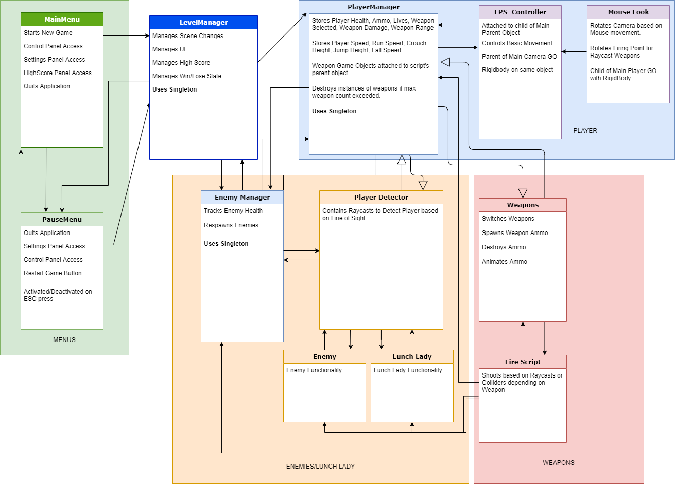

Open Issues

Document Changelist

|  |  |  |
| --- | --- | --- |
| Date | Name | Changes |
| 01/10/2020 | Tim | Document v1 |
|  |  |  |
|  |  |  |