**html/ pongo2/ valyala - template**

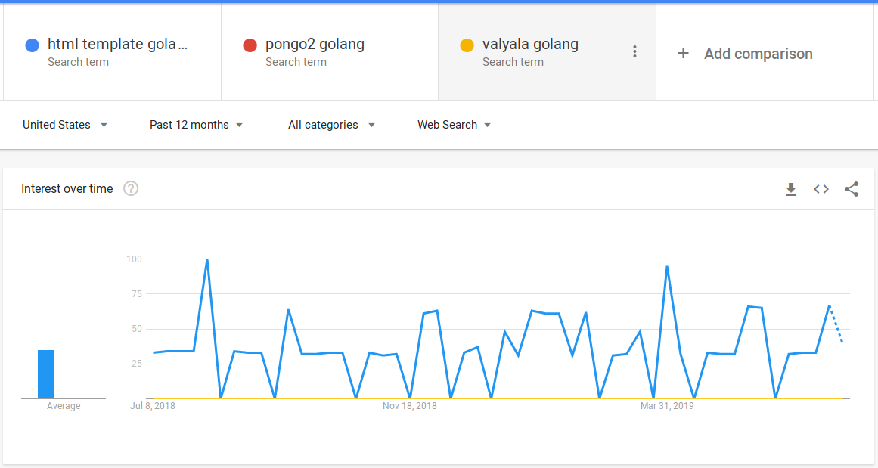

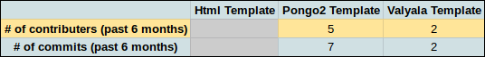

**Html-template:**

pros:

Part of the standard library that comes with golang.

Alot of support posts can be found online.

cons:

Valyala is faster:

https://github.com/valyala/fasttemplate

**Pongo2-template:**

pros:

Has Django like syntax

Has many contributors

cons:

I have not used Django in the past

Version 4 has been in production for 5 years, does not seem to be updated very frequently.

Not alot of help can be found online.

**Valyala(fasttemplate)-template:**

pros:

Is faster than html/template

cons:

Does not have many contributors.

Not much support can be found online.