ESC/VP21 Command User’s Guide for
Business Projectors

Table of Contents

1. Introduction to ESC/VP21 4
2. ESC/VP21 Command Formats 5
2.1. Set command format 5
2.2. Get command format 5
2.3. Null command 5
2.4. Illegal commands 5
3. Projector state and commands 6
3.1. Standby state (Operation indicator is in orange) 6
3.2. Power on state (Operation indicator is in green) 6
4. Command transmission timing 7
4.1. Standby state 7
4.2. Power on state 7
4.3. Warning and abnormal cases 7
5. Error Status 8
Communication specification 9
6. Revision History 10

Copyright Notice:
All rights reserved. No part of this publication may be reproduced, stored in a retrieval system, or transmitted in any form or by any means, electronic, mechanical, photocopying, or otherwise, without the prior written permission of SEIKO EPSON CORPORATION. No patent liability is assumed with respect to the use of the information contained herein. Neither is any liability assumed for damages resulting from the use of the information contained herein.

Neither SEIKO EPSON CORPORATION nor its affiliates shall be liable to the purchase of this product or third parties for damages, losses, costs, or expenses incurred by purchaser or third parties as a result of: accident, misuse, or abuse of this product or unauthorized modifications, repairs, or alterations to this product, or (excluding the U.S.) failure to strictly comply with SEIKO EPSON CORPORATION(s operating and maintenance instructions.

SEIKO EPSON CORPORATION shall not be liable against any damages or problems arising from the use of any options or any consumable products other than those designated as Original EPSON Products or EPSON Approved Products by SEKO EPSON CORPORATION.

EPSON is a registered trademark of SEIKO EPSON CORPORATION. EasyMP is a trademark of SEIKO EPSON CORPORATION.
Macintosh, Mac, and iMac are registered trademarks of Apple Computer, Inc. IBM is a registered trademark of International Business Machines Corporation. Windows and Windows NT are registered trademarks of Microsoft Corporation in the United States of America.

General Notice:
Other product names used herein are also for identification purposes only and may be trademarks of their respective owner. EPSON disclaims any and all rights in those marks.
©SEIKO EPSON CORPORTION 2003-2013. All rights reserved.

Introduction to ESC/VP21
ESC/VP21 is a control command and protocol for Epson projectors, which is used for A/V controller to control and monitor Epson projectors. The command codes are comprised of ASCII codes. Therefore the command codes can be understood very easily and you can easily control projectors using a PC with a terminal emulator such as Microsoft Hyper terminal.
Since ESC/VP21 is independent of communication protocols. Serial, USB or TCP/IP network can be used to transmit the commands to projectors.

* Serial connection
A/V controller normally use as serial connection to control projectors. Refer to Appendix for details.

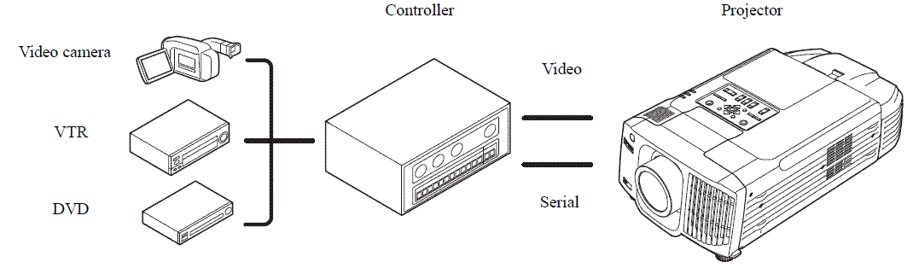

* USB connection

A USB interface can be used to control a projector. Refer to Appendix for details.
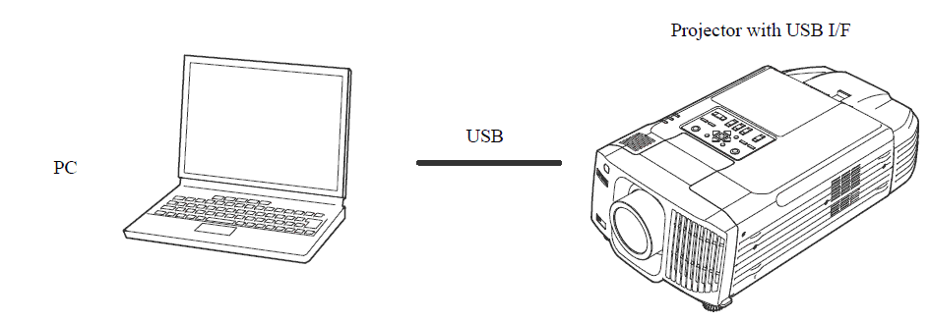

* Network connection

After establishing a TCP session, ESC/VP21 commands can be sent to projectors. Refer to ESC/VP.net protocol manual

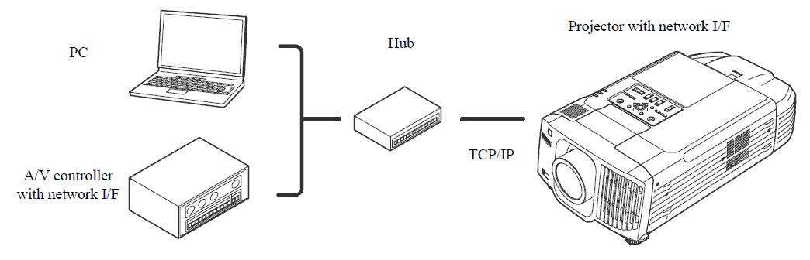

ESC/VP21 Command Formats

Set command format
A set command consists of a command and a parameter. Projector returns a colon after executing the command.
There are two types of parameters. One is fixed such as ON, OFF, or 21. Other is a step parameter such as INC, DEC or INIT.

INC: increments the parameter by one.
DEC: decrements the parameter by one.
INIT: initializes the parameter.
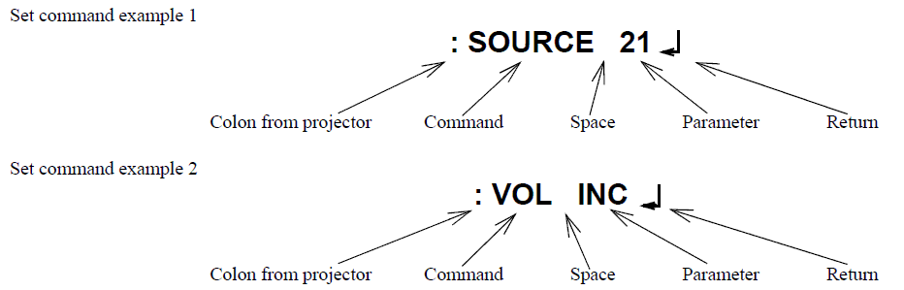

Get command format
A get command consists of a command and ?. Projector returns a response parameter after executing the command.

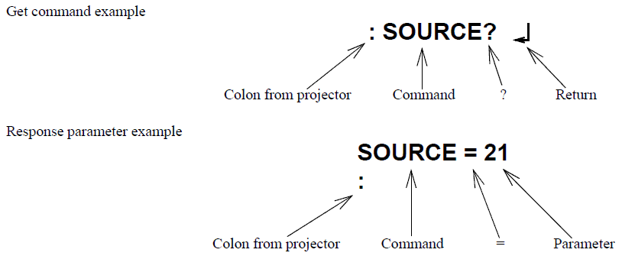

Null command
The null command is as command code of the return key code (Hex 0D). Projector returns a colon。The null command can be used to confirm that the projector is in operation.

Illegal commands
Projector returns “ERR” and a return key code (Hex 0D) and a colon when it receives invalid commands.
ERR
：

Projector state and commands

Standby state (Operation indicator is in orange)
When a projector is in a standby state, executable commands depends on projector models and standby configuration (network
on, network off). Refer to the following table.
Models | Configuration | Executable commands
61/81, 830/835, 821/828  740/745/732/737, 760/765  S3/S4, 765/760/755/750  62/82/X3(76), 6100/6000  1715/1710/1705/1700  1815/1810/1825  S5/X5/83/822/823/83+/822+,  260/280, 400W/410W  G5350/G5300/G5100/G5200W/  G5150/G5000, 6110/6010,  1735W/1730W/1725/1720  84/85/824/825/826W  Z8000WU/Z8050W  S7/X7/W7, S8/X8/W8  1900/1910/1915/1920W/1925W  84H/85H/825H/826H  440W/450W/460  , and later model | Network on/off | PWR ON  PWR?  LAMP?
7800/7850  8300/8350/9300  7900/7950  (note3) | Network on | PWR ON, PWR?, SOURCE?,  Null command(note1)
7800/7850  8300/8350/9300  7900/7950  (note3) | Network off | PWR ON(Note2)
Others | - | PWR ON(Note2)

(note1)EMP-61/81/830/835/740/745/821/828 returns “ERR” when it received commands other than PWR ON, PWR?, LAMP? and Null commands.
(note2) EMP-7800/7850 returns “ERR” when it received commands other than PWR ON, PWR?, SOURCE? and Null commands.
(note3) EMP-8300/9300 returns “ERR” when it received commands other than PWR ON, SOURCE xx, PWR?, SOURCE? and Null commands

All projectors returns “ERR” when the command format is not good. All projectors returns “ERR” when the projector is not ready to reply the command. A null command is command name for “ENTER” or “RETURE” key of the keyboard the reply is “:”.

Power on state (Operation indicator is in green)
All commands are executable.

Command transmission timing

Standby state
1). For all mode with the standby configuration of “network on”
The first command can be sent anytime and the subsequent commands should be sent after receiving a colon from the projector.
2). Other than 1)
PWR ON can be sent any time.

Power on state
A command should be sent after receiving the colon of the previous command from the projector. The following is an exception. When the PWR OFF command is sent to 7800/7850/8300/9300 with the standby configuration of “network off”, the subsequent command should be sent 10 seconds after the colon is received.
In case that you can not wait for the colon and send a command after receiving it, instead send a command after the execution time listed in the following table.

Command | Models | Execution time
PWR ON | Others | 40seconds
PWR ON | 830/835(note5)  7900/7950/740/745 | 20seconds
PWR ON | 61/81/821/S3/S4 | 25seconds
PWR OFF (note4) | 600/800/810/811/820 | 130seconds
PWR OFF (note4) | 740745, 732/737, 821 | 20seconds
PWR OFF (note4) | S3/S4, 765/760/755/750, 830/835  82, 6100, 1715/1710/1705/1700,  1815/1810/1825, X5/822/823,  400W/410W, G5350/G5100/G5200W  S6/X6/W6,1735W/1730W/1725/1720,  84/85/824/825/826W, and later model | 10seconds
SOURCE (note3) | - | 5seconds (note2)
All others | - | 3seconds

(note1) When a projector receives the PWR ON command, it tries to ignite the lamp by activating the ballast unit. In case that the lamp fails to be ignited, it tries to ignite the lamp three times at maximum. When the lamp fails to be ignited three times, it is a lamp failure.
The projector returns a colon within 40, 70 and 100 seconds when successful in the first, second and third times respectively.

(note2) When the input vide sync signal is stable, a colon is returned within 5 seconds. However, it may take more than 5 seconds when the input video sync signal is unstable.

(note3) Projector initiates the process of the input video signal recognition when it receives a SOURCE command. If the signal of the video input is changing (for example, from SVGA to XGA by A/V controller) during the process of the input video signal recognition, the projector returns “ERR”.

(note4) Projectors execute the PWR OFF command after they start completely.

(note5) Projectors might return “ERR” when “Quick Setup” and “Auto Focus” functions are set to ON.

Warning and abnormal cases
Projector executes commands normally while a warning indicator such as a high temperature warning is on.
Projector does not execute commands nor return a colon when the projector is in an abnormal state such as a lamp failure and abnormal high temperature.
As for EMP-6100/6000, EMP-1715/1710/1705/1700, EMP-1815/1810, EMP-S5/X5/83/822 and the following models, when an abnormal state is continued for 130 seconds after, PWR ON command becomes possible.

Error Status
A projector returns the error status when a projector receives "ERR?" command.

The following projectors can return the error status while the projectors become
the error status after cooling down.
EMP-1700/1705/1710/1715, 6000/6100/6110/6010, 1815/1810/1825, S5/X5/83/
EB-G5000/G5100/G5150/G5200W/G5300/G5350
And later models.

[The other models except the above models]
The models except the above models can return the error status while the projectors

The following table shows the return codes and the meaning of error status.

Command | Return code
ERR? | 00 :There is no error or the error is recovered
ERR? | 01 : Fan error
ERR? | 03 : Lamp failure at power on
ERR? | 04 : High internal temperature error
ERR? | 06 : Lamp error
ERR? | 07 : Open Lamp cover door error
ERR? | 08 : Cinema filter error
ERR? | 09 : Electric dual-layered capacitor is disconnected
ERR? | 0A : Auto iris error
ERR? | 0B : Subsystem Error
ERR? | 0C : Low air flow error
ERR? | 0D : Air filter air flow sensor error
ERR? | 0E : Power supply unit error (Ballast)
ERR? | 0F : Shutter error
ERR? | 10 : Cooling system error (peltiert element)
ERR? | 11 : Cooling system error (Pump)
ERR? | 12 : Static iris error
ERR? | 13 : Power supply unit error (Disagreement of Ballast)
ERR? | 14 : Exhaust shutter error
ERR? | 15 : Obstacle detection error
ERR? | 16 : IF board discernment error
ERR? | 17 : Communication error of “Stack projection function”
ERR? | 18 : I2C error

Appendix

Communication specification

Serial connection
A projector and a computer can be connected using a serial or USB port. The projector can be remotely controlled by sending commands to the projector.

- Select RS-232C at Advanced Setting of the Menu.
- Communication condition
Baud rate : 9600bps
Data length : 8 bits
Parity : No
Stop bit : 1 bit
Flow control : No
- Connector : D-Sub 9pin
- Projector input : Control(RS-232C)

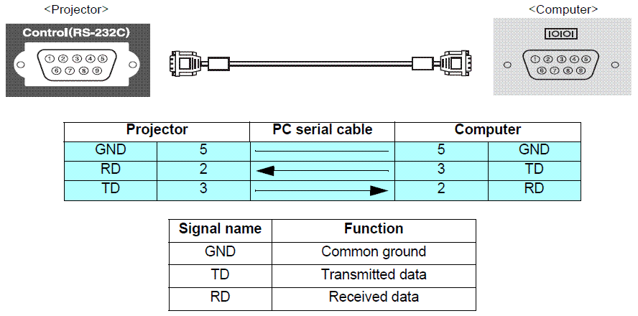

USB connection

- For 600/800/810/811/820, 74/54, select USB at advanced setting of the Menu.
- For 720/730/520, 73/53, 740/745, 732/737, S3/S4/X3, 760/765, 1715/1710/1705/1700, S5/X5, 260, select Link 21L at Advanced Setting of the Menu.
- For 8300/8350/9300, select USB at Advanced2 setting of the Menu.
- For 61/81, 830/835/821, select USB at Extended setting of the Menu.
- Except for above model select Wireless Mouse and select Link 21L at Extended Setting of the Menu.

- EPSON USB COM Driver has to be installed in your computer to use USB for communication. A COM port is added to your computer, when the projector and your computer is connected by a USB cable. The added COM is listed at PORT (COM/LPT) in the device manager tab of System in Control Panel as EPSON COM Emulation port (COMn).

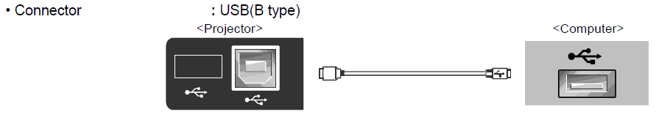

Revision History
Revision | Issued date | Page | Description
A | Apr 15, 2014 | All pages | First release.

